**Experiment No: 09**

**Name of the Experiment:** Study Of Gauss Seidel(GS) Method To Find the Solution Of Simultaneous Equations.

**Objectives:** The objective of this experiment is to apply GS method to find out the very precise values of the equations, using MATLAB.

**Theory:** Although it seems that the Gauss elimination method gives an exact solution, the accuracy of this method is not very good in large systems. The main reason of inaccuracy in the gauss elimination method is round-off error because of huge mathematical operations of this technique. Furthermore, this method is very time consuming in large systems. Many of systems of linear algebraic equations which should be solved in engineering problems are large and there are lots of zeros in their coefficient matrix. To solve this kinds of problems, iterative methods often is used. Gauss-Seidel one of the iterative techniques, is very well-known because of its good performance in solving engineering problems. For a system of linear equation as follows:

*a11x1 + a12x2 + … + a1nxn = c1*

*a21x1 + a22x2 + … + a2nxn = c2*

………………………

*an1x1 + an2x2 + … + annxn = cn*

 where *xi* are unknowns and *aij* are coefficients of unknowns and *ci* are equations’ constants. The Gauss-Seidel method needs a starting point as the first guess. The new guess is determined by using the main equation as follows:

[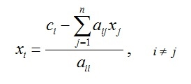](http://www.numericmethod.com/About-numerical-methods/system-of-linear-equations/gauss-seidel/Eq1.jpg?attredirects=0)

Mathematically, it can be shown that if the coefficient matrix is diagonally dominant this method converges to exact solution[1].

**Tool:** MATLAB Software

**Methodology:**

## (I)Algorithm:

1. Start
2. Take the coefficients of the linear equations.
3. Let x=0,y=0,z=0.
4. Put x,y,z in the functions and collect values in a,b,c. And again use x=a,y=b,z=c.
5. Stop

**(II) MATLAB Code:**

%declaring functions

f1 =@(x,y,z) (1/20)*(17-y+2*z);

f2 =@(x,y,z) (1/20)*(-18-3*x+z);

f3 =@(x,y,z) (1/20)*(25-2*x+3*z);

a_arr = [];

b_arr = [];

c_arr = [];

x=0;y=0;z=0;

%Iteration

for i=1:20

a=x;

x=f1(x,y,z);

if(abs(x-a)<0.001)

break;

end

y=f2(x,y,z);

z=f3(x,y,z);

a_arr(i) = x;

b_arr(i) = y;

c_arr(i) = z;

end

datatable = table(a_arr', b_arr', c_arr','VariableNames',{'x','y','z'});

**Output:**

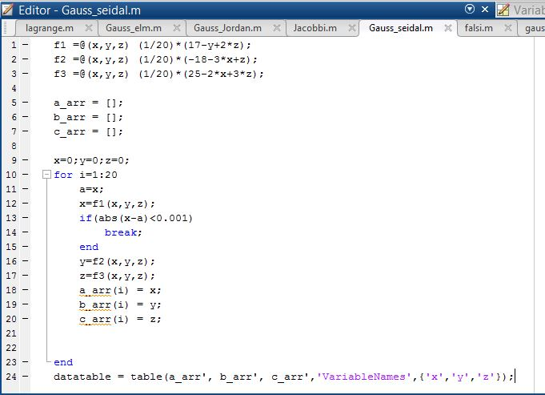

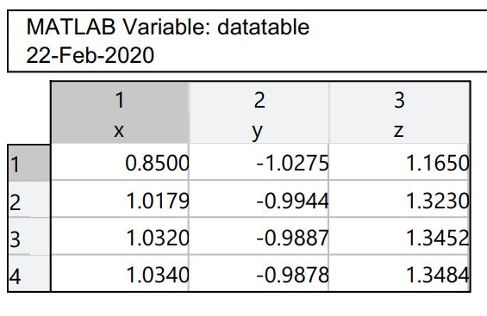

**Figure 09: Data Table**

**Result& Discussion:** The values of the given function is are 1.0430,-9878, 1.3484.Which is nearly close to the original values (1.043,-988, 1.34) direct calculated by calculator.

**Conclusion:** So from the above test we saw that nearly 3rd iteration we get the resultant value of two roots which is very close to the original roots.

**References:**

[1]C. Chapra and P. Canale Raymond , “*Numerical Methods for Engineers”,* 7th ed. McGraw-Hill Education, 2 Penn Plaza, New York, NY 10121, 2015