**Experiment No: 10**

**Name of the Experiment:** Study Of Jacobi Method To Find The Solution Of Simultaneous Equations.

**Objectives:** The objective of this experiment is to apply Jacobi method to find out the very precise values of the equations, using MATLAB.

**Theory:** The Jacobi method is very similar to Gauss-Seidel method. The only difference is that Jacobi method doesn’t use the latest evaluated *xi* s in the equation. This method employs a set of old *xi* s to determine a set of new *xi* s. It means:

[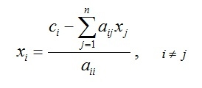](http://www.numericmethod.com/About-numerical-methods/system-of-linear-equations/jacobi/Eq1.jpg?attredirects=0)[1]

**Tool:** MATLAB Software

**Methodology:**

## (I)Algorithm:

1. Start
2. Take the coefficients of the linear equations.
3. Let x=0,y=0,z=0.
4. Put x, y, z in the functions. And again use new x, y, z.
5. Stop

**(II) MATLAB Code:**

%declaring functions

f1 =@(x,y,z) (1/20)*(17-y+2*z);

f2 =@(x,y,z) (1/20)*(-18-3*x+z);

f3 =@(x,y,z) (1/20)*(25-2*x+3*z);

a_arr = [];

b_arr = [];

c_arr = [];

x=0;y=0;z=0;

%Iteration

for i=1:20

a=f1(x,y,z);

b=f2(x,y,z);

c=f3(x,y,z);

if(abs(x-a)<0.001)

break;

end

a_arr(i) = a;

b_arr(i) = b;

c_arr(i) = c;

x=a;y=b;z=c;

end

datatable = table(a_arr', b_arr', c_arr','VariableNames',{'x','y','z'});

**Output:**

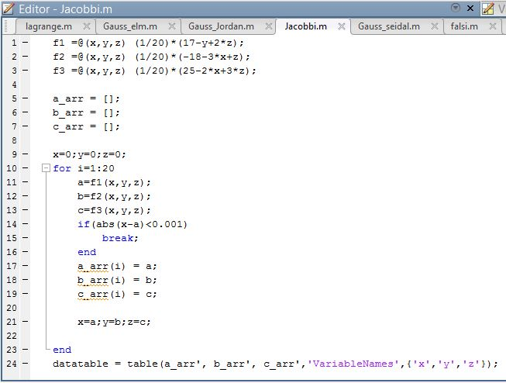

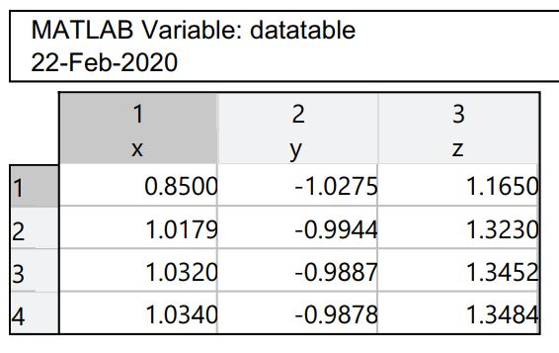

**Figure 10: Data Table**

**Result& Discussion:** The values of the given function is are 1.0430,-9878, 1.3484.Which is nearly close to the original values (1.043,-988, 1.34) direct calculated by calculator.

**Conclusion:** So from the above test we saw that nearly 4th iteration we get the resultant value of two roots which is very close to the original roots.

**References:**

[1]C. Chapra and P. Canale Raymond , “*Numerical Methods for Engineers”,* 7th ed. McGraw-Hill Education, 2 Penn Plaza, New York, NY 10121, 2015