**Experiment No: 14**

**Name of the Experiment:** Study Of Newton Backward Difference Method To Predict Unknown Value(s) For Any Geographic Point Data.

**Objectives:** The objective of this experiment is to use Newton backward difference method to find out the very precise values of the given data point, using MATLAB.

**Theory:** The differences y1 – y0, y2 – y1, ……, yn – yn–1 when denoted by dy1, dy2, ……, dyn, respectively, are called first backward difference. Thus the first backward differences are: 

NEWTON’S GREGORY BACKWARD INTERPOLATION FORMULA:

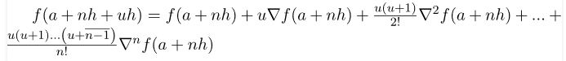

**Tool:** MATLAB Software

**Methodology:**

**MATLAB Code:**

x=[1921 1931 1941 1951 1961 1971 1981];

fx=[35 42 58 84 120 165 220];

n=size(x,2)

%array of zeros

dt=zeros(n,n)

%% inserting x and fx in dt

for i=1:n

dt(i,1)=x(i);

dt(i,2)=fx(i);

end

%% creating Newton backward difference table

z=3;k=2;

for i=1:n-1

for j=k:n

dt(j,z)=(dt(i+1,z-1)-dt(i,z-1));

i=i+1;

if(i>=n)

break;

end

end

k=k+1;z=z+1;

end

%value for fx to find

x_int=1975;

%determining u=(x-x1)*h

u=(x_int-x(n))/(x(2)-x(1));

%% determining sum by formula

y_sum=dt(n,2);k=1;d=1;

for i=2:4

for j=0:i-2

d=d*(u + j);

k=k*(j+1);

end

y_sum=y_sum+(dt(n,i+1)/k)*d;

d=1;

dt(n,i+1);

end

%% result

dt

y_sum

%% ploting the graph

plot(x, fx, 'bo', x_int, y_sum, 'r*')

axis([1900 2000 0 250])

xlabel('x')

ylabel('y')

**Output:**

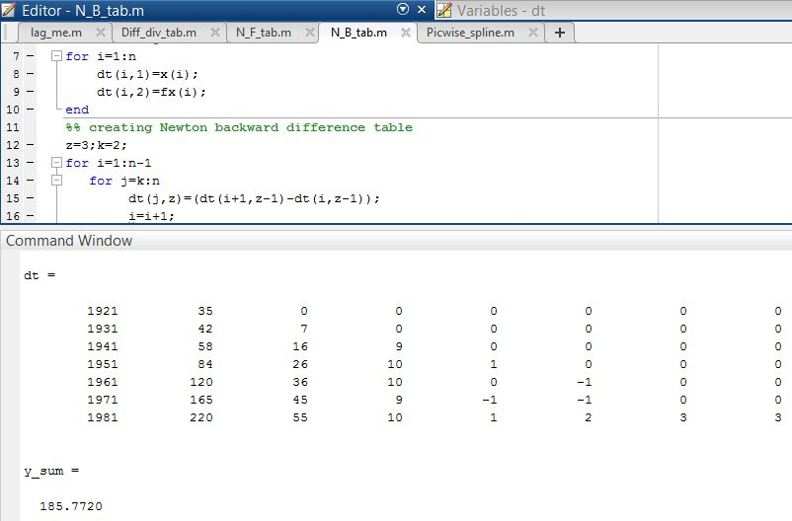

**------------------------------------------------------**

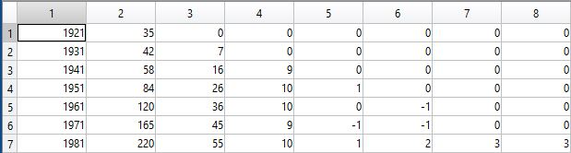

**Figure 14.1: Table of Newton Backward Difference**

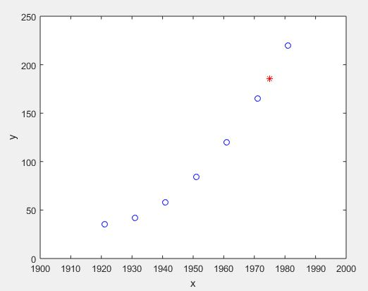

**Figure 14.2: Graph Of The Function**

**Result(s)& Discussion:** The unknown values for x = 1975 is y = 185.7720 . From text book[1] for x=1975 is y=185.8=186(round)

**Conclusion:** We have found the approximate unknown value for 1975 which is same as text book[1]. Matlab read the exact result 185.7720.

**References:**

[1]C. Chapra and P. Canale Raymond , “*Numerical Methods for Engineers”,* 7th ed. McGraw-Hill Education, 2 Penn Plaza, New York, NY 10121, 2015