**Experiment No: 15**

**Name of the Experiment:** Study Of Piecewise Linear Fit Interpolation Method To Predict Unknown Value(s) For Any Geographic Point Data.

**Objectives:** The objective of this experiment is to use piecewise linear fit interpolation method to find out the very precise values of the given data point, using MATLAB.

**Theory:** The interpolating polynomials which have been seen to this point have been defined on for all the *n* points (*x*1, *y*1), (*x*2, *y*2), ..., (*xn*, *yn*). An alternative approach is to define a different interpolating polynomial on each sub-interval under the assumption that the *x* values are given in order.

The simplest means is to take each pair of adjacent points and find an interpolating polynomial between the points which using Newton polynomials is

This can be expanded to reduce the number of required operations by reducing it to a form *ax* + *b* which can be computed immediately. The reader may note that if the value *x* = *xk* + 1 is substituted into the above equation that the value is *yk* + 1.

A significant issue with piecewise linear interpolation is that the interpolant is not differentiable or *smooth*. A non-differentiable function can introduce new issues in a system almost as easily as a non-continuous function.

Given a set of *n* points (*x*1, *y*1), (*x*2, *y*2), ... (*xn*, *yn*) where *x*1 < *x*2 < ··· < *xn*, a piecewise linear function is defined for a point *x* such that *xk* ≤ *x* ≤ *xk* + 1 .

Using the Piecewise Linear Fit Interpolation Method formula we can easily calculate the aspire value for a particular point. Where x_int is the given value for which we have to find f(x).

F(x)=(y(i+1)*(x_int - x(i))-y(i)*(x_int-x(i+1)))/(x(i+1)-x(i))

**Tool:** MATLAB Software

**Methodology:**

**MATLAB Code:**

x = [1 2 3 4 5 6];

y = [33 16 35 25 35 26];

%value for fx to find

x_int = 3.7;

%% using formula

for i=2:7

if(x_int <= x(i))

i=i-1;

f=(y(i+1)*(x_int - x(i))-y(i)*(x_int-x(i+1)))/(x(i+1)-x(i));

break;

end

end

%% result

x_int

f

%% ploting the graph

hold on

plot(x, y, x_int, f,'ro')

axis([0 10 10 50])

xlabel('x')

ylabel('y')

**Output:**

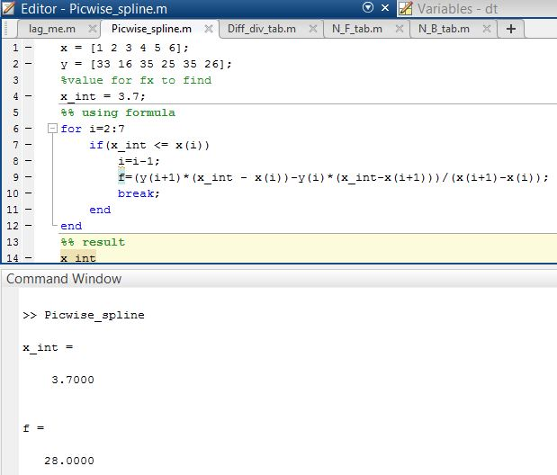

**--------------------------------------------------------**

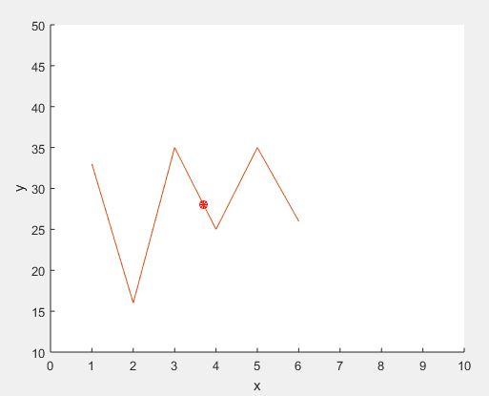

**Figure 15.1: Graph of the Function**

**Result(s)& Discussion:** The unknown values for x = 3.7 is y = 28 . From text book[1] for x=3.7 is y=28

**Conclusion:** We have found the exact unknown value for 3.7 which is same as text book[1].

**References:**

[1]C. Chapra and P. Canale Raymond , “*Numerical Methods for Engineers”,* 7th ed. McGraw-Hill Education, 2 Penn Plaza, New York, NY 10121, 2015