**Experiment No: 15**

**Name of the Experiment:** Study Of Piecewise Linear Fit Interpolation Method To Predict Unknown Value(s) For Any Geographic Point Data.

**Objectives:** The objective of this experiment is to use piecewise linear fit interpolation method to find out the very precise values of the given data point, using MATLAB.

**Theory:**

**Tool:** MATLAB Software

**Methodology:**

## (I)Algorithm:

**(II) MATLAB Code:**

x = [1 2 3 4 5 6];

y = [33 16 35 25 35 26];

%value for fx to find

x_int = 3.7;

%% using formula

for i=2:7

if(x_int <= x(i))

i=i-1;

f=(y(i+1)*(x_int - x(i))-y(i)*(x_int-x(i+1)))/(x(i+1)-x(i));

break;

end

end

%% result

x_int

f

**Output:**

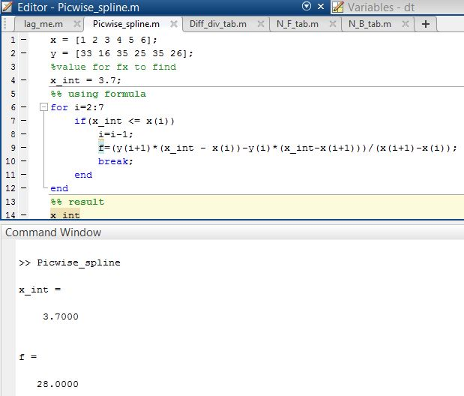

**Result(s)& Discussion:** The unknown values for x = 3.7 is y = 28 . From text book[1] for x=3.7 is y=28

**Conclusion:** We have found the exact unknown value for 3.7 which is same as text book[1].

**References:**

[1]C. Chapra and P. Canale Raymond , “*Numerical Methods for Engineers”,* 7th ed. McGraw-Hill Education, 2 Penn Plaza, New York, NY 10121, 2015