**Experiment No: 16**

**Name of the Experiment:** Study Of Simpson’s 1/3 Integral Method To Calculate Integral Value Of A Function With Limit.

**Objectives:** The objective of this experiment is to use Simpson’s 1/3 Integral Method to calculate integral value of any limited function, using MATLAB.

**Theory:** If the interval [a,b] is split up into n subintervals, and n is an even number, the composite Simpson's rule is calculated with the following formula:

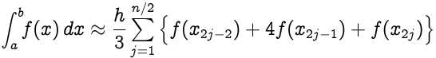

where **xj = a+jh** for **j = 0,1,…,n-1,n** with **h=(b-a)/n**; in particular, **x0 = a** and **xn = b**.

**Tool:** MATLAB Software

**Methodology:**

**MATLAB Code:**

%Function declaration

f= @(x) 3*x^2+3;

a=0;b=6;

n=b-a;

%height

h = (b - a) / n;

%simpson's formula

sum_x1 = 0;sum_x2=0;

for i=0:1:n

x = a + i * h;

if(i>1 && i<n && mod(i,2)==0)

sum_x2=sum_x2+f(x);

end

if (i>0 && i<n && mod(i,2)~=0)

sum_x1 = sum_x1 + f(x);

end

end

xi = h / 3 * (f(a) + 4 * sum_x1 +2*sum_x2+ f(b));

%Output

xi

**Output:**

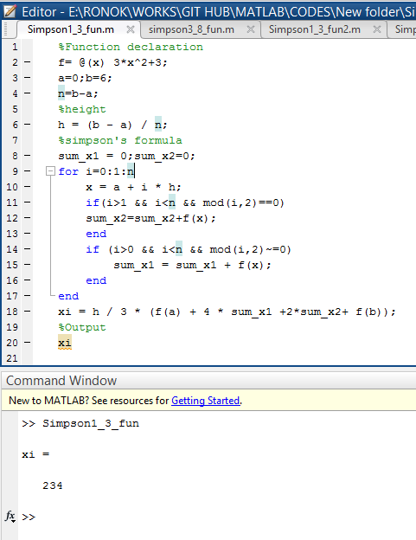

**Result(s)& Discussion:** The integration value is 234.

**Conclusion:** We have found the exact integral value of function **3x2 +3** from limit 0 to 6 which is same as the calculated value (∫**60 3x2 +3 dx**).

**References:**

[1]C. Chapra and P. Canale Raymond , “*Numerical Methods for Engineers”,* 7th ed. McGraw-Hill Education, 2 Penn Plaza, New York, NY 10121, 2015