The Search for Outbursters – Physics B0049 Lab Computers

# 0 – Log in

Log in to one of the Mac Lab computers in B0049 or your personal device. The following instructions are made for the Mac Lab computers, but the changes to these instructions for other devices are very minor (for Windows) or *almost* nonexistent (for Mac and Linux). For Windows devices, for example, rather than using the terminal, you would use Windows Powershell. If my memory serves, the commands should be identical except the folder separator slashes are backslashes (\) instead of forward slashes (/)

If you are using your own device and would like help applying these instructions to your device, I’ll be happy to help you.

NOTE: It would be best if you worked at the same computer every time you come to work on this research as all files are stored locally. Moving from one computer to another may mean that you’d have to perform the first-time setup for each computer you use.

NOTE: In a few places, you will see text in font that looks like this. That font is for text shown in the terminal or commands that you will type into the terminal. The terminal is essentially a text-based method of interfacing with the computer. In some of those commands, you may see braces [containing some text]. Those braces represent blanks that will be filled by whatever is described by the text in the braces (for instance, a target number). You do not need to type the braces themselves. So for example, if the instructions said something like cd Desktop/[name of folder], you would type into the terminal something like cd Desktop/MyFolder. I will describe what these commands do as they are encountered in this manual.

# 1 - First Time Setup

If you have already done this for the computer you’re working on, skip to section 2.

## 1.1 – Downloading your needed files and folders

1. Log into CyBox using your ISU credentials
2. There you should see two folders I have shared with you, “ResearchStarterFiles” (shared via link) and “[YourName]Folder” (shared directly via CyBox). If you do not see one or both of these, please let me know as soon as possible.
   1. Reminder, text in braces is placeholder text. Your second folder will not be “[YourName]Folder” but rather a folder with your name in the title
3. Open “ResearchStarterFiles” Check to make sure the seven following files are in there:
   1. LICENSE
   2. README.md
   3. requirements.txt
   4. SampleC.vot
   5. TESS-LS.py
   6. TESSutils.py
   7. UpdatedMacLabManual-2024.xlsx (This manual)
4. Download the “ResearchStarterFiles” folder and place it anywhere you would like on your computer. As the rest of this manual works as if you placed it on the Desktop, I recommend you put it there
5. Open “[YourName]Folder.” Check to ensure that there is an Excel Spreadsheet called “[YourName]TargetList” there. If this file does not exist, please let me know.
   1. I recommend that you open but do not download “[YourName]Folder” because then you can just edit the target list in that folder and you won’t have to keep uploading new versions at the end of each session.

# 2 – Searching for Outbursting White Dwarfs

## 2.1 – Preparing to Search for Outbursters

1. Open the copy of “ResearchStarterFiles” that you downloaded
   1. Again, the remainder of the manual assumes you put it on the Desktop, and future instructions will reflect that
2. Open a terminal. You can find it in Launchpad → Other
   1. The icon will look similar to this: 
   2. You can know that your terminal is ready for use when you have the flashing cursor following the prompt line, which will say [computer tag]:~ [ISU Net ID]$
   3. See the figure for what you should see in your terminal:

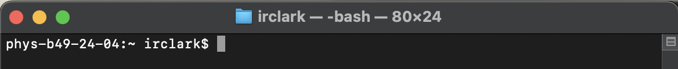

* 1. Info: “Computer tag” is basically just what the IT people named the computer

1. In the terminal, navigate to “ResearchStarterFiles”.
   1. To do this, type cd Desktop/[Name of your work folder], and press enter. 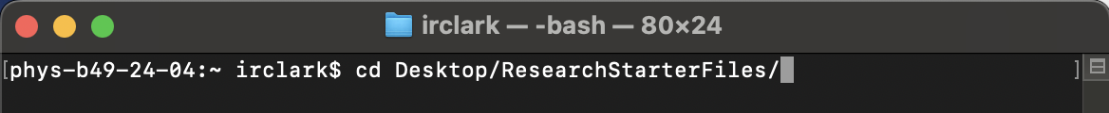
      1. This command tells the terminal to change the folder or directory it’s working from (cd for change directory) and the destination folder (the part after cd).
   2. There may be a prompt that comes up that asks if you want to allow the terminal to modify files on the desktop. Click “OK” If this prompt comes up.
2. Your terminal display should now look like this: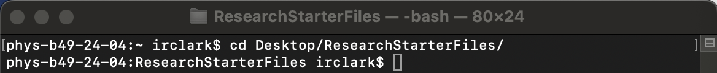

## 2.2 – Search for Outbursters

If you need a reminder of how the target lists work, please see Appendix A.

1. Open your target list in CyBox in “[YourName]Folder”
2. Check to see which targets next need to be worked on
3. Create a results directory in your downloaded “ResearchStarterFiles” for your next target
   1. You can do this either in the GUI (the Graphical User Interface that you are most likely more used to) or the terminal
      1. To do this in the GUI, right click (or control+click) inside of the Finder window displaying the contents of your “ResearchStarterFiles” folder, pick the option to create a new folder, and name the new folder “Results_[TICNumber of your next target]”
      2. If you want to do this in the terminal, type mkdir Results_[TICNumber of your next target] and press returnA screenshot of a computer

         Description automatically generated
         1. The mkdir command makes a directory, or creates a new folder.
4. In your terminal, type python TESS-LS.py [TIC Number of your next target] and press enter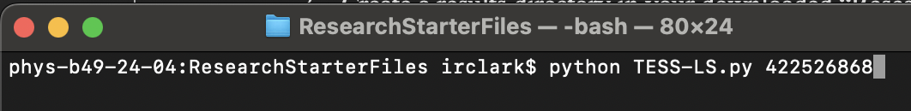
   1. You may see an error that says, “No module named ‘[name of module]’, similar to this display:
      1. This means that the script simply doesn’t have all the Python modules needed to run. To remedy the problem, type pip install [name of missing module] and press return
      2. Wait a moment and the prompt line should reappear (see the figure in Section 2.1, step 2c for a reminder of what the prompt line looks like). Once the prompt line reappears, repeat Section 2.2 (this section) step 4. If you receive this missing package error again, install the missing packages with the same procedure.
      3. Another error that may appear: (FileNotFoundError: [Errno 2] No such file or directory: ‘COMPLETE’) This one comes due to a too-new version of one of the packages (astropy) being installed.
         1. To remedy this error, type pip install astropy==5.2.2 and press enter to install a compatible version of the astropy package. After the prompt line reappears, repeat Section 2.2 (this section) step 4.
5. If there is data on this object, after a moment the script will ask you four questions in the terminal prompt. These are about additional files it could make and another phasing of the data that it could make. Press 0 then enter after each one.
6. Wait until the script completes.
   1. You can tell that the script is completed when your prompt line reappears in your terminal window, instead of the last line being blank (see the figure in Section 2.1, step 2c for a reminder of what the prompt line looks like)
7. Once it is finished, open the images and examine the bottom left panel for outburster or any other unusual behavior. This panel is the lightcurve, which is essentially a graph of the star’s brightness over time.
   1. What constitutes outburster behavior will be a few somewhat regularly-spaced spikes in the lightcurve (although sometimes there will only be one spike) with notches below them. For example, see the following image. The outbursts are circled in red. If you look at the whole scatter plot, you see that the whole of the data spikes up during an outburst.

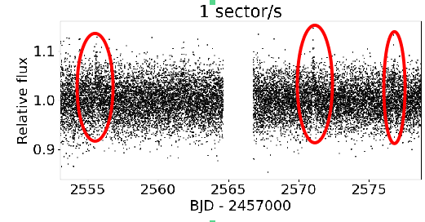

1. Enter the outburst behavior of the object in your target list (even if there is no outburst or other unusual behavior).
   1. See Appendix A if you need a reminder on the intended use of the target list
2. Move all the files produced by the script associated with your object into the directory that you made in Section 2.2 step 3.
   1. You can do this by dragging and dropping in the GUI, or by using the terminal
      1. To do this in the terminal, type mv TIC* Results_[TICNumber of your target] and press enter.
         1. The mv command moves files.
      2. Note: the TIC* part lets the terminal know to move everything that starts with a TIC in its filename into the directory you tell it to.
         1. **IMPORTANT**: This will only work properly if you have been following Section 2.2 steps 3-9 every time you have sat down to do this work. Otherwise, you will end up with files belonging to the wrong objects in your results folders.
   2. Note: There should be 2 or 3 files moved to your results folder, depending on the data available for the target object.
      1. TIC[number].log, which tells you some information about the star that the script retrieved
      2. Two image files, one that has “fast” in its filename, and the other that does not. The former used data that were taken with TESS’s camera open for 20 seconds for each data point and the latter uses data taken with TESS’s camera open for 120 seconds for each data point.
         1. Sometimes there is only either 20 second or 120 second data. If that is the case, there will be only one image
3. Upload the now full results folder to your “[YourName]Folder” on CyBox.
4. Repeat all previous steps in Section 2.2 for as many objects as you want to do today.

# Appendix A: Description of the Target Lists

Your target list also doubles as your log sheet.

Your target list has the TIC numbers, or the TESS Input Catalog numbers of your stars. These TIC numbers are how TESS identifies its targets.

You will have three columns in your target list.

Column 1: The *TIC numbers* of your targets

Column 2: The *status* of your target. There will be 5 options here:

**Done – No outburster**: For if you have investigated the star and it does not show outbursting or other unusual behavior. In other words, the graph will basically just look like a fuzzy bar. See the figure for an example: A black and white image of a graph

**Done – Outburster**: If you have investigated the star and it shows outbursting behavior.

**Done – No Available Light Curves**: For when there are no lightcurves available for your object.

**Done – Other**: If you have investigated the star and it does not show outbursting behavior, but it does show some other interesting behavior.

**Done – Can’t tell**: This is when the data is so packed together that it’s hard to tell what’s going on, outburst or otherwise.

Column 3: *Notes* you have about your target. If it is an outburst, list at what time it it occurss on the lightcurve (the x-coordinate), and how bright they are, as recorded by how high the outburst is on the graph. If it is not an outburster but has some other interesting behavior, you would also describe that behavior here, in detail.