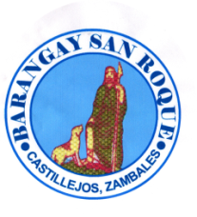 REPUBLIC OF THE PHILIPPINES
PROVINCE OF CASTILLEJOS
MUNICIPALITY OF ZAMBALES
BARANGAY SAN ROQUE
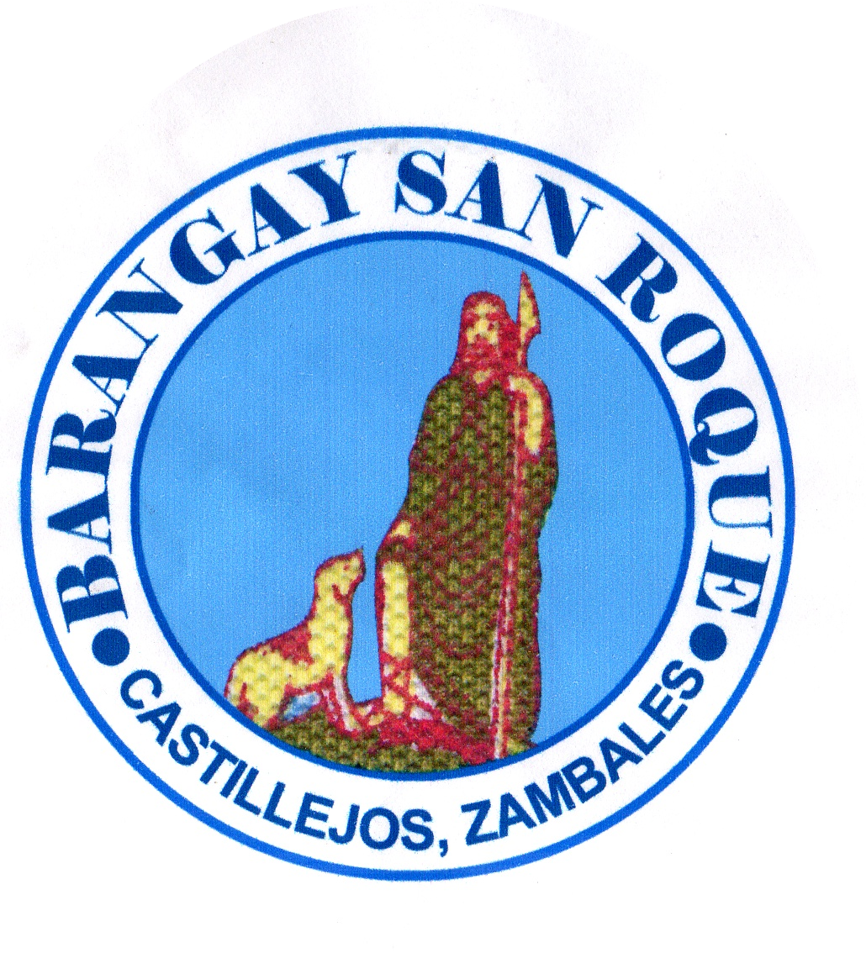

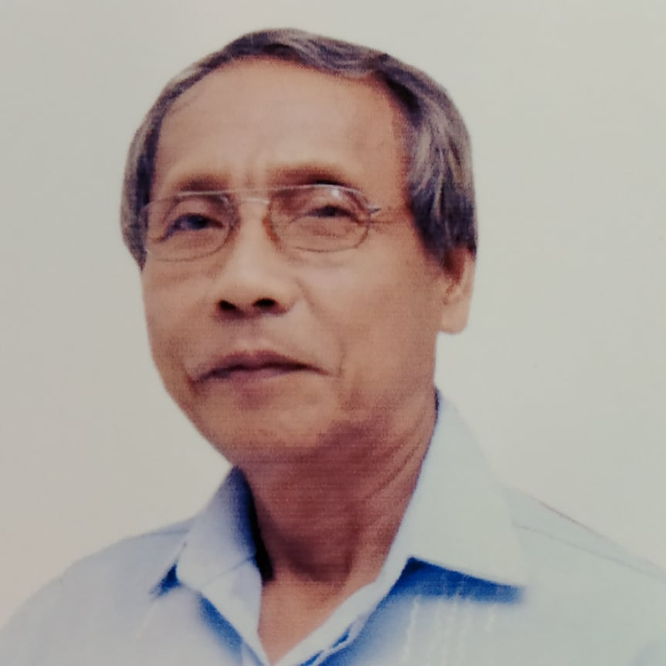
BRGY. SAN ROQUE BARANGAY CLEARANCE
OFFICIALS

Hon. Rafael R. Tugadi
Punong Barangay
To Whom It May Concern
Hon. Joel T. Miguel
Committee on Peace & Order
This is to certify that Ephraim Dumaya,
Hon. Juanita P. Tiong was born on January 2, 1963 at Castillejos, Zambales.
Committee on Appropriation is a resident of Purok III, San Roque, Castillejos, Zambales.
Said person is known to me to be of good moral character, peaceful and
Hon. Warren M. Gonzaga a law –abiding citizen of this Barangay.
Committee on Agriculture/ESWM
Subject person is not charged of any criminal offenses, Have no pending case
Hon. Maria Luz P. Garcia under Republic Act 7160, known as the Katarungang Pambarangay Law.
Committee on Health & Sanitation
Women & Family, VAWC Officer This certification is issued upon request of the above-named for any legal Purposes it may serve.
Hon. Ronny Q. Egsao
Committee on Education/Tourism Issued this 14th day of 2024-12-01
Hon. Catalina A. Sagum
Committee on Ways & Means

Hon. Jovito B. Manzano HON. RAFAEL R. TUGADI
Committee on Infrastructure Punong Barangay

Mrs. Jacquelyn E. Raguini
Barangay Secretary

Mr. Rhyan M. Melgar
Barangay Treasurer
Left Thumb Mark Right Thumb Mark
SK Chairperson
Hon. Erickson C. Antolin 
Committee on Sports

VISION:
To indulge the executive and legislative
body to a much stronger ties working
in harmony and unity towards ___________________________ accomplishment of vital projects for Signature of Applicant
the common good and welfare of
constituents. Paid Under:
OR No.: __________________
MISSION: Date: _November 14, 2023___ 2024-12-01
Making Barangay San Roque a well – oriented
community and an ideal dwelling place with
the objective to achieve progress and
development empowering transparent
governance and prompt public services. NO TO CORRUPTION !! YES TO GOOD GOVERNANCE!!!
*** Not Valid Without Barangay Seal***

