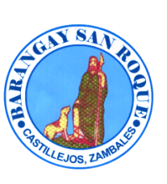

REPUBLIC OF THE PHILIPPINES
PROVINCE OF CASTILLEJOS
MUNICIPALITY OF ZAMBALES
BARANGAY SAN ROQUE
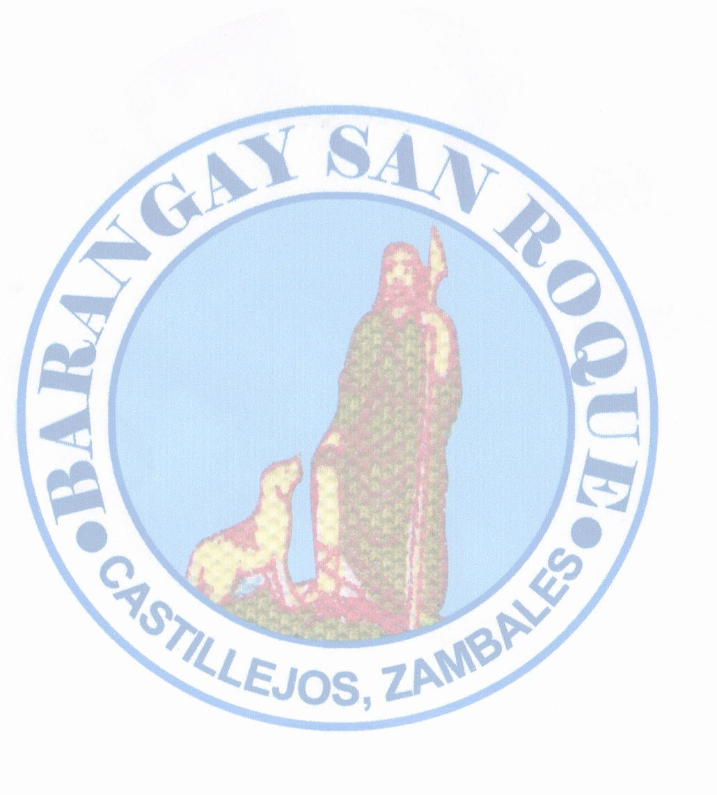

BRGY. SAN ROQUE BARANGAY CLEARANCE
OFFICIALS

Hon. Ronnie T. Isidro
Punong Barangay
To Whom It May Concern
Hon. Joel T. Miguel
Committee on Infrastructure
This is to certify that {name}, {age
years old ,
Hon. Warren M. Gonzaga was born on {dateOfBirth
} at Castillejos, Zambales.
Committee on Health is a resident of San Roque, Castillejos, Zambales.
Said person is known to me to be of good moral character, peaceful and
Hon. Erickson C. Antolin a law –abiding citizen of this Barangay.
Committee on Agriculture/ESWM
Subject person is not charged of any criminal offenses, Have no pending case
Hon. Gilbert A. Serrano under Republic Act 7160, known as the Katarungang Pambarangay Law.
Committee on Peace & Order
This certification is issued upon request of the above-named for any legal Purposes it may serve.
Hon. Ronny Q. Egsao
Committee on Education/Tourism Issued this {day
} day of {month
} {year
}.
Hon. Fernando A. Manzano
Committee on Tourism & VAWC

Hon. Manolito D. Gatdula HON. RONNIE T. ISIDRO
Committee on Ways & Means &
Agriculture Punong Barangay

Mrs. Sonia P. Fontillas {%image}
Barangay Secretary

Mr. Rhyan M. Melgar
Barangay Treasurer
Left Thumb Mark Right Thumb Mark
SK Chairperson
Hon.Trixia Daine L. Merigildo
Committee on Sports

VISION:
To indulge the executive and legislative
body to a much stronger ties working
in harmony and unity towards ___________________________ accomplishment of vital projects for Signature of Applicant
the common good and welfare of
constituents. Paid Under:
OR No.: __________________
MISSION: Date: ____
Making Barangay San Roque a well – oriented
community and an ideal dwelling place with
the objective to achieve progress and
development empowering transparent
governance and prompt public services. NO TO CORRUPTION !! YES TO GOOD GOVERNANCE!!!
*** Not Valid Without Barangay Seal***

