 REPUBLIC OF THE PHILIPPINES

PROVINCE OF CASTILLEJOS

MUNICIPALITY OF ZAMBALES

**BARANGAY SAN ROQUE**

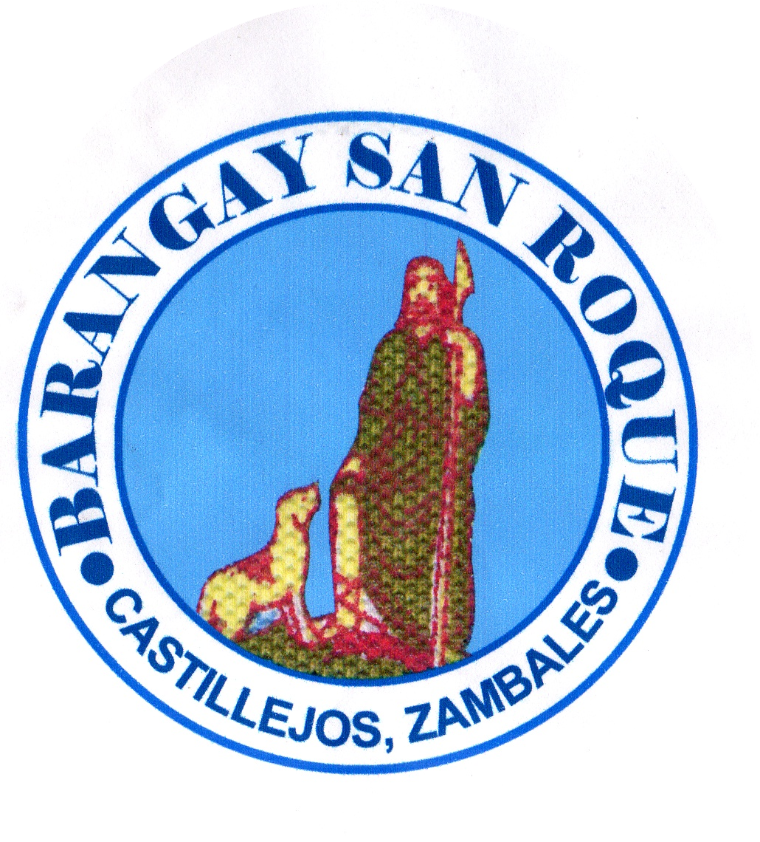

**BRGY. SAN ROQUE BARANGAY CLEARANCE**

**OFFICIALS**

**Hon. Ronnie T. Isidro**

Punong Barangay

**To Whom It May Concern**

**Hon. Joel T. Miguel**

Committee on Infrastructure

This is to certify that **{name}, {age**

**years old ,**

**Hon. Warren M. Gonzaga** was born on  **{dateOfBirth**

**} at Castillejos, Zambales.**

Committee on Health is a resident of  **San Roque, Castillejos, Zambales.**

Said person is known to me to be of good moral character**,** peaceful and

**Hon. Erickson C. Antolin** a law –abiding citizen of this Barangay.

Committee on Agriculture/ESWM

Subject person is not charged of any criminal offenses, Have no pending case

**Hon. Gilbert A. Serrano** under Republic **Act 7160**, known as the Katarungang Pambarangay Law.

Committee on Peace & Order

This certification is issued upon request of the above-named for **any legal** Purposes it may serve.

**Hon. Ronny Q. Egsao**

Committee on Education/Tourism Issued this  **{day**

**}** day of  **{month**

**} {year**

**}.**

**Hon. Fernando A. Manzano**

Committee on Tourism & VAWC

**Hon. Manolito D. Gatdula HON. RONNIE T. ISIDRO**

Committee on Ways & Means &

Agriculture Punong Barangay

**Mrs. Sonia P. Fontillas** {%image}

Barangay Secretary

**Mr. Rhyan M. Melgar**

Barangay Treasurer

Left Thumb MarkRight Thumb Mark

**SK Chairperson**

**Hon.Trixia Daine L. Merigildo**

Committee on Sports

VISION**:**

To indulge the executive and legislative

body to a much stronger ties working

in harmony and unity towards **___________________________**  accomplishment of vital projects for **Signature of Applicant**

the common good and welfare of

constituents. Paid Under:

**OR No.: __________________**

**MISSION: Date: ____**

Making Barangay San Roque a well – oriented

community and an ideal dwelling place with

the objective to achieve progress and

development empowering transparent

governance and prompt public services. **NO TO CORRUPTION !! YES TO GOOD GOVERNANCE!!!**

*** Not Valid Without Barangay Seal***