{image}

**BRGY. SAN ROQUE OFFICIALS**

**Hon. Ronnie T. Isidro**

Punong Barangay

**Hon. Joel T. Miguel**

Committee on Infrastructure

**Hon. Warren M. Gonzaga**

Committee on Health

**Hon. Erickson C. Antolin**

Committee on Agriculture/ESWM

**Hon. Gilbert A. Serrano**

Committee on Peace & Order

**Hon. Ronny Q. Egsao**

Committee on Education/Tourism

**Hon. Fernando A. Manzano** Committee on Tourism & VAWC

**Hon. Manolito D. Gatdula**

Committee on Ways and Means & Agriculture

**Mrs. Sonia P. Fontillas**

Barangay Secretary

**Mr. Rhyan M. Melgar**

Barangay Treasurer

**SK Chairperson**

**Hon. Trixia Daine L. Merigildo**

Committee on Sports

**VISION**

To indulge the executive and legislative body to a much stronger ties working in harmony and unity towards accomplishment of vital projects for the common good and welfare of constituents.

**MISSION**

Making Barangay San Roque a well oriented community and an ideal dwelling place with the objective to achieve progress and development empowering transparent governance and prompt public services.

**OFFICE OF THE PUNONG BARANGAY**

**C E R T I F I C A T E OF INDIGENCY**

This is to certify that __{name}____ **_______ __,_{age}___**years old is a Bona Fide resident of this Barangay. She /he is currently and permanently residing at **San Roque, Castillejos, Zambales.** Said person has no permanent employment/low income as of this date and validated by the undersigned to be one of the indigent family in this Barangay.

This certification is issued upon request of the above- named for  **{purpose}________** Assistance Purposes.

Issued this **_{day}______**  day of **_ {month}, {year}_______________** for any legal intent it may serve.

**RONNIE T. ISIDRO**

Punong Barangay

**NO TO CORRUPTION!!! YES, TO GOOD GOVERNANCE!!!**

*** Not Valid Without Barangay Seal***

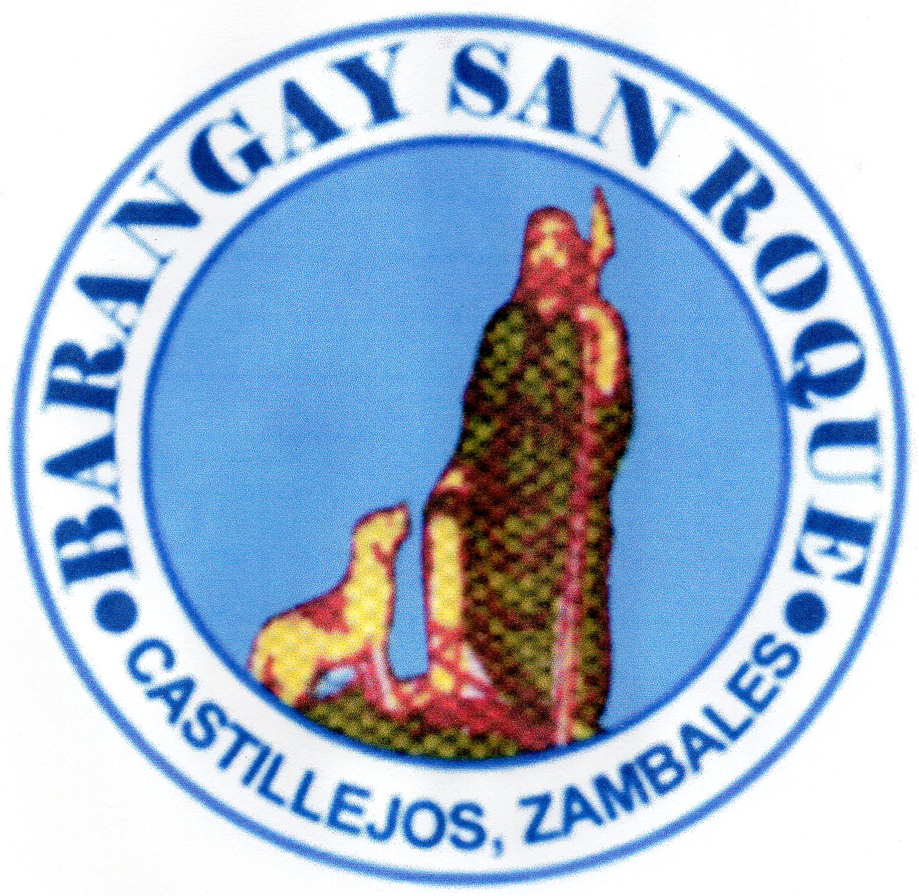



Republic of the Philippines

Municipality of Castillejos

Province of Zambales

**BARANGAY SAN ROQUE**



