**OFFICE OF THE PUNONG BARANGAY**

**CERTIFICATION**

This is to certify that **Cesar R. Tugadi,66** years old, was born on **June 02, 1957 at Castillejos, Zambales** is a resident of **Acayan St, Purok_IV, Barangay San Roque, Castillejos, Zambales** since birth.

Issued this **__3rd__** day of **___October 2023___**for any legal intent it may serve.

**RONNIE T. ISIDRO**

Punong Barangay

**NO TO CORRUPTION!!! YES TO GOOD GOVERNANCE!!!**

*** Not Valid Without Barangay Seal***

**NO TO CORRUPTION!!! YES TO GOOD GOVERNANCE!!!**

*** Not Valid Without Barangay Seal***

**BRGY. SAN ROQUE OFFICIALS**

**Hon. Ronnie T. Isidro**

Punong Barangay

**Hon. Joel T. Miguel**

Committee on Infrastructure

**Hon. Warren M. Gonzaga**

Committee on Health

**Hon. Erickson C. Antolin**

Committee on Agriculture/ESWM

**Hon. Gilbert A. Serrano**

Committee on Peace & Order

**Hon. Ronny Q. Egsao**

Committee on Education/Tourism

**Hon. Fernando A. Manzano**

Committee on Tourism & VAWC

**Hon. Manolito D. Gatdula**

Committee on Ways and Means & Agriculture

**Mrs. Sonia P. Fontillas**

Barangay Secretary

**Mr. Rhyan M. Melgar**

Barangay Treasurer

**SK Chairperson**

**Trixia Daine L. Merigildo**

Committee on Sports

**VISION**

To indulge the executive and legislative body to a much stronger ties working in harmony and unity towards accomplishment of vital projects for the common good and welfare of constituents.

**MISSION**

Making Barangay San Roque a well oriented community and an ideal dwelling place with the objective to achieve progress and development empowering transparent governance and prompt public services.

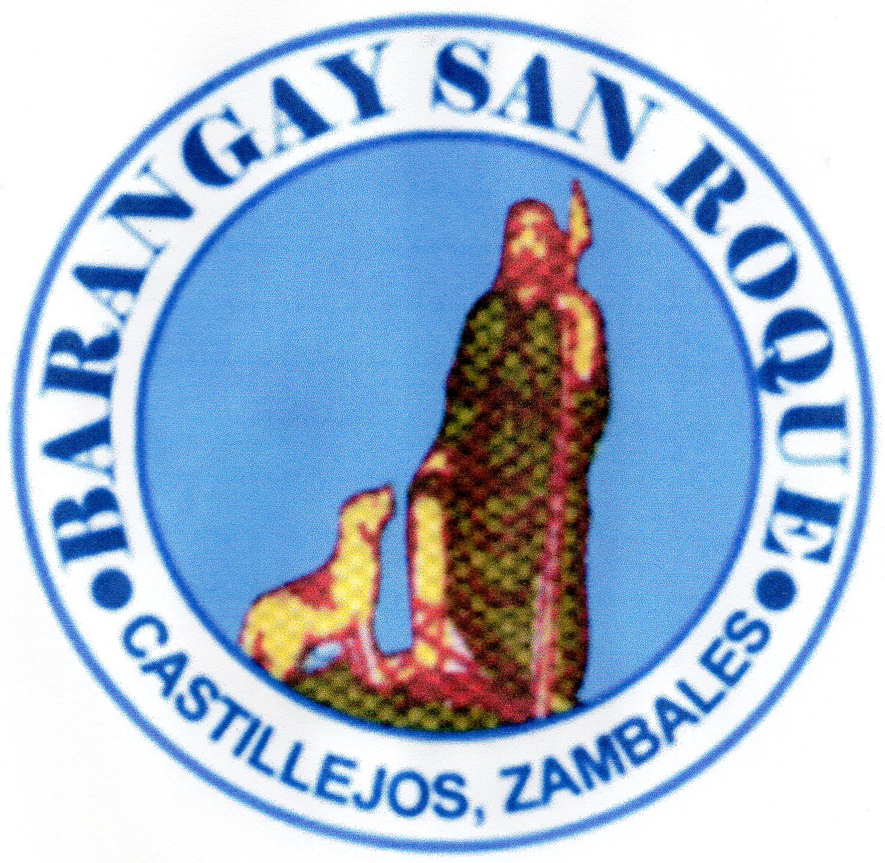



Republic of the Philippines

Municipality of Castillejos

Province of Zambales

**BARANGAY SAN ROQUE**



