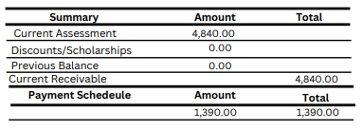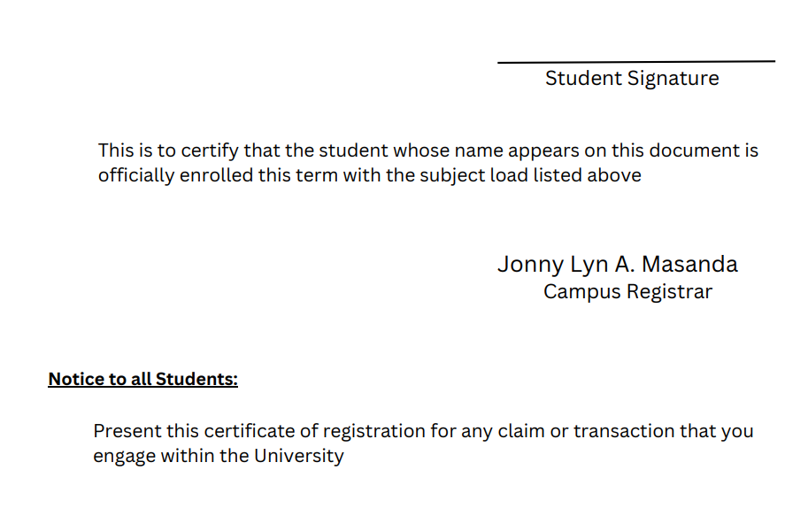

CERTIFICATE OF REGISTRATION

Total Assessment

4,840.00

1,390.00

3,450.00

3,450.00

50.00

25.00

50.00

20.00

20.00

30.00

40.00

100.00

100.00

30.00

50.00

225.00

20.00

20.00

100.00

80.00

30.00

200.00

200.00

Tuition Fee

Tuition Fee 23 X 15-/ unit

Miscellaneous Fee

Athletics Fee

Audio Visual Fee

Cultural Fee

Entrance Fee

Future technologies Association Fee

Guidance Fee

Student Handbook Fee

Identification Fee

Library Fee

Medical and Dental Fee

Membership Fee

NSTP Fee 1.5 x 150/unit

Research Journal Fee

Registration Fee

SCUAA Fee

School Paper Fee

SSG Fee

Student Training Fund Fee

Systems Fee

**Assessment Amount Total**

In consideration of my admission to President Ramon Magsaysay State University, and of the privileges of students in this institution, I hereby pledge to abide by comply with all the rules and regulations laid down by the University and in the academic unit in which I am Enrolled

**Instructor**

**Schedule**

**Lab**

Scientific and Technical Writing

Architecture and Organization

0.0

21.0

21.0

**Total of Units:**

Automata Theory and Formal Languages

**PSTAT 101 OSSAD**

**A2**

9-12pm S HYBRID LAB

3.0

Probability Theory and

Statistical Analysis

3.0

0.0

**-**

**BSCS-3A**

**OS 101 OSSAD**

**BSCS-3A**

**-**

**-**

**-**

**-**

**-**

**-**

10-11am W HYBRID LAB

10-11am TH ONLINE ROOM

3.0

3.0

0.0

Operating System

**A4**

**A6**

**A5**

**A3**

10-11am M HYBRID LAB

11am-12pm W Online Room

4-5 pm T HYBRID

4-5 pm T Online Room

11am-12pm T COM LAB

1-4 pm W COM LAB

**BSCS-3A**

0.0

3.0

3.0

**AR 101**

**A7**

**BSCS-3A**

3.0

0.0

3.0

**AL 102**

**PL 101**

**BSCS-3A**

8-9am MTh COM LAB

1-4pm Th COM LAB

3.0

0.0

0.0

3.0

Programming Languages

**BSCS-3A**

11am-12pm M Hybrid

3.0

3.0

Software Engineering II

**SE 102**

9-11am T Online-Room

**BSCS-3A**

1-2 pm M Room

0.0

3.0

3.0

**ENN1**

**A1**

**Section**

**TF**

**Units**

**Subject Code**

**Subject Description**

**Code**

**Name: {{NAME}} Course/Yr: {{COURSE_YEAR}} Period: {{SEMESTER}}**

**ID No: {{ID_NUMBER}} Date: {{DATE}}**

**Address: {{ADDRESS}}**