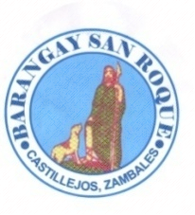

**BARANGAY BUSINESS CLEARANCE**

To Whom It May Concern:

This is to certify that the business of trade activity described below:

**__{{PURP}}_**

Business Name of Trade Activity

Barangay San Roque, Castillejos, Zambales_

Location

**{{NAME}}_**

Operator/Manager

Purok 1, Rizal St.,Barangay San Roque, Castillejos, Zambales

Address

Proposed to be established in this Barangay and is being applied for a Barangay Clearance to be used in seeking a corresponding Mayor’s Permit has been found to be:

* In conformity with the provision of the existing barangay ordinances, rules and regulations being enforced in this Barangay.
* Not among this business or trade activities being banned to be established in this Barangay.
* In view of the foregoing, this Barangay through the undersigned.
* Interposes no objection for the issuance of the corresponding Mayor’s Permit being applied for.

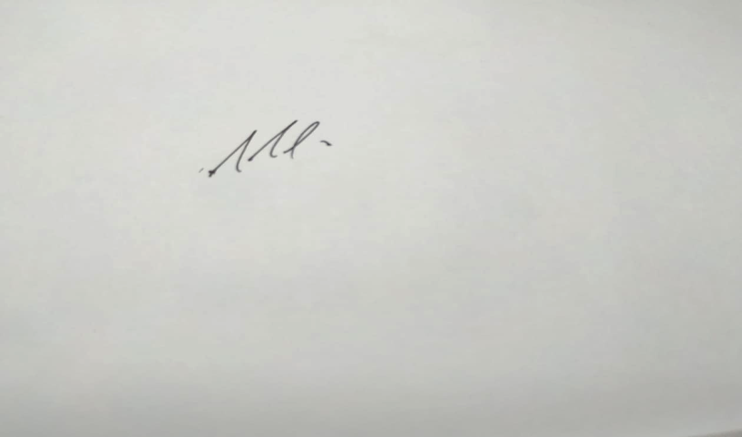

**HON. RAFAEL R .TUGADI**

Punong Barangay

OR No._11496694 ____

Date: _{{DATE}}__ Serial No. SR – 132- 2023

**BARANGAY SAN ROQUE**

**OFFICIALS**

**HON. RAFAEL R. TUGADI**

Punong Barangay

**HON. JOEL T. MIGUEL**

Committee on Peace & Order

**HON. JUANITA P. TIONG**

Committee on Appropriation

**HON. WARREN M. GONZAGA**

Committee on Agriculture/ESWM

**HON. MARIA LUZ P. GARCIA**

Committee on Health & Sanitation

Women & Family, VAWC Officer

**HON. RONNY Q. EGSAO**

Committee on Education/ Tourism

**HON. CATALINA A. SAGUM**

Committee on Ways & Means

**HON. JOVITO B. MANZANO**

Committee on Infrastructure

**MRS. JACQUELYN E. RAGUINI**

Barangay Secretary

**MR. RHYAN M. MELGAR**

Barangay Treasurer

**SK Chairperson**

**HON. ERICKSON C. ANTOLIN**

Committee on Sports