**OFFICE OF THE PUNONG BARANGAY**

**CERTIFICATION**

This is to certify that **{{NAME_AGE}}** years old, was born on **June 02, 1957 at Castillejos, Zambales** is a resident of **Acayan St, Purok_IV, Barangay San Roque, Castillejos, Zambales** since birth.

Issued this **__3rd__** day of **___October 2023___**for any legal intent it may serve.

**RAFAEL R. TUGADI**

Punong Barangay

**NO TO CORRUPTION!!! YES TO GOOD GOVERNANCE!!!**

*** Not Valid Without Barangay Seal***

**NO TO CORRUPTION!!! YES TO GOOD GOVERNANCE!!!**

*** Not Valid Without Barangay Seal***

**BRGY. SAN ROQUE OFFICIALS**

**Hon. Rafael Tugadi**

Punong Barangay

**Hon. Joel T. Miguel**

Committee on Peace & Order

**Hon. Juanita P. Tiong**

Committee on Appropriation

**Hon. Warren M. Gonzaga**

Committee on Agriculture/ESWM

**Hon. Maria Luz P. Garcia**

Committee on Health & Sanitation

Women & Family, VAWC Officer

**Hon. Ronny Q. Egsao**

Committee on Education/Tourism

**Hon. Catalina A. Sagum**

Committee on Ways & Means

**Hon. Jovito B. Manzano**

Committee on Infastructure

**Mrs. Jacquelyn E. Raguini**

Barangay Secretary

**Ms. Richzen M. Antolin**

Barangay Treasurer

**SK Chairperson**

**Erickson C. Antolin**

Committee on Sports

**VISION**

To indulge the executive and legislative body to a much stronger ties working in harmony and unity towards accomplishment of vital projects for the common good and welfare of constituents.

**MISSION**

Making Barangay San Roque a well oriented community and an ideal dwelling place with the objective to achieve progress and development empowering transparent governance and prompt public services.

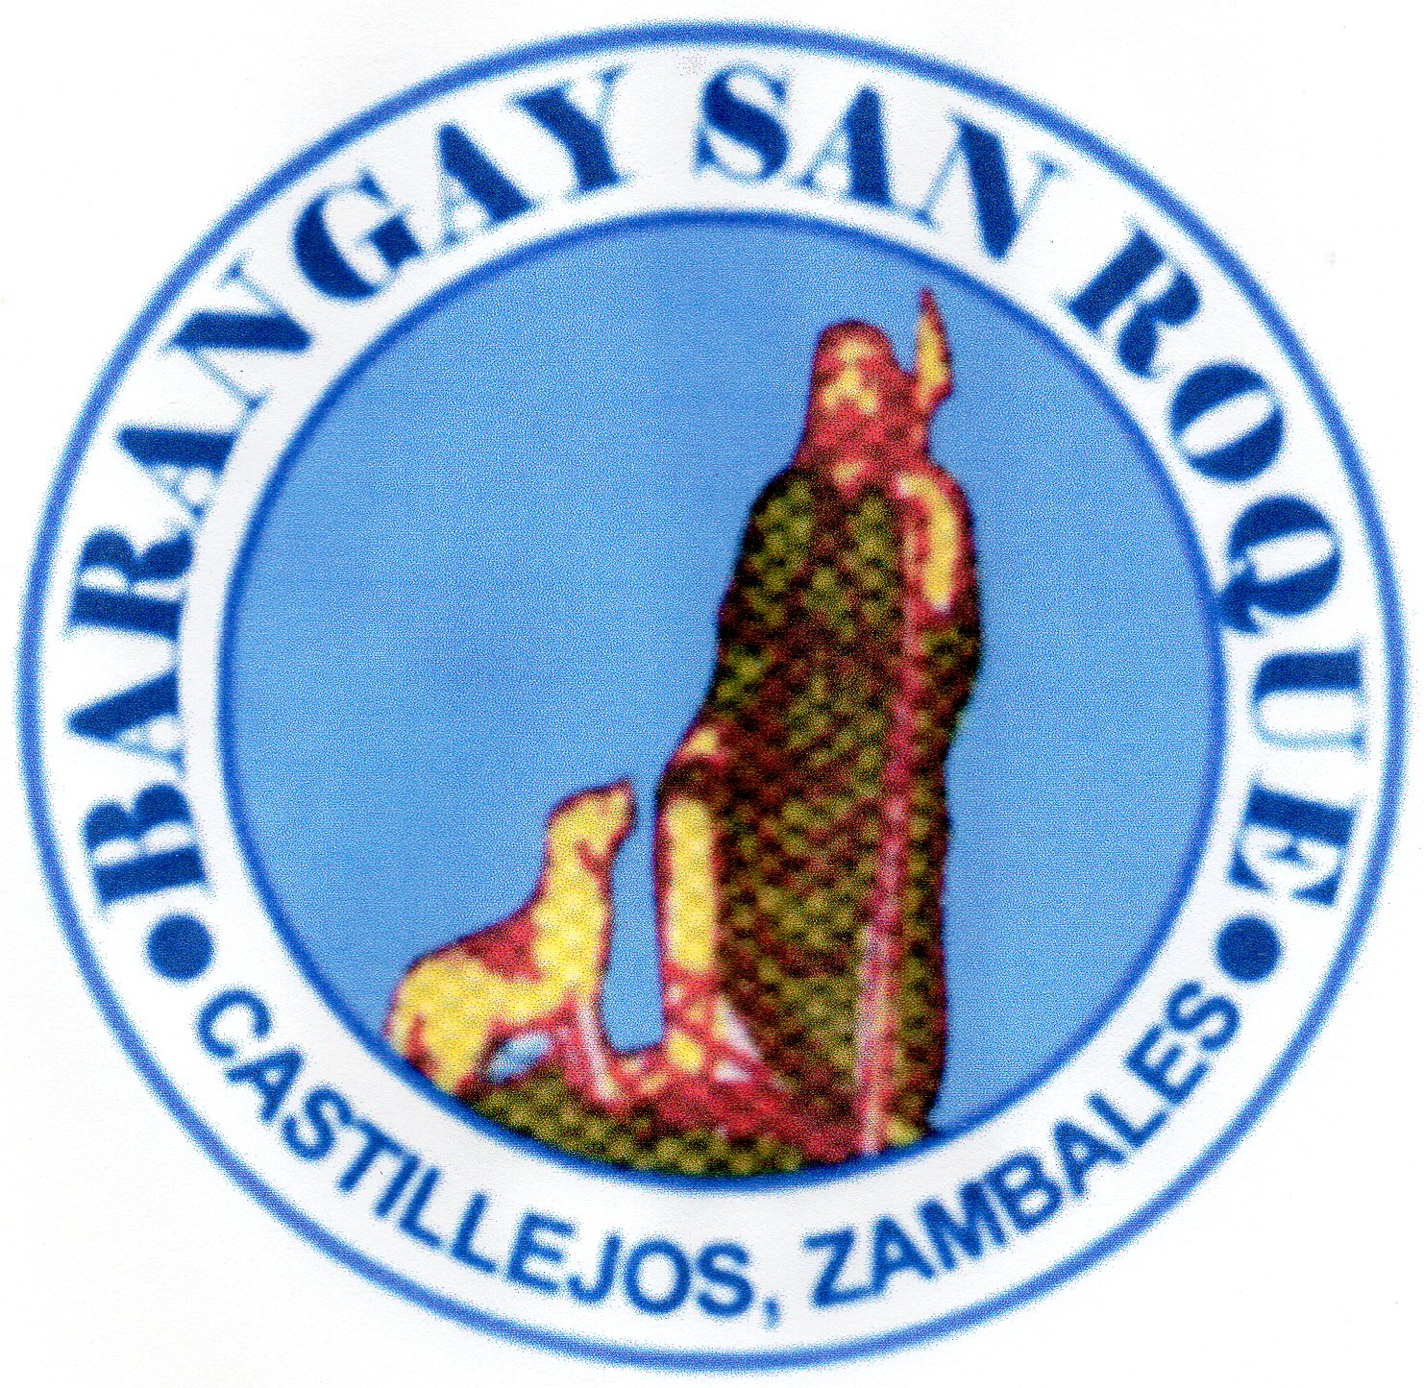



Republic of the Philippines

Municipality of Castillejos

Province of Zambales

**BARANGAY SAN ROQUE**

