**Exercise 7 (10 points)**

* **Can be done by a group of 2-3 students**
* **The first lines of your source files must be comments containing your names & IDs**
* **Add file readme.txt containing names & IDs of everyone in the group**
* **Put all files in folder named after someone’s ID. The group representative submits actual exercise to Google Classroom. The other members submit only readme.txt**
* **Email submission is not accepted**

**============================================================================================**

Use the given image files and source file (FourCharactersFrame.java)

Complete the source file to make the program work as follows:

There are 2 toggle characters: (1) Bird that can switch to Plane, (2) Horse that can switch to Motorcycle. Only 1 character can move at a time

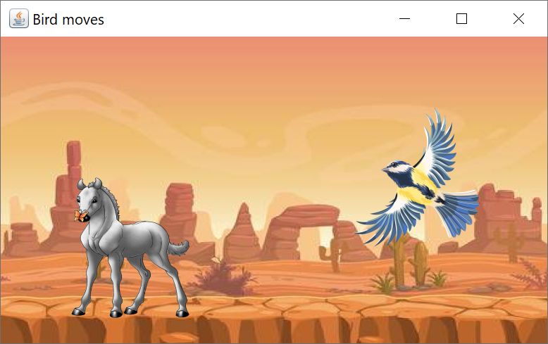

Keyboard

* Alphabet key B, P, H, P to switch to Bird, Plane, Horse, Motorcycle & make the chosen character move
* Bird and Plane can move up, down, left, right by using arrow keys
* Horse and Motorcycle can move left, right by using arrow keys
* For horizontal move: all characters can go through one side of the frame & appear on the other side
* For vertical move: Bird and Plane can move only within the frame area

Mouse click

* Right click on a character to make it disappear -- alphabet key B, P, H, M will make the chosen character appear again

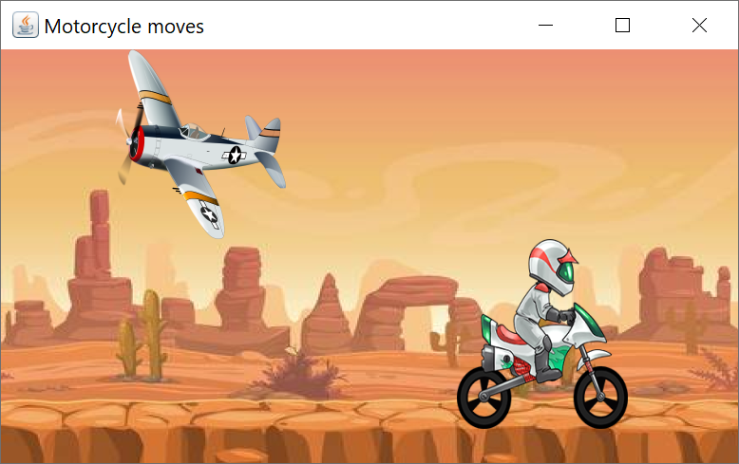

1. Make class FourCharactersFrame extends JFrame implements KeyListener

** JLabel cannot hear KeyEvent. We have to make JFrame hear & handle KeyEvent on its behalf. And because JFrame can handle one JLabel at a time, we will make it handle targetLabel where targetLabel = BirdLabel or HorseLabel

* 1. For horizontal moves, use arrow keys LEFT/RIGHT to move targetLabel left/right (i.e. call methods moveLeft/moveRight of the targetLabel). The label can go through one side of the frame and appear on the opposite side
  2. For vertical moves, use arrow keys UP/DOWN to move targetLabel up/down but only within the frame area (i.e. call methods moveUp/moveDown of the targetLabel)
  3. Use alphabet keys B/P to set BirdLabel to Bird/Plane. Use alphabet keys H/M to set HorseLabel to Horse/Motorcycle
* Set title bar accordingly
* Set targetLabel to BirdLabel or HorseLabel, respectively

1. Make class MyLabel extends JLabel implements MouseListener
   1. Right-click on a label to make it disappear (i.e. set its icon to null)

** To check left or right mouse click, suppose that e is MouseEvent object

if (e.getButton() == MouseEvent.BUTTON1) { System.out.println("left click"); }

if (e.getButton() == MouseEvent.BUTTON3) { System.out.println("right click"); }

1. Add listener objects to proper component objects