Requirements

This handout is based on Chapter 4: Requirements Engineering of the book “Software Engineering” by Ian Sommerville 2016. You can access this book online from your reading list on Blackboard. It is strongly recommended to read this chapter.

Table of Contents
User and System Requirements 2
Functional and Non-Functional Requirements 3
Requirements elicitation and analysis 4
Requirements Specification 5
References 6

The requirements for your software system describe the services that your system should provide and the constrains on its operation. The requirements reflect the needs of customers.

User and System Requirements

User Requirements

These are high-level abstract requirements. User requirements are statements of what services the system is expected to provide to the system users and the constrains under which it must operate. Their expression can be done both via natural language and diagrams. They vary from broad statements to detailed descriptions of the system’s functionality.

System Requirements

They provide a more detailed description of the software system’s functions, services and operational constrains. The system requirements document (also called functional specification) should define exactly what is to be implemented. It can be part of the contract between the developer and the buyer.
The system requirements provide more specific information as to what is to be implemented.

User Requirements | System Requirements
- Not interested in the details. Provides a broad description of services and constrains.  - Mainly for managers | - Provides more details. Describes specific services, functions and constrains.  - Mainly for system end-users, software developers etc.

For the purposes of your Final Year Project you don’t need to distinguish user from system requirements. Your requirements need to provide adequate details (20 requirements in total – 10 functional and 10 non-functional – should be enough) on how the system will operate describing the system’s services, functions and operational constrains. Your requirements need to be testable.

Functional and Non-Functional Requirements

Functional: These are statements of services the system should provide, how the system should react to specific inputs and under particular situations. They can also include what the system should not do.

An example of functional requirements:

R1: A user shall be able to search the appointments list for all clients
R2: The system shall generate each day, for each clinic, a list of patients who are expected to attend appointments that day.
R3: Each user shall be uniquely by his or her eight-digit employee number

Non-functional: These are constrains on the services or functions offered by the system. They include timing constrains, constrains in the development process and constrains imposed by standards. In most cases they apply to the whole system rather than its parts.

Example: Limiting access to the system to authorised users for security purposes is a non-functional requirement. However, this may generate functional requirements such as the need to include user authentication.

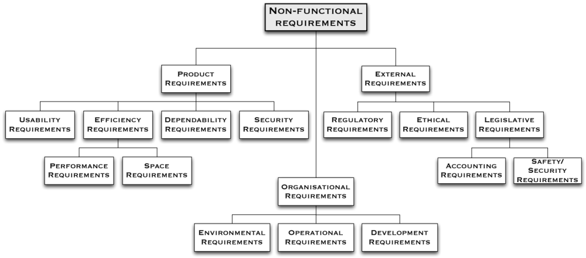

Requirements elicitation and analysis

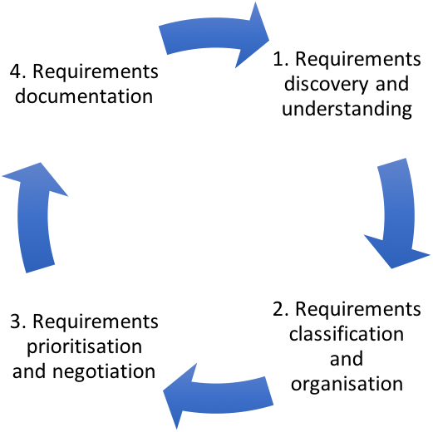

To understand the current system and its environment you need to work through the followings stages:

- Identify the stakeholders: people with a stake in the new system
- Discover each stakeholder’s requirements
- Investigate the environment, in particular the current process in which the current computer-based system plays a part
- Model that process in a process model e.g. role activity diagram or UML activity diagram

To discover each stakeholder’s requirements for a new system, and to find out about the environment, use one or more of the following techniques:
- Interviews
  - Individual
  - Focus group
- Questionnaires

Special thanks to Dr Stewart Green for sharing his notes.

Requirements Specification

- Natural Language specification
- Structure Specification
- Use Cases

It is not sufficient just to list a set of requirements. You must describe the reason they exist in your requirement analysis and prioritise them (e.g. MoSCoW prioritisation or similar). Ideally, some of your requirements need to be linked with the output of your research.

Use Cases and UML diagrams should be used to provide additional context to the analysis of your requirement.

Finally, don’t forget that the design of your software tests needs to take into account your requirements (e.g. software tests should check whether the requirements have been met).

References

Sommerville, I. 2016, Software engineering, Tenth, Global ed, Pearson, Harlow, Essex, England.

