WhatsApp Order Message Formula Explained
This formula is designed to generate a dynamic WhatsApp message link for a customer order system. When clicked, it opens a pre-filled chat in WhatsApp addressed to a specific contact with a detailed summary of their order.
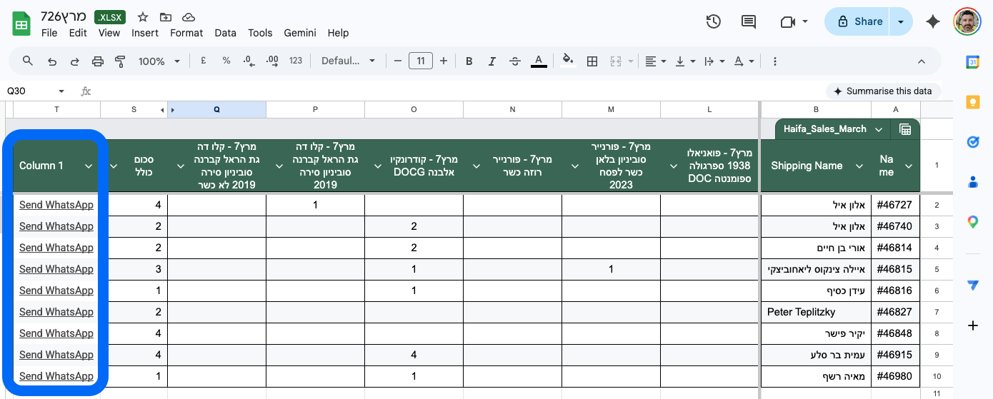

=HYPERLINK("https://wa.me/" &
IF(LEFT(REGEXREPLACE(TO_TEXT(D2), "\D", ""), 3) = "972",
REGEXREPLACE(TO_TEXT(D2), "\D", ""),
"972" & RIGHT(REGEXREPLACE(TO_TEXT(D2), "\D", ""), 9)
) & "?text=" &
ENCODEURL("Hello " & B2 & ", This is Philip from *Bakbookim project* in Haifa. Just letting you know that your order " & A2 & " is ready for collection at my place." & CHAR(10) & CHAR(10) &
TEXTJOIN(CHAR(10), TRUE,
MAP(
OFFSET(E$1, 0, 0, 1, COLUMN()-5),
OFFSET(E2, 0, 0, 1, COLUMN()-5),
LAMBDA(header, qty, IF(qty>0, header & ": " & qty, ""))
)
) & CHAR(10) & CHAR(10) &
"You can grab a pickup slot at this link:"
& CHAR(10) &
"https://calendar.app.google/npZiCDk8WMTdNdY6"
& CHAR(10) &
"Don't worry about being precise; it's mostly so I can block out the time for you." & CHAR(10) & CHAR(10) &
"*Pickup Address:* _Bar Rav Hai 37 Haifa_"), "Send WhatsApp")

To personalise this formula for your own project, you can adapt the text and details while keeping the functional logic intact. Use the following guide based on the highlighted sections of the screenshot:

1. Mandatory Changes (Yellow)
These sections contain specific personal details that must be updated for the link to function correctly for you:
- Your Name & Project: Change "Philip" and "*Bakbookim project*" to your own name and business or project title.
- Location: Update "Haifa" to your specific city or area.
- Calendar Link: Replace the Google Calendar URL ("https://calendar.app.google/...") with your own scheduling link (e.g., Calendly, Google Appointment Slot, or a personal website).
- Pickup Address: Change "_Bar Rav Hai 37 Haifa_" to your actual collection address. Keep the underscores if you want the text to appear in italics on WhatsApp.

2. Optional Changes & Localisation (Green)
The green sections represent the "voice" of your message. You can modify these to match your brand or translate them into another language, such as Hebrew:
- The Greeting: You can change "Hello " to a more casual "Hi " or a Hebrew greeting like "שלום ".
- Message Body: Feel free to rephrase "Just letting you know..." to something more formal or different entirely. For example, in Hebrew: "ההזמנה שלך מוכנה לאיסוף".
- Instructions: The text regarding the pickup slot and the "don't worry about being precise" note can be edited to fit your specific rules or translated (e.g., "ניתן לקבוע מועד איסוף בקישור הבא:").
- Labeling: You can change the final "Send WhatsApp" text to whatever you want to appear in the spreadsheet cell, such as "שלח הודעה".

Important Technical Note
When editing the text, always ensure you keep the quotation marks (" ") and the ampersands (&) exactly where they are. These are the "glue" that holds the formula together. If you delete one by accident, the formula will break.

Here is the breakdown of how the logic works:

1. Phone Number Formatting
The first part of the formula cleans and formats the phone number found in cell D2:
- Cleaning: It uses REGEXREPLACE to strip away any non-numeric characters (like spaces, dashes, or parentheses).
- Country Code Logic: It checks if the number already starts with the country code 972.
  - If it does, it uses the number as is.
  - If it doesn’t, it takes the last 9 digits of the number and prefixes them with 972 to ensure the WhatsApp link functions correctly.

2. Message Personalisation
The formula constructs a custom greeting using data from other cells:
- Greeting: It pulls the customer's name from B2 and the order number from A2.
- The Message: It identifies the sender (Philip) and the project (Bakbookim) and informs the customer their order is ready in Haifa.

3. Dynamic Order Summary
This is the most complex part of the formula. It automatically lists the items the customer ordered:
- Mapping: It looks at the headers (item names) in the first row and the quantities in the current row (starting from column E).
- Filtering: Using a LAMBDA function, it checks every column. If a quantity is greater than zero, it includes that item and the amount in the message (e.g., "Wine: 2"). If the quantity is zero, it skips it entirely.
- Joining: All these items are joined together with line breaks (CHAR(10)) to create a neat list.

4. Scheduling and Pickup Details
Finally, the formula appends static text to provide clear instructions:
- Booking Link: It includes a Google Calendar link so the customer can book a pickup slot.
- Address: It provides the specific pickup address in Haifa, formatted with underscores (_) to make the text appear in italics within WhatsApp.

Result
The entire block of logic is wrapped in a HYPERLINK function. In your spreadsheet, you will simply see a clickable link that says "Send WhatsApp". When you click it, it assembles all the data into a single URL that opens WhatsApp with the full message ready to be sent.

To ensure this formula works correctly for your Bakbookim project orders, your spreadsheet must follow a specific structure. Because the formula uses "math" to find your order items (the COLUMN()-5 part), the placement of your columns is critical.

1. Mandatory Column Order
The formula expects your data to be arranged in this exact sequence starting from the very first column (Column A):

Column | Content | Description
A | Order Number | Used in the message text.
B | Customer Name | Used for the "Hello [Name]" greeting.
C | (Any data) | The formula doesn't use this, but it must exist to maintain the count.
D | Phone Number | Used to generate the WhatsApp link.
E onwards | Order Items | Each column header (Row 1) should be an item name (e.g., "Cider," "IPA").

The "Link" Column
You must paste the formula into the column immediately following your last item column.
- Example: If you have items in columns E, F, G, and H, you must paste the formula into Column I.
- Why? The formula uses COLUMN()-5 to calculate how many item columns to check. If you place it too far to the right, it will try to include empty columns in the message.

2. Where to Paste the Formula
- Go to Row 2 (the first row of actual customer data).
- Navigate to the column immediately to the right of your items.
- Click into the formula bar at the top and paste your original formula.

3. How to Copy to the Entire Table
Once the first link is working in Row 2, use one of these two methods to apply it to all other orders:

Method A: The Fill Handle (Fastest)
- Select the cell where you just pasted the formula (e.g., I2).
- Look for the small blue square in the bottom-right corner of that cell (the Fill Handle).
- Double-click that blue square. Google Sheets will automatically shoot the formula down to the bottom of your data.

Method B: Copy & Paste
- Select the cell with the formula and press Ctrl + C (or Cmd + C).
- Click the cell below it, hold Shift, and click the bottom cell of your table to highlight the range.
- Press Ctrl + V (or Cmd + V) to paste.

4. Final Checklist
- Header Row: Ensure your item names are in Row 1. The formula is hard-coded to look at $1 for headers.
- Phone Numbers: Ensure Column D contains the phone numbers. The formula will handle the formatting (adding 972) automatically.
- Quantities: The items will only show up in the WhatsApp message if the number in the item column is greater than 0.

Recommended Workflow
For the best results with this setup, the workflow you choose depends on your comfort level with technology. Here is a recommended strategy to ensure the setup is smooth and the execution is efficient.

Phase 1: Setup & Customisation (Desktop Recommended)
Best for: Tech-savvy users or those who want to avoid errors.
It is highly recommended to perform all "surgery" on the formula using a computer.
- Precision: Managing the quotation marks, ampersands (&), and brackets in a complex formula is much easier with a keyboard and a large screen.
- Bulk Actions: Using the "Fill Handle" or double-clicking to copy the formula down hundreds of rows is a desktop-only feature that saves significant time.
- Testing: It is easier to verify that the generated links look correct in your browser before you start sending them.

Phase 2: Daily Operations (The "Switch" to Mobile)
Once your table is set up and your orders are ready, you can switch to your smartphone (using the Google Sheets app) to actually send the messages.
- Seamless Integration: Since you likely already have WhatsApp installed on your phone, clicking the "Send WhatsApp" link in the app will jump directly into the chat with the message pre-filled.
- On-the-Go Convenience: You can manage pickups and send notifications while standing in your storage area or kitchen, without needing to be tethered to a desk.

Workflow Summary by "Tech-Savviness"
Tech Level | Setup Strategy | Sending Strategy
Beginner | Must use a computer. Copy the formula exactly as provided and only change the text inside the quotes. | Use a phone. It is much more intuitive to "tap and send" via the WhatsApp app than using WhatsApp Web on a PC.
Intermediate | Use a computer to adjust the logic (like adding more columns). | Use WhatsApp Web on a computer if you prefer using a physical keyboard to manage conversations.
Advanced | You can try editing on a tablet/mobile, but beware of "Smart Quotes" (curly quotes) which will break the formula. | Use whichever device is currently in your hand!

Expert Tip: If you are working on a computer, keep WhatsApp Web or the WhatsApp Desktop App open in the background. This way, when you click the link in your sheet, it opens a new tab, you hit "Enter" to send, and you can immediately click back to your spreadsheet to handle the next order.

