Assignment -6
Name: Rontala Pooja Reddy
HTNO: 2503B05130
Mtech 1st year CSE

Q1. LAB TASK: TCP Congestion Control Simulation
Question:
Using a TCP congestion control simulator (Python or any tool of your choice), simulate and analyze TCP Reno under three different packet-loss conditions:
- 0.1% loss
- 1% loss
- 2% loss
For each case:
- Plot the Congestion Window (cwnd) vs Time for at least 20 seconds of simulation.
- Compute the average throughput (in MSS/second or Mbps).
- Explain how packet loss affects the behavior of TCP Reno, specifically discussing:
  - Slow Start
  - Congestion Avoidance
  - Multiplicative Decrease (cwnd halving)
- Compare the three cases and write a short conclusion on how increasing loss impacts network performance.

Code:
import matplotlib.pyplot as plt
import random

RTT = 0.05
sim_time = 20.0
mss = 1.0
packets_per_seg = 1

algorithm = "reno"
initial_cwnd = 1.0
ssthresh_init = 64.0

def simulate(loss_prob):
t = 0.0
cwnd = initial_cwnd
ssthresh = ssthresh_init

time_steps = []
cwnd_trace = []
bytes_acked = 0.0

def send_window(cwnd):
segs = int(max(1, round(cwnd / mss)))
lost = False
acks = 0
for _ in range(segs):
if random.random() < loss_prob:
lost = True
else:
acks += 1
return lost, acks

while t < sim_time:
time_steps.append(t)
cwnd_trace.append(cwnd)

lost, acks = send_window(cwnd)
bytes_acked += acks * mss

if lost:
ssthresh = max(cwnd / 2, 2)
cwnd = max(cwnd / 2, 1)
else:
if cwnd < ssthresh:
cwnd *= 2
else:
cwnd += 1

cwnd = min(cwnd, 1000)
t += RTT

throughput = bytes_acked / sim_time
return time_steps, cwnd_trace, throughput

# Run for 0.1%, 1%, 2%
loss_levels = [0.001, 0.01, 0.02]

for loss in loss_levels:
t, cwnd, thr = simulate(loss)
plt.figure(figsize=(9,4))
plt.step(t, cwnd, where='post')
plt.title(f"TCP Reno cwnd vs Time (Loss = {loss*100}%)")
plt.xlabel("Time (s)")
plt.ylabel("cwnd (MSS)")
plt.grid(True)
plt.show()

print(f"Loss {loss*100}% → Throughput: {thr:.2f} MSS/s")

Output:
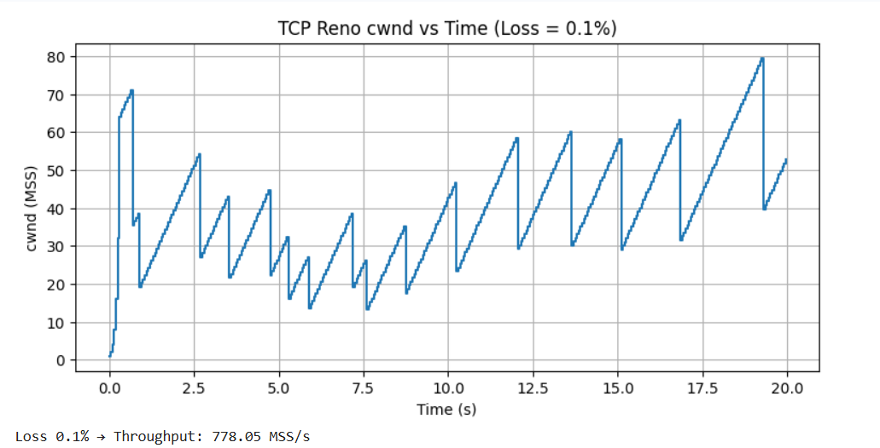
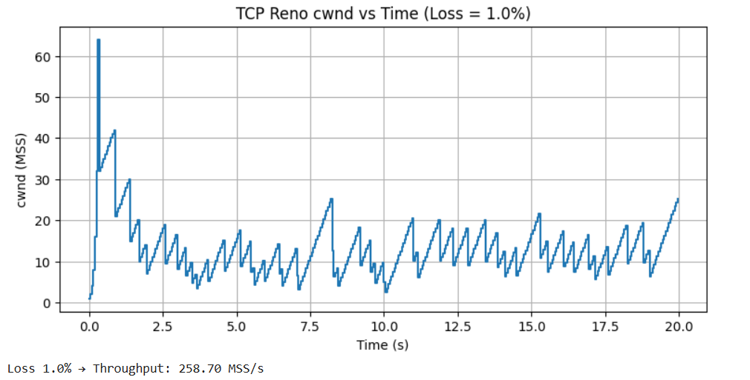
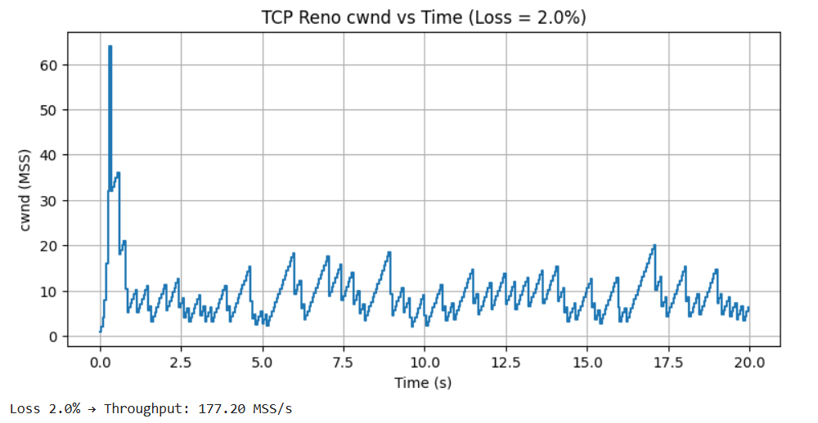
Effect of Packet Loss on TCP Reno Behavior

TCP Reno regulates its congestion window (cwnd) based on the feedback it receives from the network, and its overall behavior changes noticeably as packet-loss rates increase. The three core components of Reno—Slow Start, Congestion Avoidance, and Multiplicative Decrease—respond differently under varying loss levels.

• Slow Start
Reno begins with a cwnd of 1 MSS and doubles the window every RTT, allowing it to quickly probe the available bandwidth.

At 0.1% loss:
Loss events occur rarely, so the slow start phase continues uninterrupted for a longer period. This lets cwnd grow rapidly and reach high values (around 70 MSS), leading to strong throughput performance.

At 1% and 2% loss:
Losses appear much earlier and more frequently. Because of this, slow start terminates prematurely, and the cwnd is forced to reset before it becomes large. As a result, the congestion window rarely grows beyond small values.

• Congestion Avoidance (Linear Growth)
Once cwnd reaches the threshold, Reno enters congestion avoidance, growing the window by 1 MSS each RTT.
At 0.1% loss:
The connection spends extended periods in this phase. cwnd increases smoothly and steadily, with only occasional drops. When a reduction happens, the window recovers quickly.
At 1% and 2% loss:
The flow struggles to remain in congestion avoidance; repeated loss events keep pushing cwnd down. Because of these frequent interruptions, the cwnd cannot build up. The classic saw-tooth pattern becomes compressed and irregular.
• Multiplicative Decrease (cwnd Halving)

When Reno detects a packet loss, it performs a multiplicative decrease:
cwnd = cwnd / 2 and ssthresh = cwnd / 2.

At 0.1% loss:
These events are uncommon, so cwnd remains large and stable for long periods.
At 1% loss:
Halving occurs often. cwnd tends to fluctuate within a small range, typically between 5–20 MSS, resulting in a noticeable drop in throughput.
At 2% loss:
Constant losses trigger repeated halving. cwnd stays very low (approximately 5–12 MSS), significantly restricting data transmission.

Comparison Across Loss Levels
0.1% Loss
- cwnd rises quickly to around 70 MSS
- Clear slow-start behavior followed by long congestion-avoidance periods
- Very few congestion-related drops
- Throughput: 778.05 MSS/s (highest)
1% Loss
- Initial growth followed by rapid collapse
- cwnd oscillates frequently between small values
- Minimal time spent in congestion avoidance
- Throughput: 258.70 MSS/s (much lower)
2% Loss
- cwnd rarely increases
- Frequent multiplicative decreases dominate behavior
- Window remains consistently small
- Throughput: 177.20 MSS/s (lowest)
Final Conclusion:

As packet loss increases, TCP Reno’s efficiency declines sharply. Because Reno interprets every lost packet as a congestion signal, higher loss rates trigger more transitions back to slow start and more multiplicative decreases. This continual shrinking of cwnd prevents Reno from achieving stable growth, resulting in a significant reduction in throughput. In short, higher packet loss severely restricts Reno’s ability to utilize the available network bandwidth.

