Theme_3 2.0.0-Dev Documentation
Starter Usage:
Utils: List of Commands
> $gulp [commands]
Commands | Description
$gulp  $gulp default | Default task will list task.
$gulp --task | List all current gulp tasks.
$gulp keyCheck | List all available Key base on conf.js.
$gulp check | View version and any other information regarding this project.
$gulp clean | Remove the build folder.

Bundle: List of Commands
> $gulp [command]
Commands | Description
$gulp buildInit | Build HTML, SCSS, CSS, JS and Images.
$gulp watch | Watch HTML, SCSS, CSS, JS and Images folders.

CSS: List of Commands
> $gulp compileCSS [--key]
Options | Description
$gulp compileCSS [--key][--compress][--autoprefixer][numversion][--dest][location] | Compile CSS to build folder with option to destination, add auto prefixed and compress. Version is limited to 1 – 5 with default of 2.
--compress | Option to Compress CSS.
--autoprefixer [numversion] | Option to auto prefixed for previous version limited to 1 – 5 versions and default to 2 versions.
--css | Compile CSS
--scss | Compile SCSS
--bootstrap | Compile Bootstrap CSS.
--bootstrapIcon | Compile Bootstrap Icon CSS.
--fontawesome | Compile Fontawesome CSS.
--bulma | Compile Bulma CSS.
--prism | Should be set on resources.
--dest [location] | Compile on Destination folder under CSS(controlled section).  Change the Destination in Config csspaths > maindest.
Gulp Task | Description
$gulp keyCheck | List all available Key base on conf.js.
$gulp watchCSS | Watch changes on src > css and src > scss.
$gulp buildCSS | Only compile the src > css.
$gulp buildSCSS | Only compile the src > scss.

Usage:
** This will compile css and build on build/css/inc folder.
$gulp compileCSS --css --dest inc
** This will compile css , scss and boostrap , build on default folder build/css.
$gulp compileCSS --css --scss --bootstrap
** This will compile css that is compress , build on default folder build/css
$gulp compileCSS --css –compress
** This will compile css that is auto prefixed for last 3 previous version , build on default folder build/css
$gulp compileCSS --css –autoprefixer 3

JS: List of Commands
> $gulp compileJS [--key]
Options | Description
$gulp compileJS [--key][--uglify][--dest][location] | Compile JS to build folder with option to destination and compress.
--uglify | Option to Compress JS.
--jquery | Compile jQuery.
--js  --popper | Compile JS  Compile Popper.
--tether | Compile Tether.
--bootstrap | Compile Bootstrap JS.
--fontawesome | Compile Fontawesome JS.
--dest [location] | Compile on Destination folder under JS(controlled section).  Change the Destination in Config jspaths > maindest.
Gulp Task | Description
$gulp keyCheck | List all available Key base on conf.js.
$gulp watchJS | Only watch changes on src > js.
$gulp buildJS | Only compile the src > js.

Usage:
** This will compile js and build on build/js/inc folder.
$gulp compileJS --js --dest inc
** This will compile js , jquery and popper build on default folder build/js
$gulp compileJS --js --jquery --popper
** This will compile js that is compress build on default folder build/js
$gulp compileJS --js –uglify

HTML: List of Commands
> $gulp [commands]
Commands | Description
$gulp buildHTML | Compile HTML to build folder.
$gulp watchHTML | Only watch changes on html.  This is powered by panini.  This is powered by BrowserSync.

Usage:
** This will compile HTML and build on build/ folder.
$gulp buildHTML
** This will watch /html and build on folder build/.
$gulp watchHTML

Image: List of Commands
> $gulp [commands]
Commands | Description
$gulp buildImages | Compile Images to build folder.
$gulp watchImages | Only watch changes on src > images.

Usage:
** This will compile images and build on build/img folder.
$gulp buildImages
** This will watch src/images and build on folder build/img
$gulp watchImages
Icons: List of Commands
> $gulp [commands] [--key] [--dest] [location]
Commands | Description
$gulp compileIcons [--key] [--dest][location] | Compile multiple key and move it on multiple destination if set.
--dest location | Compile on location  Note: bootstrap icon module is set to /fonts, make sure folder is within the reach of bootstrap-icon CSS.
--bootstrap | Compile bootstrap
--fontawesome | Compile fontawesome
Multi Key and Multi Dest
$gulp compileIcons --bootstrap --fontawesome | This will compile boot bootstrap icon and fontawesome on default folder

Usage:
$gulp compileIcons --bootstrap --fontawesome --dest bootstrap --dest fontawesome
> the order of dest is based on the order of key , if more than dest has been defined the third one will be drop , null value of dest will result to default folder, null value on multiple dest will result to default.
> Take note of bootstrap icons font reference , moving it on different dest without updating url below may result to bootstrapicon not working.
Bootstrap
> $gulp [commands]
Commands | Description
$gulp buildAllBi | Compile bootstrapicon CSS and bootstrap icon files.  Note: make sure that any bootstrapicon is imported on src > scss > styles.scss to prevent any duplicate styles.

$gulp buildInit
$gulp buildAllBi
$gulp watch
Test: Nav > Icon Test
Define in html > default > resources > icon available.
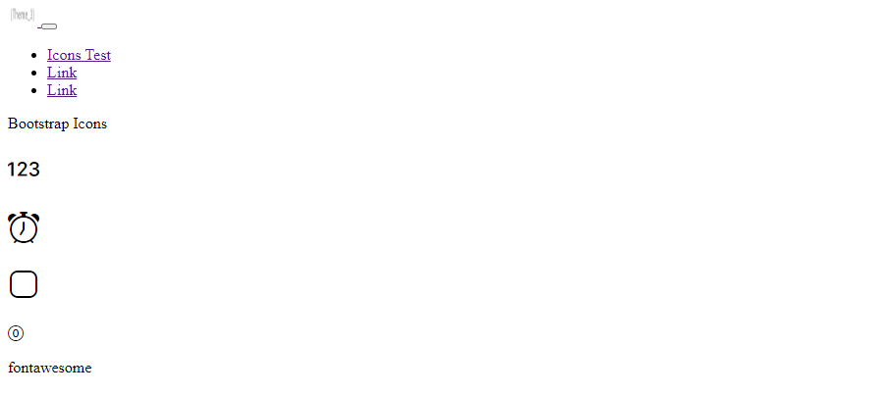
CSS reference:
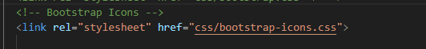
Fontawesome
> $gulp [commands]
Commands | Description
$gulp buildAllFa | Compile fontawesome CSS and fontawesome icon files.  Note: make sure that any fontawesome is imported on src > scss > styles.scss to prevent duplicate styles.

Usage:
$gulp buildInit
$gulp buildAllFa
$gulp watch
Test: Nav > Icon Test
Define in html > default > resources > icon available.
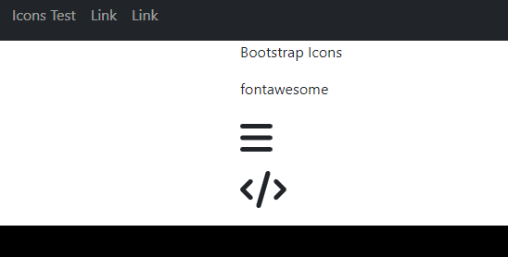
CSS reference:
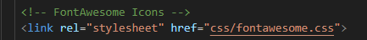
JS reference:
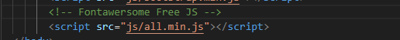

Combine: List of Commands
> $gulp [commands]
Commands | Description
$gulp buildInit | Compile HTML , SCSS, JS, and Images

Watch Options: List of Commands
> $gulp [commands]
Commands | Description
$gulp watch | Watch HTML, SCSS, JS, and Images

Resources Options: List of Commands
> $gulp move –src [source] –dest [destination]
Commands | Description
$gulp move –src source –dest destination | Move the folder or file under the source specified(not the specified src that was enter but under it, if it is a folder) on resources folder to specified section on build. Note that the current setting is lock on build destination, to unlock this you will need to change it on config, if this is unlocked it can be move anywhere (not yet tested).
Usage
gulp move --src prismjs/css --dest css/inc | Sample of moving /resources/prismjs/css, files and folders under it on build/css/inc
gulp move --src prismjs/css --dest | Sample of moving /resources/prismjs/css, files and folders under it on null –dest will result to /build as default.

