**Theme_3 2.0.0-Dev Documentation**

**Starter Usage:**

**Utils: List of Commands**

**>** $gulp [commands]

|  |  |
| --- | --- |
| Commands | Description |
| $gulp  $gulp default | Default task will list task. |
| $gulp --task | List all current gulp tasks. |
| $gulp keyCheck | List all available Key base on conf.js. |
| $gulp check | View version and any other information regarding this project. |
| $gulp clean | Remove the build folder. |

**Bundle: List of Commands**

**>** $gulp [command]

|  |  |
| --- | --- |
| Commands | Description |
| $gulp buildInit | Build HTML, SCSS, CSS, JS and Images. |
| $gulp watch | Watch HTML, SCSS, CSS, JS and Images folders. |

**CSS: List of Commands**

**>** $gulp compileCSS [--key]

|  |  |
| --- | --- |
| Options | Description |
| $gulp compileCSS [--key][--compress][--autoprefixer][numversion][--dest][location] | Compile CSS to build folder with option to destination, add auto prefixed and compress. Version is limited to 1 – 5 with default of 2. |
| --compress | Option to Compress CSS. |
| --autoprefixer [numversion] | Option to auto prefixed for previous version limited to 1 – 5 versions and default to 2 versions. |
| --css | Compile CSS |
| --scss | Compile SCSS |
| --bootstrap | Compile Bootstrap CSS. |
| --bootstrapIcon | Compile Bootstrap Icon CSS. |
| --fontawesome | Compile Fontawesome CSS. |
| --bulma | Compile Bulma CSS. |
| --prism | Should be set on resources. |
| --dest [location] | Compile on Destination folder under CSS(controlled section).  Change the Destination in Config csspaths > maindest. |
| Gulp Task | Description |
| $gulp keyCheck | List all available Key base on conf.js. |
| $gulp watchCSS | Watch changes on src > css and src > scss. |
| $gulp buildCSS | Only compile the src > css. |
| $gulp buildSCSS | Only compile the src > scss. |

Usage:

** This will compile css and build on build/css/inc folder.

$gulp compileCSS --css --dest inc

** This will compile css , scss and boostrap , build on default folder build/css.

$gulp compileCSS --css --scss --bootstrap

** This will compile css that is compress , build on default folder build/css

$gulp compileCSS --css –compress

** This will compile css that is auto prefixed for last 3 previous version , build on default folder build/css

$gulp compileCSS --css –autoprefixer 3

**JS: List of Commands**

**>** $gulp compileJS [--key]

|  |  |
| --- | --- |
| Options | Description |
| $gulp compileJS [--key][--uglify][--dest][location] | Compile JS to build folder with option to destination and compress. |
| --uglify | Option to Compress JS. |
| --jquery | Compile jQuery. |
| --popper | Compile Popper. |
| --tether | Compile Tether. |
| --bootstrap | Compile Bootstrap JS. |
| --fontawesome | Compile Fontawesome JS. |
| --dest [location] | Compile on Destination folder under JS(controlled section).  Change the Destination in Config jspaths > maindest. |
| Gulp Task | Description |
| $gulp keyCheck | List all available Key base on conf.js. |
| $gulp watchJS | Only watch changes on src > js. |
| $gulp buildJS | Only compile the src > js. |

Usage:

** This will compile js and build on build/js/inc folder.

$gulp compileJS --js --dest inc

** This will compile js , jquery and popper build on default folder build/js

$gulp compileJS --js --jquery --popper

** This will compile js that is compress build on default folder build/js

$gulp compileJS --js –uglify

**HTML: List of Commands**

**>** $gulp [commands]

|  |  |
| --- | --- |
| Commands | Description |
| $gulp buildHTML | Compile HTML to build folder. |
| $gulp watchHTML | Only watch changes on html.  This is powered by panini.  This is powered by BrowserSync. |

Usage:

** This will compile HTML and build on build/ folder.

$gulp buildHTML

** This will watch /html and build on folder build/.

$gulp watchHTML

**Image: List of Commands**

**>** $gulp [commands]

|  |  |
| --- | --- |
| Commands | Description |
| $gulp buildImages | Compile Images to build folder. |
| $gulp watchImages | Only watch changes on src > images. |

Usage:

** This will compile images and build on build/img folder.

$gulp buildImages

** This will watch src/images and build on folder build/img

$gulp watchImages

**Icons: List of Commands**

**>** $gulp [commands] [--key] [--dest] [location]

|  |  |
| --- | --- |
| Commands | Description |
| $gulp compileIcons [--key] [--dest][location] | Compile multiple key and move it on multiple destination if set. |
| --dest location | Compile on location  Note: bootstrap icon module is set to /fonts, make sure folder is within the reach of bootstrap-icon CSS. |
| --bootstrap | Compile bootstrap |
| --fontawesome | Compile fontawesome |
| Multi Key and Multi Dest |  |
| $gulp compileIcons --bootstrap --fontawesome | This will compile boot bootstrap icon and fontawesome on default folder |

Usage:

$gulp compileIcons --bootstrap --fontawesome --dest bootstrap --dest fontawesome

> the order of dest is based on the order of key , if morethan dest has been defined the third one will be drop , null value of dest will result to default folder, null value on multiple dest will result to default.

> Take a note of bootstrap icons font reference , moving it on different dest without updating url below may result to bootstrapicon not working.



**Bootstrap**

**>** $gulp [commands]

|  |  |
| --- | --- |
| Commands | Description |
| $gulp buildAllBi | Compile bootstrapicon CSS and bootstrap icon files.  Note: make sure that any bootstrapicon is imported on src > scss > styles.scss to prevent any duplicate styles. |

$gulp buildInit

$gulp buildAllBi

$gulp watch

Test: Nav > Icon Test

Define in html > default > resources > icon available.

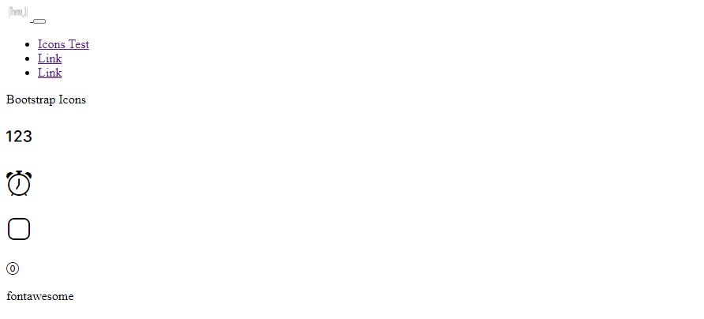

CSS reference:

**Fontawesome**

**>** $gulp [commands]

|  |  |
| --- | --- |
| Commands | Description |
| $gulp buildAllFa | Compile fontawesome CSS and fontawesome icon files.  Note: make sure that any fontawesome is imported on src > scss > styles.scss to prevent duplicate styles. |

Usage:

$gulp buildInit

$gulp buildAllFa

$gulp watch

Test: Nav > Icon Test

Define in html > default > resources > icon available.

CSS reference:



JS reference:

**Combine: List of Commands**

**>** $gulp [commands]

|  |  |
| --- | --- |
| Commands | Description |
| $gulp buildInit | Compile HTML , SCSS, JS, and Images |

**Watch Options: List of Commands**

**>** $gulp [commands]

|  |  |
| --- | --- |
| Commands | Description |
| $gulp watch | Watch HTML, SCSS, JS, and Images |

**Resources Options: List of Commands**

**>** $gulp [commands]

|  |  |
| --- | --- |
| Commands | Description |
| $gulp move |  |