LAMBADA & MMLU Benchmark Evaluation Report
Evaluating small language models on long-range word prediction (LAMBADA) and multi-subject knowledge & reasoning
(MMLU).
Submitted to: Prof. Anna Corazza
Submitted by: Francesco Ventimiglia, Danilo Rodriguez, Rohan Baidya
Github link: https://github.com/ronvoy/gen-ai
Site Link: https://unina.cc/gen-ai

Introduction
We test three small language models on two complementary benchmarks.
LAMBADA asks the model to predict the final word of a passage, guessable only from the full context - a focused test of long-range context handling.
MMLU (Massive Multitask Language Understanding) is a multiple-choice knowledge and reasoning test spanning 57 subjects in four categories (STEM, Humanities, Social Sciences, Other); the model must write short step-by-step reasoning before committing to an answer letter.
All models run through the OpenRouter API for a hardware-neutral comparison.
Both benchmarks share one web app with live terminal output, run history, presets, and charts.

Small Language Models Used

Models at Glance
# | Model | Developer | Parameters | OpenRouter id | Architecture | Key Technique
1 | Gemma-  3-4B | Google | 4B | google/gemma-3-4b-it | Dense decoder-only transformer with interleaved local/global attention | Knowledge  distillation + local/global attention interleaving
2 | Llama-  3.2-3B | Meta | 3B | meta-llama/llama-3.2-3b-instruct | Dense decoder-only transformer with Grouped  Query  Attention | Compact dense transformer
3 | Ministral-  8B | Mistral AI | 8B | mistralai/ministral-8b-2512 | Decoder-only transformer with Sliding Window Attention | Sliding  Window Attention +  GQA

Gemma-3-4B (Google)
4B instruction-tuned dense decoder-only transformer from Google, built with the same research that powers Gemini. Interleaves several local sliding-window attention layers with an occasional global attention layer, keeping memory low while information still flows across a long context (up to 128k tokens).
The small Gemma 3 models are trained with knowledge distillation from larger teacher models.
Working technique - Knowledge distillation + local/global attention interleaving:
Most layers only look at a local window of nearby tokens (cheap); every few layers one global layer lets any token attend to the whole context (expressive).
Distillation teaches the small model to match a larger teacher's output distribution rather than raw text alone, delivering strong quality per parameter at edge-friendly cost.
Key properties:
Dense decoder-only transformer, no expert routing.
5:1 interleaving of local sliding-window and global attention layers.
Grouped Query Attention with QK-norm; 128k-token context window.
Distilled from larger Gemma/Gemini-family teacher models.

Process flow - Gemma-3-4B inference

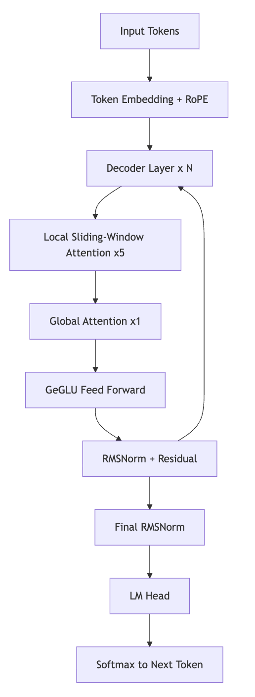

Llama-3.2-3B (Meta)
3B instruction-tuned model from Meta for on-device, low-cost use.
Standard Llama recipe: dense transformer with RoPE, GQA, and SwiGLU layers.
Built by pruning and distilling from larger Llama 3.1 models.
Working technique - Compact dense transformer:
Takes the proven dense transformer design and shrinks it. Predictable and easy to serve on modest hardware.
Key properties:
Dense decoder-only transformer.
RoPE position embeddings for length generalisation. Grouped Query Attention and SwiGLU layers.

Process flow - Llama-3.2-3B inference

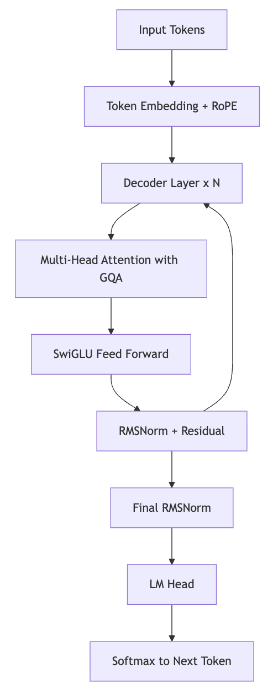

Ministral-8B (Mistral AI)
8B model from Mistral AI, built for edge use.
Interleaved sliding window attention keeps memory and compute low on long inputs.
Grouped query attention further shrinks the KV cache.
Working technique - Sliding Window Attention + GQA:
Each layer attends only to a local window instead of every token.
Stacked layers carry context further than any single window.
GQA shares key-value heads for fast decoding on long passages.
Key properties:
Sliding window attention for local context.
Grouped Query Attention for a smaller KV cache.
Efficient long-context inference at the edge.

Process flow - Ministral-8B inference

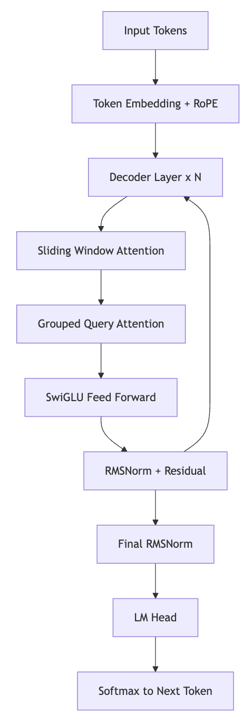

LAMBADA Benchmark

Dataset Overview
LAMBADA is drawn from the BookCorpus.
Each passage is chosen so the final word is predictable from the full passage but not from the last sentence alone.

Splits
Split | File | Passages | Purpose
Test | lambada_test_plain_text.txt | 5,153 | Primary evaluation
Development | lambada_development_plain_text.txt | 4,869 | Validation and tuning
Control Test | lambada_control_test_data_plain_text.txt | 5,000 | Baseline, unfiltered
Rejected | rejected_plain_text.txt | 11,941 | Passages cut during curation
Training Novels | train-novels/ (16 genres) | 2,662 novels | Pre-training material
Vocabulary | lambada-vocab-2.txt | 112,746 entries | Reference vocabulary

Properties
Property | Value
Source corpus | BookCorpus (unpublished novels)
Language | English
Task type | Word prediction
Curation criterion | Target guessable from full context only
First published | ACL 2016 (Paperno et al.)

Metrics
Metric | Definition | Better
Exact-match accuracy | correct / total after lowercasing and stripping punctuation | Higher
Average response time | Mean wall-clock time per API call | Lower
Error rate | errors / total (timeouts, failures) | Lower
Throughput | total / total wall-clock time | Higher

Scoring Flow
Yes
No
Passage
Remove last word
Build prompt with few-
shot examples
OpenRouter API call
Parse predicted word
Normalize: lowercase and
strip punctuation
Equals target?
Correct
Incorrect
Accuracy and latency

Fine-Tuning Parameters
The Fine Tune panel exposes decoding parameters; it does not change model weights.
For single-word prediction, greedy decoding with more examples works best.
Parameter | Range | Effect
Temperature | 0.0 - 2.0 | Higher adds randomness; 0.0 is greedy and deterministic
Top-p | 0.0 - 1.0 | Nucleus sampling cutoff; lower keeps only the likeliest tokens
Max tokens | 1 - 128 | Cap on answer length; a single word needs very few
Few-shot examples | 0 - 5 | Worked examples added to the prompt to set the format
Frequency penalty | -2.0 - 2.0 | Discourages repeating tokens
Presence penalty | -2.0 - 2.0 | Encourages introducing new tokens
Presets (see Section 6): Optimal (greedy decoding, five worked examples - most reliable accuracy), Normal (balanced defaults), Best Performance (trimmed token and example budget for the fastest, cheapest runs).

Results
Latest saved metrics per model on the test split.
Model | Accuracy (%) | Correct | Total | Avg Latency (s) | Errors
Gemma-3-4B | 22.0 | 11 | 50 | 0.579 | 0
Llama-3.2-3B | 20.8 | 208 | 1000 | 0.577 | 0
Ministral-8B | 38.1 | 381 | 1000 | 0.731 | 0
Best accuracy: Ministral-8B at 38.1 percent. Fastest: Llama-3.2-3B at 0.577 s per query, with Gemma-3-4B essentially tied at
0.579 s.

Charts
Accuracy per model: Average response time per model:

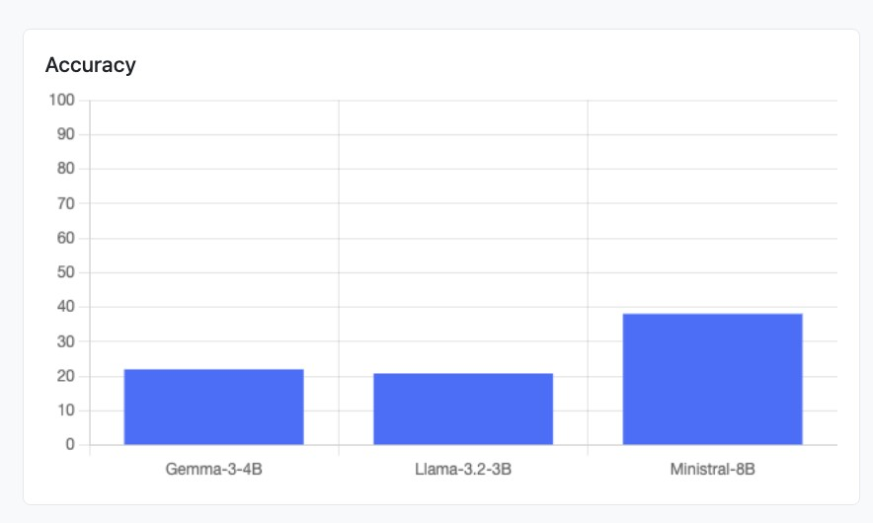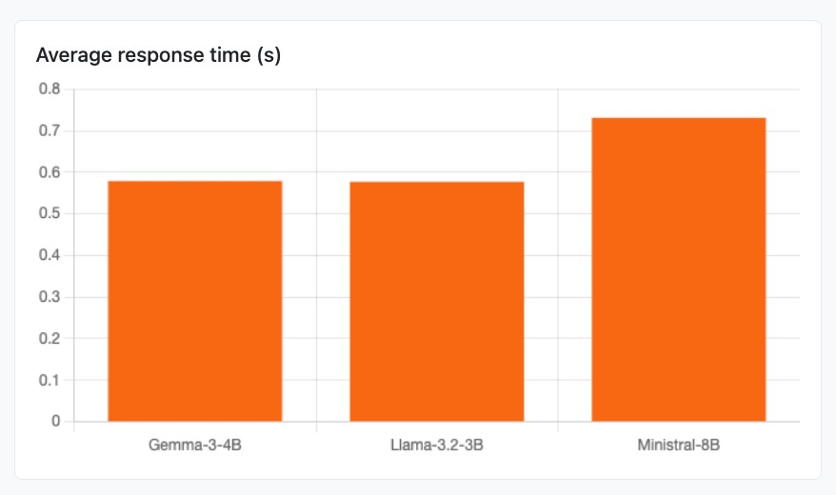

SLM Web App

The LAMBADA run panel: model and sample-count inputs, Run Benchmark and Fine Tune (presets) buttons, the live terminal streaming per-sample processing output (green = correct prediction, red = wrong), and the metrics table below with the latest saved results for all three models.

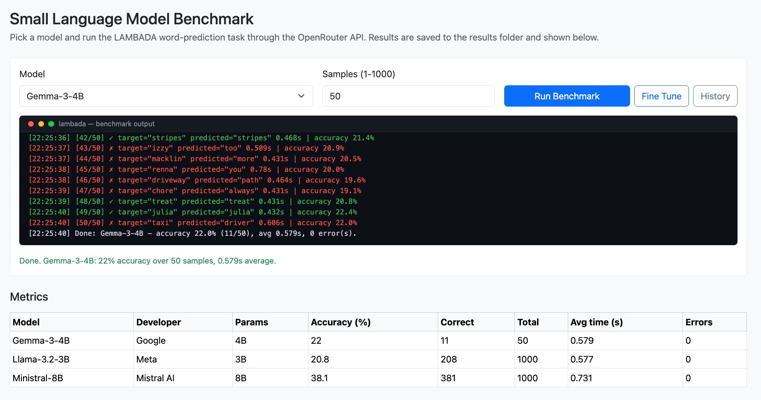

MMLU Benchmark
How the MMLU benchmark runs in this project, from a click on "Run MMLU" (or ./run_mmlu.sh ) to the ranking table, charts, and per-question reasoning shown in the web app. For every question the model must first write short step-by-step reasoning and then commit to one of four options (A-D); both the final letter and the reasoning text are parsed and evaluated.

Workflow Diagram

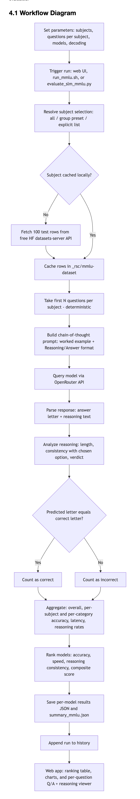

Chronological Steps

# | Step | What happens | Where (file / function)
1 | Parameters | Read subjects, questions per subject, models, decoding params (all documented at the top of the script and shell runner) | evaluate_slm_mmlu.py (RUN  PARAMETERS), run_mmlu.sh
2 | Trigger | User clicks Run MMLU, runs ./run_mmlu.sh , or  python evaluate_slm_mmlu.py | passenger_wsgi.py ( /mmlu/run ) or  run_mmlu_evaluation
3 | Resolve subjects | Turn "all", a group preset, or a list into valid subject names | resolve_subjects
4 | Fetch questions | Download the first 100 test rows per subject from the free Hugging Face datasets-server API (cais/mmlu, fallback tasksource/mmlu); no API key needed | _download_subject
5 | Cache | Store rows in _rsc/mmlu-dataset/<subject>.json so reruns are offline and repeatable | fetch_subject_questions
6 | Sample | Take the first N questions per subject (deterministic, no randomness) | fetch_subject_questions ,  load_mmlu_tasks
7 | Build prompt | Chain-of-thought prompt: one worked example, strict  Reasoning: then Answer: <letter> output format | build_mmlu_prompt ,  WORKED_EXAMPLE
8 | Query model | Send the prompt to the chosen model through  OpenRouter | query_model_mmlu (HTTP POST)
9 | Parse | Extract the answer letter AND the reasoning text (handles  Reasoning:/Answer: , <think> blocks, "the answer is (B)", bare letters, truncation) | parse_mmlu_response
10 | Evaluate reasoning | Score the reasoning: is it present, how long, does it actually support the chosen option; assign a verdict | analyze_reasoning
11 | Compare | Exact match: predicted letter equals the correct letter | evaluate_model_mmlu
12 | Aggregate | Overall / per-subject / per-category accuracy, latency, errors, reasoning rates | evaluate_model_mmlu
13 | Rank | Per-dimension ranks and composite score across all evaluated models | build_mmlu_summary
14 | Save | Write results/<model>_mmlu.json and  results/summary_mmlu.json | run_mmlu_evaluation /  run_mmlu_benchmark
15 | History | Append the run (models, subjects, question count, params) to history | passenger_wsgi.append_history
16 | Present | Ranking table, accuracy charts, and the per-question Q/A  + reasoning accordion | templates/mmlu.html (Chart.js)

Components

Component | File | Role
Run parameters | evaluate_slm_mmlu.py (top), run_mmlu.sh (top) | Subject selection ("all", group presets, or explicit list), questions per subject (1-100), models, decoding params - every option listed in comments
Subject catalogue | MMLU_SUBJECTS , SUBJECT_GROUPS ,  CATEGORY_LABELS | The 57 subjects mapped to their official categories; group presets derived from the mapping
Dataset fetcher | fetch_subject_questions ,  _download_subject | Free HF datasets-server API client with source fallback and local JSON cache
Task loader | load_mmlu_tasks | Flattens subjects x questions into one ordered task list
Prompt builder | build_mmlu_prompt , WORKED_EXAMPLE | Chain-of-thought prompt with a worked example enforcing a parseable format
Model client | query_model_mmlu | OpenRouter chat-completions call with timing and error capture
Response parser | parse_mmlu_response | Splits a raw response into (answer letter, reasoning text)
Reasoning analyzer | analyze_reasoning | Heuristic quality check: presence, word count, consistency, verdict
Evaluator | evaluate_model_mmlu | Runs all tasks for one model; aggregates accuracy and reasoning metrics
Component | File | Role
Ranker | build_mmlu_summary | Per-dimension ranks + composite score across models
CLI runner | run_mmlu_evaluation , _parse_cli ,  run_mmlu.sh | One-shot terminal pipeline: setup, install, run, print ranking
Web routes | passenger_wsgi.py : /mmlu , /mmlu/run ,  /mmlu/metrics , /mmlu/details ,  /progress/<job_id> | Online runs, live progress feed, ranking JSON, and the per-question detail feed
Web page | templates/mmlu.html | Subject picker with presets, decoding sliders + presets, live terminal, ranking table, charts, Q/A + reasoning viewer

Metrics Produced

Metric | Definition
Accuracy | correct letters / total questions (exact match)
Category accuracy | Accuracy aggregated over STEM / Humanities / Social Sciences / Other
Subject accuracy | correct / total per individual subject
Average response time | Mean wall-clock seconds per API call
Errors | Count of failed or timed-out API calls
Reasoning rate | Share of answers that came with a non-trivial explanation (>= 5 words)
Reasoning consistency | Share of answers whose reasoning actually supports the chosen option (names the letter or reuses the choice's key words)
Avg reasoning words | Mean length of the parsed reasoning text
Composite score | 0.70 x accuracy + 0.15 x reasoning consistency + 0.15 x relative speed (fastest avg time / model's avg time)

Reasoning Verdicts (per question)

Verdict | Meaning
sound | Correct answer, and the reasoning clearly supports it
right-weak-link | Correct answer, reasoning present but does not clearly support the pick
lucky-guess | Correct answer with no real reasoning
flawed-reasoning | Reasoned its way to a wrong answer
blind-guess | Wrong answer and no reasoning
no-answer | No A-D letter could be parsed (API error or malformed output)

Results
Latest full run: all 57 subjects x 5 questions = 285 questions per model, zero API errors.
Rank | Model | Accuracy  (%) | STEM | Human. | Social | Other | Reasoning consist.  (%) | Avg words | Avg time  (s) | Composite
1 | Ministral-  8B | 78.9 | 78.9 | 73.9 | 83.3 | 80.0 | 69.1 | 54.1 | 1.537 | 0.731
2 | Llama-  3.2-3B | 55.8 | 43.3 | 63.1 | 63.3 | 58.6 | 59.7 | 61.8 | 0.768 | 0.630
3 | Gemma-  3-4B | 63.9 | 61.1 | 61.5 | 73.3 | 61.4 | 64.6 | 59.3 | 2.502 | 0.590

Ministral-8B leads every category and the composite score.
Gemma-3-4B is second on accuracy and reasoning consistency, but its 2.5 s average latency drops it below the much faster Llama-3.2-3B on the composite ranking.
Models are ranked per dimension (1 = best) on accuracy, speed, and reasoning consistency, then ordered by the composite score. Accuracy dominates the composite (70%); reasoning quality and latency (15% each) break ties, which mirrors how small language models are picked in practice: quality first, then cost and latency.

Charts
Overall accuracy per model, driving the composite ranking:
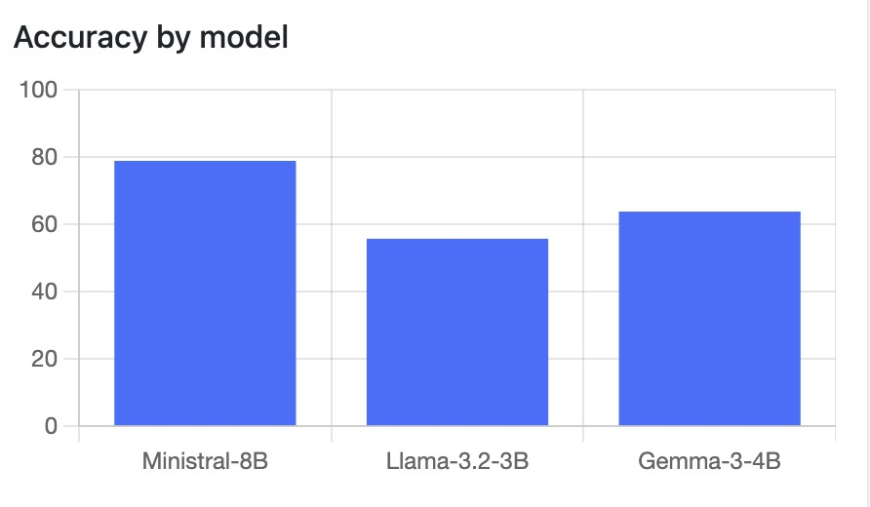
Subject-category accuracy (STEM / Humanities / Social Sciences / Other) per model:
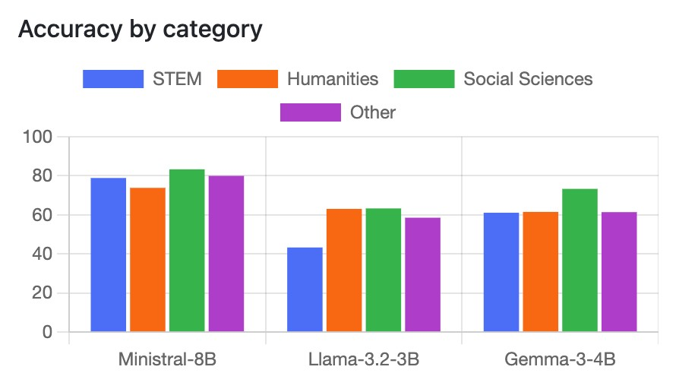

MMLU Web App

The MMLU run panel: model and questions-per-subject inputs, subject picker with category presets, and the live terminal that streams processing output below the input fields before and during a run.

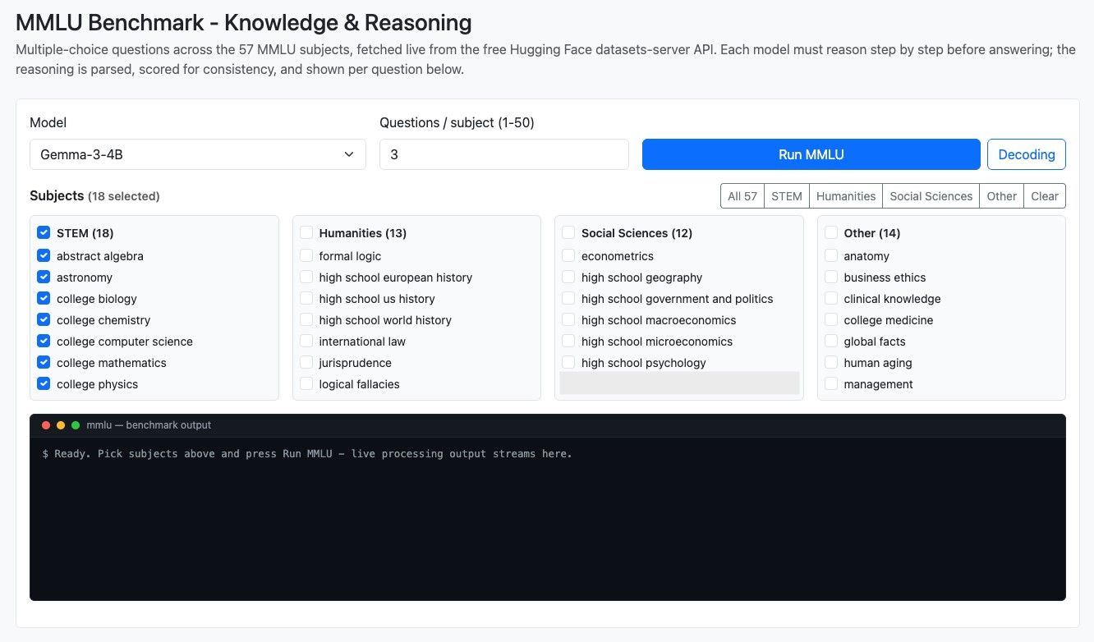
The Q/A section lists every question the selected model saw, grouped per subject with a correct-count badge and category tag:

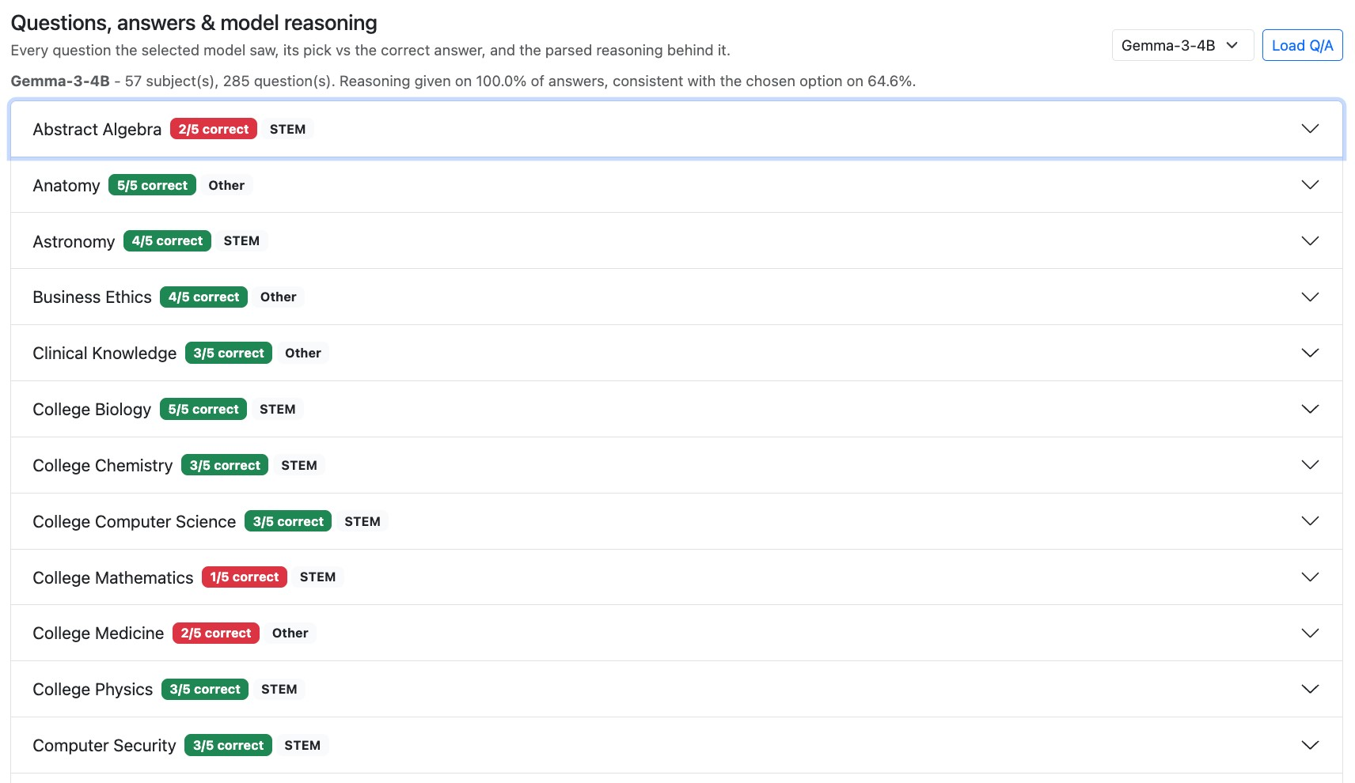

Expanding a subject shows each question with the model's pick vs the correct answer, its parsed reasoning, the reasoning verdict, and per-question latency:

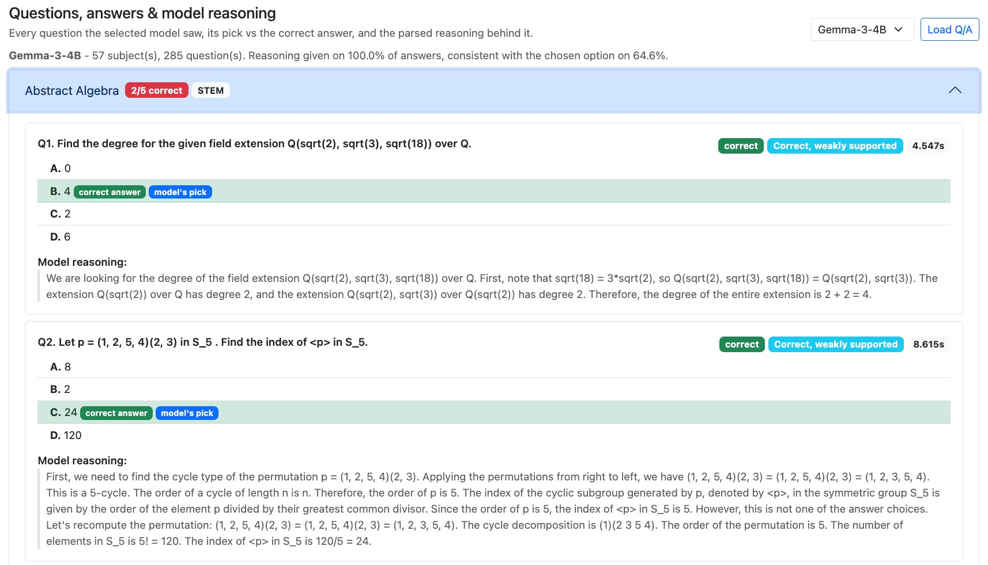

Fine-Tuning Presets
Both benchmark pages expose one-click presets over the decoding parameters. They control decoding, not model weights.

LAMBADA Presets ( _{PRESETS} in config.py)
Preset | Temperature | Topp | Max  tokens | Fewshot | Intent
Optimal | 0.0 | 1.0 | 16 | 5 | Greedy decoding with the most worked examples  - most reliable accuracy
Normal | 0.3 | 0.9 | 32 | 3 | Balanced default
Best  Performance | 0.0 | 1.0 | 8 | 2 | Trimmed token and example budget - fastest, cheapest runs

MMLU Presets ( MMLU_PRESETS in config.py)
Preset | Temperature | Top-p | Max tokens | Intent
Optimal | 0.0 | 1.0 | 512 | Most reasoning room - most reliable accuracy
Normal | 0.2 | 0.95 | 384 | Matches the defaults
Best Performance | 0.0 | 1.0 | 192 | Caps the reasoning budget so runs finish faster

Project Workflow
Load configuration
Load LAMBADA dataset /
fetch MMLU subjects
Sample N passages or N
questions per subject
Run each model via
OpenRouter in a
background job
Gemma-3-4B
Llama-3.2-3B
Ministral-8B
Collect predictions +
stream progress to terminal
Compute metrics and
rankings
Save results JSON and
history
Charts, report,
presentation

Conclusion and Reference

Ministral-8B was the most accurate on both benchmarks (38.1% LAMBADA, 78.9% MMLU); Llama-3.2-3B was consistently the fastest.
Gemma-3-4B is competitive on accuracy and reasoning quality but pays for it in latency.
LAMBADA rewards real use of context over surface patterns; MMLU adds breadth of knowledge and rewards reasoning that actually supports the answer.
The usual trade-off holds: stronger context handling and reasoning help accuracy, smaller models answer faster.
Live terminal streaming and the Optimal / Normal / Best Performance presets make runs observable in real time and easy

Reference:

Paperno, D. et al. (2016). The LAMBADA dataset. Proceedings of ACL 2016.
Hendrycks, D. et al. (2021). Measuring Massive Multitask Language Understanding. Proceedings of ICLR 2021. Google (2025). Gemma 3 technical report.
Meta (2024). Llama 3.2 model card.
Mistral AI (2024). Ministral model family.

