Identifying key risk factors for Alzheimer's disease

1. Introduction

1.1 Overview of Alzheimer's disease

Alzheimer's disease (AD) is a chronic and progressive neurodegenerative disorder that primarily impacts memory, thinking, and behavior. It is the major cause of dementia, which is characterized by a gradual decline in mental faculties, disrupting an individual's ability to perform routine activities. To date, AD affects millions of individuals worldwide, with its high incidence rate among the elderly, especially those in the 65 years and older category. Even with its far-reaching effects, the precise cause of Alzheimer's is still unknown, although a number of risk factors are thought to be responsible for its development and progression.

1.2 Key Risk Factors for Alzheimer's disease:
- Age: The primary risk factor for Alzheimer’s is age. The risk of developing AD increases significantly after the age of 65, with a higher incidence in those over 85.
- Genetics: Family history and specific genetic markers, such as the APOE gene, have been linked to an increased risk of developing Alzheimer’s. However, genetics alone are not solely responsible.
- Lifestyle Factors: Poor cardiovascular health, high cholesterol, obesity, smoking, and insufficient physical or mental activity are associated with a higher risk of developing Alzheimer’s.
- Cognitive Reserve: Individuals with higher levels of education and intellectual engagement may have a lower risk of developing AD, possibly due to a higher "cognitive reserve," which helps them compensate for the brain changes caused by the disease.
- Medical Conditions: Conditions like hypertension, diabetes, and depression have also been linked to an increased risk of Alzheimer’s. These conditions often exacerbate the brain's vulnerability to damage, promoting cognitive decline.

1.3 Importance of early diagnosis
Early detection of Alzheimer's disease (AD) is desirable for many reasons, ranging from:
- Enhanced Treatment and Care Options:
Medication: Even though there is no cure for Alzheimer's, early diagnosis allows for early administration of medications that may delay the progression of symptoms. Drugs such as acetylcholinesterase inhibitors (e.g., Donepezil) can reduce cognitive symptoms and improve functioning during the early stages of the disease. Early treatment can then possibly delay the worsening of symptoms and provide patients with a longer period of stable cognition.
Non-Pharmacological Interventions: Early diagnosis permits the application of non-pharmacological treatments such as cognitive training, physical exercise, and social interaction that may help maintain cognitive abilities and improve the patient's quality of life.
- Personalized Care and Planning
Caregiver Preparation: It is physically and emotionally taxing to take care of a person with Alzheimer's disease. Through early diagnosis, the caregivers are well equipped to deal with the challenges by learning, gaining resources, and coping mechanisms. They are able to help the patient better.
Advance Planning and Directives: Patients diagnosed at an early stage can discuss their future care, including legal concerns, money, and personal decisions. They can make decisions on advanced care directives, living wills, and end-of-life care so that their will is done when they are unable to speak for themselves.

2. Scope of the project:

3. Data Source and Import:

Parameters used in the study

Age: The age of the patient plays a key factor in the risk of developing Alzheimer's and other cognitive disorders. The risk increases as people age, especially after the age of 65.
Gender: The gender of the patient (0 = Male, 1 = Female) has been shown to influence the risk and progression of Alzheimer’s disease, with women generally being at higher risk, particularly at older ages.

Ethnicity: The ethnic background of the patient (0 = Ethnicity 1, 1 = Ethnicity 2, etc.) may influence the prevalence of Alzheimer's and other health conditions due to genetic, environmental, or social factors. Some ethnic groups are more predisposed to cognitive decline than others, but the ethnic identity in the original dataset itself has not been disclosed.

Education Level: The patient's highest level of education (e.g., 0 = No formal education, 1 = Primary school, etc.) is associated with a lower risk of Alzheimer's, as higher education helps build cognitive reserve, delaying the onset of symptoms.

BMI (Body Mass Index): A measure of body fat based on height and weight. Obesity and high BMI are risk factors for various diseases, including Alzheimer's, as obesity, particularly in mid-life, is associated with a higher risk of dementia.

Smoking: Whether the patient smokes or has a history of smoking (0 = No, 1 = Yes). Smoking is a significant risk factor for cognitive decline, vascular dementia, and Alzheimer's due to its effects on blood vessels and brain health.

Alcohol Consumption: The amount of alcohol the patient consumes. Excessive alcohol consumption can lead to cognitive impairments and increase the risk of dementia, but moderate alcohol consumption may have protective effects due to its impact on cardiovascular health.

Physical Activity: The level of physical activity the patient engages in. Regular physical activity reduces the risk of cognitive decline and dementia, as it boosts brain health, circulation, and reduces inflammation.

Diet Quality: A measure of the patient's overall diet, with healthier diets (higher values) linked to a lower risk of cognitive decline. Diets rich in nutrients, antioxidants, and omega-3s help protect against Alzheimer’s.

Sleep Quality: The quality of the patient’s sleep, including duration and disturbances. Poor sleep quality is associated with an increased risk of Alzheimer’s, as sleep is critical for memory consolidation and brain health.

Family History of Alzheimer’s: Whether there is a family history of Alzheimer’s disease (0 = No, 1 = Yes). A family history increases the risk of developing the disease, suggesting genetic and hereditary components.

Cardiovascular Disease: Whether the patient has cardiovascular disease (0 = No, 1 = Yes). Cardiovascular diseases, like heart disease or stroke, increase the risk of dementia due to their impact on brain blood flow.

Diabetes: Whether the patient has diabetes (0 = No, 1 = Yes). Poorly controlled diabetes is a risk factor for Alzheimer's, as high blood sugar damages blood vessels, leading to neurodegeneration.

Depression: Whether the patient has depression (0 = No, 1 = Yes). Depression increases the risk of Alzheimer’s, particularly in older adults, as it may exacerbate cognitive decline and act as an early sign.

Head Injury: Whether the patient has had a history of head injury (0 = No, 1 = Yes). Traumatic brain injury increases the risk of developing Alzheimer's and other dementias by causing long-term brain damage.

Hypertension: Whether the patient has high blood pressure (0 = No, 1 = Yes). Hypertension is a major risk factor for cognitive decline and dementia, as it can damage brain blood vessels over time.

Systolic BP (Blood Pressure): The systolic value of the patient’s blood pressure (top number). Elevated systolic blood pressure is a well-known risk factor for cardiovascular and brain diseases, including dementia and Alzheimer’s.

Diastolic BP (Blood Pressure): The diastolic value of the patient’s blood pressure (bottom number). High diastolic blood pressure can contribute to brain damage and increase the risk of cognitive decline over time.

Cholesterol Total: The total cholesterol level in the patient’s blood. High cholesterol, especially in midlife, is associated with an increased risk of developing Alzheimer’s and other forms of dementia.

Cholesterol LDL (Low-Density Lipoprotein): The "bad" cholesterol that can accumulate in blood vessels. Elevated LDL levels contribute to atherosclerosis, reducing blood flow to the brain, which is linked to Alzheimer’s.

Cholesterol HDL (High-Density Lipoprotein): The "good" cholesterol that helps remove bad cholesterol from the bloodstream. Higher HDL levels are linked to a reduced risk of dementia and Alzheimer's.

Cholesterol Triglycerides: The level of triglycerides in the blood. High triglyceride levels are associated with cardiovascular disease, which can increase the risk of cognitive decline and dementia.

MMSE (Mini-Mental State Examination): A score that measures cognitive function and assesses for cognitive impairments. Lower MMSE scores are indicative of cognitive decline, helping to diagnose Alzheimer's and other dementias.

Functional Assessment: A measure of the patient’s ability to perform everyday tasks. Decline in functional abilities is often observed in Alzheimer’s and dementia, indicating the severity of cognitive impairment.

Memory Complaints: Whether the patient reports issues with memory (0 = No, 1 = Yes). Memory complaints, especially in the early stages, are a common sign of Alzheimer's disease and other cognitive disorders.

Behavioral Problems: Whether the patient exhibits behavioral issues (0 = No, 1 = Yes). Behavioral changes, such as aggression or irritability, are common symptoms in Alzheimer’s patients.

ADL (Activities of Daily Living): A measure of how well the patient can perform basic daily activities (e.g., eating, bathing, dressing). Impairments in ADLs are a hallmark of Alzheimer’s and other dementias, as patients may need assistance with self-care tasks.

Confusion: Whether the patient experiences confusion (0 = No, 1 = Yes). Confusion is a common symptom in Alzheimer’s, where patients may become disoriented in time, place, or personal identity.

Disorientation: Whether the patient is disoriented (0 = No, 1 = Yes). Disorientation is often seen in Alzheimer’s, where patients may lose track of their surroundings or time.

Personality Changes: Whether the patient has noticeable changes in personality (0 = No, 1 = Yes). Personality changes, such as increased anxiety or aggression, are typical in Alzheimer’s and dementia.

Difficulty Completing Tasks: Whether the patient struggles with completing daily tasks (0 = No, 1 = Yes). Difficulty completing tasks is a symptom of Alzheimer’s, as cognitive decline impairs the ability to perform routine activities.

Forgetfulness: Whether the patient is forgetful (0 = No, 1 = Yes). Forgetfulness, particularly regarding recent events, is one of the earliest signs of Alzheimer’s disease and other cognitive impairments.

Data Import:
In this section, describe how to import the dataset using pandas, load it from various sources, and inspect the data.
- Explanation: Discuss the columns and the structure of the dataset, including the types of variables (categorical, continuous), and provide initial observations.

Visualizing Existing Data:
The following data set is visualization of various parameters and frequency of occurrence over the dataset in the given Bar Graph with Kernel Density Estimation (or KDE) Curve.
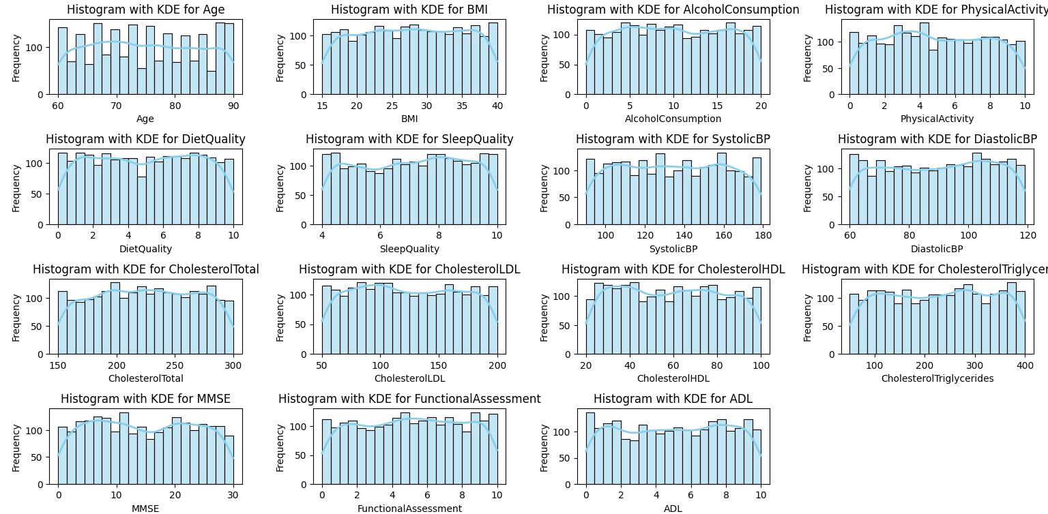
Here we can clearly see that most of the data have a plateau representation while some having slightly bimodal in nature. Since the age has deviation has a pattern of periodic change, the age category can be split with a range difference of 5, i.e. from 60 – 65, 65 – 70 and so on.

