**TEST 1 - TASK 1  
  
How the layout should change and look for mobile users?**

* Firstly, I suggest that we should aim to make the website as responsive as possible to ensure flexibility across all devices.
* Following mobile-first approach, prioritizing a vertical arrangement of items for better usability.
* Because the screen size is small, we should make the components collasible when possible, I suggest that we consider implementing a "hamburger menu" for the search bar, header links, and buttons to streamline navigation.
* We should display only relevant information; consider replacing buttons and links with icons for a cleaner interface.

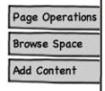

* Implement a collapsible component for the children section, avoid using too much links, displaying buttons only upon tapping to maximize space efficiency.
* Overall, The page might look like this:  
  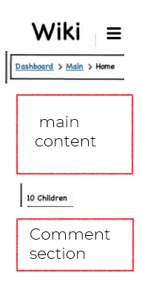
* We can keep the main content but ensure that it is responsive, including paragraphs and responsive images.
* We also need to make the website accessible by running accessibility check tools and implementing best practices for accessibility.

**Basic UX things and Other best practices when developing responsive websites to keep in mind:**

* **Responsive layouts:** adapt to different screen sizes and orientations
* **Navigation easily:** Mobile screens have limited space, so use clear labels, icons, and hierarchical menus to help users easily find what they need.
* **Focus on content:** Prioritize content that is essential for mobile users and avoid overwhelming them with unnecessary information or features. Use concise language, engaging visuals, and clear calls-to-action to communicate effectively on smaller screens.
* **Optimize for Touch**: Design interactive elements such as buttons, links, and form fields to be touch-friendly and easily tappable.
* **Performance Optimization & Prioritize Speed**: Reduce loading heavy content, long requests, etc.
* **Accessibility:** Make sure the page is accessible to users with disabilities
* **Writing Tests and Collect User Feedbacks**: Write enough unit testings, end-to-end testings to cover the design and collect user feedbacks to improve the design.