Deploy to Test ManagementPerformance  Test Regression Test Functional Test Deploy to Performance  Test EnvironmentDeploy to  Function Test EnvironmentDeploy to  Regression Test EnvironmentManage Test Scheduler Basic trigger from SC Upload to Source Control 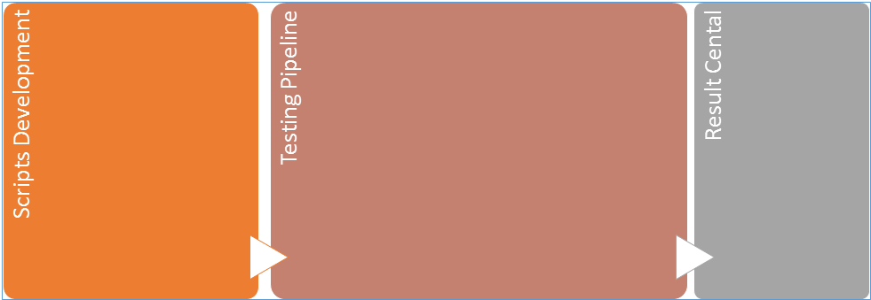

Figure 1- Test Strategy

Version Control – Bonobo  Environment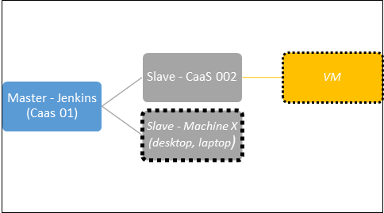

Figure 2 - Environment Assignment