Does the essay follow the logical pattern?
It should follow the logical pattern; you make it logical when you write the rough draft. Writing the rough draft before you start to write the essay ensures that your essay will be logically correct.
Example of Rough Draft:
- I am not in agreement with this statement
- Reasons why not in agreement
Equality issues
Education quality issues
- Possibilities if banned
Inexpensive as compared to private institution if banned
Multicultural environments increment if banned
- Disabled Children issues
- Conclusion
Is it grammatical correct? You have to make sure that your essay is grammatically correct. If you have any doubt about a word which you think may not be correct do not use it in you essay. Avoid using the words you have problems with; instead use alternate words which convey same or similar meaning. Also, when you finish writing your essay check for the grammatical errors and rectify them.
Did you made your introduction relevant and attractive by adding your option and range of vocabulary with the topic given to you? Observe your introduction and see if you have used at least three high quality words in introduction. Also observe if you have stated your opinions in the introduction and correlated with statement. Make sure you do these things to make your introduction an excellent start.
Did you express the main reasons for your opinion when you write the conclusion in your essay? Observe your conclusion and see if you have mentioned your opinions and the main reasons behind your opinions from the above paragraphs. Also, observe if you have paraphrased the sentences from introduction paragraph to the conclusion paragraph. Make sure you do this to finish your essay on a positive note.
Using a computer every day can have more negative than positive effects on children. Do you agree or disagree?
Give reasons for your answer and include any relevant examples from your own knowledge or experience.
Essay 1 – High Score – Band 8-9
In today's modern world, computers are an essential part of everyday life. Around the globe, children often use computers from a very young age. Although it is important for children to participate in various well-balanced activities, in my opinion, children who use the computer daily are actually developing a critical skill for future success. The bases for my views are personal, academic, and professional.
From a personal point of view, computers are an invaluable resource to help young people explore the world around them. For example, children who use Internet to satisfy their curiosity about diverse topics are already becoming independent learners. No child with a computer is ever bored! By starting early in their lives, children feel totally at ease around computers; they are also able to take advantage of the wide range of services computers provide.
From an academic viewpoint, children have no choice but to master this technological invention. For instance, when I was in university, students brought their laptops to class to take notes, do research and exchange information. They wrote assignments, created presentations and developed databases. Children who build early confidence and experience in these abilities are at a distinct advantage over those who have not.
From a professional perspective, the computer has found a permanent place in the workplace. Today, employers still pay to provide computer training to their employees. Tomorrow, corporations will expect prospective job applicants to already possess these critical job skills. Consequently, parents who encourage their child to use the computer for a reasonable period of time daily are in fact investing in the child's future career.
In conclusion, there is no doubt that the computer as a technological tool is here to stay. The sooner children become computer-literate, the better for many aspects of their future lives.
(299 words)
Successful sports professionals can earn a great deal more money than people in other important professions. Some people think this is fully justified while others think it is unfair. Discuss both these views and give your opinion.
Give reasons for your answer and include any relevant examples from your own knowledge or experience.
Write at least 250 words.
The world of sports is a multimillion dollar industry. Around the globe, people flock to sporting events or watch their favourite teams faithfully each week on television. As a result, professional sports athletes receive huge salaries – well above, for example, those of doctors, lawyers, teachers or social workers. There is some debate about whether such outrageously high salaries are justified.
On the one hand, sport is viewed as a professional career, in which the top players should rightly earn high salaries. Athletes train rigorously from an early age to become peak performers in their field. They face tremendous pressure in each and every game, match or competition. Their personal lives are compromised and they lose all privacy. At the same time, their strong achievements bring honour and attention, not only to themselves, but also to their teams, schools, cities or countries.
On the other hand, various professions contribute to making our world run smoothly. Doctors put in at least ten years of grueling study and internship; their work saves lives. Teachers educate and inspire young people to be responsible citizens: their efforts produce the citizens of tomorrow. Social workers rescue individuals facing physical, mental and psychological challenges: their intervention creates safer societies.
Yet, professionals in the fields above usually struggle to get by, despite their meaningful and critical contribution to the world.
In my view, paying enormous salaries to sportspeople is unnecessary. We need to reconsider our social priorities and eliminate the great disparity in income received by diverse professionals. By doing so, we can build societies in which each one feels valued, appreciated and appropriately compensated for their own vocation or specialization.
(273 words)
As computers are being used more and more in education, there will be soon no role for teachers in the classroom.
There is no doubt that education and the learning process has changed since the introduction of computers: The search for information has become easier and amusing, and connectivity has expedited the data availability. Though experts systems have made computers more intelligent, they have not yet become a substitute of the human interaction in the learning process. In my opinion what can be expected is a change of the teachers’ role, but not their disappearance from the classroom.
Nobody can argue that the acquisition of knowledge is more fun and easier with computers. The mere activity of touching and exploring this device constitutes an enjoyable task for a child. This, accompanied by the relaxing attitude and software interactivity, usually contributes to a better grasping of new knowledge. At a higher educational level the availability of digital books, simulators and other academic materials provide the student with an ever accessible source of information, that otherwise would not be at hand.
But, besides the increasing complexity and behavior of intelligent software, which is usually embedded in the academic digital material, the need for human interaction in the learning process will always be present, at least in the foreseeable future. There is the necessity for a human being to be able to determine what the specifics needs of each individual are. The expertise of a teacher in how to explain and adapt complex concepts to different individuals can hardly be mimicked by a computer, no matter how sophisticated its software is.
As computers are becoming a common tool for teaching, teachers should be more aware of their role as guides in the acquisition of knowledge rather than transmitters of facts. They have to be open minded to the changes that are taking places, keep updated and serve as problem solvers in the learning process, thus allowing students to discover the fact for themselves.
To summarize, in my personal view, teachers play and will continue to play an important role in the classroom, especially at the primary level. No matter how complex computers become, there will be no replacement for the human interaction, but in the way haw this interaction takes place.
This is an excellent essay! Are you a native English speaker? Well done. The only problem is that this essay is too long, 365 words instead of 250-265 maximum.

Essay Writing – Sample Essay 1
Do you think that Private Institutions Should be Banned? Discuss your options in 250 words.
Apropos of this statement, I am in consummate discord with it. Private institutions should not be banned. Because it will mean, abating the choices made by parents for the future of their children. They may not get best education and quality of studies in Government institution. Hence, life for bright students may be downsized. Furthermore, consequences could be devastating for the future of individual and perhaps for the whole nation.
On the other hand, there will be huge positive impact on the way our Government Schools work if the private institutions are banned. Once government institutions realize their problems and shortcomings, quality of teaching and code of practice will improve. As the code for conduct improve in the Government institutions, their way of teaching will be more pragmatic. Also there will definitely be profits from schools which will go in Government Treasury once the private institutes are banned; hence the school conditions will improve. These schools will then retrospect the multi-religious culture and will teach students to be respectful towards other religions. Parents will definitely benefit from this decision by paying less tuition fees in Government institutions as compared to private institutions. Furthermore, there will be sense of equality between students and there will be exhibit of nor rich or poor in schools.
Absence of private schools may become a source of anguish in middle and high income people. It may be misunderstood as a loss in freedom of choice as Government has taken the right of choice form parents for their children education.
Some of the children who need special education or attention need private education. For instance, people with disabilities will be cared more in private institutions for their needs as compared with Government Institutions. Similarly, blind or deaf students also need special attention and care which in my option is impossible to provide in Government institutions.
In nutshell, I would like to assert the importance of private institutes in our community. Private institutions cater needs for all type of students. They always change their teaching styles and skills in accord to the demand of students, providing them with high stands of education. So I strongly feel that private education should not be banned.

Essay Writing – Sample Essay 2
As our nations are becoming stronger and more powerful economically, the quality of life seems to be improved. However, that is not actually true. We may think that we are healthy individuals and our off springs will be same, unfortunately that is just a mirage. As we look around us we find the poisons which will be polluting our generations to come. For instance alcohol and drugs are affecting our wellbeing. In accord to the statistics the percentage of smokers has risen to almost 17% in five years and that is a major cause of concern. And it is not unusual to understand that majority of lung and heart diseases are consequences of smoking. In addition to that, people who do not smoke actually are also smoking it is called as “Passive Smoking”. Recently Australia has implemented some regulations for smokers which is a relief to nonsmokers.
Choice of smoking is made freely and with cognition of a smoker. However, since smoker is commensurately addicted to smoking, providing warning on the cigarette pack is not enough. Furthermore, Government should impose high taxes on cigarettes, so that smoking addiction could be controlled in youngsters. But it is also a fact that most of the Government’s revenue comes from cigarettes and alcohol. If smoking is controlled then it is questionable, what will be happening to the strong economy of that country? I believe there must be equilibrium for this crisis.
Smokers can be considered as the high risk people because of vulnerability of disease. Majority of people are smokers with complications in lungs and heart. So it should be kept in mind that these people will be expected to pay more for their treatment. But there is actually a fine line between smokers and nonsmokers. For instance, non smokers may have to pay enormous amount of money for medical treatment, if the disease is serious.
I am in partial accord with this statement. It is a possibility that smokers may have high medical treatment bills, but it doesn’t necessary means non smokers bound to have less complications and hence less medical expenses. The scenario depends upon person to person and it may even vary from one nation to another.

Essay Writing – Sample Essay 3
I am not in consummate accord with the statement. Smoking is bad for health. But it is only on case to case basis. Some of the people have been observed immune to the bad effects of smoking. In accord to one research, some people can sustain the bad effects of smoking and can live longer. However, some people can not sustain the bad effects of smoking and therefore, the results can be devastating.
People who could be severely effected by smoking are more prone to heart and lung diseases. Paying for the medical treatment should not be biased. Because it doesn’t matter if the person is smoker or non-smoker, the problem in non-smoker could be similar to a smoker. For example, a non-smoker could be “passive smoker”. Also, even though the chances of getting heart and lung diseases in smokers are high, it doesn’t mean that a non-smoker can not have the similar disease. Reasons may vary from high cholesterol level to lungs infection in non-smokers. Research has showed that a non-smoker could also exhibit the same complications as a smoker reason being non-smoker could be inhaling the smoke fumes from smokers.
In conclusion, I would like to state that even though, majority of smokers are having complications because of smoking but it does not necessarily mean that the non-smokers cannot have the same problems. On this basis, I would assert that the medical treatment should not be biased; it should be fair to anyone who needs it. If the medical treatment is not fair, it could lead to more casualties in smokers. As a consequence, it will leave a bad taste in our community and then the riots will be inevitable.

Essay Writing – Sample Essay 4
I am in consummate accord with this statement. Apropos of the statement, I strongly believe that medical professionals and engineers must be paid more as compared to film actors. By pragmatic cognizance, one can understand that doctors and engineers are buttress of our society and economy.
Doctors and nurses are individuals who not only work for a living, but also contribute to our society. They are the people who can be regarded as “hands of God”. Reason being they save our lives, hence make this planet better for living. If one really wants to understand what it means to be a doctor, ask them, they will tell that you must have a “heart of a lion and hands of a weaver” in order to be a doctor. It is so true. Doctors and nurses improve our quality of lives. They contribute to the community in ways different to any other professions.
Similarly, teachers are also building blocks of our society. They educate us in order to make us successful in our professional and personal lives. Mentors make us realize our true potential and our responsibilities as an individual. Personally speaking, they are the messengers of angels who teach us how our life should be. They give us sense of direction in life. They show us the way to success.
Doctors, teachers and nurses are undoubtedly the pillar of any nation. Therefore, it becomes imperative to understand that they must be paid well in order to help build our community not just for themselves but for the whole society. Doctors and nurses should be paid according to their rank and their department. Higher the precision required, higher should be the pay. Similarly, teachers should be paid according to their rank and qualifications. And one most important thing is to increment their salary every year to keep them motivated.
On the contrary to these professions, actors should not be paid huge amounts for their acting. Main reason being apart of showing their sexuality, emotions and their violent nature, they exhibit wrong ideas in our society. I feel they have a limited contribution to our community as compared to any other profession.
In a nutshell, I would like to assert that doctors, teachers and nurses should be paid well as compared to actors. The main reason is because doctors, teachers and nurses contribute to our society constructively. On the other hand, film industries actually contribute destructively in our community.

Essay Writing – Sample Essay 5
I am in consummate accord with this statement. There is too much attention on keeping a pet even though people throughout the world are starving. However, one cannot negate the benefits of keeping pets. Pets are known to being harmony in families and lives of people.
Pets are source of happiness and recreation for people of all ages. Pets especially dogs may keep a person fit, as it is important to take dogs for a walk. As we walk with dogs we help ourselves to be fit. So, pets could be one reason to become fit. Guide dogs are helpful to our community. Everyone knows the significance of these specially trained dogs in lives of blind people. Guide dogs act as eyes through which they see. Dogs are also known to save lives, in some cases. At night dogs act like guards on patrol, saving our houses from burglars.
Although there are benefits to keep pets, but they could also be source of diseases. Viruses are known to be present in animals and birds. By their droppings, these viruses can travel places, infecting people which could lead to deaths in worst case scenario. Some pets, like cats and parrots can be aggressive and impulsive and it can result in instant attacks in people and can show way to the hospital.
Loss of a pet can be devastating to family members especially children. Pets have tendency to blend as a family member, so loss of who can create the same effect as a loss of a family member. As a consequence, it can lead to depression in young children.
Having a pet could also mean that lots of money will be spent on them. It is up to a person weather to keep a pet or negate the idea of having one. Once it is decided to get a pet, foremost things to do is to manage finances well in advance.
In the end, I would like to say that it actually depends upon a person either to adopt a pet or give up the idea of having one. Personally speaking, I would like to have a dog in future, as I like myself to keep fit and I think it will enhance my lifestyle.

Essay Writing – Sample Essay 6
Computers, televisions, internet, these are the must have assets in our contemporary world. It seems that world without media sources would come to halt instantaneously. However, if this is the case I imagine how our ancestors would have survived all those years without these information sources?
Computers nowadays are the major buttress in any market, be it in financial sector, like offices or businesses or stocks. It has definitely changed the world we live in. With invent of this magnificent device, people have realized the benefits of technology, which is to make lives easier and comfortable, in this technological era. Even if you ask a 3 year old child how to operate a computer, answer will definitely be positive.
Generally speaking, computers are helping our communities in numerous ways. People have become more aware of technology, resulting in increased cognizance. Computers are assisting us in factories where operations are completely autonomous. In offices, computers help us to manage our data and information. Thus, computers have actually changed our world.
Having said that, in accord to some researches done in America, there have been reports that using computers are harmful to our wellbeing. According to annals published back in 2006, working on computers for long hours continuously, can lead to stress and depression. In addition to that, people tend to gain weight as they work on computers all day long. Further more, working on computers for more than four hours can lead to decrease in eyesight. But this is not all, by invent of internet; minors have easy excess to explicit materials online. In addition to that, Email frauds are all time high.
In my option, every technology has some benefits and some drawbacks, just like the medical pills have side effects. The power is ours because choice is ours, it depends upon us which side to choose from, constructive side of technology or the destructive side.

Essay Writing – Sample Essay 7
All people glorify and enthusiastically talk about human virtues and morality yet few people actually live up to them. What is your opinion? Do you agree or disagree?
Apropos to the above parable about conversation and following human virtues and ethics I would like to quote a proverb “Early to bed , early to rise makes a man healthy, wealthy and wise” which people say but don’t follow. Do they really represent what we called human nature, undoubtedly they are?
The answer is disparaging, depreciating and moribund in true sense/pragmatic way. These garrulous, so called high profiled people, lack principles themselves. They can be considered as the quintessence of incorrigible liars .The examples of these people can be found everywhere, take for instance, out esteemed politicians , they know how to convince people at the time of voting, but after elections where are those promises, moralities and merits. Their talk is really egregious but do they really apply all to themselves. Another example can be had of those people who talk about banning fashion shows as its is not up to intrinsic worth, but in reality they are the one who watch these with full spread, question arises where is the morality then, only in words?
Exceptions are always there, no qualms in it but exceptions are rare. Stats indicate the out of 100 people approx 85 are not following what they are saying to others. So where is morality, only in lectures? This tradition simply indicates that we are camouflaging our weaknesses over our sins.
In the nutshell, we can say that if forgiveness is divine why people are giving capital punishment to others? People talk about human merits and principles but still they don’t practice what they preach, isn’t it disgusting. They live on the rules that, rules are for others not for themselves. In my opinion these people are disgrace/stigma to society.
Essay Writing – Sample Essay 8
Should foreign languages be encouraged from kindergarten?
Nothing concrete can be had without aspiration, inspiration, and perspiration. Language is a mode of communication by which we can express our ideas, emotions etc. on a piece of paper or otherwise. Apart from the native languages taught in school and allied institutions I strongly feel that the foreign languages should be encouraged from the kindergarten itself.
To illustrate my above mentioned viewpoint, I would like to quote some examples. As we often know that children’s are the backbone for any developing nation. So if they are strong the nation will progress. If they know foreign languages they won’t face any difficulty when ever they go abroad, and hence will understand their culture and technology well. Secondly, we often talk about global village of world, which is we consider the world as a global village bonded by one single theme, love, so encouraging foreign languages from the kindergarten itself will promote this theme as the students/professionals won’t have any misconception regarding other language.
To support my viewpoint further, I would like to add that promoting foreign languages from the beginning will help student learn new things, they will develop themselves into well defined professionals and citizens. Even society will acknowledge them as urbane elites. This will bring an ingenious attitude in them. They won’t be feeling guilty if they come to face such a situation called language barrier. Moreover this boosting of foreign language at the kindergarten stage will generate a feeling of oneness and may simulate foreign currency growth.
In the nutshell I can say that language (written ,oral or symbolic) is the sole way to express yourself so encouraging foreign language will not bring additional burden to children or kindergartens but this will really help in proliferating their carrier and undoubtedly strengthen a nation’s stronghold apart from generating feeling of oneness.

Essay Writing – Sample Essay 9
Smoking in public places should be banned, what is your viewpoint, do you agree or disagree.
Ban on smoking in places is not only justified but also imperative. Many countries are realizing the dangers of passive smoking and are coming up with measures to curb the problems popping up with the passive smoking.
Medical science has fully supported the dangers of potential passive smoking. To illustrate my point I will like to cite the fact that most of the people die due to cigarette smoking which contains nicotine. Inveterate smokers pack up themselves with lung and oral cancer rather than from natural causes. Government is squandering astronomical sums for the treatment of pulmonary cancers and educating the populace from the dangers of smoking .The imposition of high taxes on nicotine based products has already been done to restrain this habit.
The debatable point is that to what extent these steps have been succeeded to dissuade the smokers. Cigarette smoking not only pollutes the air but also make non-smokers inhale the stale smoke imperiling their health too. Ingrained smokers are not destroying their own health but also of others. The main critical issue in this respect is that is anyone (child or adult) safe from passive smoking. The doom of asthmatics, pregnant women can we well imagined too.
Some smokers argue that banning smoking in public places is direct impingement of their human rights but this line is futile because right to smoking is not absolute, but right to life is. Many persons unintentionally take up smoking by watching others; thereby unleash the smoke in public places. This is what they call fashion.
Thus it is imperative to impose appropriate laws as it will not only prevent non-smokers from falling victim to the dangers of passive smoking, but also directly benefit the diehard smokers who would then have no choice but to curtail their smoking habit.

Essay Writing – Sample Essay 10
Societies that don’t respect and honor their women can never make progress. To what extent do you agree or disagree on this statement.
Behind every successful man there is a woman. In fact this statement can be generalized for a state, country or a nation also that a country can never make progress if it didn’t respect their women counterparts.
The prologue of this statement can be attributed to simple questions: how will you distinguish between a civilized and uncivilized person or in fact a developed or an underdeveloped nation? Can one answer this question this by saying or referring to his economic status or his rank. Well, unfortunately it is no. The answer reclines in the reverence of their better halves. The society which commits atrocities on their weaker members is not only uncivilized but also underdeveloped as referred to developed and civilized.
The brutalities done on women by men are not their sign of strength by they are construed as the sign of their weakness which they are camouflaging. Is the valor of men lies in committing crimes on the weak hapless women? The question is still debatable.
So why cant the societies who don’t respect the women progress, because the intelligence and wisdom of women is unique in every respect. By not acknowledging the efforts of women and depriving them of their rights means improper motherhood for future generations which hence weakens the society. Margaret Thatcher, Mother Teresa, Florence Nightingale, Indira Gandhi, etc. these names don’t need any words to prove themselves, they were the torch bearers and had enlightened the lives of many. They represent the sublime face of self-service and sacrifice.
To conclude, I would like to say that women are the best gift ever gifted to man by the God. Dishonoring and demonizing the women folks will not only invite the wrath of God, but also disfigure him too. It is the women who give birth to man, so how can he think of disrespecting the same and progress simultaneously.

Essay Writing – Sample Essay 11
Today in this modern contemporary world, people are striving hard to earn their living and to have two square meals a day. In this so called high profiled technological growth, people are suffering from many problems and diseases. As the growth is proliferating so is the problem of maligning image. Today the juveniles are suffering from what is called eve-teasing.
Eve teasing is scaling rapidly now-a-days. As per the dictionary meaning of eve-teasing it means commenting on someone in order to make fun, or abashing him or her. This problem has elevated now as compared to past. Question arises what is the main cause of eve- teasing? Is it that we want to show that we are superior to others? Or we just want to make fun of others. Well what ever may be the reasons; this is really a bad aspect of human life that we are treating others as inhumane.
The problem of eve teasing may be attributed to the bad education scenario, because it is what the education makes the human as humane. Today’s education scenario is such like we have some hesitation in talking to people of other gender. We are not taught how to behave with the members of other gender. Another main factor which is contributing towards growing this menace is the fashion of today. Today fashion is such that we are in volubly compelled toward teasing. Last, but not least, as far as I am concerned I think is the cinema which is responsible for some part of eve teasing. Movies are not what they used to be, they are hampering the minds of people, affecting their mentality and growth. People are becoming stoical, not convivial. They are not of placating nature now.
In the nutshell we can say that eve teasing is a becoming a serious problem now as population or penury. People who undergo eve teasing may end up their life due to abashment. Government should behave like a martinet and should imprison or impose monetary implications on those who are responsible because everyone in this world has the right to live without trepidations and tensions.

Essay Writing – Sample Essay 12
The human mind tries to find complex solutions to the simple problems. To what extent do you agree or disagree
Apropos to the above statement, I consider this as human nature. We are connotating westernization to such extent that we feel shame if we look ’simple’, this may be attributed to what is called fashion.
Why we have tied ourselves into so many kinks? Aren’t we have increased the complexities ourselves? In the retrospect it was not so. People were simple and their lifestyle matching to them so the problems were simple. The mind ‘thought’ accordingly.
Insight of this statement reveals the fact that we are ‘addicted’ to make mountain out of mole. The human nature is so complex that it makes complex solutions even to fairly easy problems. Even if there are no problems the mind tries to generate one and then visualizes it making it complex. An old saying that “empty vessels make much noise” is quite in this situation.
To exemplify I would like to give some examples. Suppose your food is not tasty, then mind will think why it is not tasty and then it starts pondering over it making it complex problem. Another instance can be had of overweight, overweight no doubt is problem, but still mind make it more complex and you switch to weight loss, dieting techniques and taking pills instead of ’simple’ exercising.
Furthermore going on the same track, I would like to add the examples of ‘looks’ which are ‘euphermal’ but for looks people are going to cosmetic or plastic surgeons for getting their face lifted and for removing wrinkles. Question arises why they or (human mind in particular) don’t understand the simple problem of ageing which is universal. Isn’t it the complex solution to a fairly simple problem? Other examples may include weathering, insomnia etc which are natural phenomenon but mind tries to find complex solutions to even these natural and simple phenomenon’s and ‘problems’
In the nutshell, I can say that if you want to get rid of all the problems, count your blessing not your sins daily.

Graph Sample 1
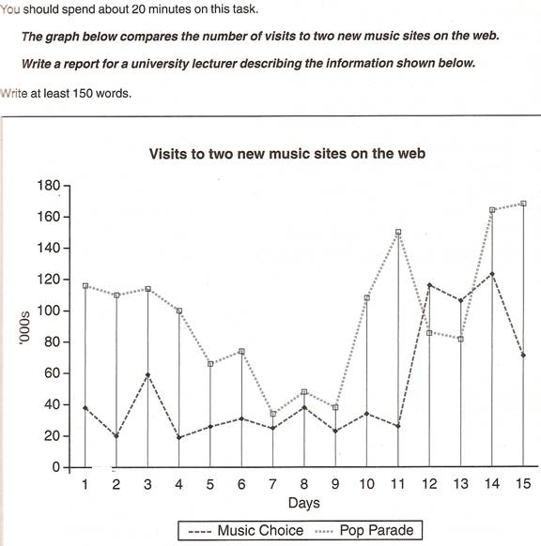

The graph exhibits people using new music places on the internet in fifteen days period of time namely personal choice and trendy pop music.
The overall trend shows fluctuation with slight increased towards the end of the period.
Staring with Music Choices websites; 40,000people went on this new site on the first day. Half of them backed out the next day. In contrast to this pop parade net sites were visited by 120,000 music lovers on the day one which decreased slightly on the next day there after regaining the same fame on 3rd day.
After 3rd day the enthusiasm for both music lines on the internet dropped slowly- reaching maximum fall of 40,000 on the 7th day. Whereas Music Choice gained popularity, slightly improving to get the original strength of 30,000 viewers on the screen, but was getting still less visitors then their opponent Pop group i.e. 40,000 on day 7.
In the beginning of the next week both gained remarkable recovery after few fluctuations for 8th and 9th day having 40,000 and 50,000 visitors respectively, reaching to their peaks of one and half thousand new visitors for Pop Parade on the 11th day showing the contrast of very few people visiting music capital choice for the same day. Thereafter, Music Choice gained popularity on the 12 day for having more than 120,000 new visitors on web.
In the end of the period Pop sites were visited by maximum viewers of 180,000 where as sides located to Music Choice were nor explored by more than 80,000 explorers on he last day of the report.

Graph Sample 2

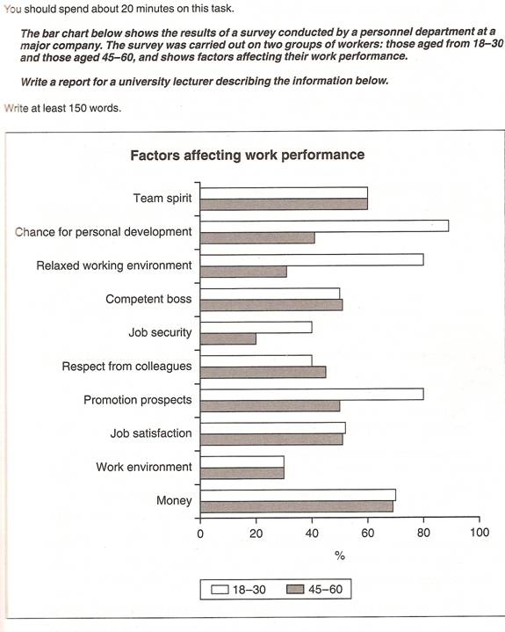
The bar chart indicates a survey on two different age groups on the factors contributing to make their environment pleasant for working.
These factors are divided in to internal and external factors. The internal factors are the team spirit, competent boss, respect from colleagues and job satisfaction. The external factors are chance for personal development, job security, promotional prospects and money.
On the internal factors above 50 % in both age groups agreed that team spirit, competent boss and job satisfaction are essential to make their environment pleasant. Whereas on the external factors, there are contrasting results. On the chance of personal development and promotional aspects, 80% to 90% of the younger groups were in favor while only less than 50% of the older group thought so. A similar pattern is also noted on job security. With regards to money, 69% to 70% on both age groups said it is essential.
In conclusion, the internal factors have similar responses from the two age groups while they had dissimilar responses on the external factors.

Graph Sample 3

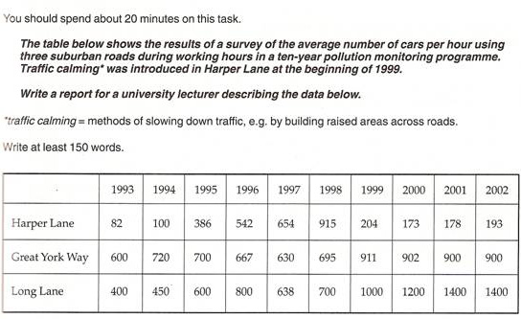
The data exhibits the conclusion of study of the average number of cars passing on three different roads between 1993 and 2002. In general the trend was upward over the period.
The most striking feature is that there was a dramatic increase in the number of cars passed on the Long Lane from 1993 to 2001, during which the number increased from 400 cars in 1993 to 1400 cars in 2001.
However, the number was stable during the following year at 1400 cars.
The evidence reveals that the number of cars on Harper Lane rose between 1993 and 1998. One year before the introduction of the methods to slow down traffic, the number declined with slight fluctuation.
The facts show that the average number of cars passed on Great York Way increased significantly from 1993 to 1999, the same year in which methods to slow down traffic was introduced. There were 600 cars in 1993 and 911 cars in 1999. However there was a slight reduction in the number of cars during the following years.
To sum up the introduction of traffic calming had a non significant impact on the cars passing on roads Long Lane and Great York Way. In comparison there was a slight effect on the cars passing on Harper Lane.

