Case 02 · Architecture: Fire-Sale Cascade Simulator
Chapter 3 (Architecture) of the Magshimim project-book template: overview, mapping to the spec, and data design and information entities. Three sections not in the template were added for the comparison stage: architectural patterns and trade-offs, failure scenarios and build order, and a closure check.

Overview

The principle that organises the whole structure
The threat model established that balance-sheet data a user loads are sensitive, so computation runs on the user's machine. This yields a split into three planes, and every component belongs to exactly one of them:
- The browser plane: everything that touches a user's world and results. Runs on their computer and sends no data out.
- The public server plane: a library of signed static files (worlds, rules, calibrations). Accepts read requests only.
- The calibration plane: an offline compute cluster that produces the calibrations and publishes them to the public server.
There is no channel through which information flows from the browser to the server. This is not just policy: it is enforced by a CSP header, which blocks in the browser any request that is not a read from our own server.

Component diagram
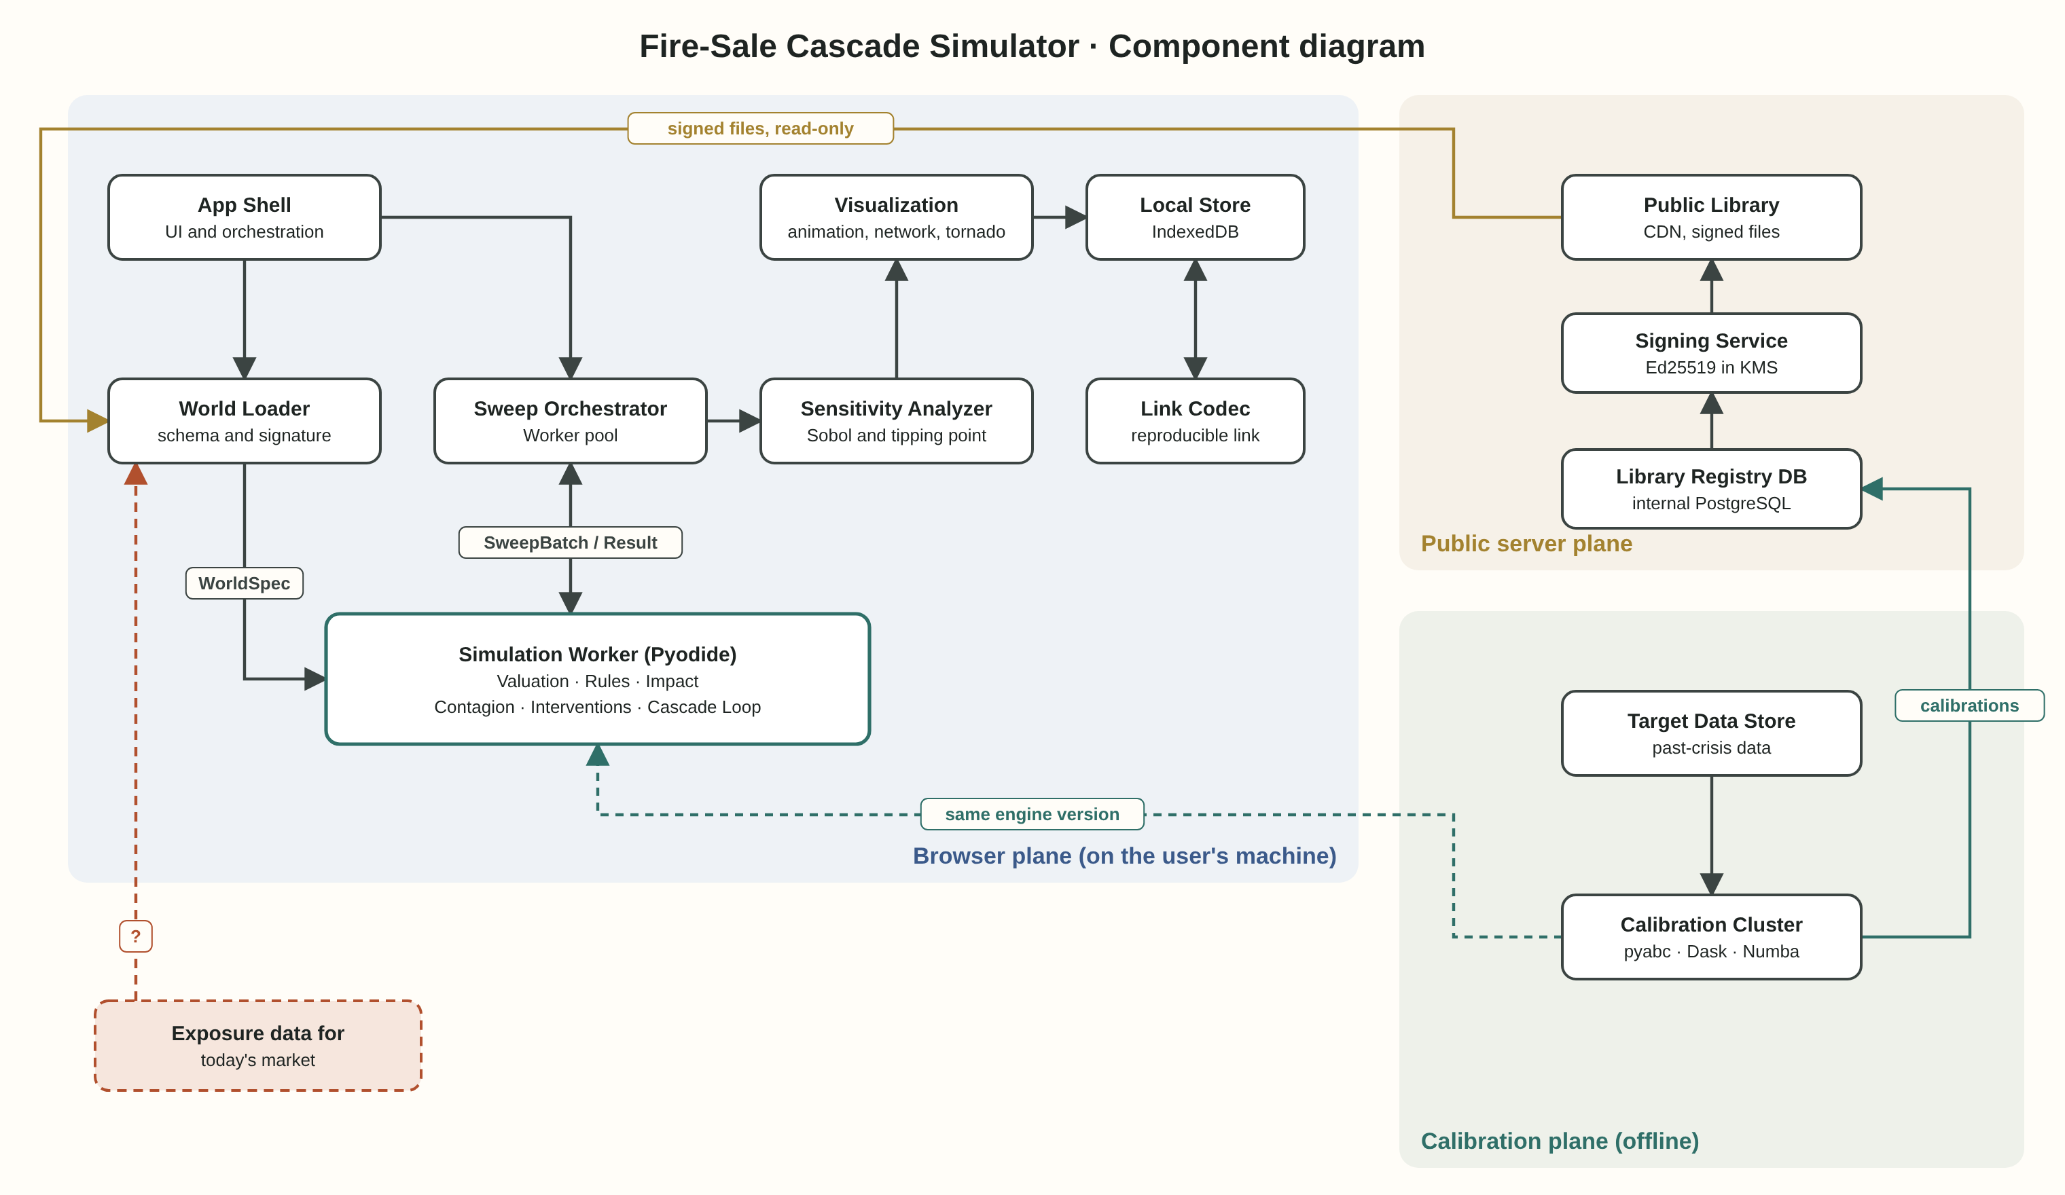

The components
- App Shell (browser plane): the application itself. Manages screens, receives user input, and hands work to components running in the background. Written in TypeScript, without a heavy framework.
- World Loader: loads a world from one of three sources (an official world from the library, a set of distributions, or a private file), validates it against the schema, and checks the signature of an official world. Produces a WorldSpec and starting balance sheets.
- Simulation Worker: a Web Worker running Pyodide with NumPy, with the simulation engine inside. Six sub-components: Valuation (revaluing balance sheets at current prices), Rules Interpreter (runs the response rules loaded as data), Market Impact (turns sales into price moves), Contagion (direct contagion and DebtRank), Interventions (fires interventions by trigger), and Cascade Loop (the loop that ties them together and returns a CascadeResult).
- Sweep Orchestrator: splits a sweep of hundreds of worlds across several Simulation Workers in parallel (by the computer's core count), collects results, and passes them on for analysis.
- Sensitivity Analyzer: computes Sobol indices, percentiles and tipping points from sweep results.
- Visualization: the cascade animation (Canvas), the network map (d3-force), the tornado chart (SVG).
- Link Codec: encodes and decodes a run into a reproducible link (in the URL fragment, which is not sent to the server).
- Local Store: IndexedDB. History of runs, sweeps and private worlds.
- Public Library (server plane): a CDN with static files: agent types, rule sets, official worlds and their signatures, calibrations and fit reports, and the public verification key.
- Library Registry DB: a PostgreSQL in which the library is managed before publication. Not reachable from outside: it exports files to the public catalog.
- Signing Service: signs every official world and calibration file before publication. The private key lives in a KMS.
- Calibration Cluster (calibration plane): Dask with pyabc and Numba. Runs the same simulation engine (exactly the same version) against target data from past crises, and produces a parameter distribution and a fit report.
- Target Data Store: the target data for calibration, with a source for every number (Bank of England, Fed and SVB reports).

Component table: role and interfaces
Component | Role | Incoming interfaces | Outgoing interfaces
App Shell | Screens, user input, orchestration | User actions, reproducible link | Requests to World Loader, Sweep Orchestrator and Visualization
World Loader | Loading, schema validation, signature check | Library world file, private file, distribution definition | WorldSpec and starting balance sheets
Simulation Worker | Full cascade on one world | RunRequest (world, shock, interventions, seed) | CascadeResult
Sweep Orchestrator | Splitting a sweep across Workers and collecting | SweepSpec | A set of CascadeResults for analysis
Sensitivity Analyzer | Sobol, percentiles, tipping points | Results and parameters | SweepResult
Visualization | Animation, network, tornado, accessible caption | CascadeResult, SweepResult, ExposureGraph | Display and downloadable image
Link Codec | Encoding and decoding a run as a link | RunLink | URL with fragment
Local Store | Local storage | Results and private worlds | Retrieval for history
Public Library | Serving signed static files | GET requests only | JSON, Parquet and signature files
Library Registry DB | Managing the library before publication | Updates from the project team, calibrations | Export to files
Signing Service | Signing official content | Canonical file | Ed25519 signature
Calibration Cluster | Calibration against past crises | Target data, priors, engine | Parameter distribution, fit report
Target Data Store | Target data with sources | Manual entry from public reports | Target data for calibration

Mapping to the spec
Spec feature | Components involved | Order of operations and why
1. World building and agent library | App Shell → World Loader → Public Library | The signature check happens before the world is passed to the engine, so a world that fails it is never marked "official"
2. Balance sheet and valuation | Simulation Worker (Valuation) | Runs at the start of every round, before the rules, because rules decide on current economic equity
3. Response rules | Public Library (rule sets) → World Loader → Simulation Worker (Rules Interpreter) | Rules are loaded as data and compiled once into vector operations, not every round
4. Price impact | Simulation Worker (Market Impact) | Runs after interventions, so central-bank absorption reduces sales before they move the price
5. Cascade engine | Simulation Worker (Cascade Loop) | The loop itself: valuation, rules, settlement, intervention, price impact, contagion, conservation checks
6. Network and contagion | World Loader (graph building) → Simulation Worker (Contagion) | DebtRank is computed once before the run (structure), and contagion every round (dynamics)
7. Intervention | App Shell (definition) → Simulation Worker (Interventions) | The announcement affects the impact coefficient from the round it is announced, and purchases from the next round
8. Sweep and sensitivity | App Shell → Sweep Orchestrator → Simulation Workers (in parallel) → Sensitivity Analyzer | A single run is also routed automatically to a default sweep, so there is no result without a range
9. Replay and calibration | Target Data Store → Calibration Cluster → Signing Service → Public Library | Calibration does not run at the user. It is published as a signed file, and official worlds point to it
10. View and link | Visualization, Link Codec, Local Store | A link is created only for a non-private world, and the fragment is not sent to the server

Data design and information entities

Information passed between components (not stored)
- RunRequest, from App Shell or Sweep Orchestrator to a Simulation Worker: a world identifier or the balance sheets themselves (as a Transferable ArrayBuffer, without copying), shock, list of interventions, seed and engine version.
- CascadeResult, from a Simulation Worker to the Orchestrator or App Shell: compressed RoundState arrays (typed arrays) and summary measures.
- SweepBatch, from the Sweep Orchestrator to a Worker: a list of parameter vectors from a segment of the Sobol sequence, so each Worker gets a separate, complete portion.
- ProgressEvent, from Workers to the App Shell: how many runs have finished, for showing progress and allowing cancellation.

Information that is stored
- On the public server (static files, read-only): agent_types, rule_sets, worlds with signatures and sources, calibrations (a Parquet posterior and a JSON fit report), and a public key.
- In the Library Registry DB (internal): the same entities in their working version, with change history. This is the table exports come from.
- In the Calibration Cluster: target data, calibration runs and posteriors. Internal, published only through the Signing Service.
- In the browser (IndexedDB): runs, sweeps, private_worlds. What is stored here never reaches the server.

Deliberate separation
A run's result (CascadeResult) and its link (RunLink) are two separate entities. The link contains only what is needed to reproduce the run, not the result. So even a leaked link reveals only a configuration, never a user's balance-sheet data.

Architectural patterns and trade-offs

Functional Core, Imperative Shell
The simulation engine is a pure function: the same world, the same shock and the same seed always return exactly the same result. It has no access to the network, the clock or outside randomness. Everything with side effects (reading files, saving, drawing) lives in the shell, in the App Shell and the Local Store.
- What we gain: full reproducibility (the reproducible link works only because of this), simple tests, and exactly the same engine in the browser and the calibration cluster.
- What we pay: the whole state must be passed to the engine as input and returned as output, which means more memory copying. We reduce this with typed arrays transferred without copying.

Data-Oriented Design (inspired by ECS in game engines)
Instead of an object per agent with methods, every attribute is an array over all agents (Structure of Arrays), and every "system" (valuation, rules, impact) is a function that passes over the arrays. This is how game engines managing millions of entities work.
- What we gain: the POC measured 1,000 runs in 0.28 seconds. A simulation with an object per agent would be tens of times slower.
- What we pay: code that reads less "naturally". An agent is not an object you can hold, but an index into arrays. That is why the rules interface (feature 3) is written in terms of a single agent, and translated into array operations.

Rules as data (Interpreter pattern)
Response rules are YAML files that are loaded and translated into operations. The engine does not know what an "LDI fund" is; it knows how to apply a condition and an action.
- What we gain: an analyst can read and change a rule, and two rule sets can be compared on the same world.
- What we pay: the rule language is deliberately limited. A rule it cannot express requires an engine change. And we must make sure the interpreter never runs arbitrary code from a user file (no eval).

Fork-Join in the browser (over a pool of Workers)
A sweep is split by segments of the Sobol sequence across several Workers, and each Worker returns partial results.
- What we gain: a sweep of 512 worlds on an 8-core machine runs about 6 times faster.
- What we pay: every Worker loads Pyodide separately (about 10 megabytes and a few seconds the first time). So the pool is created once and stays alive for the whole session.

Read-Only Publication
The public server accepts no writes from any user. All its content is created in an internal process, signed, and published as files.
- What we gain: a tiny attack surface (no forms, no write API, no exposed database), and everything can be served from a CDN.
- What we pay: no sharing between users inside the system. Anyone who wants to share sends a link.

Failure scenarios
What fails | What happens | Why that is acceptable (or not)
The CDN is unavailable | Official worlds do not load. Distribution-based and private worlds work from the local cache | The engine runs locally, so the tool works partially even without a server
A world's signature is invalid | The world loads as "custom", with a prominent warning | A result cannot be presented as official without a valid signature
A Worker crashes mid-sweep | The Orchestrator notices and reruns the segment on another Worker | Runs are deterministic, so a rerun gives the same result
The cascade does not converge after 100 rounds | The result is marked "did not converge" and is not shown as a number | A spiral that does not end is a finding, not a bug, and must be seen as one
A conservation check fails | The run stops with an error and details | An error is better than a wrong result that looks plausible
Calibration fails to reproduce a target | The report marks it in red, and the official world publishes this | The limitation is visible, not hidden

Build order
- Sprint 1, minimal engine: Valuation, Cascade Loop and two agent types (LDI and bank) in plain Python, with conservation checks. Goal: reproduce the POC in the new structure.
- Sprint 2, rules and impact: Rules Interpreter with YAML, the three impact models, and all five agent types.
- Sprint 3, browser: move the engine to Pyodide inside a Worker, World Loader, and a basic App Shell with a yield chart.
- Sprint 4, sweep: Sweep Orchestrator, Sensitivity Analyzer, and the tornado chart.
- Sprint 5, contagion and intervention: Contagion, DebtRank, and the four kinds of intervention.
- Sprint 6, library and calibration: Library Registry, Signing Service, Calibration Cluster, and the first two official worlds.
- Sprint 7, polish: animation, network map, reproducible link, Local Store, CSP and accessibility.

Closure check
The closure check asks a simple question: can the system keep its central promise end to end, using only components inside its own boundaries? The project's central promise, from ideation: to see a crisis that arrives slowly, before it arrives fast. In other words, to say something about the market as it is today.
Component or input | Inside the boundaries? | Does the promise depend on it?
The simulation engine (all sub-components) | Yes | Yes, and fully under control
Sweep and sensitivity | Yes | Yes, and fully under control
Official worlds of past crises | Yes (calibrated from public reports) | Only for replaying the past
Calibration target data | Yes (from public reports) | Only for calibration
The distribution of leverage and exposures in today's market | No | Yes, and it is the decisive input

The last row is the problem. The POC showed, and the sweep in feature 8 will measure it again on every run, that between average leverage of 4 and 5.5 the outcome moves from "calm" to "near-certain spiral". The system does not and cannot produce this figure: it can only guess a range, or receive it from an outside source. In the component diagram it is marked as a dashed box outside the boundaries: "exposure data for today's market". No component fills it.
What the system does promise, fully and within its boundaries: "if leverage and exposures are X, this is what happens, and this is how sensitive the answer is to X". That is a conditional answer. It is very useful for learning and for replaying past crises. But on the question that started the project, what is the state of the market now, its answer passes through a box it does not have.

