Case 02 · Design document: Fire-Sale Cascade Simulator
The stage after architecture. The architecture decided which components exist and what passes between them. Design goes one level down: which classes live inside each component, which states each object passes through, who talks to whom and in what order, which threads run in parallel, and what the tables look like. The structure matches the Case 01 design document and the Trivia server document.

Design principles
Four principles, taken directly from the patterns chosen in the architecture:
- The engine is pure: CascadeEngine.run() takes a world, a shock and a seed and returns a result. It makes no call to the network, the clock, IndexedDB or the DOM. Everything that touches the outside world lives in the main thread (Functional Core, Imperative Shell).
- An agent is an index, not an object: there is no Agent class. There is Balances, in which every attribute is an array over all agents, and every step of a round is a vector operation over the arrays (Data-Oriented Design).
- An interface for everything that changes between studies: the price-impact model and the intervention are interfaces (IImpactModel, IIntervention), because those are exactly what researchers will want to swap. Rules are data, not code (Interpreter).
- No result without a range: a single run is never shown alone. The main thread sends a default sweep after it, and only when that returns is the result shown with p10, p50 and p90.

Class diagram
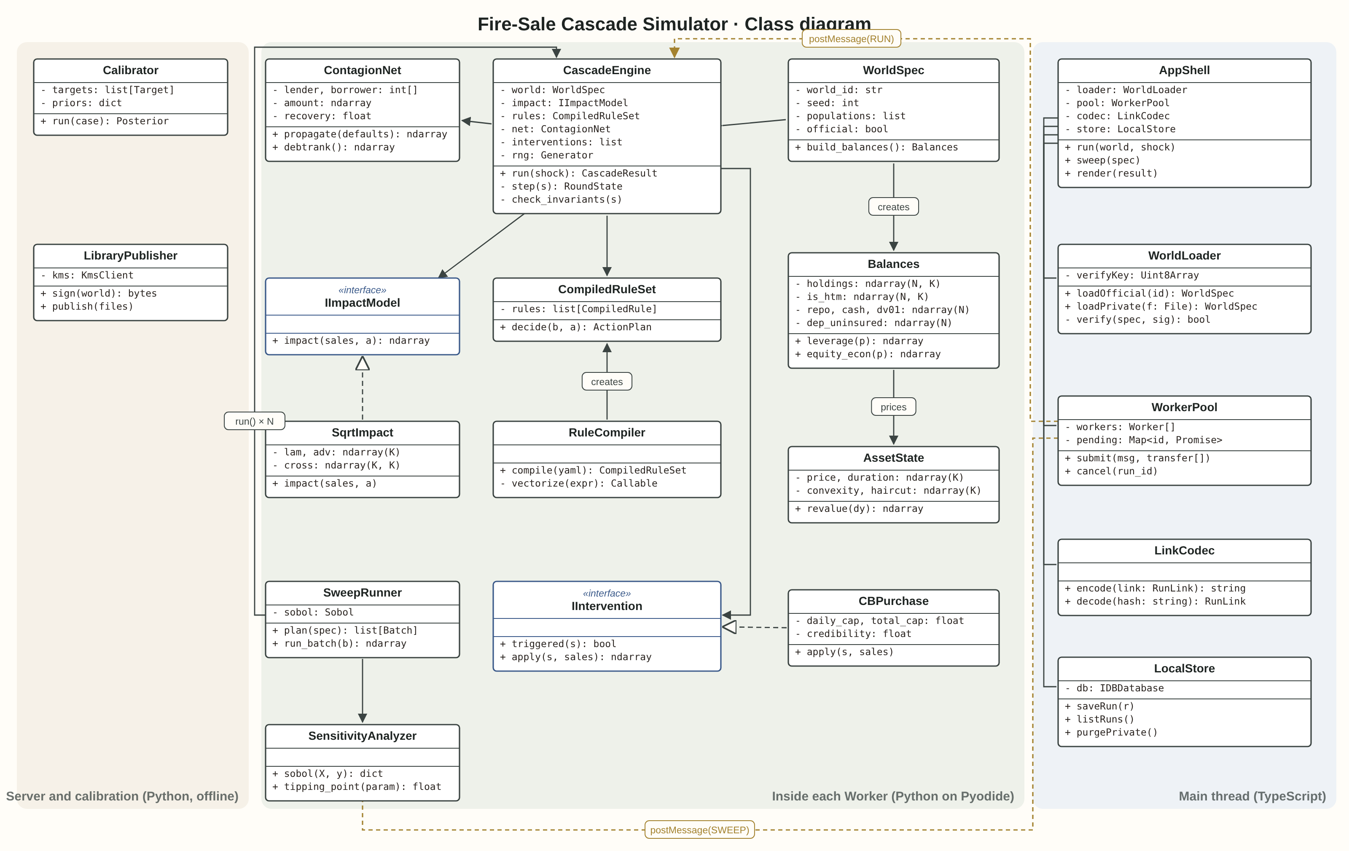
Three areas, and three runtimes. On the right, the browser's main thread in TypeScript: it manages the interface, loading and saving, and computes nothing. In the middle, what runs inside each Worker: Python on Pyodide, with NumPy. On the left, what runs on the server and not at the user: calibration and signing.
The dashed lines are postMessage: there is no direct call between the main thread and the engine. This is also what makes it possible to run exactly the same engine in the calibration cluster, with no browser at all.

The role of each class
Class | Area | Role | What it does not do
AppShell | Main | Takes input, starts runs and sweeps, draws | Computes nothing in the model
WorldLoader | Main | Loads a world from the library or a private file, checks schema and Ed25519 signature | Never sends a private file anywhere
WorkerPool | Main | Holds the Workers, distributes work and merges results | Does not know what is inside a message
LinkCodec | Main | Encodes a run definition into the URL fragment and back | Encodes only the definition, never balance sheets
LocalStore | Main | Stores runs, sweeps and private worlds in IndexedDB | Does not sync to the server
CascadeEngine | Worker | The round loop: revalue, decide, settle, intervene, impact, contagion | Does not know what an "LDI fund" is
WorldSpec | Worker | The world's description: populations, parameters, seed, official or not
Balances | Worker | All agents' balance sheets as arrays (N agents, K assets) | Has no decision logic
AssetState | Worker | Price, duration, convexity and haircut for each asset; revaluation by yield change
IImpactModel | Worker | Interface: net sales in, price change out
LinearImpact, SqrtImpact, DealerCapacity | Worker | The three implementations: linear Kyle, square root, and market makers' balance-sheet limit
RuleCompiler | Worker | Translates YAML into vector functions, once per run | Never runs eval on input
CompiledRuleSet | Worker | Returns an ActionPlan: how much each agent sells, posts or withdraws
IIntervention | Worker | Interface: triggered(state) and apply(state, sales)
CBPurchase, CollateralRelief, DepositGuarantee, ParFacility | Worker | The four tools from the spec: central-bank purchases, collateral relief, deposit insurance, a par-value facility
ContagionNet | Worker | A graph of direct debts; a default's loss passes to lenders; DebtRank up front
SweepRunner | Worker | Runs a segment of the Sobol sequence and returns an array of outcomes
SensitivityAnalyzer | Worker | Sobol indices (SALib) and a tipping point for each parameter
Calibrator | Server | ABC-SMC (pyabc) against target data from a historical case | Does not run in the browser
LibraryPublisher | Server | Signs worlds and calibrations and publishes them as static files | The private key never leaves the KMS

Message protocol
As with the Trivia server, every message between the main thread and a Worker is defined in advance: a type field, a run identifier, and content. The difference: there is no network here, there is postMessage, and large arrays move as Transferables so they are not copied.
→ Worker { type: "RUN", run_id, engine_ver, spec: WorldSpec,
buffers: { holdings, repo, cash, ... } [transfer],
shock, interventions[], seed }
→ Worker { type: "SWEEP", run_id, batch_idx, base_spec, params: Float64Array [transfer] }
→ Worker { type: "CANCEL", run_id }
← Worker { type: "PROGRESS", run_id, done, total }
← Worker { type: "RESULT", run_id, rounds: RoundState[] (typed arrays), converged: bool, summary }
← Worker { type: "SWEEP_RESULT", run_id, batch_idx, outcomes: Float64Array [transfer] }
← Worker { type: "ERROR", run_id, code, detail }

Error code | When | What is shown
E_SCHEMA | The world does not match the schema (a missing field, a negative number) | The offending field, and nothing runs
E_RULES | Invalid YAML, or a rule using an action that does not exist | The line in the file
E_INVARIANT | A conservation check failed: assets do not equal liabilities plus equity, or a sale exceeds the holding | The round, the agent and the gap. This is a bug, not a finding
E_RESOURCE | The Worker exceeded memory or time | A suggestion to shrink the world

Notice what is not an error: a cascade that has not converged after 100 rounds comes back as a RESULT with converged: false. A spiral that does not end is a finding, and the interface presents it as one.

State machines

Lifecycle of a run
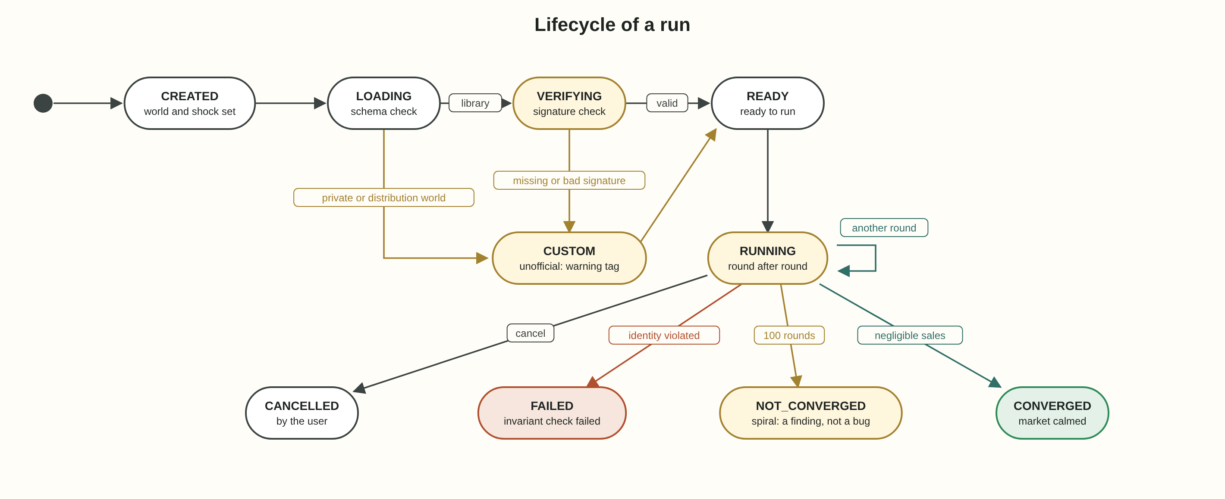
The run is the object the user sees, and every state it passes through is shown in the interface.
- VERIFYING happens only for a library world. A private world or one built from distributions goes straight to CUSTOM and receives an "unofficial" badge that cannot be removed.
- A bad signature does not stop the run. It demotes it to CUSTOM. This is deliberate: the user can still explore, but no screenshot will present the result as official.
- Four final states, and only one of them (FAILED) is a fault. NOT_CONVERGED is shown as a result in its own right, highlighted.

State of a single agent
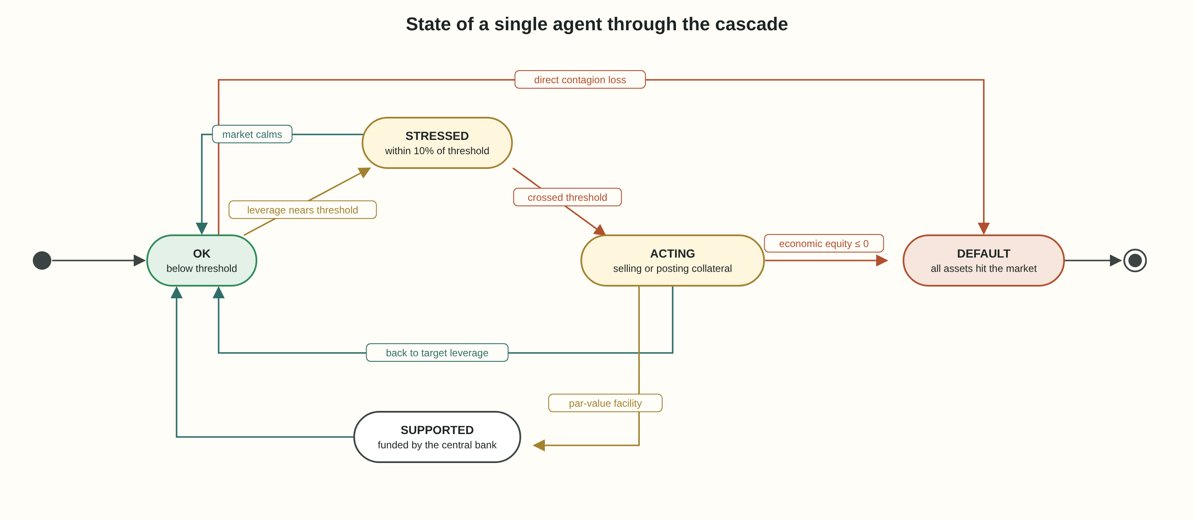
This machine does not exist as an object: it is computed each round as an array of states, one value per agent. It exists for display and understanding: it explains to the user why an agent sold.
- STRESSED is a warning state only, within 10% of the threshold. It does not change behaviour, but it is what is marked in yellow in the view, and it shows how close the market is to the tipping point.
- The path to DEFAULT can bypass everything else: a direct contagion loss (another agent failed and did not repay a loan) can bring down an agent that was in a healthy state.
- SUPPORTED exists only when a par-value facility is configured. An agent in this state does not sell, so it does not move the price. That is exactly the mechanism by which an intervention breaks the loop.

Sequence diagram
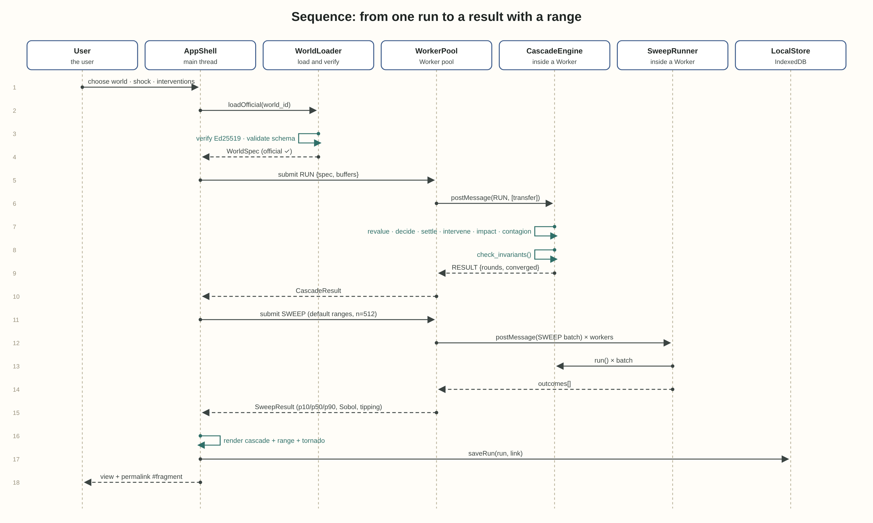
The sequence shows a single user action, end to end. Three points:
- Steps 5 and 6: the balance sheets move as Transferables. After sending, the main thread can no longer access them. That is not a bug; it is the guarantee that no two threads share the same memory.
- Step 11 happens automatically, without the user asking. It is the principle "no result without a range" translated into code.
- Step 17: the run is saved locally, and the link is a fragment (after #). Browsers do not send the fragment to the server, so even the run definition reaches nowhere the user has not sent it themselves.

Thread model
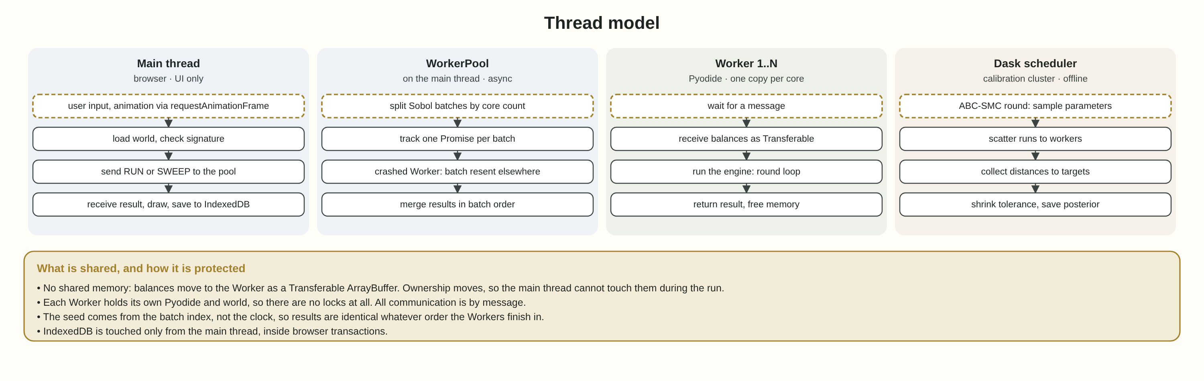
Thread | How many | What it does | How it synchronises
Main thread | One | Interface, loading, drawing, IndexedDB | Never blocks: everything is async
WorkerPool | Part of the main thread | Distributes segments, collects results, resends a failed segment | A Promise per segment
Worker 1..N | navigator.hardwareConcurrency minus 1 | Pyodide, NumPy, the engine | Messages only
Dask scheduler + workers | In the calibration cluster | ABC-SMC rounds | Dask futures

Three rules
- No shared memory, so no locks: no SharedArrayBuffer and no Atomics. Each thread holds its own data, and ownership moves with the message.
- The seed comes from the segment index: seed = hash(base_seed, batch_idx). So the sweep gives the same result even if Worker 3 finishes before Worker 1, and even if a Worker crashed and the segment was rerun elsewhere.
- One core stays free: the pool leaves a core for the main thread, so the interface does not freeze during a sweep.

Table design
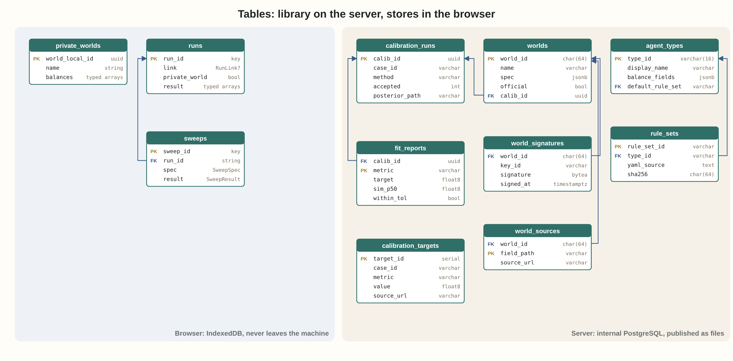
Two separate places, with no connection between them. On the server, an internal PostgreSQL from which signed static files are exported. In the browser, IndexedDB that never leaves the machine.

On the server (internal, published as files)
Table | What is stored | Note
agent_types | The five agent types and the balance-sheet fields of each | LDI, bank, PCF, insurer, MMF
rule_sets | The YAML file of each rule set, with a hash | A new version is a new row, not an update
worlds | A world definition, official or not, and which calibration fed it | world_id is the hash of the content
world_signatures | Signature, key identifier, time | A world without a signature is never marked official
world_sources | A source for every field in the world | Every number in an official world has a link
calibration_targets | Target data from the historical case (for example the gilt yield move in Britain, September 2022) | With a source
calibration_runs | A calibration run: method, number accepted, posterior path
fit_reports | For each metric: target, simulated median, within tolerance or not | Anything out of tolerance is published in red

In the browser (IndexedDB)
Store | What is stored | Note
runs | Definition, link, result as typed arrays | link empty for a private world
sweeps | Sweep definition and result | Belongs to a run
private_worlds | Balance sheets the user uploaded | purgePrivate() deletes everything in one click

Implementation order by versions
The same rule as Case 01: first the core, and only then what wraps it. The versions match the sprints in the architecture.
Version | What is built | Exit test
V0.1 | CascadeEngine, Balances, AssetState, two agent types, conservation checks, in plain Python | Reproduces the POC numbers: 0.6 becomes 1.125
V0.2 | RuleCompiler with YAML, the three impact models, all five agent types | The same rule set in YAML and in code gives an identical result
V0.3 | Pyodide inside a Worker, WorldLoader, a basic AppShell | The same seed in the browser and plain Python: identical to the bit
V0.4 | WorkerPool, SweepRunner, SensitivityAnalyzer, tornado | 512 worlds on 8 cores in under 10 seconds; a Worker killed midway does not change the result
V0.5 | ContagionNet, DebtRank, the four interventions | Intervention off: identical to V0.4. Central-bank purchases: the cascade stops
V1.0 | Signed library, calibration, LinkCodec, LocalStore | A link opened on another machine reproduces the same run; a world whose signature was altered is marked unofficial

What this document closes, and what it does not
After the design document, the engine is defined down to the level of the class and the message, and every promise from the spec (reproducibility, a range, privacy of a private world) is translated into a concrete structure.
And what is not closed, here too, is the same thing the architecture's closure check found: the worlds table has a spec field, and inside it the market's average leverage. In an official world it comes from calibration on a historical case. For today's market it has no source. Design cannot solve this, because it is not a design problem.

