Case 02 · Design document: Private Exposure Registry
The stage after architecture. The architecture decided which components exist and what passes between them. Design goes one level down: which classes live inside each component, which states each object passes through, who talks to whom and in what order, which threads run in parallel, and what the tables look like. The structure matches the Case 01 design document and the Trivia server document.

Design principles
Four principles settle almost every decision in this document. When in doubt about how to build something, we come back to them.
- No object holds both identity and content: the class that knows who the participant is (IdentityService) never sees a report, and the class that receives reports (LeaderAggregator) does not know who sent them. This separation is not a procedure; it is enforced by structure: there is no field, no parameter and no table that links the two.
- The log comes first: every significant state change is first written as an event to the transparency log, and only then is the state updated. If state and log disagree, the log is right (Event Sourcing, as decided in the architecture).
- An interface at every trust boundary: wherever we cross between parties that do not trust each other, there is an abstract interface (IAggregatorRole, ITransparencyLog). This lets us swap an implementation, test with a fake, and add a third party without touching the rest.
- Fail closed: an unverified sum is not available to any query. There is no "almost verified" state. Every branch of every state machine that does not end in verification ends in quarantine or rejection.

Class diagram
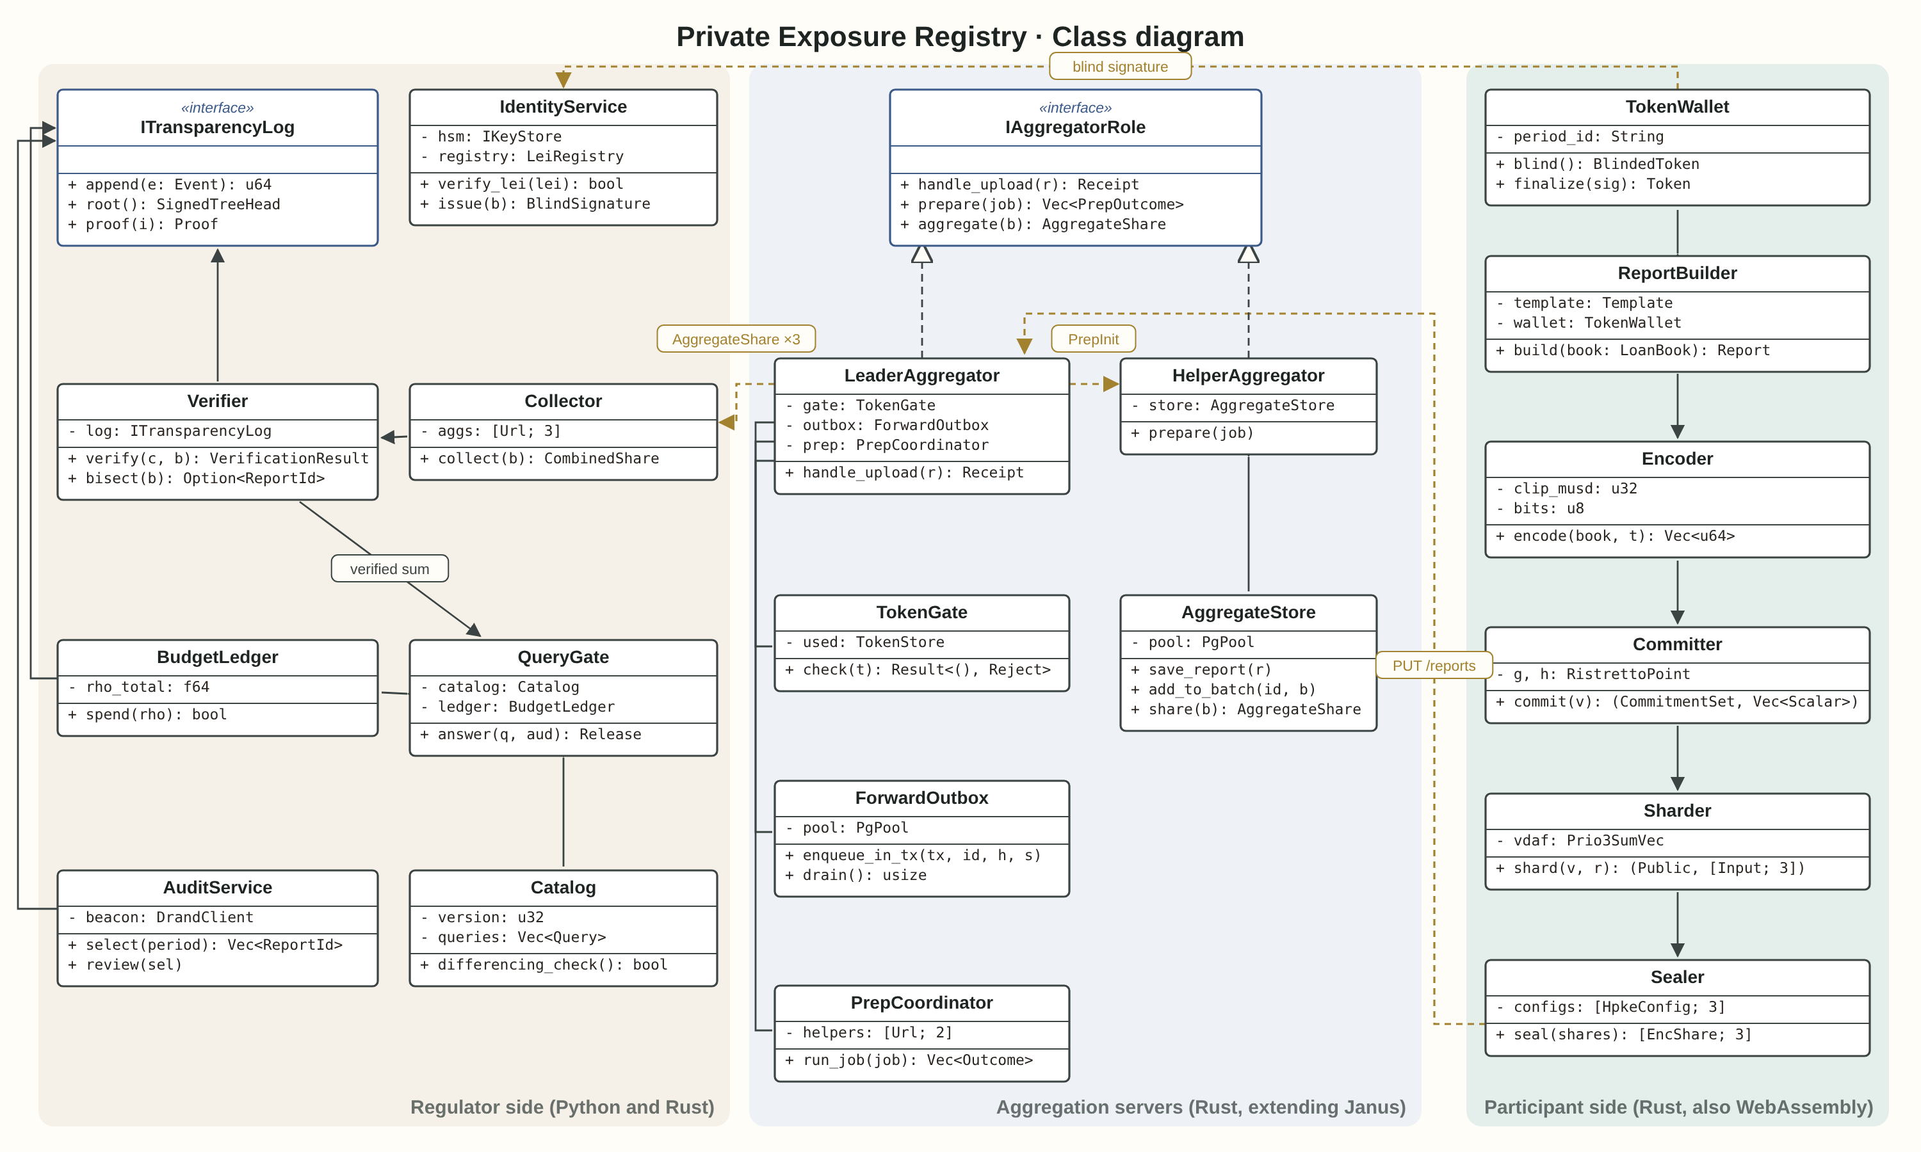
The diagram is divided into three areas, like the three kinds of party in the architecture: the participant side (a client library the reporting institution runs itself), the aggregation servers (three instances, one at each authority), and the regulator (the layer that identifies, verifies, answers queries and audits).
The labelled dashed arrows are network messages, not function calls: they cross a trust boundary, so each of them is encrypted and signed.

The role of each class
Class | Area | Role | What it does not do
TokenWallet | Participant | Holds blind tokens issued in advance, one per reporting period | Does not know which report a token will be attached to until the moment of sending
ReportBuilder | Participant | Collects the 33 cells from the institution's internal systems and checks ranges | Does not encrypt or send
Encoder | Participant | Converts the cells into finite-field integers per the template, for Prio3SumVec and Prio3Histogram | Knows nothing about the servers
Committer | Participant | Creates a Pedersen commitment on Ristretto255 for each cell, and keeps the randomness | Never shares the randomness with anyone in the clear
Sharder | Participant | Splits into three random shares that sum to the data, and attaches a range proof | Does not send
Sealer | Participant | Encrypts each share with its server's HPKE key (RFC 9180) | Cannot see the content after encryption
IAggregatorRole | Aggregation | Common interface for leader and helpers: receive a share, prepare, aggregate
LeaderAggregator | Aggregation | Receives the report, forwards shares to the helpers, runs aggregation jobs | Holds no decryption key of the helpers
HelperAggregator | Aggregation | Decrypts its own share, checks the proof, aggregates | Does not receive reports directly from participants
TokenGate | Aggregation | Verifies a blind token and marks it as spent | Does not know who received the token
ForwardOutbox | Aggregation | Stores forwards to helpers in the same transaction as receipt, and resends until success | Does not decide whether a report is valid
PrepCoordinator | Aggregation | Runs the VDAF preparation stage with the helpers and decides each report: accepted or rejected
AggregateStore | Aggregation | Holds this server's partial sum for each batch | Cannot decrypt another server's sum
IdentityService | Regulator | Verifies LEI against GLEIF and issues blind tokens per Privacy Pass | Never sees reports
Verifier | Regulator | Compares the received sum with the sum of commitments; if they differ, bisects
Collector | Regulator | Collects the three partial sums and adds them | Never sees an individual report
BudgetLedger | Regulator | Manages the privacy budget (zCDP) for each batch
QueryGate | Regulator | Takes a query from the catalog, checks the K_MIN threshold and differencing, adds Discrete Gaussian noise | Does not answer a query that is not in the catalog
AuditService | Regulator | Draws participants for audit by drand and asks them to open a commitment | Does not choose at its own discretion
Catalog | Regulator | A closed list of permitted queries, approved with three keys
ITransparencyLog | Shared | Interface to the Trillian log: append event, inclusion proof, consistency proof

Message protocol
As with the Trivia server, every message is defined in advance: who sends it, what it contains, and the possible responses. The protocol rests on DAP (draft-ietf-ppm-dap-19), so most messages are existing DAP messages, with two extensions: the blind token and the commitments.

Participant to leader
PUT /tasks/{task_id}/reports
Content-Type: application/dap-report
Body:
report_metadata { report_id: 16 bytes, time: uint64 }
public_share { commitments: 33 × 32 bytes } extension
token { blind_token: Privacy Pass } extension
leader_share HPKE ciphertext
helper_shares [ HPKE ciphertext × 2 ]

Response | Meaning | What the participant does
201 Created + Receipt | The report was accepted and logged. The Receipt includes an inclusion proof | Keeps the Receipt as evidence for the regulator
400 invalid_token | The token is invalid or not from this period | Requests a new token from the IdentityService
409 duplicate | The token has already been spent | Does not resend: the earlier report was accepted
410 period_closed | The period has closed | Contacts the regulator through the ordinary channel

Leader to helper
PUT /tasks/{task_id}/aggregation_jobs/{job_id}
Body: AggregationJobInitReq { prep_inits: [ PrepInit{ report_share, leader_prep_share } ] }
Resp: AggregationJobResp { prep_resps: [ PrepResp{ report_id, continue | reject(reason) } ] }

With three servers, the leader runs preparation with both helpers, and a report is accepted only if all three agree the proof is valid.

Regulator to the servers
POST /tasks/{task_id}/collection_jobs/{collect_id}
Body: { batch_id, aggregation_param }
Resp: Collection { report_count, interval, encrypted_agg_shares: [ × 3 ] }

Log events
Event | Written by | When | Contents
ReportReceived | LeaderAggregator | Report accepted | report_id, hash of the commitments, time. Not who sent it
ReportRejected | PrepCoordinator | Proof failed | report_id, reason
BatchClosed | LeaderAggregator | End of period | batch_id, number of reports
BatchVerified | Verifier | Sum matches commitments | batch_id, hash of the sum
BatchVerificationFailed | Verifier | Mismatch | batch_id, reports in quarantine
CatalogApproved | Catalog | New catalog version | version, three signatures
QueryAnswered | QueryGate | A query answered | query_id, catalog version, noised result
BudgetSpent | BudgetLedger | After every answer | batch_id, ρ spent, remaining
AuditSelected | AuditService | A draw | drand round, selected participants

State machines

Lifecycle of a report
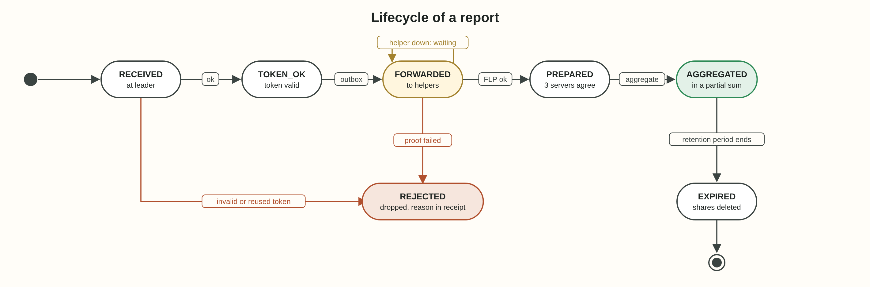
The report is the system's central object, and its state is kept in the reports table at the leader. A few things worth noticing:
- The first check is the token, before any decryption. So a flooding attack costs the attacker a valid token per report, and costs the server almost nothing.
- The self-loop on FORWARDED is the Outbox: if a helper is unavailable, the report is neither rejected nor lost. It waits, and the forward is retried until it succeeds.
- REJECTED is a final state, logged with a reason. A rejected report enters no sum.
- EXPIRED: once the batch has been verified and stored, the individual shares are deleted. There is no reason to keep them, and every day they exist is a risk.

Lifecycle of a batch
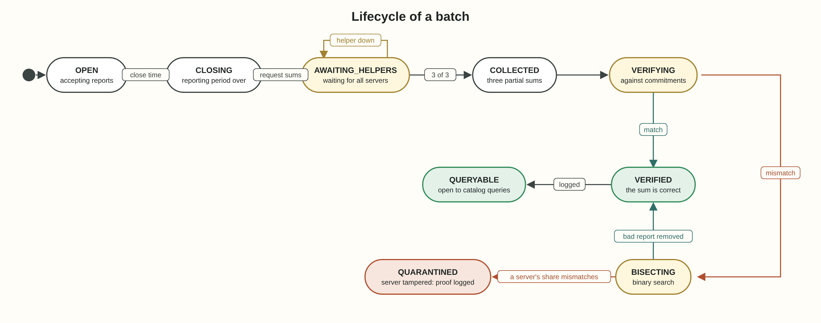
The batch is the object the regulator sees. It opens at the start of a reporting period and reaches QUERYABLE only after full verification.
- VERIFYING: the Verifier computes the sum of all commitments and checks that it commits to the received sum. This is the check that guarantees no server added or dropped a report.
- BISECTING: if the check fails, the batch is split in two and each half is checked, until the faulty reports are found. With 500 participants, that is at most 9 rounds.
- QUARANTINED: if the search finds no clear source, the whole batch is quarantined, and the log event notifies all three authorities. This is the fail-closed principle.

Sequence diagram
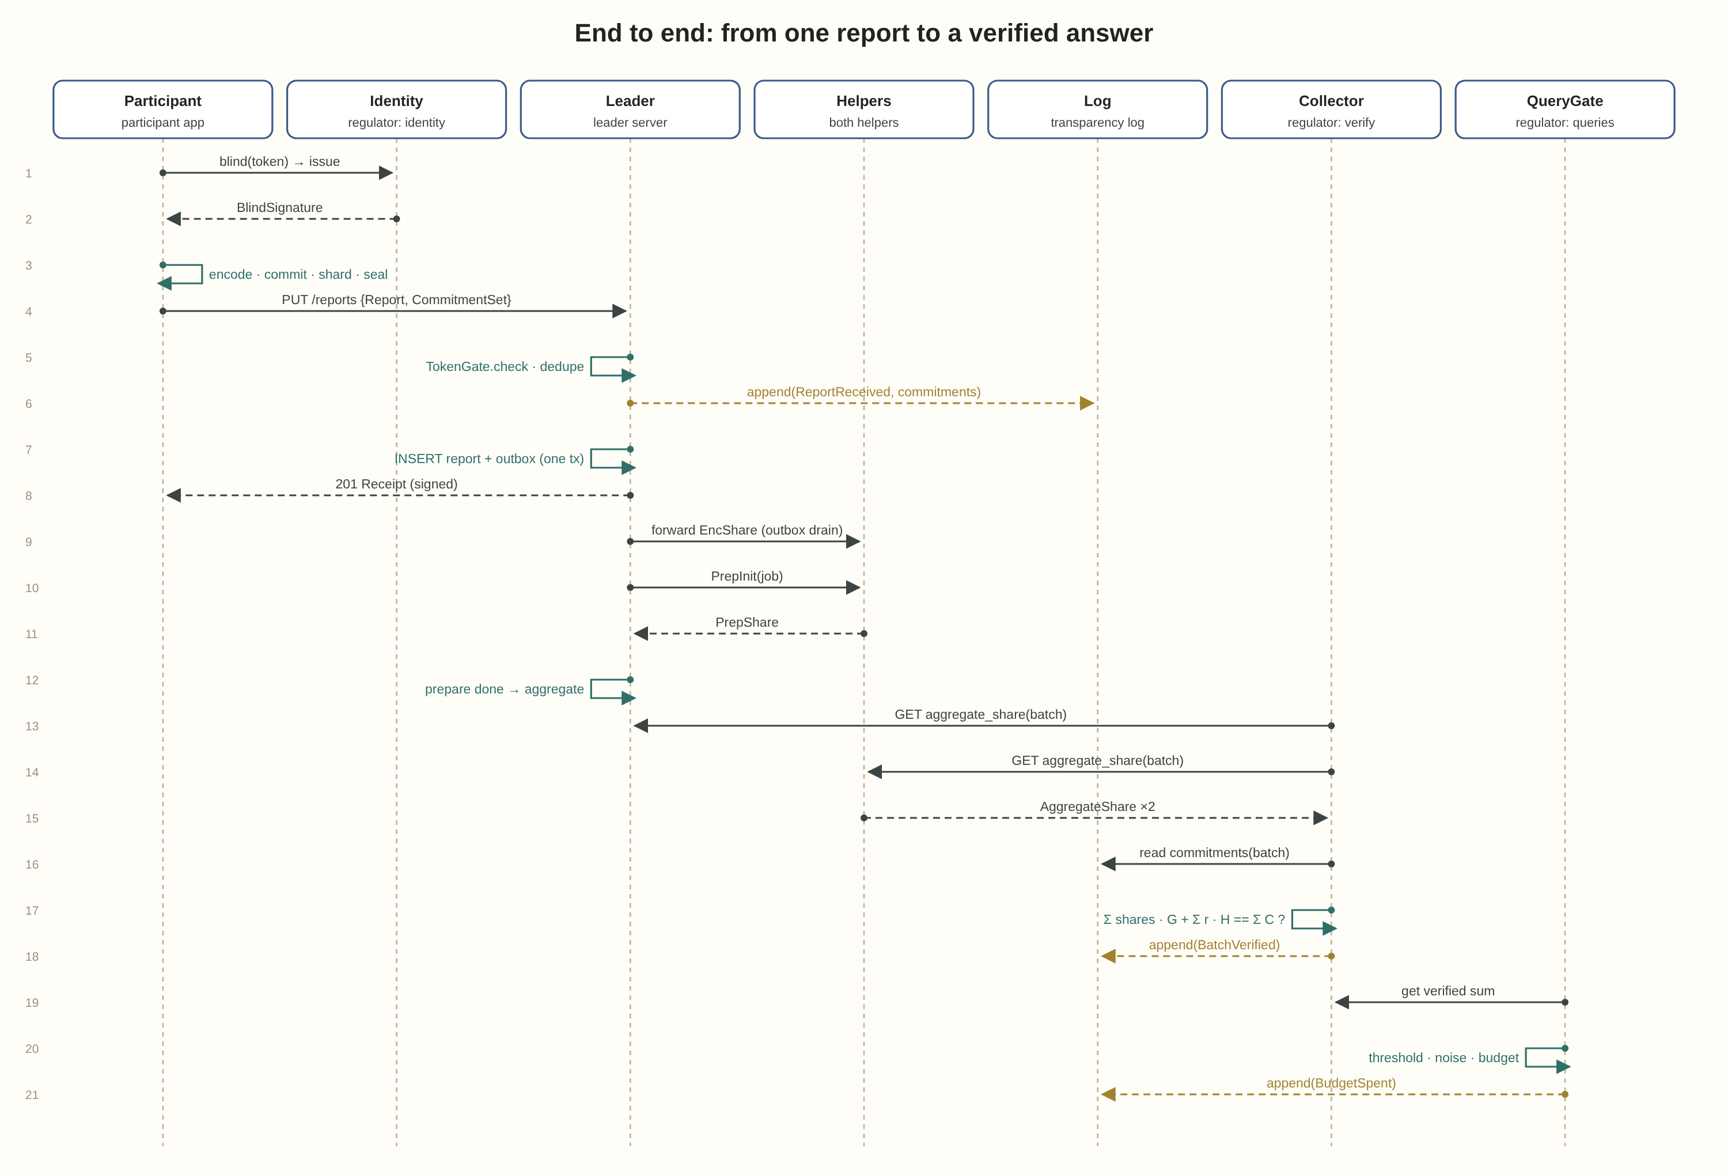
The sequence shows one reporting period end to end: from issuing the token until the budget is recorded. Three important points:
- Steps 1 to 3 happen long before reporting. The time gap between issuing a token and using it is part of the protection: even if the IdentityService and the TokenGate colluded, they could not link a token to a report by timing.
- ReportReceived is written to the log before the participant receives 201. If the log write fails, the participant gets an error and resends.
- Noise is added only at query time, not during aggregation. The verified sum stays exact, and only what goes out is noised. So we can verify first, and protect afterwards.

Thread model
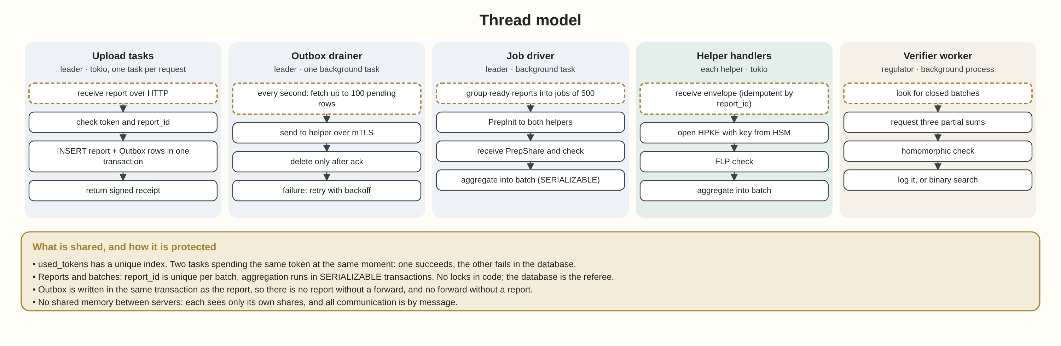
Each aggregation server is a Rust process (Janus) on the tokio runtime. That means a few operating-system threads, with thousands of asynchronous tasks running on them.
Thread or task | How many | What it does | How it synchronises
Upload tasks | One per request | Token check, storing the report, writing to the Outbox | One PostgreSQL transaction
Outbox drainer | One per server | Fetches pending forwards and sends them to helpers | SELECT ... FOR UPDATE SKIP LOCKED
Job driver | A fixed pool | Creates aggregation jobs and runs preparation | A lease on the table row
Helper handlers | One per request | Preparation and aggregation at the helper | A transaction per job
Verifier worker | One at the regulator | Verifying closed batches | A queue of events from the log

Four rules that prevent conflicts
- used_tokens with a unique index: two requests with the same token arrive in the same millisecond. One gets in, the other fails on the index and receives 409. No lock in code is needed.
- SERIALIZABLE on partial-sum updates: two jobs adding to the same batch will not overwrite each other.
- The Outbox in the same transaction: the report and the forward to the helpers are stored together or not at all. There is no state in which a report was accepted but will never reach the helpers.
- No shared memory between servers: the three servers talk only by message. This is not just a performance choice; it is a privacy requirement.

Table design
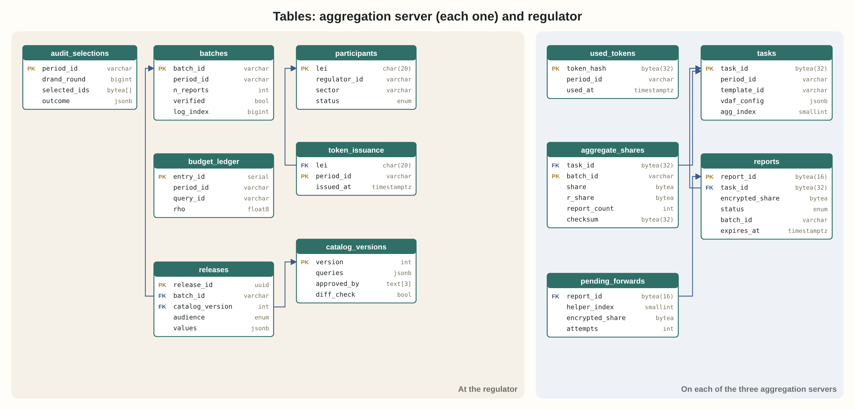
Two completely separate databases, with no foreign key between them. This is the first design principle, translated into tables: no table at the regulator contains a report_id, and no table on the servers contains an LEI.

On each aggregation server
Table | What is stored | Note
tasks | The task definition: VDAF, HPKE keys, period length | Loaded once at setup
reports | Report by report_id: encrypted share, state, commitments | Deleted on the move to EXPIRED
used_tokens | Hash of every spent token | Unique index. Not deleted until the period ends
aggregate_shares | The partial sum for each batch and the report count | What the regulator collects
pending_forwards | The Outbox: forwards not yet acknowledged | A row is deleted only after a 200 from the helper

At the regulator
Table | What is stored | Note
participants | LEI, supervising authority, status | No report data at all
token_issuance | How many tokens each participant was issued per period | Not the tokens themselves: they are blind
catalog_versions | Catalog versions, three signatures | Only a signed version is active
batches | Batch state, the verified sum | Reaches QUERYABLE only after verification
budget_ledger | ρ spent per batch | Append only, never updated
releases | Released answers, with noise | The next query checks differencing against this table
audit_selections | drand round and selected participants | Reproducible by anyone

Implementation order by versions
Each version stands on its own and is tested before moving on. The order follows the same rule as Case 01: first the core, without which the rest is pointless, then what protects it, and finally what uses it.
Version | What is built | Exit test
V0.1 | Two-server core on Janus and libprio, one report and one sum | 500 synthetic reports, the sum equals the direct sum
V0.2 | Three servers, Outbox, HPKE encryption | A helper switched off midway: no report is lost
V0.3 | Commitments, Verifier and bisection | A server deliberately drops a report: caught, and the report found
V0.4 | LEI identity, blind tokens, TokenGate | Same token twice: 409. A forged token: 400
V0.5 | Trillian transparency log | Every event with an inclusion proof, and consistency between two points in time
V0.6 | Catalog, QueryGate, noise and budget | Two queries whose difference exposes a participant: the second is blocked
V1.0 | Regulator reports, random audit, SDMX export | A full reporting period, end to end, with three authorities

What this document closes
After the design document, every class knows what it does and what it does not do, every object knows where it may move, and every table knows what it may store. The Registry's central promise, to combine without seeing, is translated here into concrete lines: no field links identity to content, and no state transition leads to an unverified sum.

