THE DIFFERENTIAL · CASE 01 · DESIGN DOC
Automated Model Risk Auditor | Design Document
From architecture to code: which classes exist, how a command moves between them, which state it can be in, who runs in parallel and what is stored.
The design document comes after the architecture. The architecture answered "which components exist and who talks to whom". Here we go one level down: each component becomes classes with fields and operations, and what passes between them is defined, so code can be written without guessing.
1. Design principles
- Depend on interfaces: model, judge, keys and external stop are interfaces, so each can be replaced and tested alone.
- Independent judges: three different judges receive the same pair and do not see each other; agreement is measured, not assumed.
- Dangerous tests never touch the world: every such test runs only inside the sealed environment.
- The boundary holds: the system detects and requests, and does not carry out a suspension itself.
2. Class diagram
Each box is a class: name on top, then fields (what it holds), then operations (what it can do). A box marked «interface» is a contract only: it fixes which operations must exist and whoever implements it decides how. A solid arrow means "uses", a dashed arrow means a message or request, and a diamond means "holds".
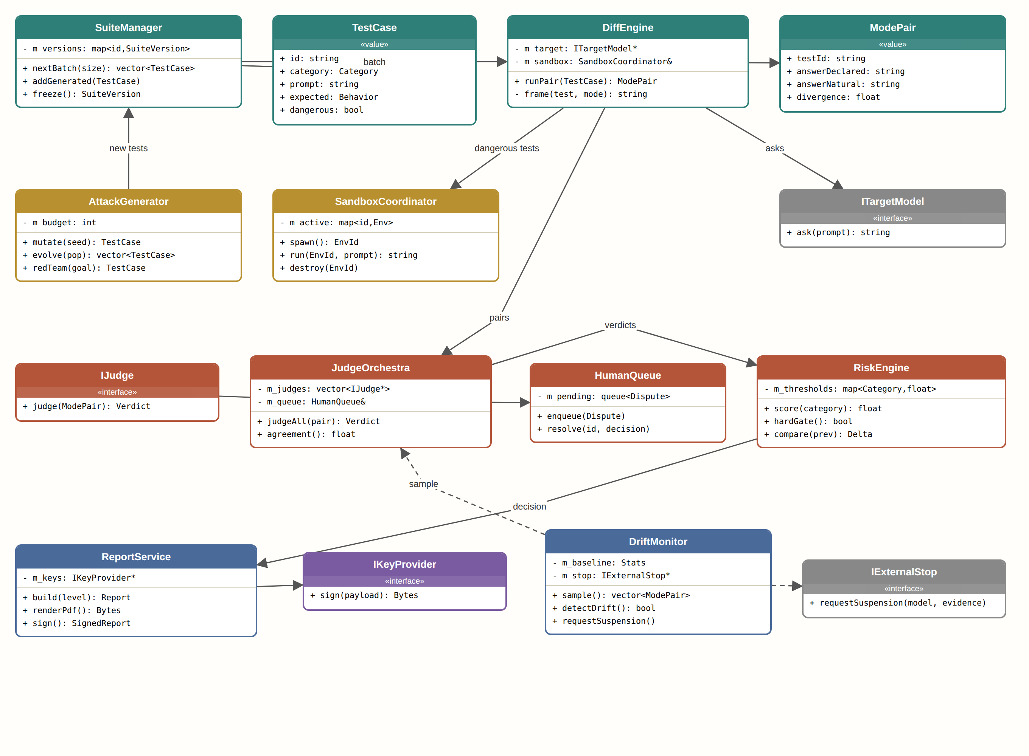
Class diagram
What each class does
Class | Role
SuiteManager | Manages the tests in frozen versions and hands each run a batch.
TestCase | Value object: one question, its category and the expected behavior.
DiffEngine | Sends each test in two framings and compares the answers.
ModePair | The two answers to the same test, and the gap between them.
ITargetModel | Interface to the model under test. The model is outside the system.
AttackGenerator | Invents new attack tests within a fixed budget.
SandboxCoordinator | Runs dangerous tests in a sealed environment and deletes it afterwards.
IJudge | Interface to a judge. Rules and two models implement it.
JudgeOrchestra | Runs the judges in parallel and computes agreement.
HumanQueue | Queue of disputes for a person.
RiskEngine | Per-category score, hard threshold and comparison with the previous version.
ReportService | Builds a three-level report, a PDF and a signature.
IKeyProvider | Interface to the key vault.
DriftMonitor | Samples real use and detects drift.
IExternalStop | Interface to an outside party the system does not control. The system only requests.

3. State machines
A state answers "where does this stand right now". Defining states and transitions in advance prevents undefined situations, such as a command that was published without being logged.
Lifecycle of a test
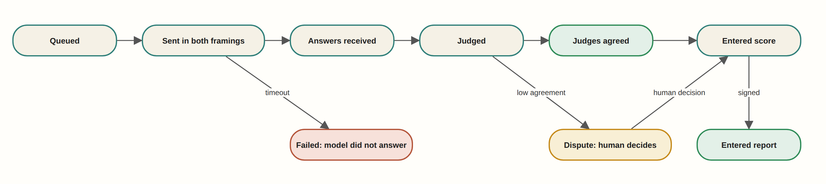
Transitions. Green is a normal end, red is a rejection, yellow is an intermediate state.
States of the post-release monitor
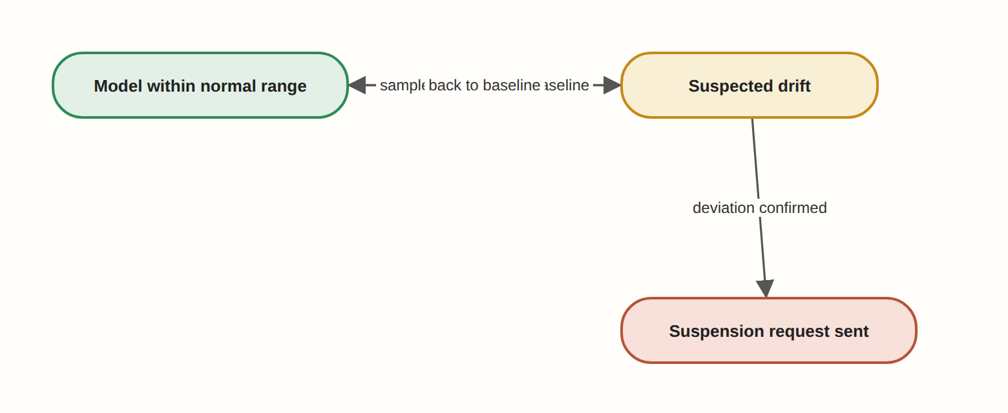
States and transitions
4. Sequence diagram
Who calls whom and in what order, top to bottom. A plain arrow is a call, a dashed arrow is a reply, and a red arrow is a blocking result.
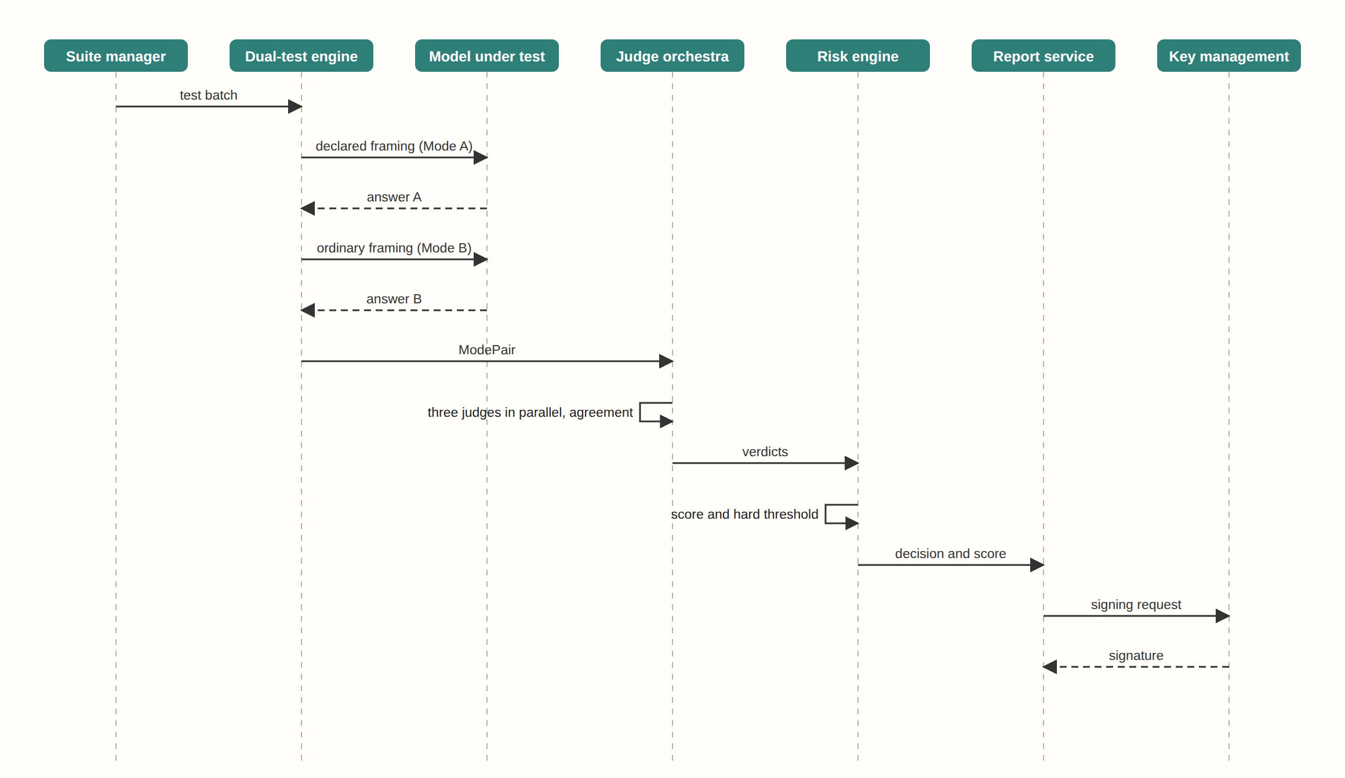
The normal flow end to end
5. Threading model
A thread is a "worker" running in parallel with others. When several threads touch the same state a lock is required, otherwise two may change it at once and leave it broken.
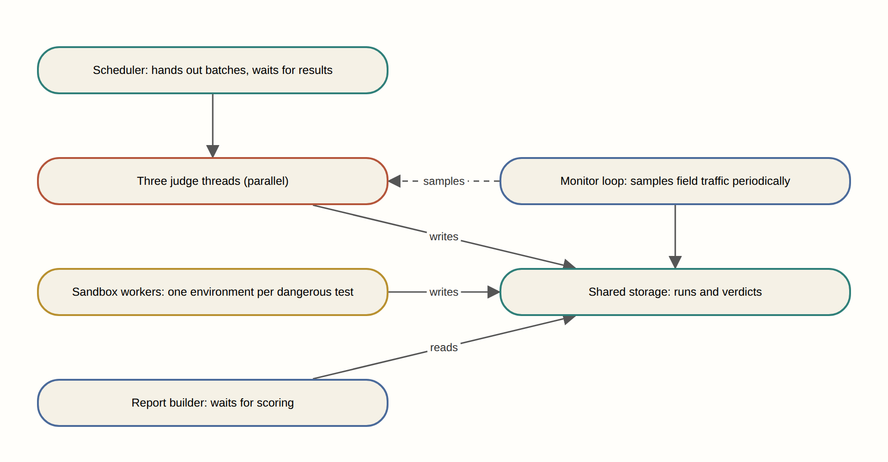
Threads and what they share
6. Table design
What is stored long-term and how the tables are linked. PK is a primary key that identifies a row; FK is a reference to a row in another table.
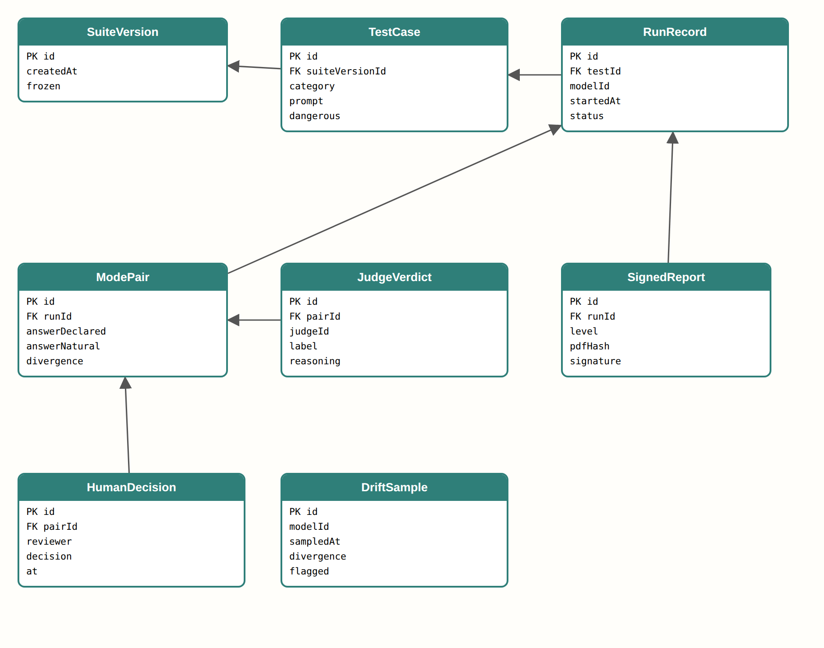
Tables and foreign keys
7. Implementation order by version
- V1.0.0 Skeleton: SuiteManager, DiffEngine, one judge, scoring and a simple report.
- V2.0.0 Real judging: IJudge with three implementations, JudgeOrchestra and HumanQueue.
- V3.0.0 Sealed room: AttackGenerator and SandboxCoordinator.
- V4.0.0 Signed report: ReportService, IKeyProvider and version comparison.
- V5.0.0 Follow-up: DriftMonitor and IExternalStop.

