THE DIFFERENTIAL · CASE 01 · DESIGN DOC
Model Kill-Switch Protocol | Design Document
From architecture to code: which classes exist, how a command moves between them, which state it can be in, who runs in parallel and what is stored.
The design document comes after the architecture. The architecture answered "which components exist and who talks to whom". Here we go one level down: each component becomes classes with fields and operations, and what passes between them is defined, so code can be written without guessing.
1. Design principles
- Depend on interfaces, not implementations: everything that may be swapped (policy, log, bus, keys) is an interface, so each part can be tested alone and technology replaced without touching the gateway.
- One direction of control: commands enter only through ControlGateway. There is no bypass, so there is one place to check and defend.
- One state, several copies: the true state is set at the center and every gateway keeps a local copy. When they disagree, the gateway follows a predefined fail-safe rule.
- Every rejection is kept: a rejection is information, not noise. It is written to the security log.
2. Class diagram
Each box is a class: name on top, then fields (what it holds), then operations (what it can do). A box marked «interface» is a contract only: it fixes which operations must exist and whoever implements it decides how. A solid arrow means "uses", a dashed arrow means a message or request, and a diamond means "holds".
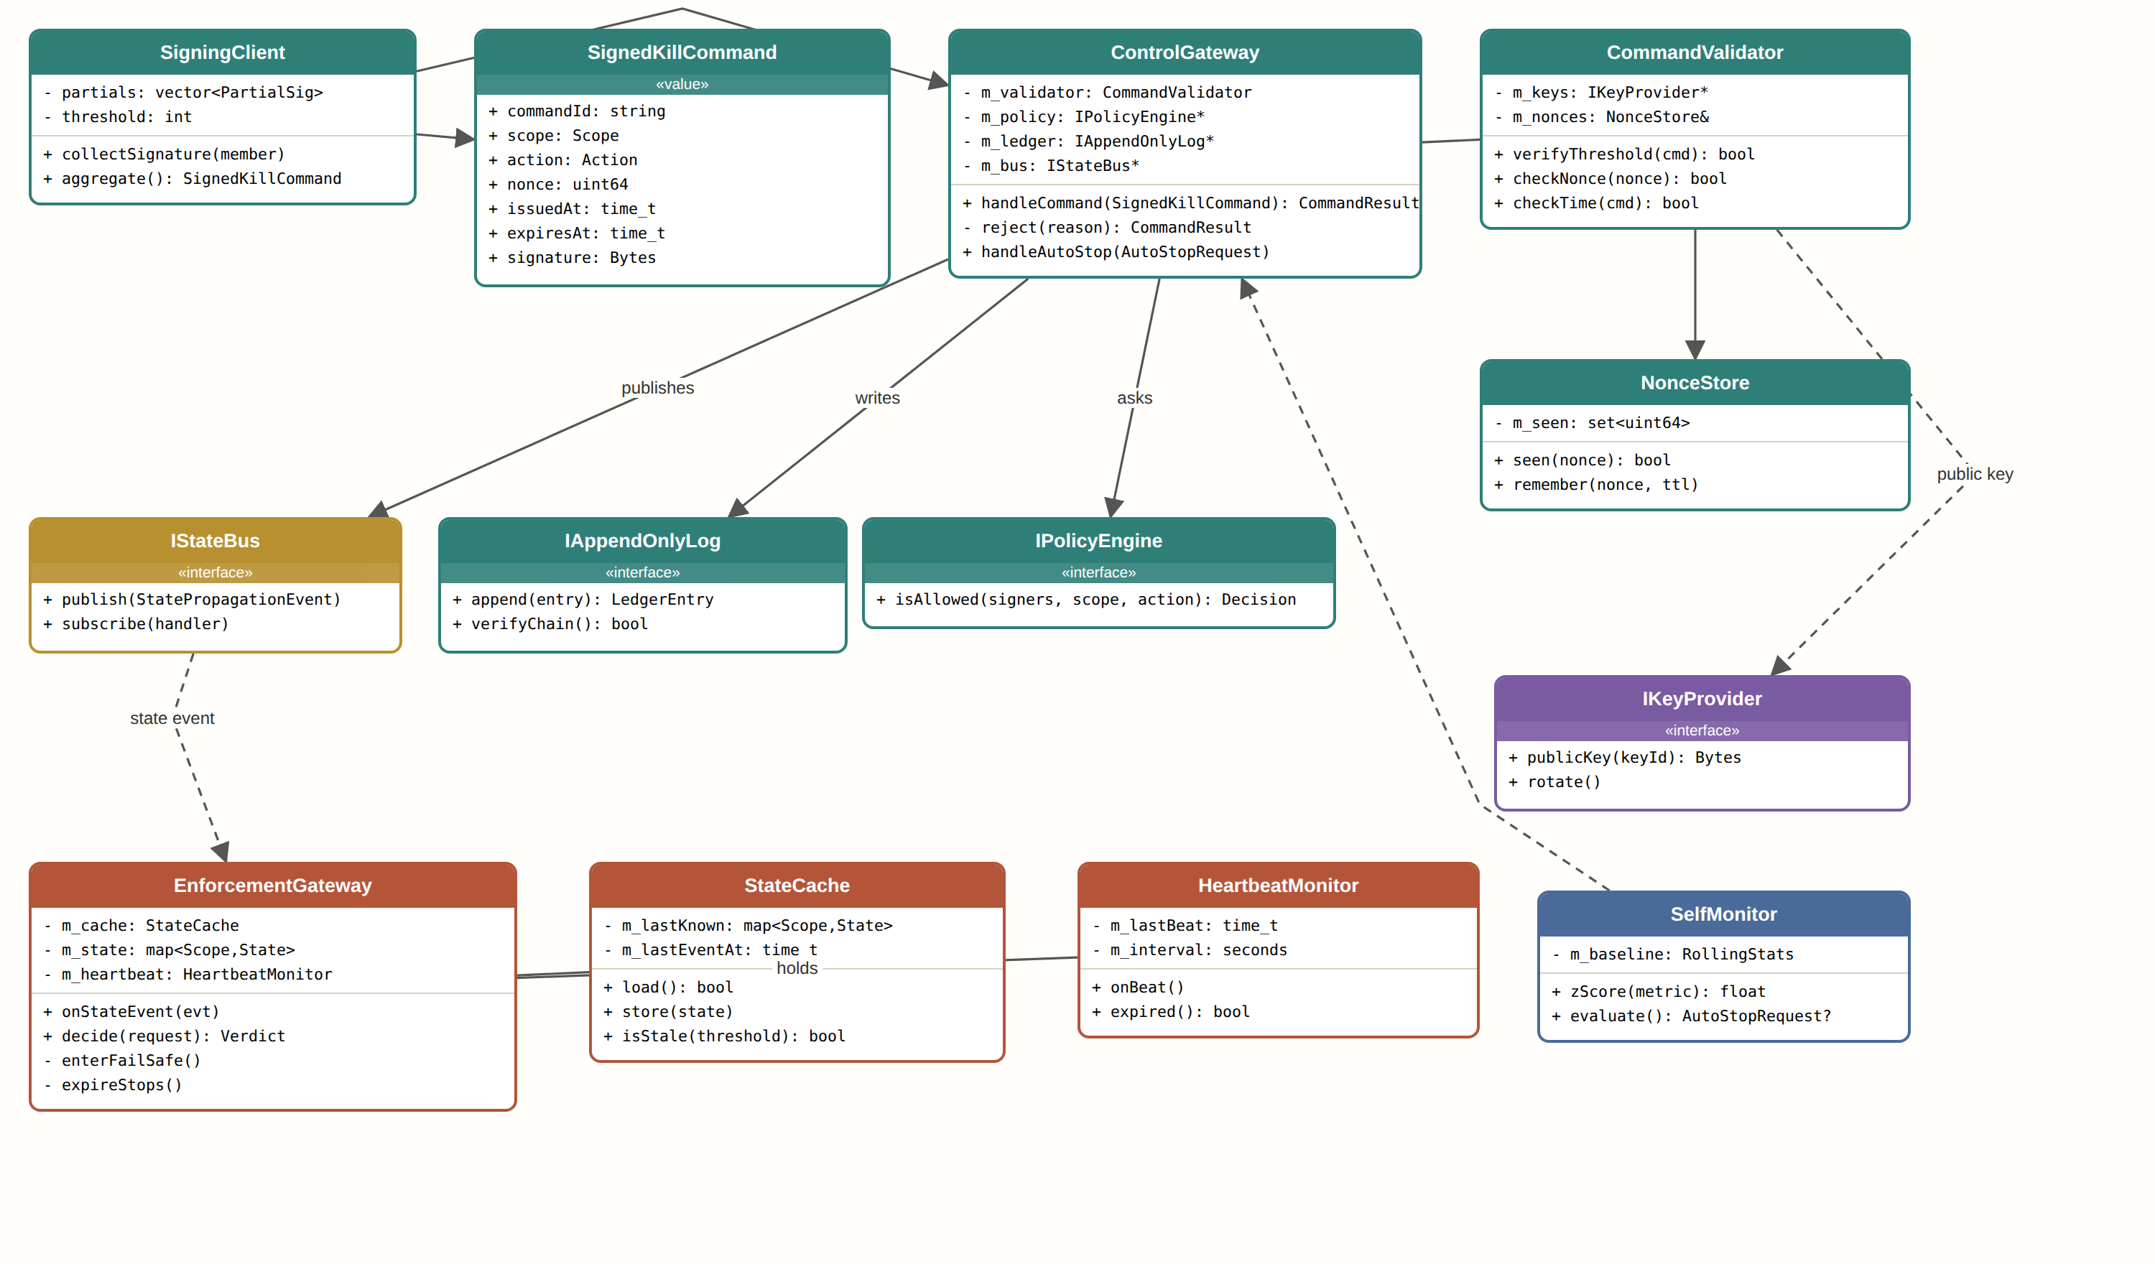
Class diagram
What each class does
Class | Role
SigningClient | Collects partial signatures from committee members and merges them into one command.
SignedKillCommand | Value object: the command itself, tied to a scope, an action and a time. Immutable after signing.
ControlGateway | The only door. Orchestrates the checks and the steps after them; decides nothing itself.
CommandValidator | Checks exactly three things: signature threshold, one-time nonce, time.
NonceStore | Remembers nonces already used, so an old command cannot be replayed.
IPolicyEngine | Interface to the policy engine. An implementation can change rules without touching the gateway.
IAppendOnlyLog | Interface to an append-only log. Each record points to the previous one by hash.
IStateBus | Interface to the distribution bus. Publish once and every gateway receives.
IKeyProvider | Interface to the key vault. No component holds a key itself.
EnforcementGateway | The guard next to the server. Receives state events, decides on every request, and enters fail-safe mode when the link is damaged.
StateCache | Local copy of the last known state, kept even when the network is down.
HeartbeatMonitor | Checks that heartbeats from the center keep arriving.
SelfMonitor | Computes deviation from normal and can only request a stop, through the same gateway.

3. State machines
A state answers "where does this stand right now". Defining states and transitions in advance prevents undefined situations, such as a command that was published without being logged.
Lifecycle of the command
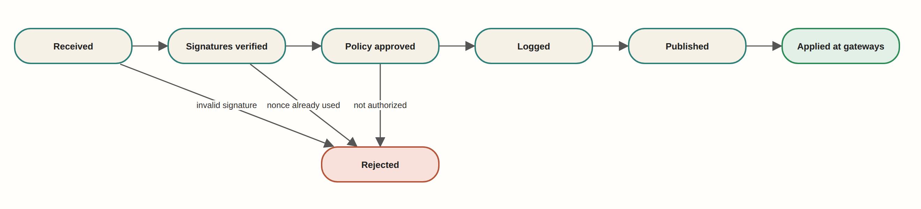
Transitions. Green is a normal end, red is a rejection, yellow is an intermediate state.
States of the enforcement gateway
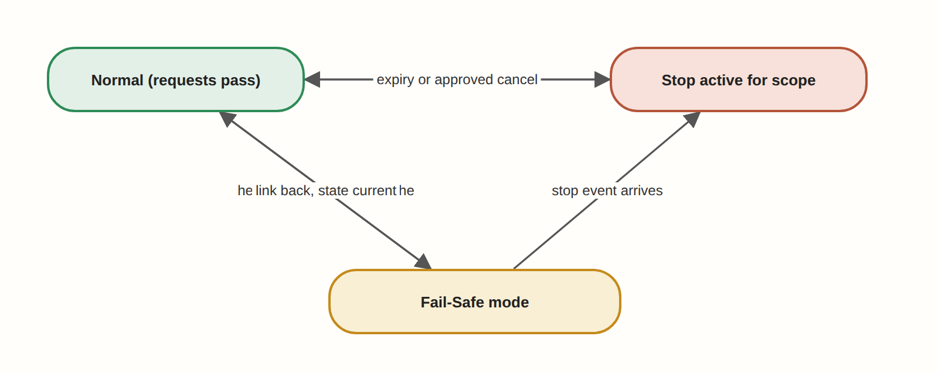
States and transitions
4. Sequence diagram
Who calls whom and in what order, top to bottom. A plain arrow is a call, a dashed arrow is a reply, and a red arrow is a blocking result.
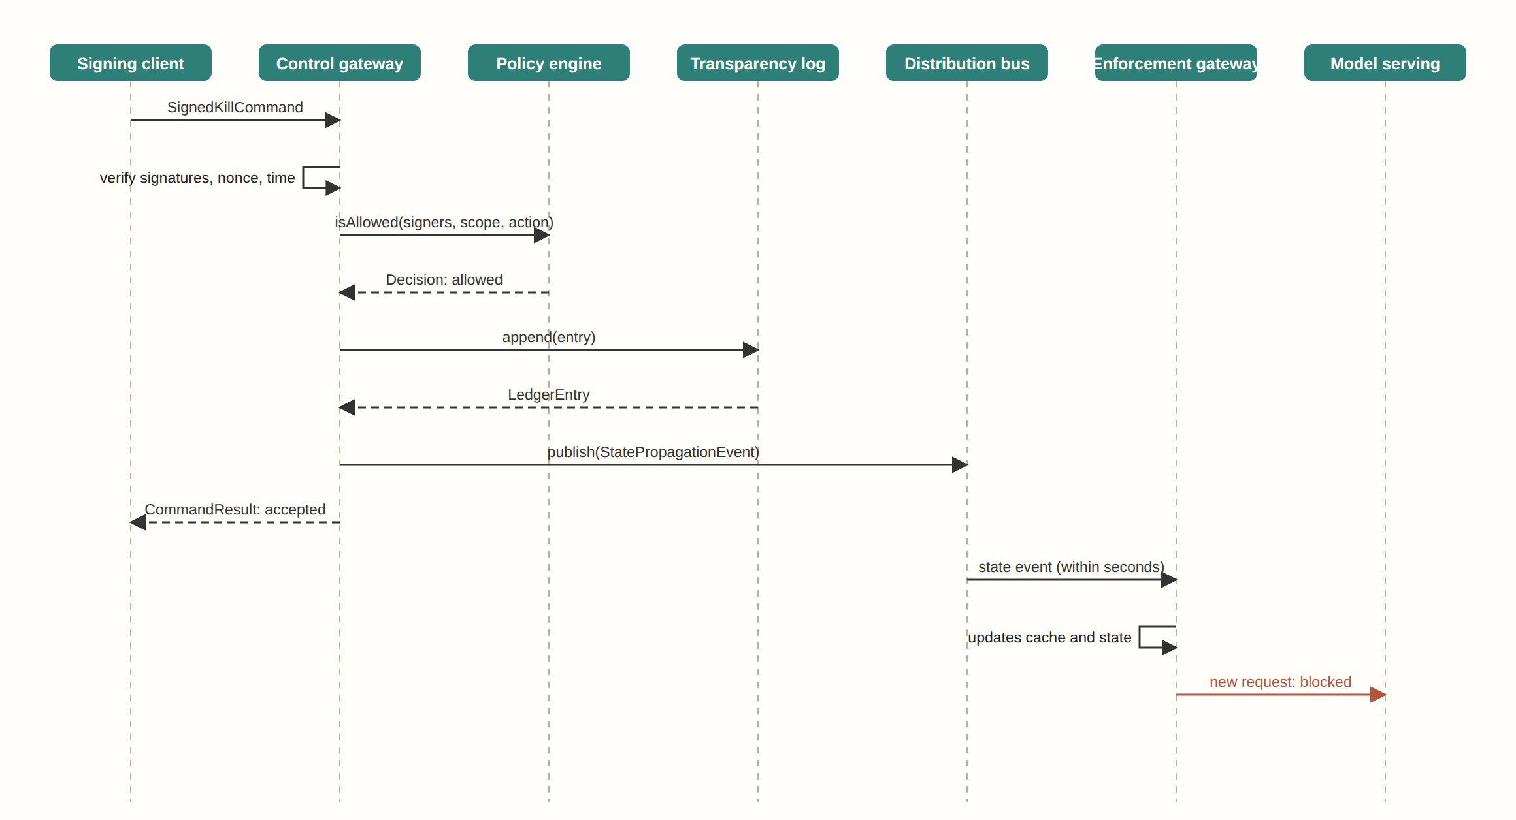
The normal flow end to end
5. Threading model
A thread is a "worker" running in parallel with others. When several threads touch the same state a lock is required, otherwise two may change it at once and leave it broken.
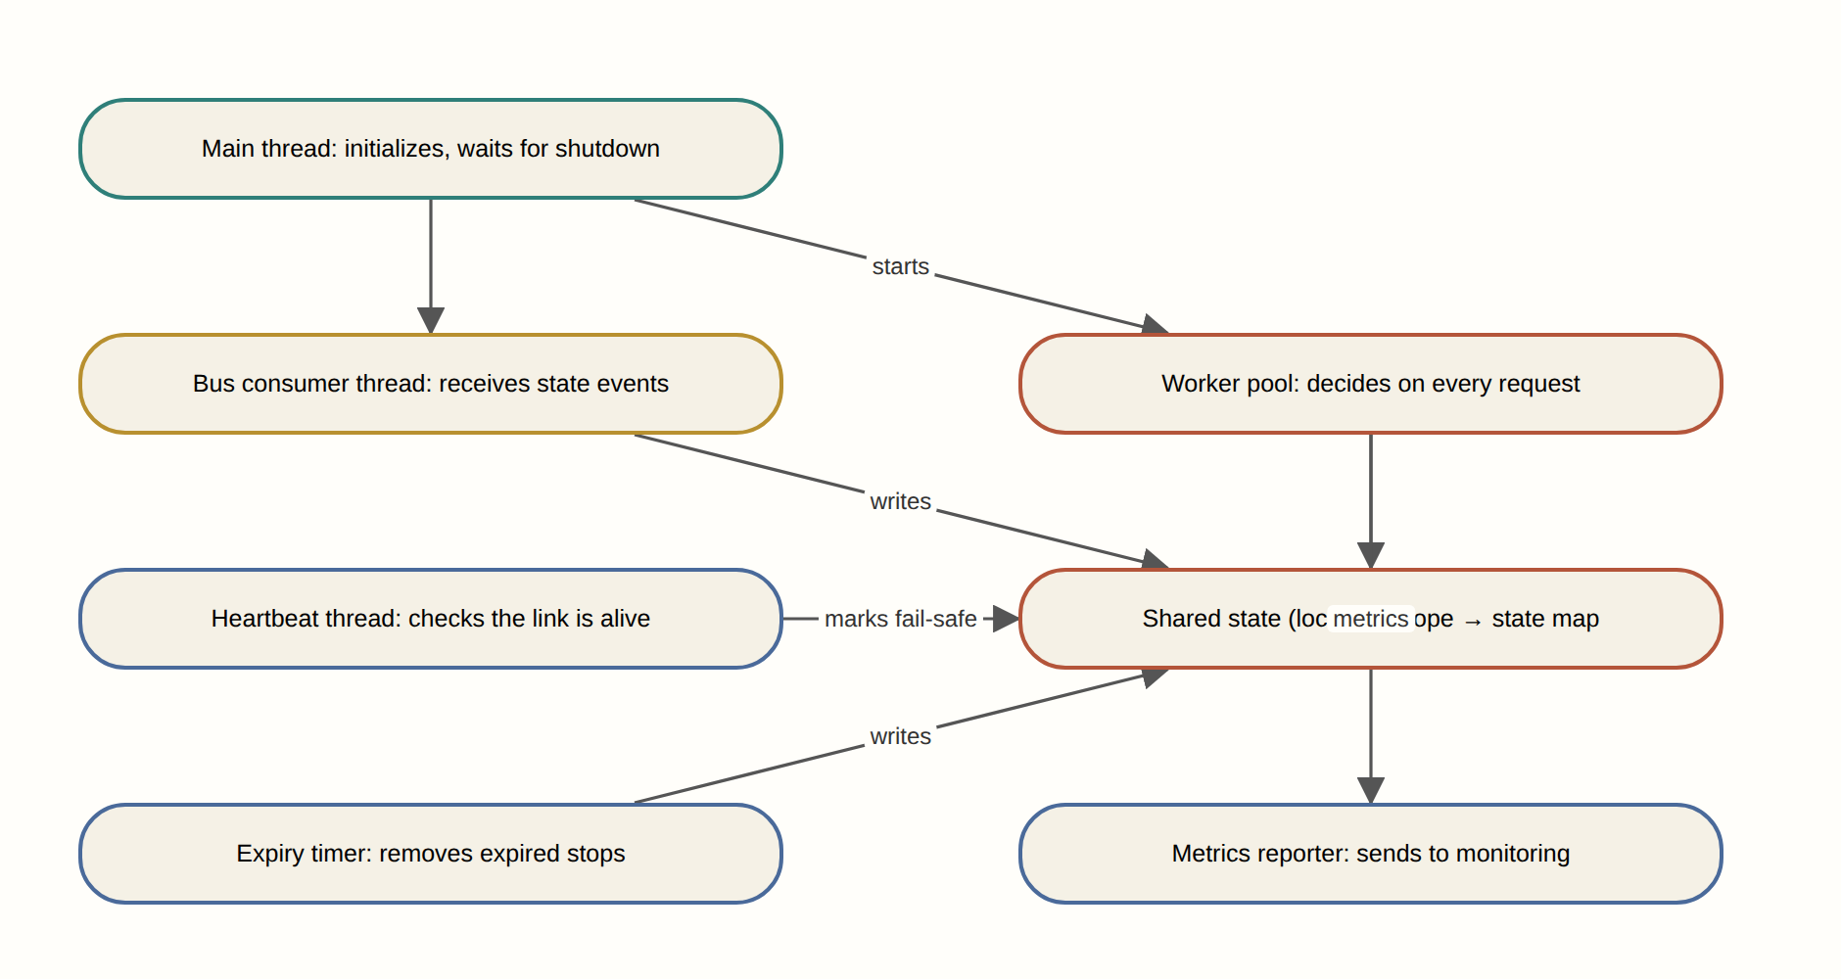
Threads and what they share
6. Table design
What is stored long-term and how the tables are linked. PK is a primary key that identifies a row; FK is a reference to a row in another table.
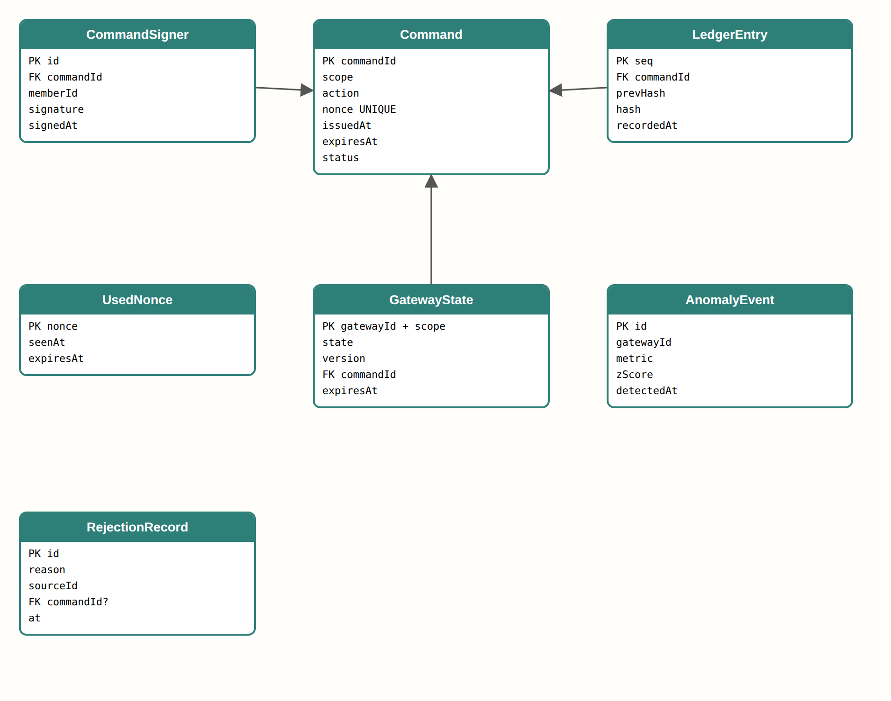
Tables and foreign keys
7. Implementation order by version
- V1.0.0 Skeleton: SigningClient, SignedKillCommand, ControlGateway and a simple enforcement gateway. One signed command stops one model.
- V2.0.0 Verification: CommandValidator, NonceStore, IPolicyEngine and a 3-of-5 signature threshold.
- V3.0.0 Transparency and distribution: IAppendOnlyLog, IStateBus and multiple regions.
- V4.0.0 Resilience: StateCache, HeartbeatMonitor, fail-safe mode and automatic expiry.
- V5.0.0 Observation: SelfMonitor, AuditSink and a central security log.

