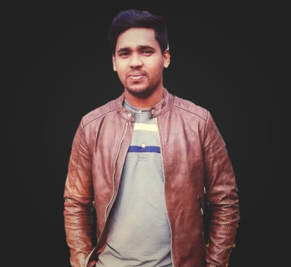**Abdur Rakib Rony**

**Software Developer**

Excellent problem solving skills with 2+ years of experience leading both frontend and backend development, and deployed multiple applications also ability to perform well in a team.

**WORK EXPERIENCE**

**NODE DEVELOPER**

Markosis Pvt. Ltd.

*11/2021 – current*

* Working as a Node JS developer.
* Built payment gateway (Paypal, Stripe), push notification, E-commerce applications.

**REACT DEVELOPER**

Eazm Limited

*08/2020 – 07/2021*

* Worked with frontend technology and build an end to end solution for multiple projects.
* Built high impact websites like Priority Accountancy, Himalayan Dine-Barrhead.

**WEB DEVELOPER**

PayBuddy Limited

02/2020 – 07/2020

* Working on front-end widgets.
* Shadowing senior developers on large projects.
* Working in an Agile Development cycle.

**EDUCATION**

B.Sc. in Computer Science & Engineering

Bangladesh Army University of Engineering & Technology

02/2017 - 04/2021

**REFERENCE**

Mohammed Golam Sarwar Bhuyan

Associate Professor & Head

Department of CSE

[csesarwar@gmail.com](mailto:csesarwar@gmail.com)

**CONTACT**

[rakib.fstackdev@gmail.com](mailto:rakib.fstackdev@gmail.com)

+880 1997513691

Chuadanga, Bangladesh

<https://fr3portfolio.netlify.app/>

[github.com/ronyfr3](https://github.com/ronyfr3)

**SKILLS**

**Front End**

HTML/CSS, Sass, TailwindCSS, JavaScript, React JS, Next JS, Redux, Responsive/Mobile Design, Cross-Browser Development, Testing/Debugging.

**Back End**

Node JS, Express JS, REST API

**Database**

MySQL, MongoDB

**IDE / Tools**

GitHub, VS Code, Git, Postman, ESLint, Google APIs, codepen, Figma.

**PROJECTS**

**MERN-STACK APPLICATIONS**

[Ecommerce Application](https://fr3shop.netlify.app/)

[Music Application](https://fr3music.netlify.app/)

[Sports Application](https://fr3sports.netlify.app/)

**REACTJS APPLICATION**

[Newspaper Application](https://fr3-newspaper.netlify.app/)

[Weather Application](https://ronyfr3.github.io/Weather-Application-in-React-Js/)

[Google search](https://fr3google.netlify.app)

[E-valy Clone](https://e-valy-clone.netlify.app/)

**NEXTJS APPLICATION**

[Covid19 Application](https://covid19-track-application.netlify.app/)

**BLOGS**

[Push notification](https://dev.to/ronyfr3/web-push-notification-using-react-and-node-js-oc9)

[File Upload](https://dev.to/ronyfr3/react-nodejs-multiple-image-upload-using-multer-hh4)