**1. Design a java script code to perform following operations. Get an input from the user for current hour.**

**i. If the time is between 7 a.m and 9 a.m., throw a message, “Good morning Its time to start to college”**

**ii. If the time is between 10 a.m. and 11 a.m., throw a message, “Good morning Its time time for tea”**

**iii. If the hour is between 12pm and 2 p.m., throw a message, “Good afternoon Its time time for lunch”**

**CODE:**

HTML:

<!DOCTYPE html>

<html>

    <head>

        <script src="question1.js"></script>

    </head>

</html>

JavaScript:

var t=prompt('What is the current hour?')

if(t>=7 && t<=9)

    alert('Good morning Its time to start to college')

else if(t>=10 && t<=11)

    alert( 'Good morning Its time time for tea')

else if(t>=12 && t<=14)

    alert('Good afternoon Its time time for lunch')

SCREEN SHOT:

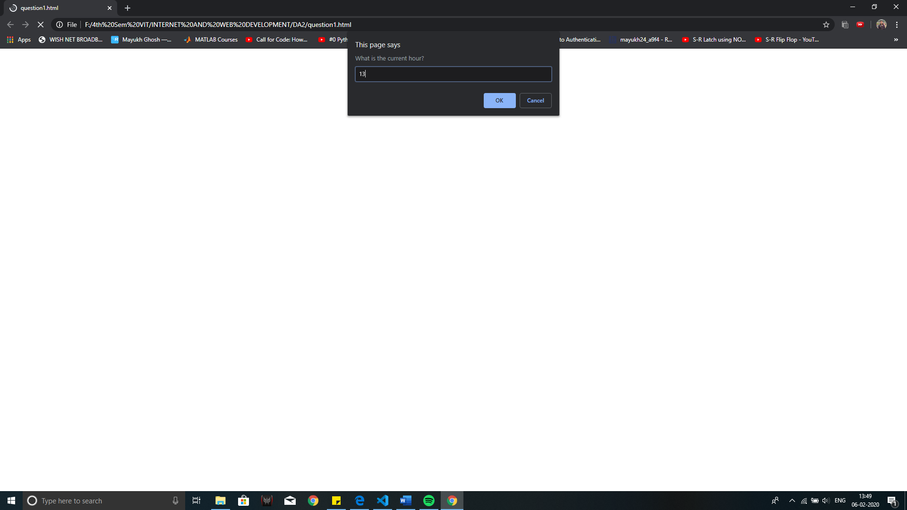

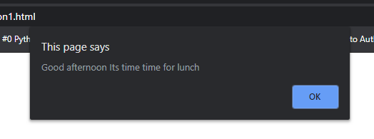

**2. Write the output for the below javascript array functions. Consider the array var event=[day,months,year]. Where day is a string array with values like Monday, Tuesday upto Sunday etc, months is a string array like January, febuaruary upto december etc.,and year is a numeric array with years 2001 to 2010.**

**i. Give the output for var event=[day,months,year]; event.splice(1, 1, "A","B","C");**

**ii. Give the output for var events=[day,months,year]; var e=events.slice(1);**

**CODE:**

HTML:

<!DOCTYPE html>

<html>

    <head>

    </head>

    <body>

        <script src="question2.js"></script>

    </body>

</html>

JavaScript:

day=prompt("Enter a day like - Monday, Tuesday upto Sunday ")

months=prompt("Enter a month like -  January, febuaruary upto december ")

year=prompt("Enter a year like - 2001 to 2010 ")

var event=[day,months,year]

var e=event.slice(1)

alert("var e=event.slice(1); e="+e)

alert('event.splice(1, 1, "A","B","C") gives '+event.splice(1, 1, "A","B","C"))

alert('and event becomes'+event)

SCREEN SHOT:

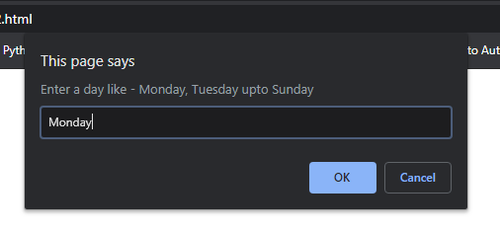

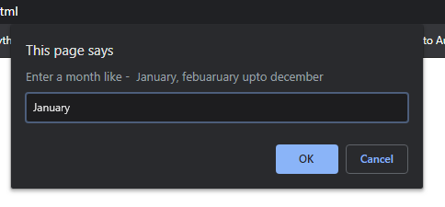

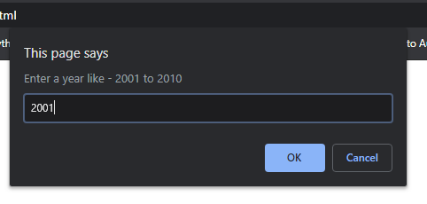

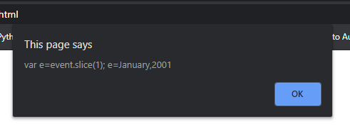

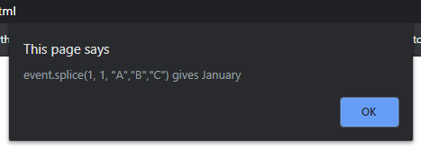

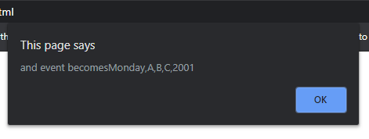

**3. Design an examination portal page with necessary form elements as mentioned below for police selection process. The test process should be finished in 10 minutes displaying the countdown timer. Submit button should be hidden after 10 minutes.**

**a. Form should have 5 multiple choice questions with 4 answers per choice.**

**b. A text area control to enter “about” him.**

**c. A file upload option to upload his photo**

**d. On submission it should consolidate the answers and display for his confirmation.**

**Tool tip text should be displayed on all the controls. Use necessary HTML elements and java script**

**CODE:**

HTML:

<!DOCTYPE html>

<html>

    <head>

        <title>Examination Portal</title>

    </head>

    <body>

        <h1 align="center">POLICE SELECTION PROCESS</h1><hr><hr>

        <div id="timer" align="center"></div>

        <script src="question3.js"></script>

        <h3>ABOUT YOU:</h3>

        <textarea cols="100" rows="10"></textarea>

        <input type="file" id="pic">

    <ol>

    <li>

        <span id="question1">    </span>

        <div>

        <p>........... is the first woman to head a public sector bank.</p>

        <span id="1.0"><input type="radio" name="question1" value="A">A. Arundhati Bhattacharya</span><br>

        <span id="1.1"><input type="radio" name="question1" value="B">B. Shikha Sharma</span><br>

        <span id="1.2"><input type="radio" name="question1" value="C">C. Chanda Kochar</span><br>

        <span id="1.3"><input type="radio" name="question1" value="D">D. Usha Ananthasubramanyan</span><br>

    </div>

</li>

<li>

</div><span id="question2">    </span>

<div>

        <p>Where is Bose Institute ?</p>

        <span id="2.0"><input type="radio" name="question2" value="A">A. Dispur</span><br>

        <span id="2.1"><input type="radio" name="question2" value="B">B. Kolkata</span><br>

        <span id="2.2"><input type="radio" name="question2" value="C">C. Mumbai</span><br>

        <span id="2.3"><input type="radio" name="question2" value="D">D. New Delhi</span><br>

    </div>

</li>

<li>

<div>

<span id="question3">    </span>

    <p>When is the International Yoga Day celebrated ?</p>

        <span id="3.0"><input type="radio" name="question3" value="A">A. March 21</span><br>

        <span id="3.1"><input type="radio" name="question3" value="B">B. April 22</span><br>

        <span id="3.2"><input type="radio" name="question3" value="C">C. June 21</span><br>

        <span id="3.3"><input type="radio" name="question3" value="D">D. May 31</span><br>

    </div>

</li>

<li>

<div>

<span id="question4">    </span>

    <p>The two-day festival 'North East Calling', is organized by which ministry ?</p>

        <span id="4.0"><input type="radio" name="question4" value="A">A. Ministry of External Affairs</span><br>

        <span id="4.1"><input type="radio" name="question4" value="B">B. Ministry of Home Affairs</span><br>

        <span id="4.2"><input type="radio" name="question4" value="C">C. Ministry of Defence</span><br>

        <span id="4.3"><input type="radio" name="question4" value="D">D. Ministry of Development of North Eastern Region (DoNER)</span><br>

    </div>

</li>

<li>

<div>

<span id="question5">    </span>

    <p>When Government of India confers the "Highest Civilian Honor for Women" by presenting "Nari Shakti Puraskars" ?</p>

        <span id="5.0"><input type="radio" name="question5" value="A">A. 8th March </span><br>

        <span id="5.1"><input type="radio" name="question5" value="B">B. June 5</span><br>

        <span id="5.2"><input type="radio" name="question5" value="C">C. April 7</span><br>

        <span id="5.3"><input type="radio" name="question5" value="D">D. June 21</span><br>

    </div>

</li>

    </ol>

    <div id="marks"></div>

    <br><br>

    <button onclick="confirmation()" id="my_submit">SUBMIT</button>

</body>

</html>

JavaScript:

function confirmation()

{

    var x=confirm("Are you sure you want to SUBMIT")

    if(x==true)

        correction()

}

function correction(){

    marks=0;

    //question1

    ele=document.getElementsByName("question1")

    for(i = 0; i < ele.length; i++)

    {

        if(ele[i].checked)

        {

            if(ele[i].value=="A")

                {

                    marks+=1

                    document.getElementById("1.0").innerHTML+='<img src="tick.jpg" height="15px" width="15px"></img>'

                    document.getElementById("question1").innerHTML='<img src="tick.jpg" height="25px" width="25px"></img>'

                }

            else

            {

                document.getElementById("1.0").innerHTML+='<img src="tick.jpg" height="15px" width="15px"></img>'

                document.getElementById("1."+i).innerHTML+='<img src="cross.jpg" height="15px" width="15px" ></img>'

                document.getElementById("question1").innerHTML='<img src="cross.jpg" height="25px" width="25px"></img>'

            }

        }

    }

    //question2

    ele=document.getElementsByName("question2")

    for(i = 0; i < ele.length; i++)

    {

        if(ele[i].checked)

        {

            if(ele[i].value=="B")

                {

                    marks+=1

                    document.getElementById("2.1").innerHTML+='<img src="tick.jpg" height="15px" width="15px"></img>'

                    document.getElementById("question2").innerHTML='<img src="tick.jpg" height="25px" width="25px"></img>'

                }

            else

            {

                document.getElementById("2.1").innerHTML+='<img src="tick.jpg" height="15px" width="15px"></img>'

                document.getElementById("2."+i).innerHTML+='<img src="cross.jpg" height="15px" width="15px" ></img>'

                document.getElementById("question2").innerHTML='<img src="cross.jpg" height="25px" width="25px"></img>'

            }

        }

    }

    //question3

    ele=document.getElementsByName("question3")

    for(i = 0; i < ele.length; i++)

    {

        if(ele[i].checked)

        {

            if(ele[i].value=="C")

                {

                    marks+=1

                    document.getElementById("3.2").innerHTML+='<img src="tick.jpg" height="15px" width="15px"></img>'

                    document.getElementById("question3").innerHTML='<img src="tick.jpg" height="25px" width="25px"></img>'

                }

            else

            {

                document.getElementById("3.2").innerHTML+='<img src="tick.jpg" height="15px" width="15px"></img>'

                document.getElementById("3."+i).innerHTML+='<img src="cross.jpg" height="15px" width="15px" ></img>'

                document.getElementById("question3").innerHTML='<img src="cross.jpg" height="25px" width="25px"></img>'

            }

        }

    }

    //question4

    ele=document.getElementsByName("question4")

    for(i = 0; i < ele.length; i++)

    {

        if(ele[i].checked)

        {

            if(ele[i].value=="D")

                {

                    marks+=1

                    document.getElementById("4.3").innerHTML+='<img src="tick.jpg" height="15px" width="15px"></img>'

                    document.getElementById("question4").innerHTML='<img src="tick.jpg" height="25px" width="25px"></img>'

                }

            else

            {

                document.getElementById("4.3").innerHTML+='<img src="tick.jpg" height="15px" width="15px"></img>'

                document.getElementById("4."+i).innerHTML+='<img src="cross.jpg" height="15px" width="15px" ></img>'

                document.getElementById("question4").innerHTML='<img src="cross.jpg" height="25px" width="25px"></img>'

            }

        }

    }

    //question5

    ele=document.getElementsByName("question5")

    for(i = 0; i < ele.length; i++)

    {

        if(ele[i].checked)

        {

            if(ele[i].value=="A")

                {

                    marks+=1

                    document.getElementById("5.0").innerHTML+='<img src="tick.jpg" height="15px" width="15px"></img>'

                    document.getElementById("question5").innerHTML='<img src="tick.jpg" height="25px" width="25px"></img>'

                }

            else

            {

                document.getElementById("5.0").innerHTML+='<img src="tick.jpg" height="15px" width="15px"></img>'

                document.getElementById("1."+i).innerHTML+='<img src="cross.jpg" height="15px" width="15px" ></img>'

                document.getElementById("question5").innerHTML='<img src="cross.jpg" height="25px" width="25px"></img>'

            }

        }

    }

    document.getElementById("marks").innerHTML = "<strong>MARKS SCORED : "+marks+"</strong>"

    clearInterval(timer)

    document.getElementById("my_submit").style.display='none'

}

t=600

var timer = setInterval(function () {

t-=1

m=Math.floor(t/60)

s=t%60

document.getElementById("timer").innerHTML="<table border='2'><tr><th colspan='2'>TIMER</th></tr><tr><td>"+m+"</td><td>"+s+"</td></tr></table>"

if(t <= 0){

    clearInterval(timer)

    document.getElementById("my_submit").style.display='none'

    correction()

}

},1000)

SCREEN SHOT:

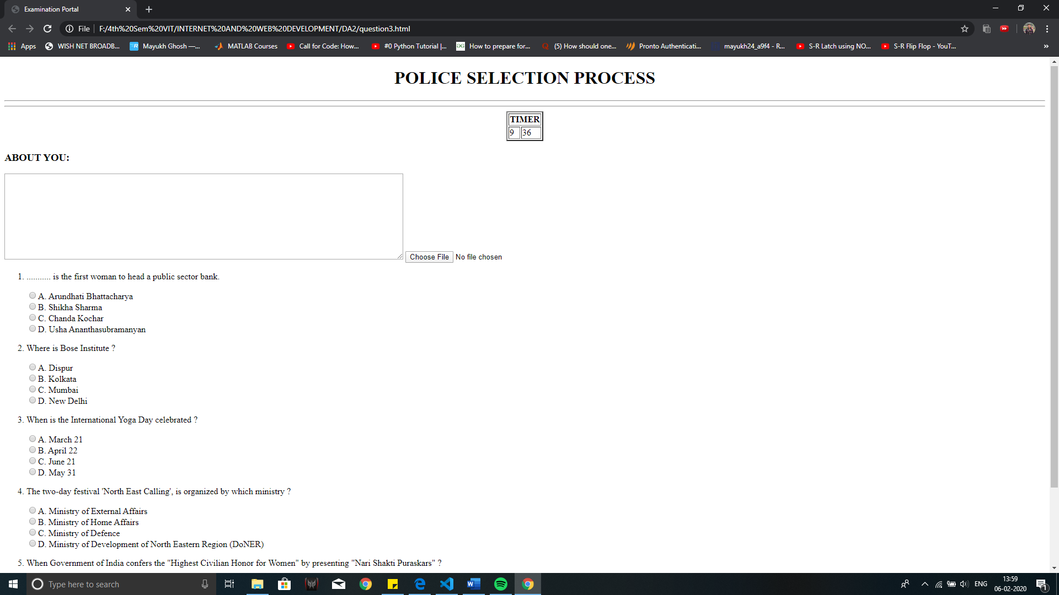

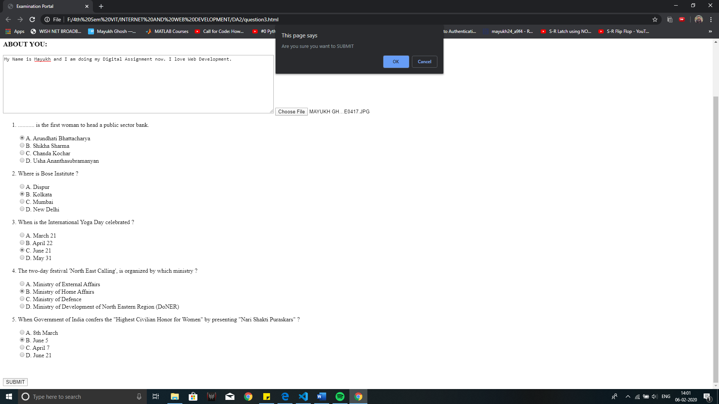

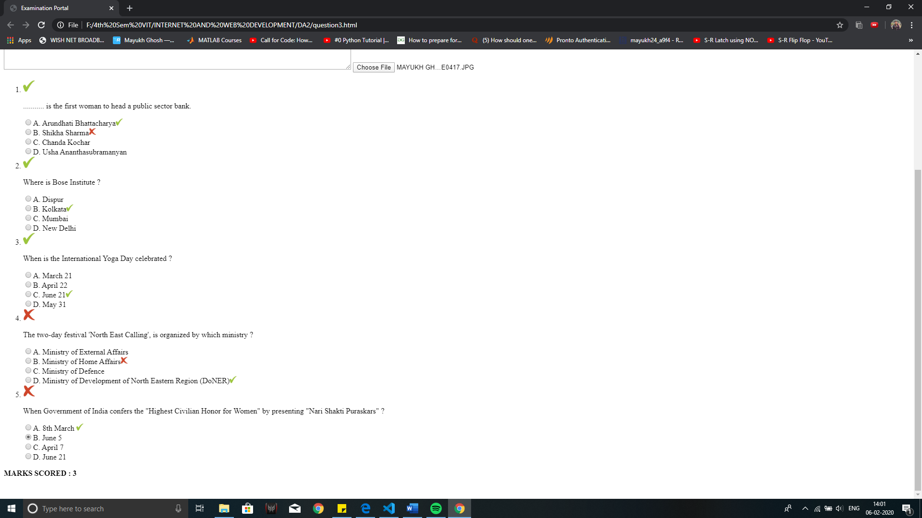

**4. Consider online order processing system which consists of a two Multiple choice lists and one single choice list**

**• The first multiple choice list, displays the Major dishes available.**

**• The second multiple choice list, displays the Starters available.**

**• The single choice list, displays the Soft drinks available.**

**• The selected items from all the lists should be captured and displayed in a Text Area along with their respective costs. Use JavaScript Event handler to calculate the total cost of all the selected items and display the total cost at end of the Text Area. A ‘Clear’ button is provided to clear the Text Area.**

**CODE:**

HTML:

<!DOCTYPE html>

<html>

    <head>

    </head>

    <body>

        <script src="question4.js"></script>

        <h1>BENGALI  DISHES</h1>

        <hr><hr>

        <table>

            <tr>

                <th colspan="2">MAJOR DISHES</th>

            </tr>

            <tr>

                <td>

                    <input type="checkbox" id="Aloo Potol Posto" value="150" >Aloo Potol Posto

                </td>

                <td>

                    -    Rs 150

                </td>

            </tr>

            <tr>

                <td>

                    <input type="checkbox" id="Ilish Macher Jhol" value="390" >Ilish Macher Jhol

                </td>

                <td>

                    -    Rs 390

                </td>

            </tr>

            <tr>

                <td>

                    <input type="checkbox" id="Shukto" value="150" >Shukto

                </td>

                <td>

                    -    Rs 150

                </td>

            </tr>

            <tr>

                <td>

                    <input type="checkbox" id="Mutton Biryani" value="240" >Mutton Biryani

                </td>

                <td>

                    -    Rs 240

                </td>

            </tr>

            <tr>

                <td>

                    <input type="checkbox" id="Tangra Macher Jhol" value="290" >Tangra Macher Jhol

                </td>

                <td>

                    -    Rs 290

                </td>

            </tr>

            <tr>

                <td>

                    <input type="checkbox" id="Kosha Mangsho" value="250" >Kosha Mangsho

                </td>

                <td>

                    -    Rs 250

                </td>

            </tr>

        </table><br><br>

        <table>

            <tr>

                <th colspan="2">STARTERS</th>

            </tr>

            <tr>

                <td>

                    <input type="checkbox" id="Kakori Kebabs" value="150" >Kakori Kebabs

                </td>

                <td>

                    -    Rs 150

                </td>

            </tr>

            <tr>

                <td>

                    <input type="checkbox" id="Stir Fried Chilli Chicken" value="200" >Stir Fried Chilli Chicken

                </td>

                <td>

                    -    Rs 200

                </td>

            </tr>

            <tr>

                <td>

                    <input type="checkbox" id="Aloo and Dal ki Tikki" value="125" >Aloo and Dal ki Tikki

                </td>

                <td>

                    -    Rs 125

                </td>

            </tr>

            <tr>

                <td>

                    <input type="checkbox" id="Cheese Balls" value="150" >Cheese Balls

                </td>

                <td>

                    -    Rs 150

                </td>

            </tr>

            <tr>

                <td>

                    <input type="checkbox" id="Chicken Satay" value="190" >Chicken Satay

                </td>

                <td>

                    -    Rs 190

                </td>

            </tr>

        </table><br><br>

        <table>

            <tr>

                <th colspan="2">SOFT DRINKS</th>

            </tr>

            <tr>

                <td>

                    <input type="radio"  name="soft" id="Margarita"  value="250" >Margarita

                </td>

                <td>

                    -    Rs 250

                </td>

            </tr>

            <tr>

                <td>

                    <input type="radio" name="soft" id="Cosmopolitan" value="240" >Cosmopolitan

                </td>

                <td>

                    -    Rs 240

                </td>

            </tr>

            <tr>

                <td>

                    <input type="radio" name="soft" id="Negroni" value="270" >Negroni

                </td>

                <td>

                    -    Rs 270

                </td>

            </tr>

            <tr>

                <td>

                    <input type="radio" name="soft" id="Mojito" value="260" >Mojito

                </td>

                <td>

                    -    Rs 260

                </td>

            </tr>

        </table><br><br>

        <button onclick="restore();check()"><strong>Bill</strong></button>   <button onclick="restore()"><strong>Clear</strong></button>

        <div id="bill"></div>

    </body>

</html>

JavaScript:

function check() {

    cost=0

    var arr

    var price

    document.getElementById("bill").innerHTML += "<strong><u><br><hr>YOUR BILL IS</u> </strong>"

    //Major Dishes

    if(document.getElementById("Aloo Potol Posto").checked==true)

    {

        cost+=parseInt(document.getElementById("Aloo Potol Posto").value)

        item="<li>" + "Aloo Potol Posto  -  Rs 150" + "</li>"+"<br>"

        document.getElementById("bill").innerHTML += item

    }

    if(document.getElementById("Ilish Macher Jhol").checked==true)

    {

        cost+=parseInt(document.getElementById("Ilish Macher Jhol").value)

        item="<li>" + "Ilish Macher Jhol  -  Rs 390" + "</li>"+"<br>"

        document.getElementById("bill").innerHTML += item

    }

    if(document.getElementById("Shukto").checked==true)

    {

        cost+=parseInt(document.getElementById("Shukto").value)

        item="<li>" + "Shukto  -  Rs 150" + "</li>"+"<br>"

        document.getElementById("bill").innerHTML += item

    }

    if(document.getElementById("Mutton Biryani").checked==true)

    {

        cost+=parseInt(document.getElementById("Mutton Biryani").value)

        item="<li>" + "Mutton Biryani  -  Rs 240" + "</li>"+"<br>"

        document.getElementById("bill").innerHTML += item

    }

    if(document.getElementById("Tangra Macher Jhol").checked==true)

    {

        cost+=parseInt(document.getElementById("Tangra Macher Jhol").value)

        item="<li>" + "Tangra Macher Jhol  -  Rs 290" + "</li>"+"<br>"

        document.getElementById("bill").innerHTML += item

    }

    if(document.getElementById("Kosha Mangsho").checked==true)

    {

        cost+=parseInt(document.getElementById("Kosha Mangsho").value)

        item="<li>" + "Kosha Mangsho  -  Rs 250" + "</li>"+"<br>"

        document.getElementById("bill").innerHTML += item

    }

    //Starter

    if(document.getElementById("Kakori Kebabs").checked==true)

    {

        cost+=parseInt(document.getElementById("Kakori Kebabs").value)

        item="<li>" + "Kakori Kebabs  -  Rs 150" + "</li>"+"<br>"

        document.getElementById("bill").innerHTML += item

    }

    if(document.getElementById("Stir Fried Chilli Chicken").checked==true)

    {

        cost+=parseInt(document.getElementById("Stir Fried Chilli Chicken").value)

        item="<li>" + "Stir Fried Chilli Chicken  -  Rs 200" + "</li>"+"<br>"

        document.getElementById("bill").innerHTML += item

    }

    if(document.getElementById("Aloo and Dal ki Tikki").checked==true)

    {

        cost+=parseInt(document.getElementById("Aloo and Dal ki Tikki").value)

        item="<li>" + "Aloo and Dal ki Tikki  -  Rs 125" + "</li>"+"<br>"

        document.getElementById("bill").innerHTML += item

    }

    if(document.getElementById("Cheese Balls").checked==true)

    {

        cost+=parseInt(document.getElementById("Cheese Balls").value)

        item="<li>" + "Cheese Balls  -  Rs 150" + "</li>"+"<br>"

        document.getElementById("bill").innerHTML += item

    }

    if(document.getElementById("Chicken Satay").checked==true)

    {

        cost+=parseInt(document.getElementById("Chicken Satay").value)

        item="<li>" + "Chicken Satay  -  Rs 190" + "</li>"+"<br>"

        document.getElementById("bill").innerHTML += item

    }

    //Soft Drinks

    if(document.getElementById("Margarita").checked==true)

    {

        cost+=parseInt(document.getElementById("Margarita").value)

        item="<li>" + "Margarita  -  Rs 250" + "</li>"+"<br>"

        document.getElementById("bill").innerHTML += item

    }

    if(document.getElementById("Cosmopolitan").checked==true)

    {

        cost+=parseInt(document.getElementById("Cosmopolitan").value)

        item="<li>" + "Cosmopolitan  -  Rs 240" + "</li>"+"<br>"

        document.getElementById("bill").innerHTML += item

    }

    if(document.getElementById("Negroni").checked==true)

    {

        cost+=parseInt(document.getElementById("Negroni").value)

        item="<li>" + "Negroni  -  Rs 270" + "</li>"+"<br>"

        document.getElementById("bill").innerHTML += item

    }

    if(document.getElementById("Mojito").checked==true)

    {

        cost+=parseInt(document.getElementById("Mojito").value)

        item="<li>" + "Mojito  -  Rs 260" + "</li>"+"<br>"

        document.getElementById("bill").innerHTML += item

    }

    document.getElementById("bill").innerHTML += "<strong>TOTAL : "+cost+"</strong>"

}

function restore(){

    document.getElementById("bill").innerHTML=""

}

SCREEN SHOT:

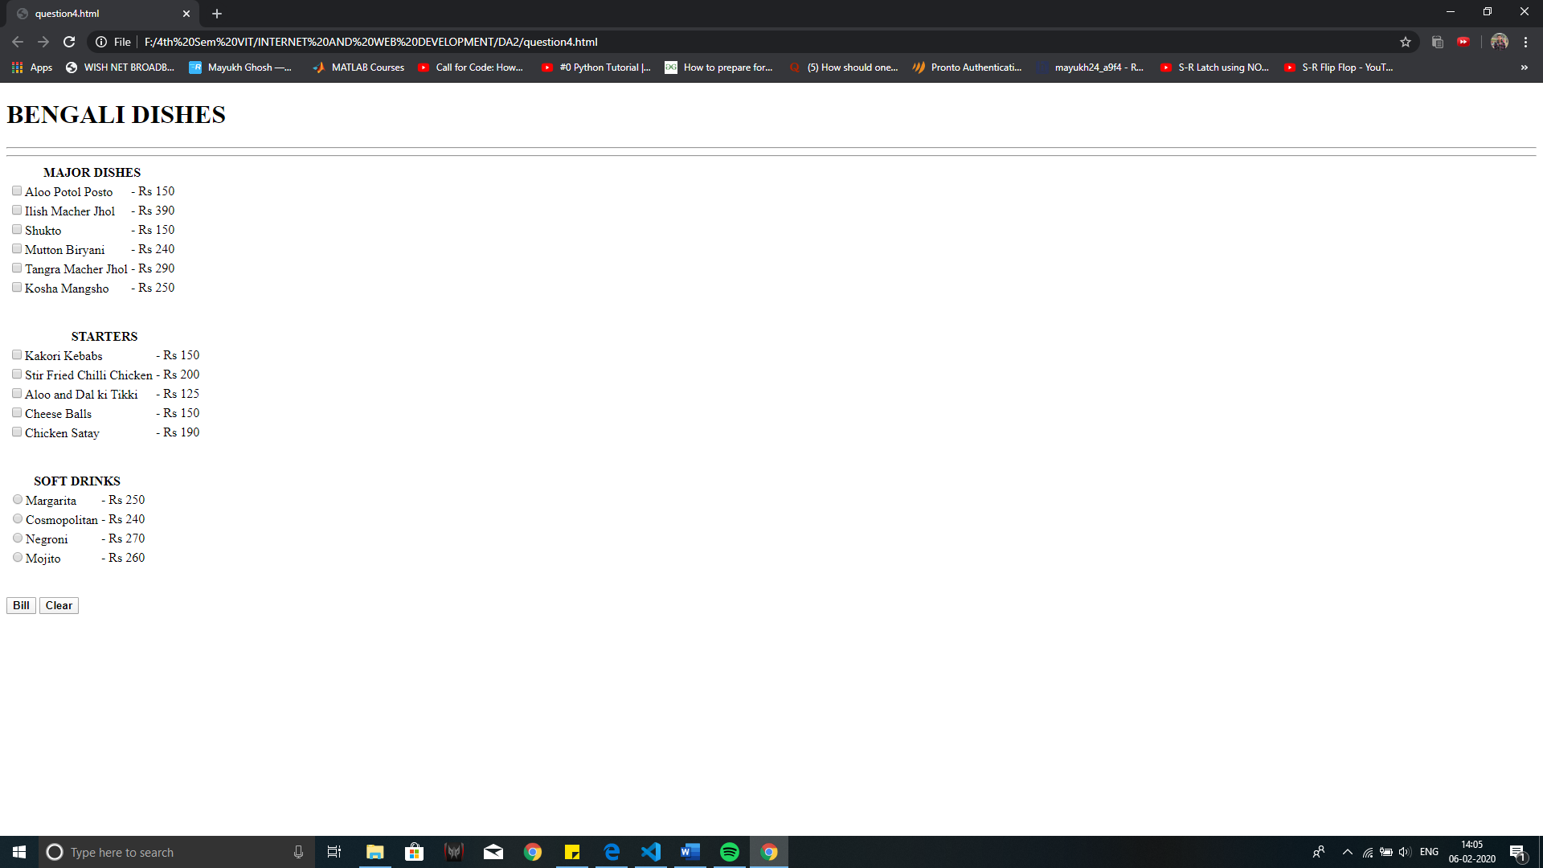

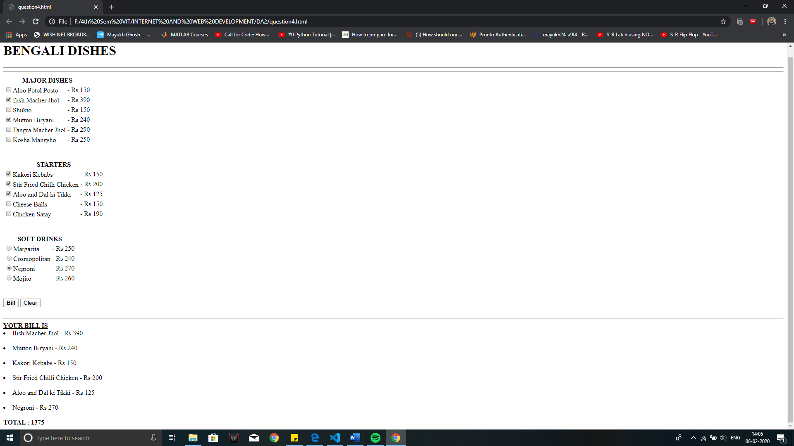

**5. Display a Simple clock. Pause the clock, whenever user moves their mouse pointer on the clock.**

**CODE:**

HTML

<!DOCTYPE html>

<html>

    <head>

        <link rel="stylesheet" href="question5.css">

    </head>

    <body >

        <div id="clock"></div>

        <script src="question5.js"></script>

    </body >

</html>

CSS

body { background:black; }

#clock {

  position: absolute;

  left: 50%;

  top: 50%;

  transform: translate(-50%, -10%);

  font-size: 50px;

  font-weight: bold;

  color: #fff;

  background: teal;

  padding: 2rem;

  border-radius: 5px 5px 5px 5px

}

JavaScript

let clock = document.getElementById('clock');

console.log(clock)

let timer = null;

clock.addEventListener("mouseover", function(){

    clearInterval(timer);

    timer = null;

  });

  clock.addEventListener("mouseout", function() {

    timer = setInterval(runClock, 1000);

  });

timer = setInterval(runClock, 1000);

function runClock(){

    clock.innerHTML = new Date().toLocaleTimeString();

}

SCREEN SHOT:

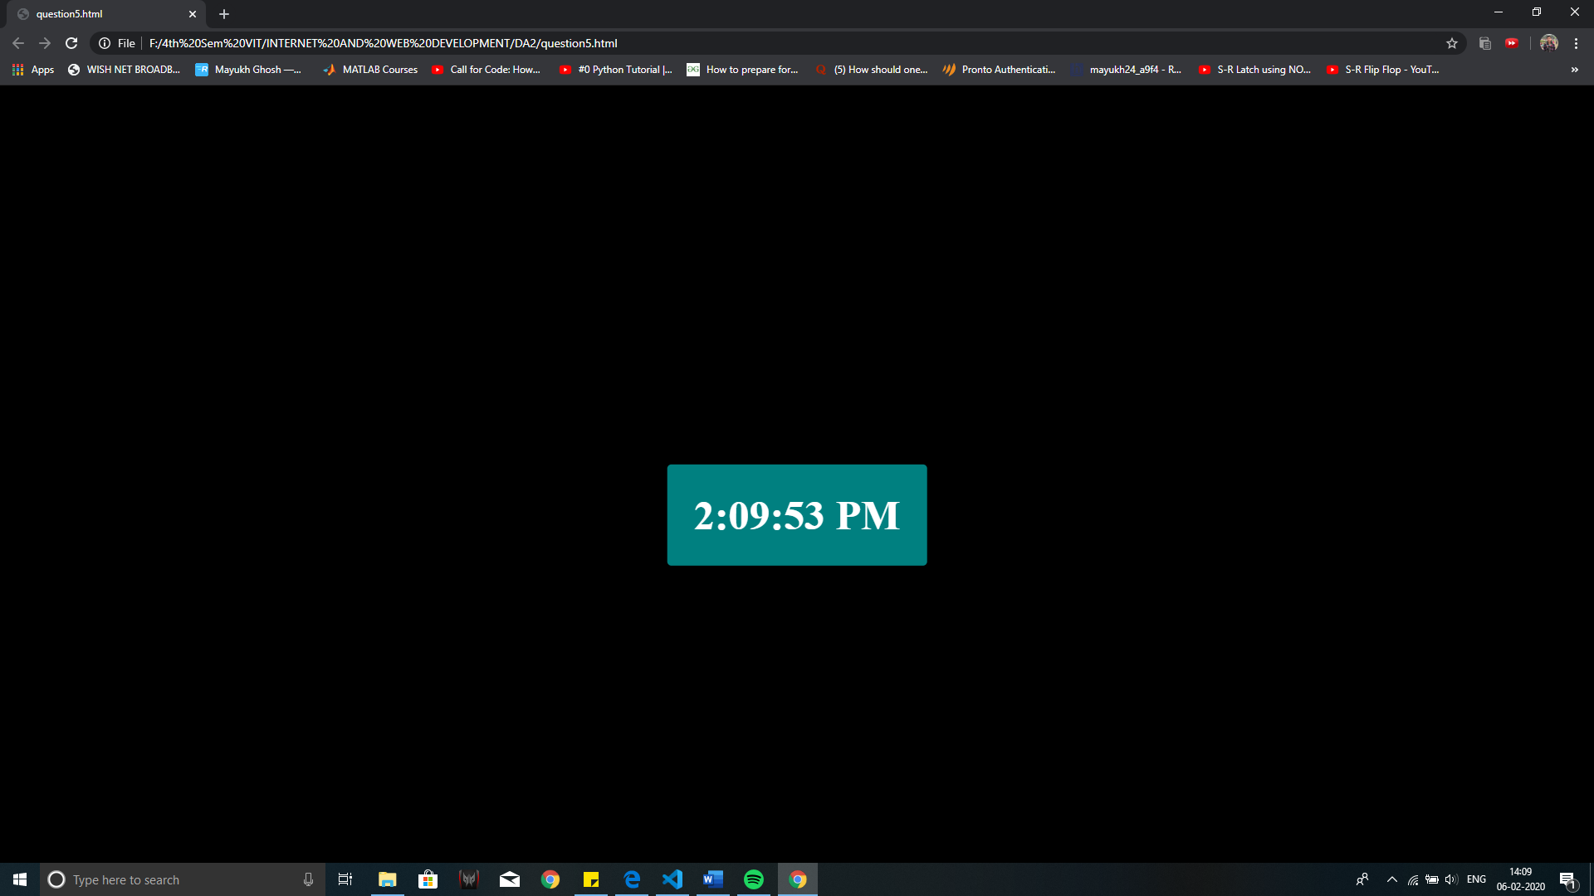

GitHub Link: