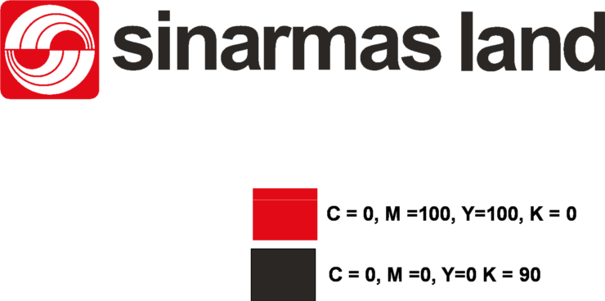

**NEGOTIATION FORM**

Work : [budgetplan]

Date : [negodate]

Place : [negoplace]

Attendance :

[participan]

[vendorwinner] is willing to do all the above work base on the quatation [fptid] number : ___________________ and according to all clauses in the tender process with all the requirement as follow :

√ Price include **Service, Over Head, PPh** (exclude 10 % tax)

Rp. [bidvalue]

√ Starting Date : [exequtionschedule]

√ Duration : [duration]

√ Maintenance Period : [maintenance]

√ Guarantee : [warranty]

√ Contract Type : [contracttype]

√ Payment Method : [paymenmethod]

√ Retention [Retention] % paid after maintenance period and after the obligation has been fulfill.

√ Notes :

____________________________________________________________________________________________________________

____________________________________________________________________________________________________________

____________________________________________________________________________________________________________

____________________________________________________________________________________________________________

PT. ___________________ _______________ PT.

Sinar Mas Land Plaza

Jl. Grand Boulevard, BSD Green Office Park, BSD City, Tangerang 15345 – Indonesia

Phone: (62-21) 50368368 Fax: (62-21) 50588255

**www.sinarmasland.com**