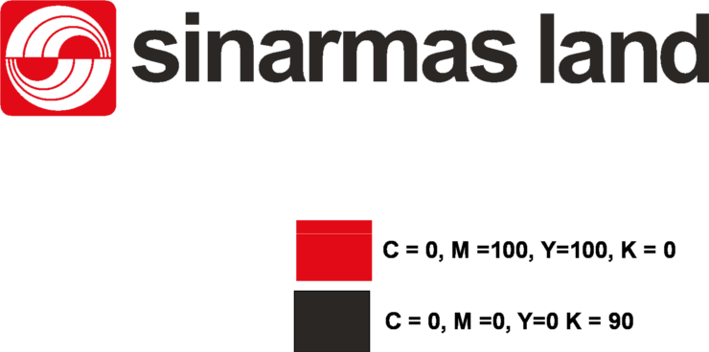

**BERITA ACARA**

**NEGOSIASI HARGA PENAWARAN**

Pekerjaan : [budgetplan]

Tanggal Negosiasi : [negodate]

Tempat Negosiasi : [negoplace]

Daftar Hadir :

[participan]

[vendorwinner] bersedia melaksanakan pekerjaan di atas sesuai dengan penawaran tanggal [negodate] no : ___________________ dan sesuai dengan persyaratan persyaratan yang ada dalam tender serta ketentuan ketentuan berikut ini:

√ Harga Pekerjaan Termasuk **Jasa, Over Head, PPh** (Belum Termasuk PPN 10%)

Rp. [bidvalue]

√ Jadwal Pelaksanaan : [exequtionschedule]

√ Durasi : [duration] bulan kalender

√ Masa Pemeliharaan : [maintenance] hari

√ Garansi : [warranty]

√ Sifat Kontrak : [contracttype]

√ Cara Pembayaran : [paymenmethod]

NOTE : SPM (Surat Pemberitahuan Masa) sebelumnya, **WAJIB** dilampirkan untuk pembayaran berikutnya.

√ Retensi [Retention] % dibayarkan setelah masa pemeliharaan dan Penerima Tugas telah menyelesaikan seluruh kewajibannya.

√ Catatan :

____________________________________________________________________________________________________________

____________________________________________________________________________________________________________

____________________________________________________________________________________________________________

____________________________________________________________________________________________________________

PT. _____________________________ PT. ­__________________________________________

Sinar Mas Land Plaza

Jl. Grand Boulevard, BSD Green Office Park, BSD City, Tangerang 15345 – Indonesia

Phone: (62-21) 50368368 Fax: (62-21) 50588255

**www.sinarmasland.com**