20MCA241-Data Science Lab C
- Below is a table of student’s scores out of 100 on their Maths and English tests. Plot a
scatter graph from this data.
- Provide appropriate label to co-ordinates and Title
- Display description of graph in upper right corner
- Use different shapes and colors for representing marks of each subject.
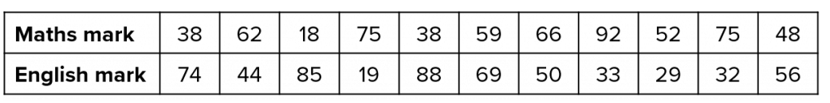
- Write a Python program that accepts a 10 digit mobile number, and find the digits which
are absent in a given mobile number

