#flashcards

**# Trivia**

**## Capitals**

**### Africa**

Kenya::Nairobi

**### North America**

Canada::Ottawa

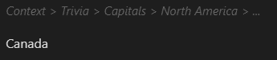

Obsidian Heading Level

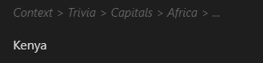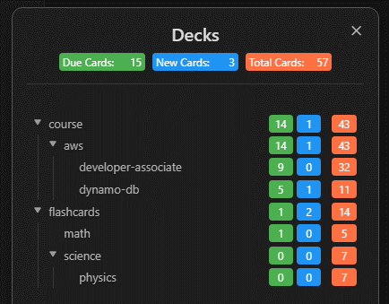

Review

Cram

