1. Upload titanic data in snowflake and do all the 5 questions from DBT

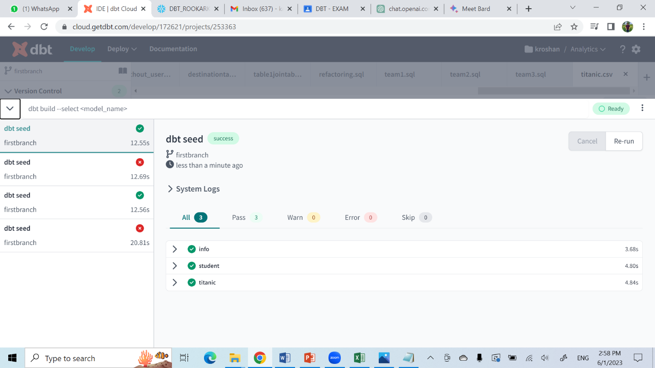

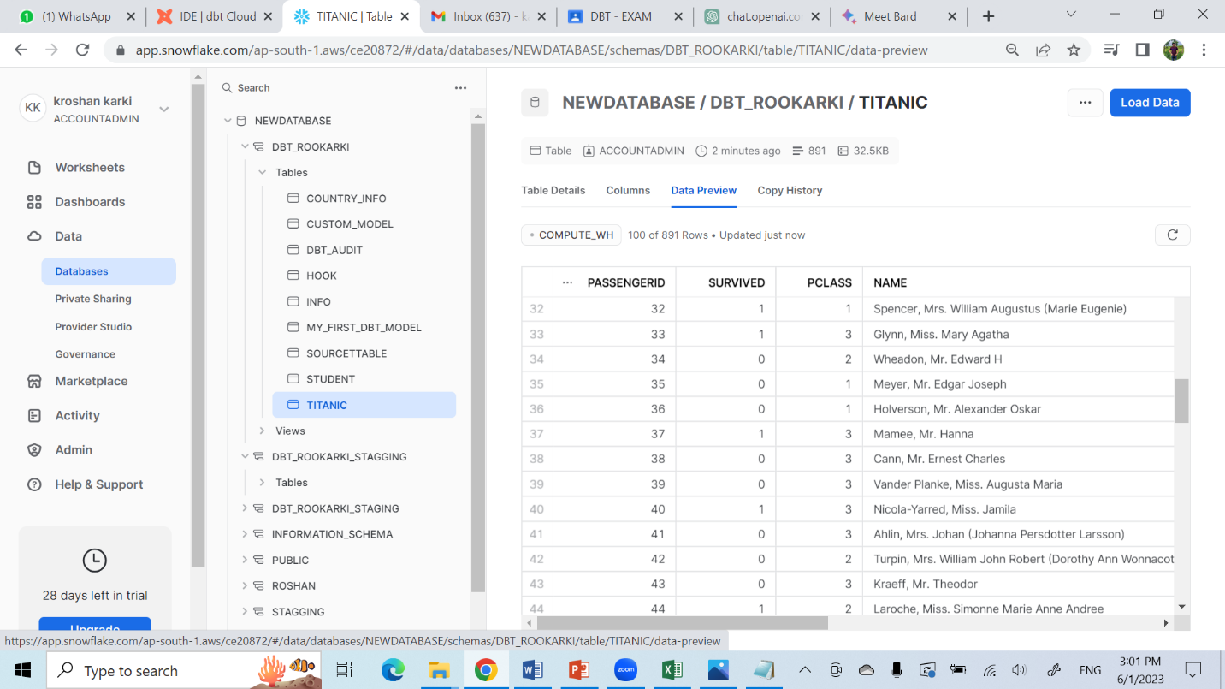

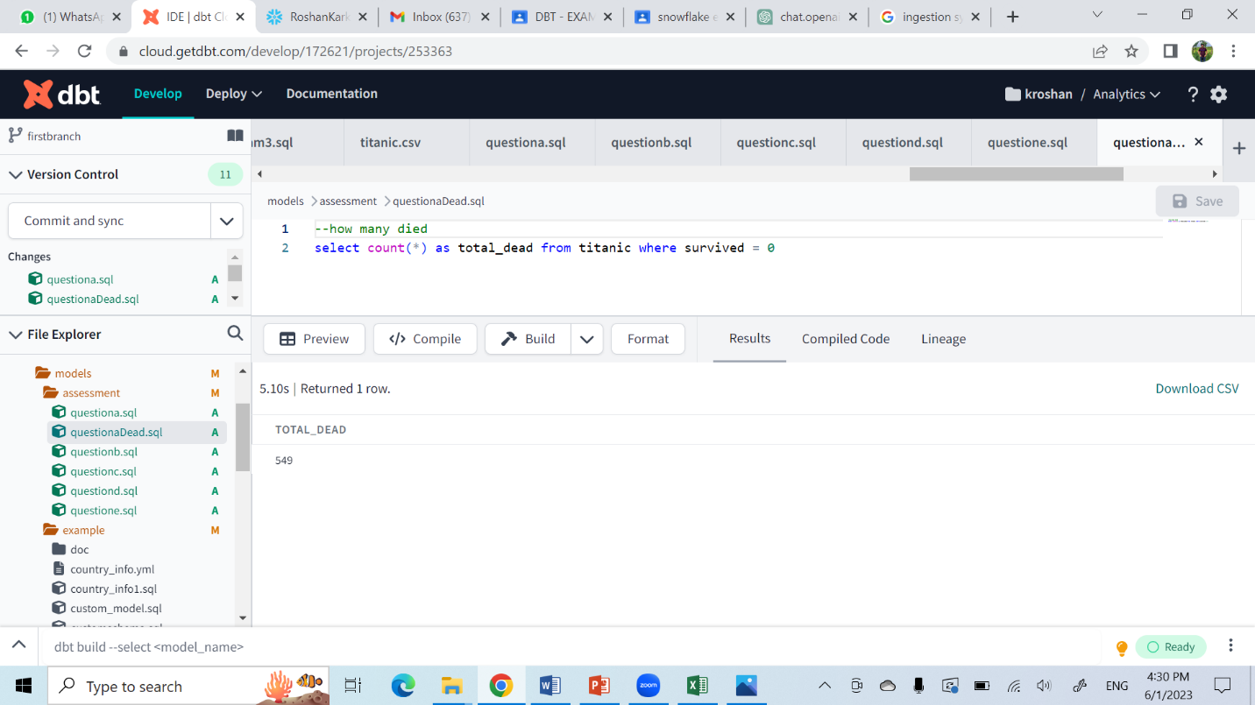

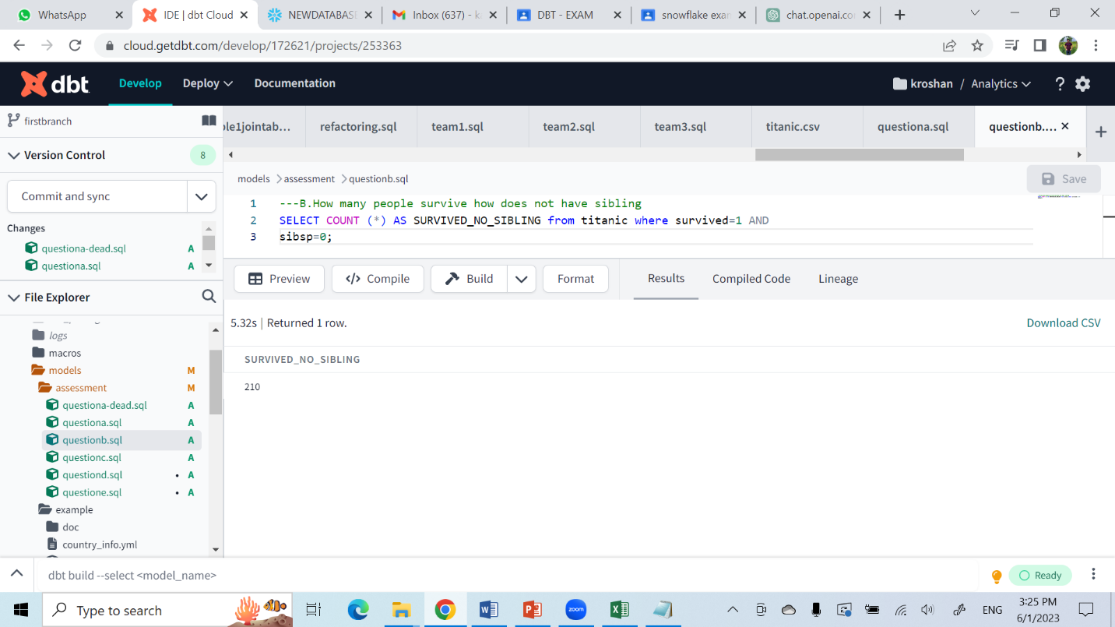

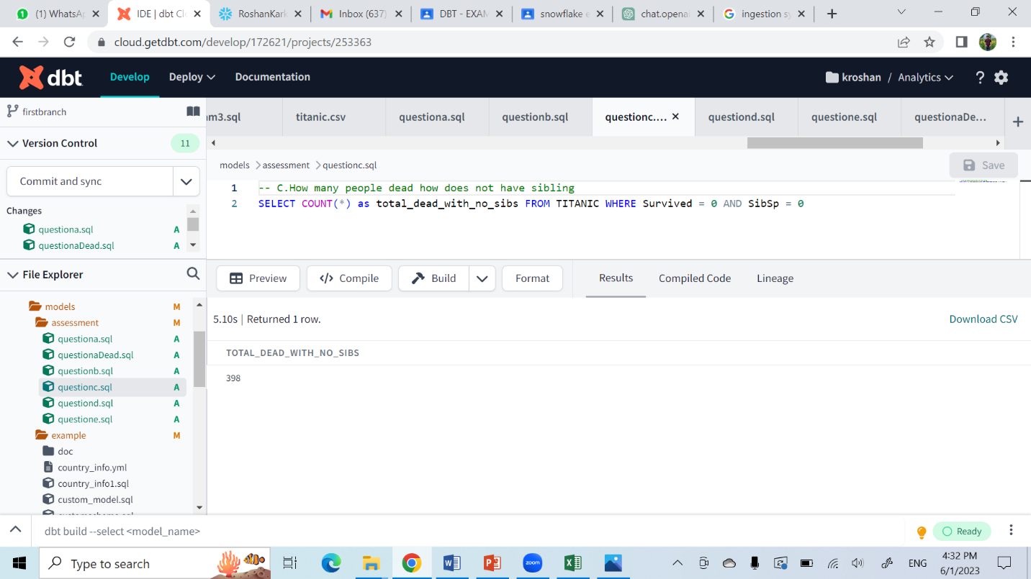

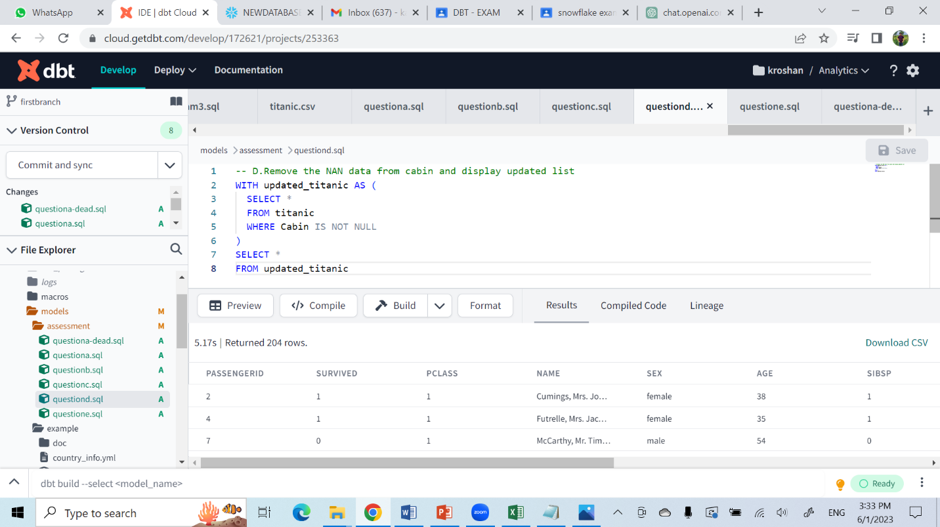

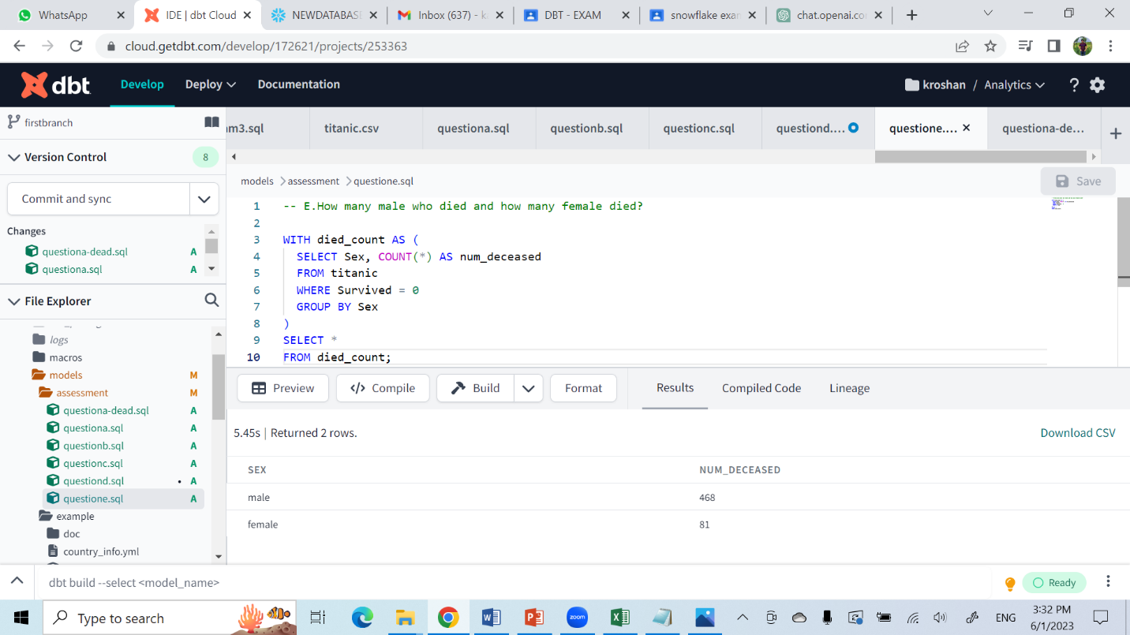

2. Create one source file and destination file and present all incremental approach

Append:

In dbt:

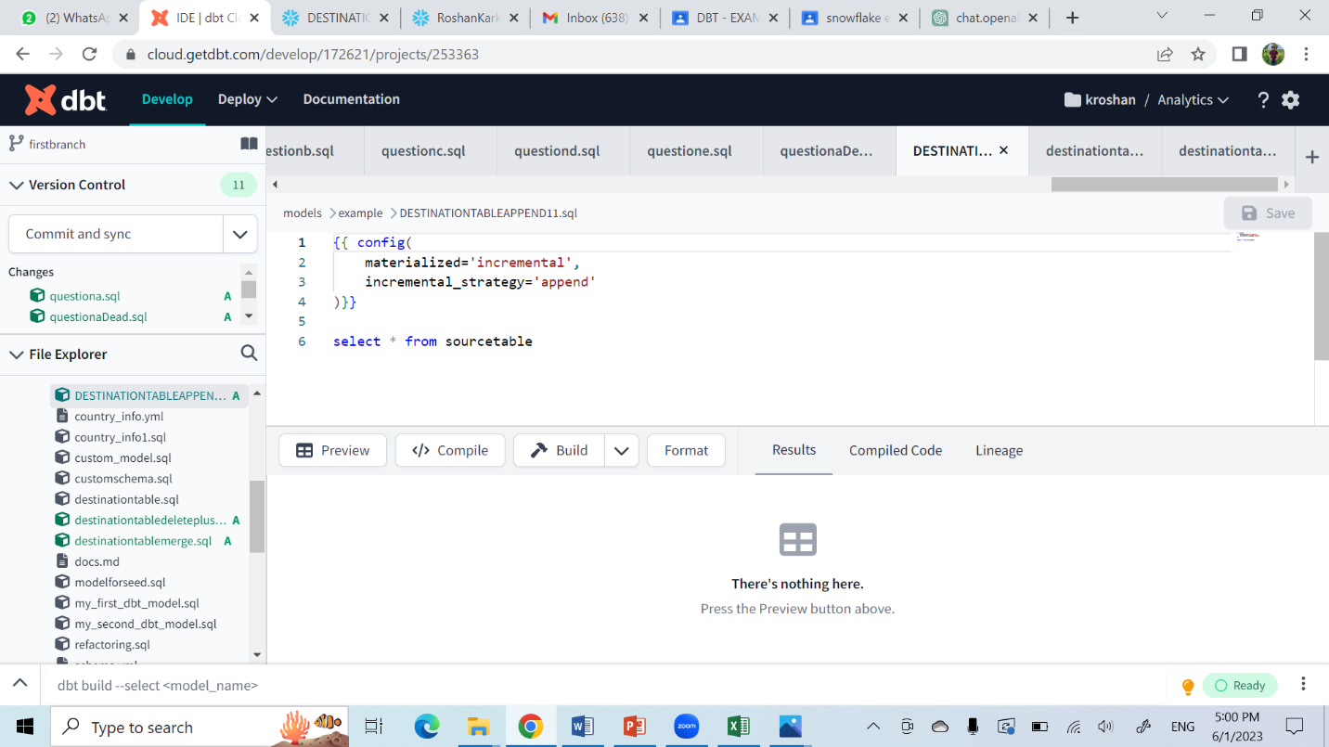

In snowflakes:

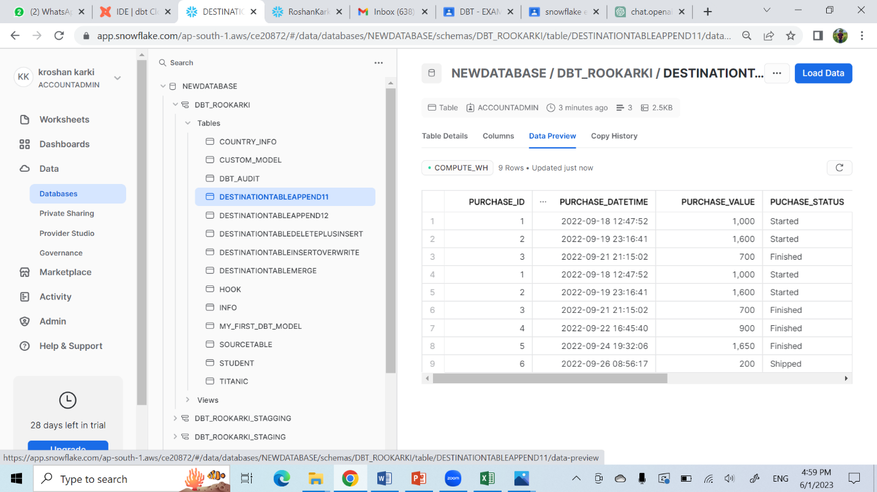

Merge:

In dbt:

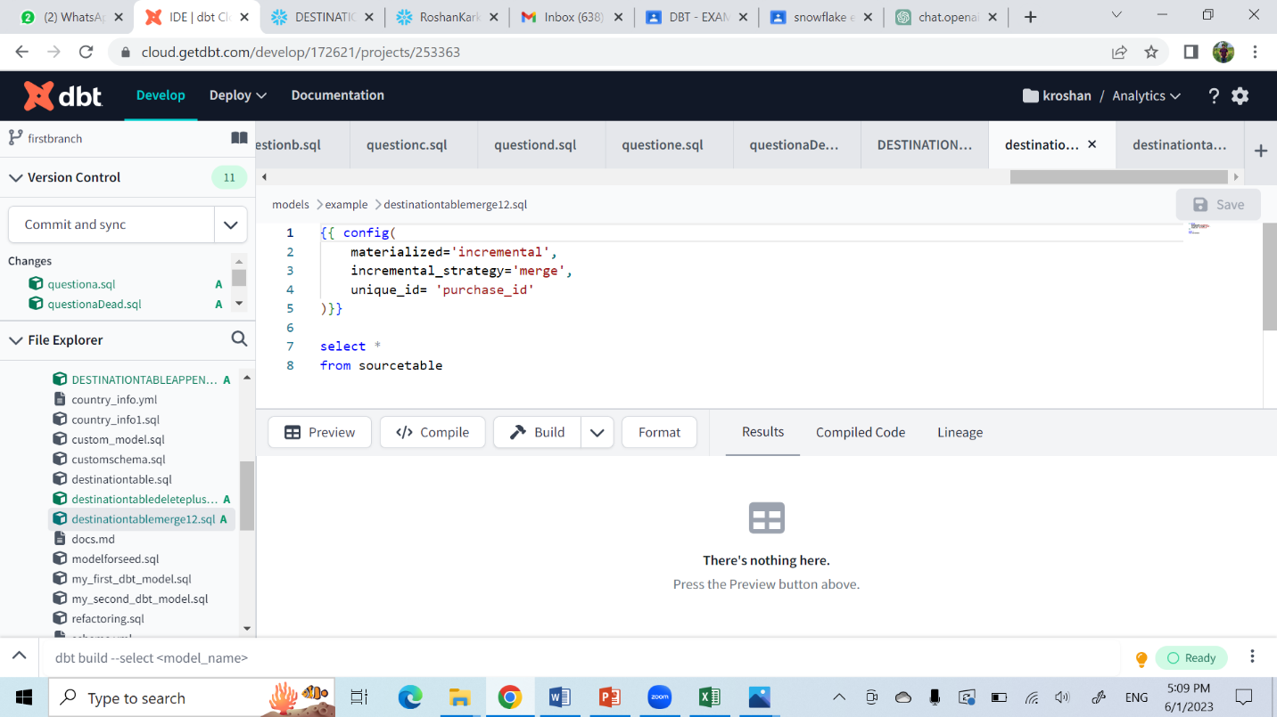

In snowflakes:

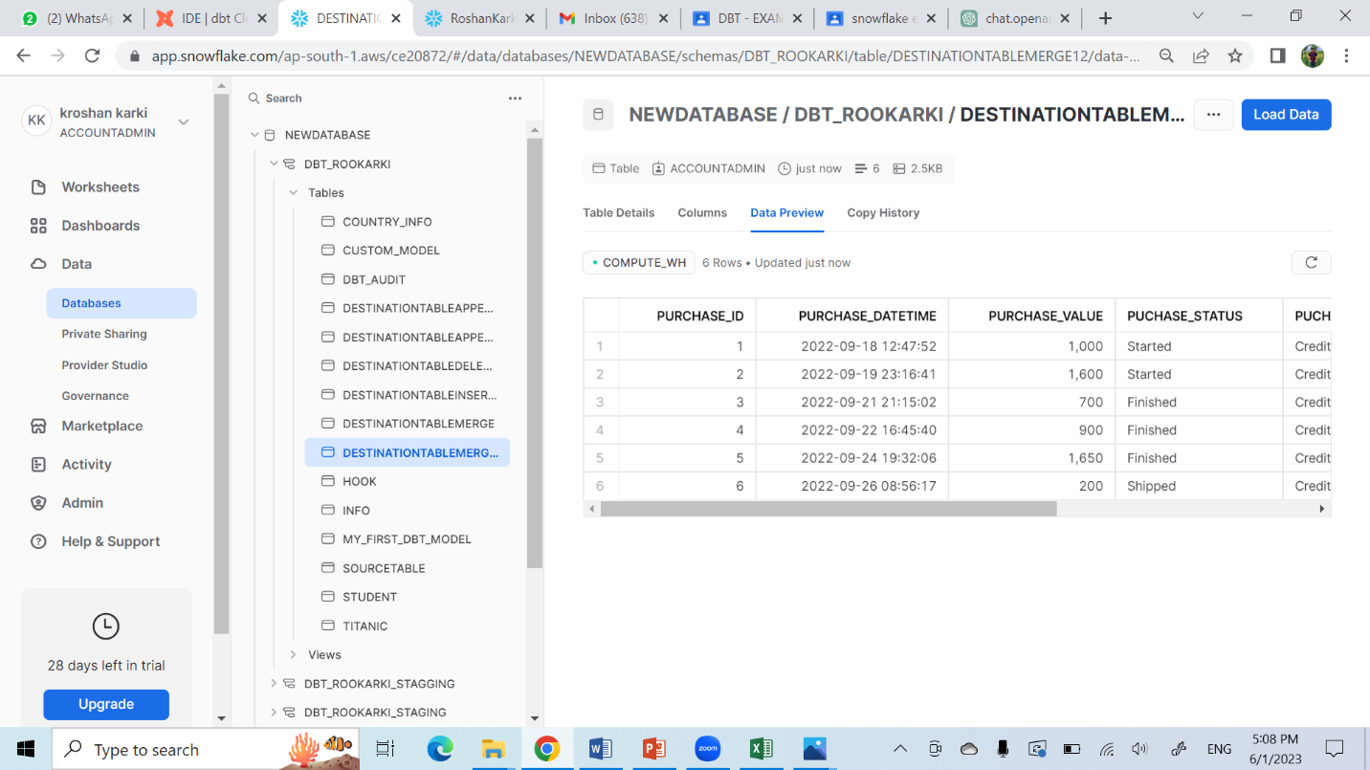

**Delete plus Insert:**

**In dbt:**

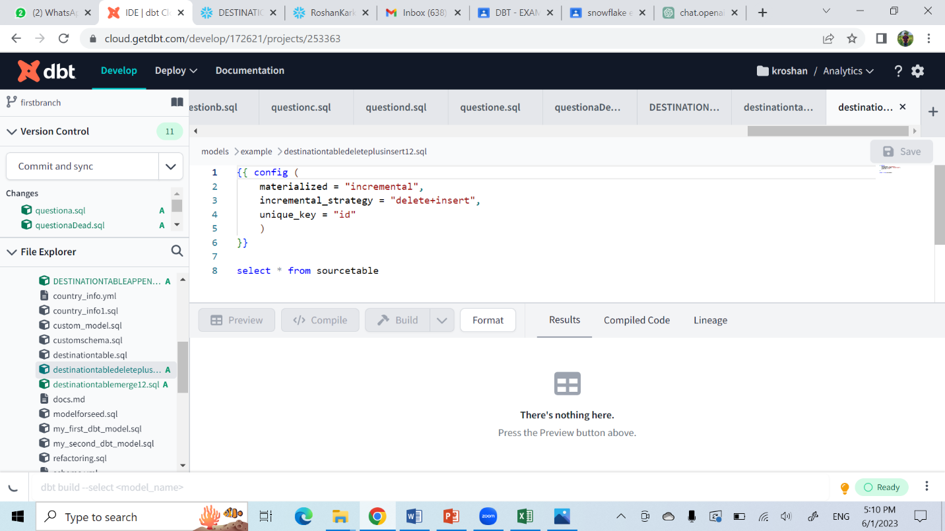

**In snowflakes:**

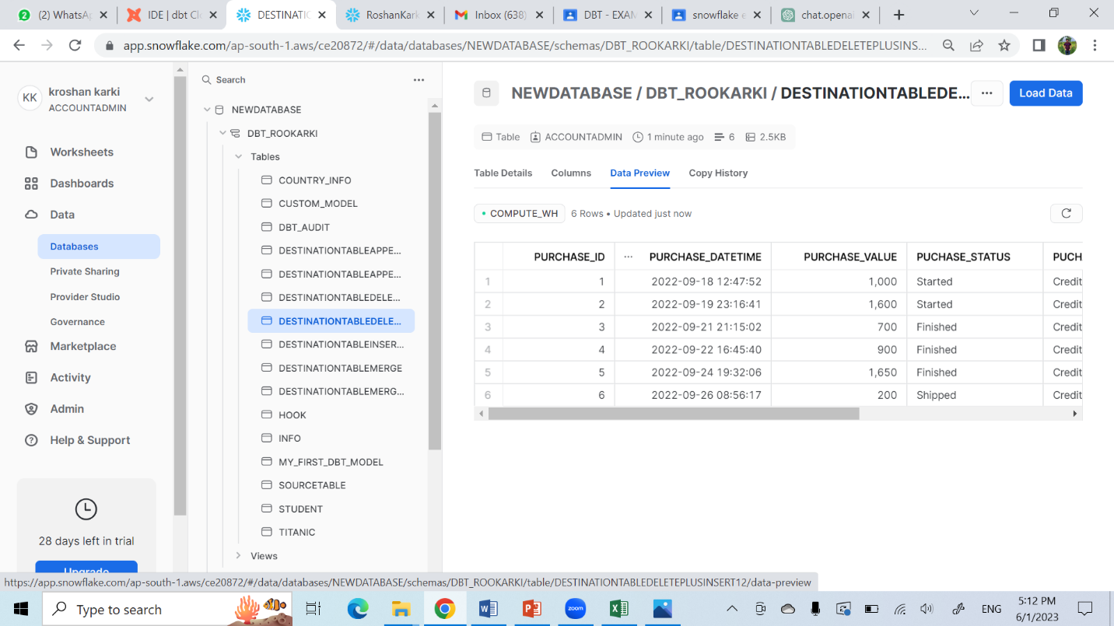

**Query for table:**

create or replace table sourcetable(

purchase_id int,

purchase_datetime TIMESTAMP,

purchase_value int,

puchase_status varchar(200),

puchase_payment_method varchar(200),

purchase_ing_datetime TIMESTAMP

);

insert into sourcetable values

(1, TO_TIMESTAMP('2022-09-18 12:47:52','YYYY-MM-DD HH:MI:SS'), 1000, 'Started', 'Credit Card', TO_TIMESTAMP('2022-09-18 13:10:12','YYYY-MM-DD HH:MI:SS')),

(2, TO_TIMESTAMP('2022-09-19 23:16:41','YYYY-MM-DD HH:MI:SS'), 1600, 'Started', 'Credit Card', TO_TIMESTAMP('2022-09-19 23:36:21','YYYY-MM-DD HH:MI:SS')),

(3, TO_TIMESTAMP('2022-09-21 21:15:02','YYYY-MM-DD HH:MI:SS'), 700, 'Finished', 'Credit Card', TO_TIMESTAMP('2022-09-21 21:20:14','YYYY-MM-DD HH:MI:SS')),

(4, TO_TIMESTAMP('2022-09-22 16:45:40','YYYY-MM-DD HH:MI:SS'), 900, 'Finished', 'Credit Card', TO_TIMESTAMP('2022-09-22 16:50:59','YYYY-MM-DD HH:MI:SS')),

(5, TO_TIMESTAMP('2022-09-24 19:32:06','YYYY-MM-DD HH:MI:SS'), 1650, 'Finished', 'Credit Card', TO_TIMESTAMP('2022-09-24 19:53:22','YYYY-MM-DD HH:MI:SS')),

(6, TO_TIMESTAMP('2022-09-26 08:56:17','YYYY-MM-DD HH:MI:SS'), 200, 'Shipped', 'Credit Card', TO_TIMESTAMP('2022-09-26 09:10:20','YYYY-MM-DD HH:MI:SS'));

select * from sourcetable;

create or replace table destinationtableappend (

purchase_id int,

purchase_datetime TIMESTAMP,

purchase_value int,

puchase_status varchar(200),

puchase_payment_method varchar(200),

purchase_ing_datetime TIMESTAMP

);

insert into destinationtableappend values

(1, TO_TIMESTAMP('2022-09-18 12:47:52','YYYY-MM-DD HH:MI:SS'), 1000, 'Started', 'Credit Card', TO_TIMESTAMP('2022-09-18 13:10:12','YYYY-MM-DD HH:MI:SS')),

(2, TO_TIMESTAMP('2022-09-19 23:16:41','YYYY-MM-DD HH:MI:SS'), 1600, 'Started', 'Credit Card', TO_TIMESTAMP('2022-09-19 23:36:21','YYYY-MM-DD HH:MI:SS')),

(3, TO_TIMESTAMP('2022-09-21 21:15:02','YYYY-MM-DD HH:MI:SS'), 700, 'Finished', 'Credit Card', TO_TIMESTAMP('2022-09-21 21:20:14','YYYY-MM-DD HH:MI:SS'));

select * from destinationtableappend;

create or replace table destinationtablemerge (

purchase_id int,

purchase_datetime TIMESTAMP,

purchase_value int,

puchase_status varchar(200),

puchase_payment_method varchar(200),

purchase_ing_datetime TIMESTAMP

);

insert into destinationtablemerge values

(1, TO_TIMESTAMP('2022-09-18 12:47:52','YYYY-MM-DD HH:MI:SS'), 1000, 'Started', 'Credit Card', TO_TIMESTAMP('2022-09-18 13:10:12','YYYY-MM-DD HH:MI:SS')),

(2, TO_TIMESTAMP('2022-09-19 23:16:41','YYYY-MM-DD HH:MI:SS'), 1600, 'Started', 'Credit Card', TO_TIMESTAMP('2022-09-19 23:36:21','YYYY-MM-DD HH:MI:SS')),

(3, TO_TIMESTAMP('2022-09-21 21:15:02','YYYY-MM-DD HH:MI:SS'), 700, 'Finished', 'Credit Card', TO_TIMESTAMP('2022-09-21 21:20:14','YYYY-MM-DD HH:MI:SS'));

select * from destinationtablemerge;

create or replace table destinationtabledeleteplusinsert (

purchase_id int,

purchase_datetime TIMESTAMP,

purchase_value int,

puchase_status varchar(200),

puchase_payment_method varchar(200),

purchase_ing_datetime TIMESTAMP

);

insert into destinationtabledeleteplusinsert values

(1, TO_TIMESTAMP('2022-09-18 12:47:52','YYYY-MM-DD HH:MI:SS'), 1000, 'Started', 'Credit Card', TO_TIMESTAMP('2022-09-18 13:10:12','YYYY-MM-DD HH:MI:SS')),

(2, TO_TIMESTAMP('2022-09-19 23:16:41','YYYY-MM-DD HH:MI:SS'), 1600, 'Started', 'Credit Card', TO_TIMESTAMP('2022-09-19 23:36:21','YYYY-MM-DD HH:MI:SS')),

(3, TO_TIMESTAMP('2022-09-21 21:15:02','YYYY-MM-DD HH:MI:SS'), 700, 'Finished', 'Credit Card', TO_TIMESTAMP('2022-09-21 21:20:14','YYYY-MM-DD HH:MI:SS'));

select * from destinationtabledeleteplusinsert;

create or replace table destinationtableinsertoverwrite (

purchase_id int,

purchase_datetime TIMESTAMP,

purchase_value int,

puchase_status varchar(200),

puchase_payment_method varchar(200),

purchase_ing_datetime TIMESTAMP

);

insert into destinationtableinsertoverwrite values

(1, TO_TIMESTAMP('2022-09-18 12:47:52','YYYY-MM-DD HH:MI:SS'), 1000, 'Started', 'Credit Card', TO_TIMESTAMP('2022-09-18 13:10:12','YYYY-MM-DD HH:MI:SS')),

(2, TO_TIMESTAMP('2022-09-19 23:16:41','YYYY-MM-DD HH:MI:SS'), 1600, 'Started', 'Credit Card', TO_TIMESTAMP('2022-09-19 23:36:21','YYYY-MM-DD HH:MI:SS')),

(3, TO_TIMESTAMP('2022-09-21 21:15:02','YYYY-MM-DD HH:MI:SS'), 700, 'Finished', 'Credit Card', TO_TIMESTAMP('2022-09-21 21:20:14','YYYY-MM-DD HH:MI:SS'));

select * from destinationtableinsertoverwrite;

Query for append, merge, delte plus insert :

{{ config(

    materialized='incremental',

    incremental_strategy='append'

)}}

select * from sourcetable

{{ config(

    materialized='incremental',

    incremental_strategy='merge',

    unique_id= 'purchase_id'

)}}

select *

from sourcetable

{{ config (

    materialized = "incremental",

    incremental_strategy = "delete+insert",

    unique_key = "id"

    )

}}

select * from sourcetable

**Note: As insert overwrite is not available in snowflakes, so I cannot do it.**