Ideation Phase
Brainstorm & Idea Prioritization Template

Date | 24 September 2026
Team ID | SWTID-2026- 7288
Project Name | AI BlogNest API
Maximum Marks | 4 Marks

Brainstorm & Idea Prioritization Template:
Brainstorming for AI BlogNest API was organized around the two customer problem statements already defined for the ideation phase: reducing the manual effort experienced by content creators and improving the ability of blog readers to locate relevant information. The objective was to generate a broad set of solution ideas first, group related ideas, and then prioritize them using importance and feasibility.
The project foundation describes AI BlogNest API as a secure AI blogging and content management platform. The backend package includes Google GenAI integration, MongoDB/Mongoose support, authentication/security utilities, validation, rate limiting, slug generation and development tooling; these technical cues were used to keep the ideation connected to the actual project direction rather than producing unrelated ideas.
Step-1: Team Gathering, Collaboration and Select the Problem Statement
The ideation session begins with the two problem statements from the preceding Define Problem Statements activity. Both are retained because they represent complementary sides of the same platform: the content creator needs a more efficient content-management experience, while the reader needs faster and more relevant content discovery.
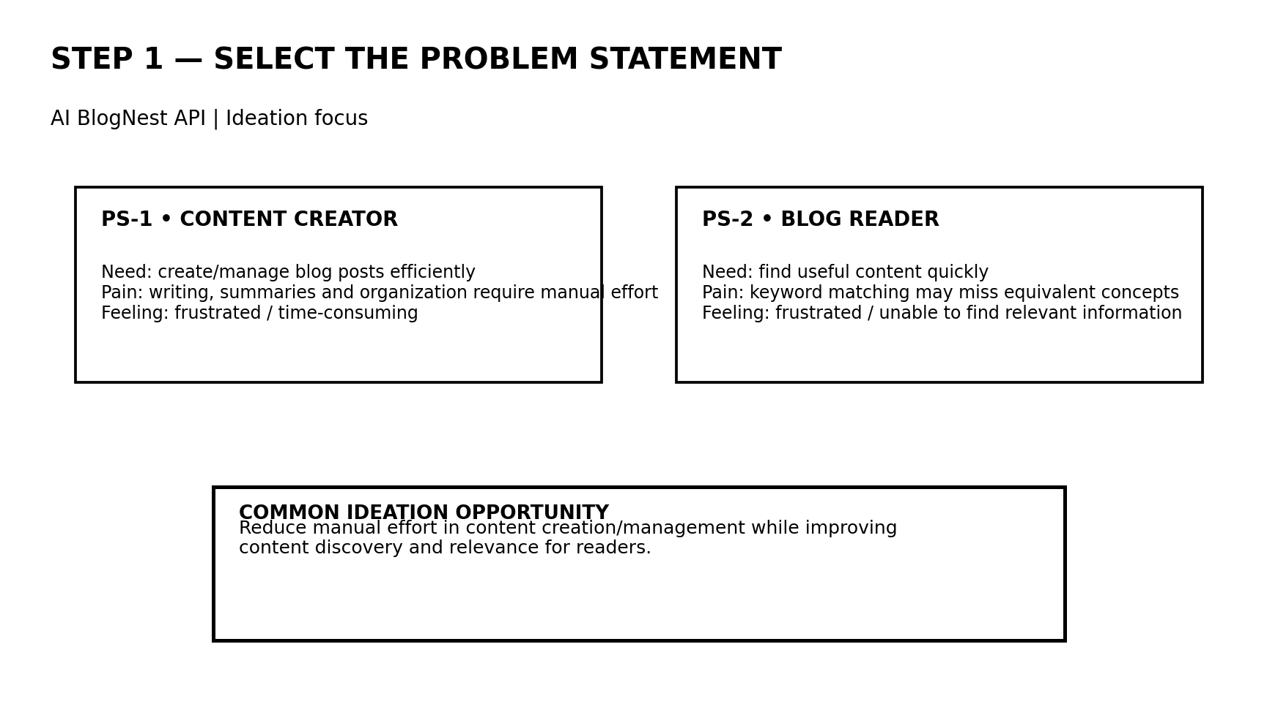
Problem Statement | User Need | Main Friction | Ideation Focus
PS-1: Content Creator | Create and manage posts efficiently; organize with categories/tags. | Writing, summaries and content management require manual effort. | AI assistance + organization + secure management.
PS-2: Blog Reader | Find useful blog content quickly. | Keyword matching can miss equivalent concepts. | More relevant discovery and search support.

Selected common ideation direction: explore a secure AI-powered blogging API that reduces content-production effort and improves content organization/discovery without losing control over authentication, validation and API safety.
Step-2: Brainstorm, Idea Listing and Grouping
The brainstorming stage intentionally prioritizes breadth. The ideas below are grouped by the user/problem area they address and by the technical direction visible in the supplied project configuration. They are treated as ideation candidates; the list does not claim that every idea is already implemented in the supplied source files.
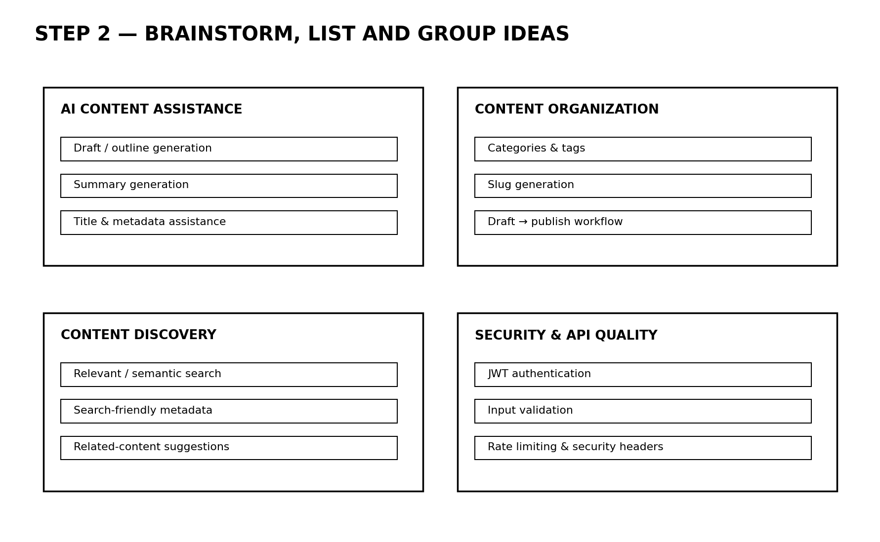
Idea Group | Candidate Ideas | Why It Connects to the Problem
AI Content Assistance | AI-assisted draft/outline generation; summary generation; title/metadata assistance. | Directly targets the creator's manual effort in producing and preparing content.
Content Organization | Categories and tags; slug generation; draft-to-publish workflow. | Makes growing blog content easier to structure, identify and manage.
Content Discovery | Relevant/semantic search; search-friendly metadata; related-content suggestions. | Addresses the reader's difficulty when useful content does not share the exact query words.
Security & API Quality | JWT authentication; input validation; rate limiting; security headers. | Supports a secure and controlled API foundation while user-facing features are developed.
Technical foundation considered during ideation:
- Google GenAI integration is present in the project dependencies, supporting the AI-oriented direction.
- Mongoose is included for MongoDB data access, supporting structured storage for blog/content management.
- JWT, bcryptjs, Helmet, CORS, express-rate-limit and express-validator indicate a security/validation-oriented API foundation.
- Slugify supports readable, stable blog URL identifiers.
- Express and Nodemon provide the server/runtime and development workflow.
Step-3: Idea Prioritization
Ideas were compared on two practical dimensions: importance to the identified user problem and feasibility within the project direction. The resulting matrix is a planning aid for selecting the ideas that should receive attention first; the numerical values are ideation estimates, not measured product metrics.
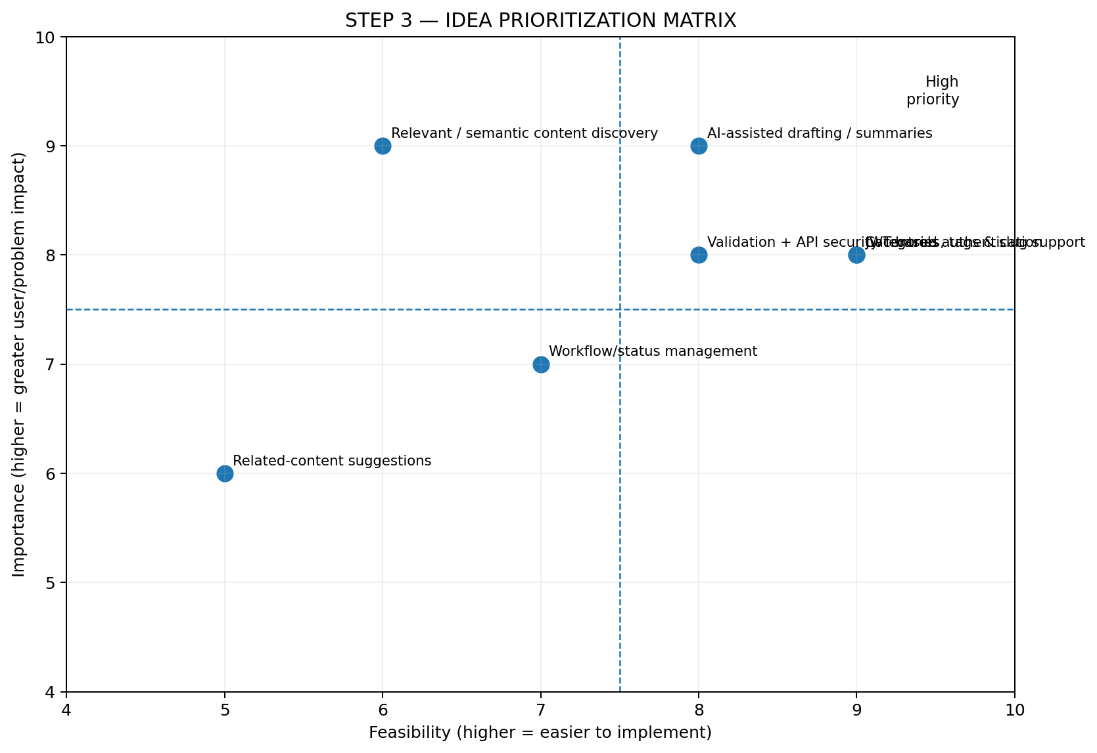
Idea | Importance /10 | Feasibility /10 | Priority Rationale | Phase-1 Decision
AI-assisted drafting / summaries | 9 | 8 | Strong direct response to creator effort and aligned with GenAI dependency. | Carry forward
Categories, tags & slug support | 8 | 9 | Clear organization benefit and closely aligned with supplied backend tooling. | Carry forward
Relevant / semantic content discovery | 9 | 6 | High reader value, but requires more design/implementation consideration. | Carry forward for design
JWT authentication | 8 | 9 | Important API foundation and directly supported by the project stack. | Carry forward
Validation + API security controls | 8 | 8 | Improves reliability and safe operation of the platform. | Carry forward
Related-content suggestions | 6 | 5 | Useful extension, but less central to the two defined problem statements. | Defer
Workflow/status management | 7 | 7 | Helpful for content lifecycle, but can follow the core creation/organization features. | Secondary

Outcome of the ideation phase: The brainstorming process produced a connected set of ideas spanning AI-assisted creation, content organization, content discovery, and secure API operation. The ideas carried forward form a coherent foundation for the subsequent phases rather than treating each feature as an isolated concept.

