

Jamalpur Science & Technology University

Department of Computer Science and Engineering

LAB REPORT

Course Name : Automata Theory and Compiler Design
Course Code : CSE 4111

Submitted by : | Submitted to :
Name : Md Robiul Islam  ID: 22111102  Session: 2021-22  Department of CSE  Jamalpur Science & Technology University | Md. Sydur Rahman  Lecturer  Department of CSE, JSTU

Submission Date : 31-07-26

Index
No | Topic
01 | i. Write a C++ code which calculate Binary Search and show the debugging process.
01 | ii. Write a C++ code which calculate multiplication of two matrix and show the debugging process.
01 | iii. Write a C++ code which perform Selection Sort and show the debugging process.
02 | Identify whether a string is a single-line comment, a multi-line comment, or not a comment (three examples), with debugging.
03 | Check the validity of a string as a C++ identifier (variable name), with debugging.
04 | Take a context-free production rule and check whether it is left recursive, with debugging.
05 | Take multiple sentences and separate each sentence into word tokens, with debugging.

Lab 01: Debugging

i. Write a C++ code which calculate Binary Search and show the debugging process.

Steps:

Create a new project: File -> New -> Project -> Console application -> Project title -> Finish.

Write a C++ program for Binary Search.

Select the while (low <= high) loop line using a Red Circle.

Open Watch Window: Debug Windows -> Watch -> Watch 1.

Add variables: low, high, mid, key.

Then run the program: Debug Start/Continue -> Debug Step Into (F11).

Click Step Into (F11) repeatedly to see the values of low, high, and mid change in the Watch Window until the element is found or the search ends.

Source Code
#include <iostream>
using namespace std;

int binarySearch(int a[], int n, int key) {
int low = 0, high = n - 1;
while (low <= high) {
int mid = (low + high) / 2;
if (a[mid] == key)
return mid;
else if (key > a[mid])
low = mid + 1;
else
high = mid - 1;
}
return -1;
}

int main() {
int n, key;
cout << "Enter array size: ";
cin >> n;
int a[n];

cout << "Enter sorted array elements: ";
for (int i = 0; i < n; i++)
cin >> a[i];

cout << "Enter element to search: ";
cin >> key;

int result = binarySearch(a, n, key);
if (result == -1)
cout << "Element not found";
else
cout << "Element found at index " << result;

return 0;
}

Screenshot 1: Code::Blocks with breakpoint set and Watch window open and output for a comment
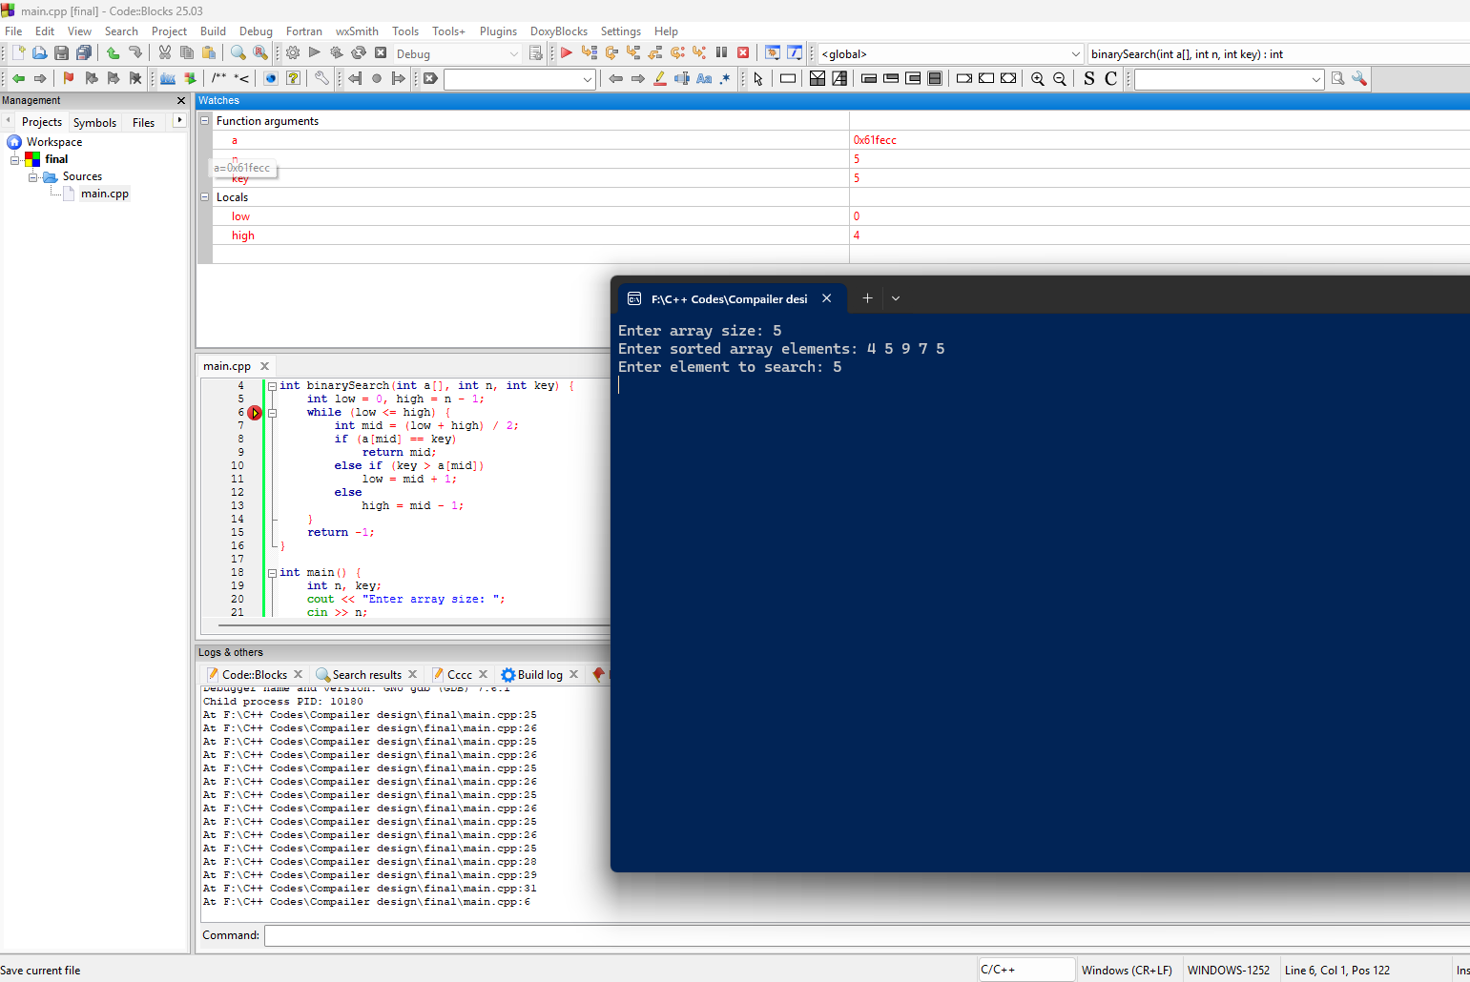

Discussion
This program is debugged by executing the binary search algorithm step by step. A breakpoint is set inside the search loop, and the values of variables like low, high, mid, and the search element are observed using the debugger. By using Step Into, we can see how the middle position is calculated and how the search range is updated after each comparison. This helps to understand the working process, identify errors, and verify that the binary search program gives the correct result.

ii. Write a C++ code which calculate multiplication of two matrix and show the debugging process.

Steps:
- Create a new project: File -> New -> Project -> Console application -> Next -> Project title -> Finish.
- Write a C++ code which calculate a multiplication of two matrix.
- Select loop line Using Red circle.
- Open Dubbing windows and run code.
- Goto: Debugging Windows -> watches.
- Next Goto: Debug -> start/continue -> step into.
- From each click on step into we can see changes loop values.

Source Code:
#include <iostream>
using namespace std;

int main() {
int a[10][10], b[10][10], c[10][10];
int r1, c1, r2, c2;

cout << "Enter rows and columns of first matrix: ";
cin >> r1 >> c1;

cout << "Enter rows and columns of second matrix: ";
cin >> r2 >> c2;

if(c1 != r2) {
cout << "Matrix multiplication is not possible";
return 0;
}

cout << "Enter first matrix elements:\n";
for(int i=0; i<r1; i++) {
for(int j=0; j<c1; j++) {
cin >> a[i][j];
}
}

cout << "Enter second matrix elements:\n";
for(int i=0; i<r2; i++) {
for(int j=0; j<c2; j++) {
cin >> b[i][j];
}
}

// Matrix multiplication
for(int i=0; i<r1; i++) {
for(int j=0; j<c2; j++) {
c[i][j] = 0;
for(int k=0; k<c1; k++) {
c[i][j] += a[i][k] * b[k][j];
}
}
}

cout << "Result Matrix:\n";
for(int i=0; i<r1; i++) {
for(int j=0; j<c2; j++) {
cout << c[i][j] << " ";
}
cout << endl;
}

return 0;
}

Output:
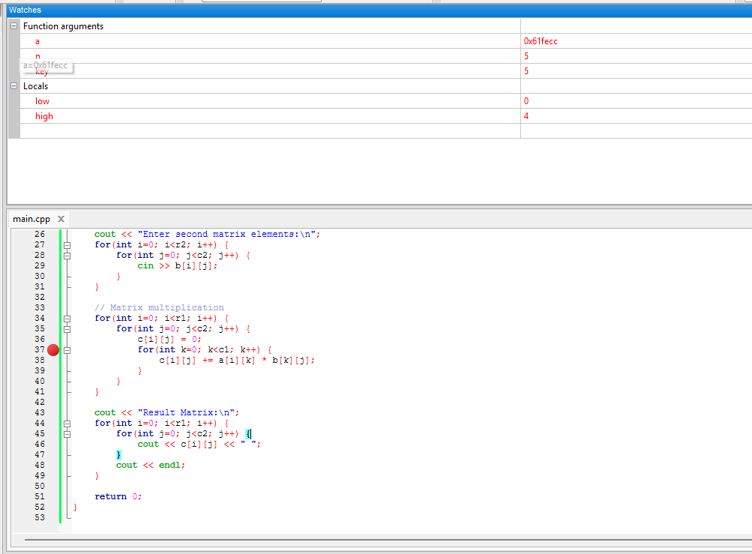

Discussion:
Matrix multiplication is performed using three nested loops. During debugging, the values of loop variables and matrix elements are monitored step by step. The debugger helps to understand how each element of the result matrix is calculated by multiplying rows of the first matrix with columns of the second matrix. This process helps identify errors and understand program execution flow.

iii. Write a C++ code which perform Selection Sort and show the debugging process.
Steps:
- Create a new project: File -> New -> Project -> Console application -> Next -> Project title -> Finish.
- Write a C++ code which performSelection sorting operation on an array.
- Select loop line Using Red circle.
- Open Dubbing windows and run code.
- Goto: Debugging Windows -> watches.
- Next Goto: Debug -> start/continue -> step into.
- From each click on step into we can see changes loop values.
Source Code:
#include <iostream>
using namespace std;

int main() {
int arr[100], n;

cout << "Enter number of elements: ";
cin >> n;

cout << "Enter elements: ";
for(int i=0; i<n; i++) {
cin >> arr[i];
}

// Selection Sort
for(int i=0; i<n-1; i++) {
int min = i;
for(int j=i+1; j<n; j++) {
if(arr[j] < arr[min]) {
min = j;
}
}
// Swap
int temp = arr[i];
arr[i] = arr[min];
arr[min] = temp;
}

cout << "Sorted Array: ";
for(int i=0; i<n; i++) {
cout << arr[i] << " ";
}

return 0;
}

Output:
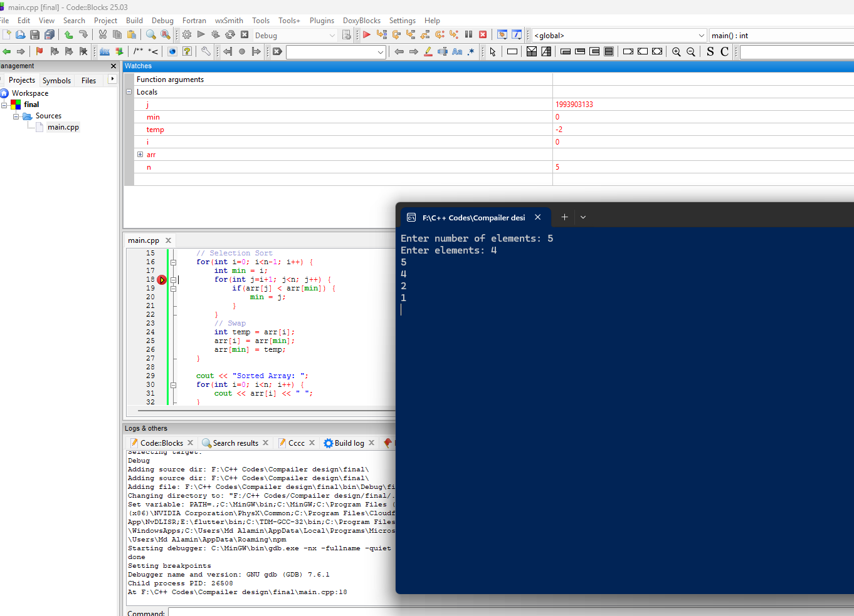
Discussion:
This debugging process shows array sorting using step-by-step debugging with watch variables in Code::Blocks. The program uses a simple selection sort approach to arrange five numbers {3, 7, 2, 5, 1} in ascending order. The nested loops compare each element, and the swap() function exchanges values when the earlier element is greater than the later one. During debugging, the Watches window displays the array a, updating its values after each swap. This helps visualize how the smallest numbers gradually move to the beginning of the array. Step-by-step debugging makes it easier to understand how sorting logic works internally. It ensures the correctness of comparisons and value exchanges at every iteration.

Lab 02: Classify a String as Single-line / Multi-line Comment or Plain String

Objective
To write a C++ program that reads several lines and classifies each one as a single-line comment, a multi-line comment, or an ordinary string (not a comment), and to verify the classification through debugging. Three example inputs are used to demonstrate all three cases.

Logic
1. Read the number of test lines n, then read each line.
2. If a line starts with '//' it is classified as a Single Line Comment.
3. Else if a line starts with '/*' and ends with '*/' it is classified as a Multi Line Comment.
4. Otherwise it is classified as Not a Comment (a plain string).

Source Code
#include <bits/stdc++.h>
using namespace std;

int main()
{
int n;
cout << "Enter number of lines: ";
cin >> n;
cin.ignore();

for (int i = 1; i <= n; i++)
{
string s;
getline(cin, s);

if (s.size() >= 2 && s[0] == '/' && s[1] == '/')
{
cout << "Line " << i << " -> Single Line Comment" << endl;
}
else if (s.size() >= 4 && s[0] == '/' && s[1] == '*' &&
s[s.size() - 2] == '*' && s[s.size() - 1] == '/')
{
cout << "Line " << i << " -> Multi Line Comment" << endl;
}
else
{
cout << "Line " << i << " -> Not a Comment (String)" << endl;
}
}

return 0;
}

Example Inputs Used
Example 1 (single-line comment): // This is a single line comment
Example 2 (multi-line comment): /* This is a multi line comment */
Example 3 (plain string): This is just a normal sentence

Debugging Process
1. Open the project in Code::Blocks (or Visual Studio) and write the source code shown below.
2. Set a breakpoint by clicking the left margin (or selecting the line with a red circle) on the key loop/condition line inside the logic.
3. Open the Watch window: Debug → Debugging Windows → Watches.
4. Add the following variables to the Watch window: s, i, n.
5. Build and start debugging: Debug → Start / Continue.
6. Use Step Into (F11) / Step Over (F10) repeatedly to move through the code line by line.
7. Observe how each watched variable changes after every step until the program produces its final output.
Screenshot 2: Breakpoint on the classification if-else block, Watch window with s and I ,, also output showing all three classifications for the three examples
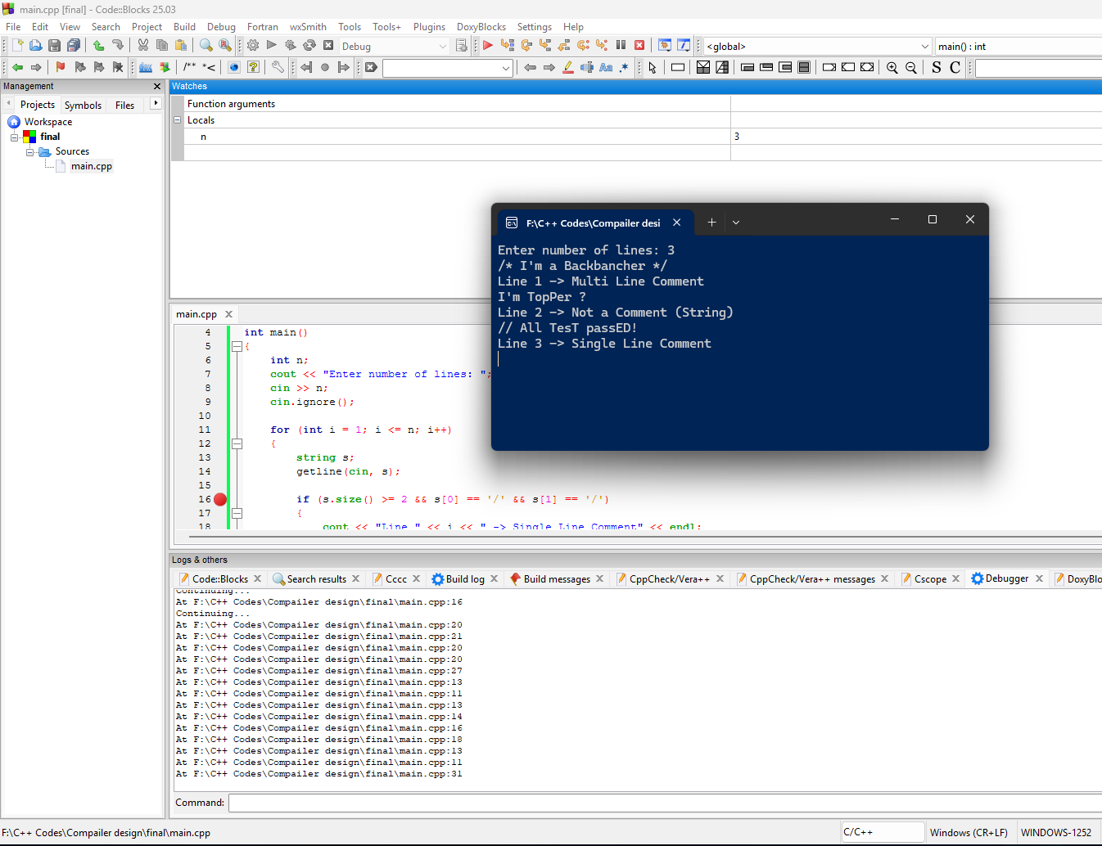

Discussion
This program extends the comment check of Lab 01 into a three-way classification. During debugging, the loop variable i and the current line s were watched on every Step Into so that each of the three example lines could be traced through the if-else chain individually. This confirmed that the single-line check, the multi-line check, and the fallback case all trigger correctly for their respective examples.

Lab 03: Check the Validity of a String as an Identifier

Objective
To write a C++ program that reads a string (proposed variable name) and validates it against the identifier-naming rules of C++, and to debug the validation logic step by step.

Identifier Rules Checked
1. Must start with a letter (a-z, A-Z) or an underscore (_).
2. May contain only letters, digits (0-9), and underscores after the first character.
3. Must not contain whitespace or special symbols such as #, $, %, *.
4. Must not be one of the reserved C++ keywords (e.g. int, float, while).

Source Code
#include <bits/stdc++.h>
using namespace std;

int main()
{
int n;
cout << "Enter number of strings: ";
cin >> n;

string keyword[] = {"int", "float", "double", "char", "while",
"for", "if", "else", "return", "class"};

while (n--)
{
string s;
cin >> s;
bool ok = true;

// Rule 1: must start with a letter or underscore
if (!((s[0] >= 'a' && s[0] <= 'z') ||
(s[0] >= 'A' && s[0] <= 'Z') || s[0] == '_'))
ok = false;

// Rule 2: only letters, digits, underscore allowed
for (int i = 0; i < (int)s.size(); i++)
{
char c = s[i];
if (!((c >= 'a' && c <= 'z') || (c >= 'A' && c <= 'Z') ||
(c >= '0' && c <= '9') || c == '_'))
ok = false;
}

// Rule 3: must not be a C++ keyword
for (int i = 0; i < 10; i++)
if (s == keyword[i])
ok = false;

if (ok)
cout << s << " -> Valid Identifier" << endl;
else
cout << s << " -> Invalid Identifier" << endl;
}

return 0;
}

Debugging Process
1. Open the project in Code::Blocks (or Visual Studio) and write the source code shown below.
2. Set a breakpoint by clicking the left margin (or selecting the line with a red circle) on the key loop/condition line inside the logic.
3. Open the Watch window: Debug → Debugging Windows → Watches.
4. Add the following variables to the Watch window: s, ok, i.
5. Build and start debugging: Debug → Start / Continue.
6. Use Step Into (F11) / Step Over (F10) repeatedly to move through the code line by line.
7. Observe how each watched variable changes after every step until the program produces its final output.
Screenshot 3.1: Breakpoint on the character-validation loop, Watch window with s, ok,, output for valid and invalid identifiers
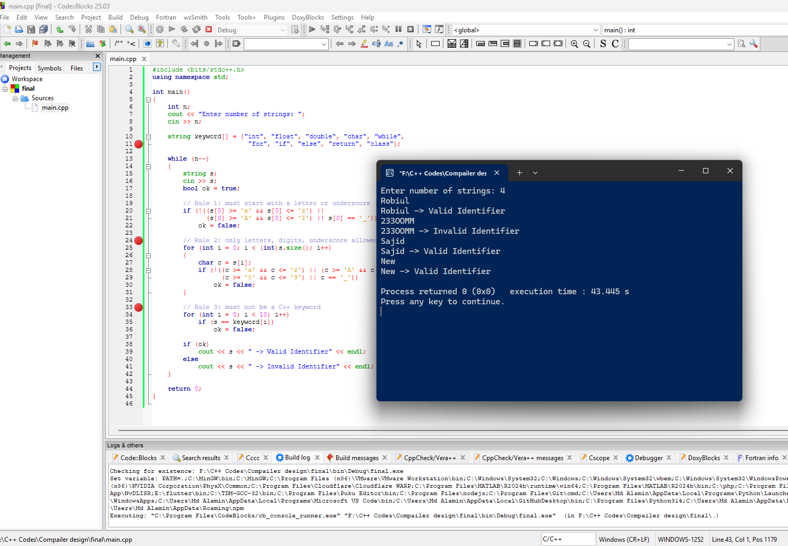

Discussion
The program checks each candidate identifier character by character and also compares it against a list of reserved keywords. While debugging, the boolean flag ok was watched together with the loop index i, which made it possible to see exactly which character or which keyword match caused a given string to be rejected. This step-by-step trace verified that all four identifier rules are enforced correctly.

Lab 04: Check Left Recursion in a Production Rule

Objective
To write a C++ program that reads a context-free production rule (e.g. A->Aa|b) and determines whether it is left recursive, and to debug how each alternative on the right-hand side is examined.

Logic
1. Store the left-hand side symbol (first character of the rule) as lhs.
2. Skip the 'A->' part and split the remaining right-hand side by the '|' symbol into separate alternatives.
3. For each alternative, if its first character equals lhs, the rule is left recursive.
4. If no alternative starts with lhs, the rule is not left recursive.

Source Code
#include <bits/stdc++.h>
using namespace std;

int main()
{
int t;
cout << "Enter the number of production rules: ";
cin >> t;

while (t--)
{
string s;
cin >> s; // format: A->Aa|b
char lhs = s[0];
bool leftRecursive = false;
string part = "";

// skip "A->" i.e. first 3 characters, split remaining by '|'
for (int i = 3; i < (int)s.size(); i++)
{
if (s[i] != '|')
{
part += s[i];
}
else
{
if (part.size() > 0 && part[0] == lhs)
leftRecursive = true;
part = "";
}
}
// check the last part after the loop ends
if (part.size() > 0 && part[0] == lhs)
leftRecursive = true;

if (leftRecursive)
cout << s << " -> Left Recursive" << endl;
else
cout << s << " -> Not Left Recursive" << endl;
}

return 0;
}

Debugging Process
1. Open the project in Code::Blocks (or Visual Studio) and write the source code shown below.
2. Set a breakpoint by clicking the left margin (or selecting the line with a red circle) on the key loop/condition line inside the logic.
3. Open the Watch window: Debug → Debugging Windows → Watches.
4. Add the following variables to the Watch window: s, lhs, part, leftRecursive.
5. Build and start debugging: Debug → Start / Continue.
6. Use Step Into (F11) / Step Over (F10) repeatedly to move through the code line by line.
7. Observe how each watched variable changes after every step until the program produces its final output.
Screenshot 4.1: Breakpoint inside the alternative-splitting loop, Watch window with part, lhs, output for a left recursive rule and a non-left-recursive rule
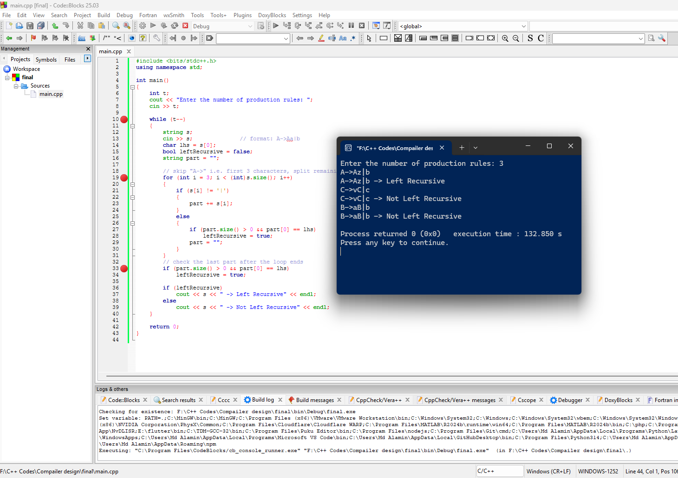

Discussion
This program separates a production rule's alternatives at every '|' and compares the first character of each alternative with the left-hand side symbol. During debugging, the variable part was watched as it was rebuilt character by character, and leftRecursive was observed flipping to true the moment an alternative beginning with the left-hand symbol was found. This confirmed that the left-recursion check works correctly for rules with any number of alternatives.

Lab 05: Separate Words of a Sentence into Tokens

Objective
To write a C++ program that reads multiple sentences and splits each sentence into individual word tokens printed on separate lines, and to debug the tokenizing loop.

Logic
1. Read the number of sentences n, then read each full sentence with getline.
2. Scan the sentence character by character; while a character is not a space, append it to the temporary string token.
3. When a space is found, print the token collected so far and reset it to empty.
4. After the scan ends, print any remaining token (the last word, which is not followed by a space).

Source Code
#include <bits/stdc++.h>
using namespace std;

int main()
{
int n;
cout << "Enter number of sentences: ";
cin >> n;
cin.ignore();

for (int i = 1; i <= n; i++)
{
string s;
getline(cin, s);
cout << "Sentence " << i << ": " << s << endl;

string token = "";
int count = 1;

for (int j = 0; j < (int)s.size(); j++)
{
if (s[j] == ' ')
{
if (token != "")
{
cout << " Token " << count++ << ": " << token << endl;
token = "";
}
}
else
{
token += s[j];
}
}

if (token != "")
cout << " Token " << count++ << ": " << token << endl;

cout << endl;
}

return 0;
}

Debugging Process
1. Open the project in Code::Blocks (or Visual Studio) and write the source code shown below.
2. Set a breakpoint by clicking the left margin (or selecting the line with a red circle) on the key loop/condition line inside the logic.
3. Open the Watch window: Debug → Debugging Windows → Watches.
4. Add the following variables to the Watch window: s, j, token, count.
5. Build and start debugging: Debug → Start / Continue.
6. Use Step Into (F11) / Step Over (F10) repeatedly to move through the code line by line.
7. Observe how each watched variable changes after every step until the program produces its final output.
Screenshot 5.1: Breakpoint inside the character-scanning loop, Watch window with token, j, output showing each sentence split into numbered tokens
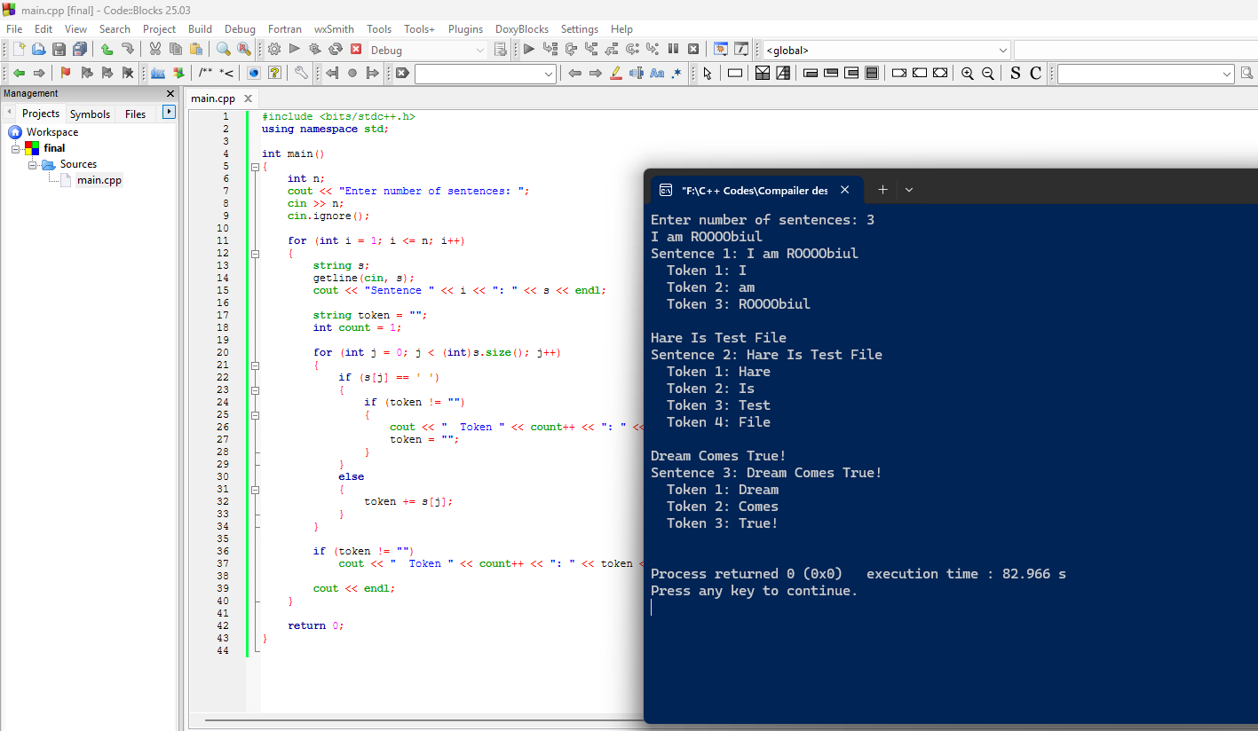

Discussion
The tokenizer builds up each word in the string token and flushes it to the output whenever a space is encountered, with a final flush after the loop to catch the last word. During debugging, token and the loop index j were watched on every Step Into, which made it clear exactly when a character was appended versus when a completed word was printed. This verified that every sentence is broken into the correct number of tokens in the correct order.

