MINIPROJECT
TITLE:- "Basic Calculator using Tkinter"
CODE:-
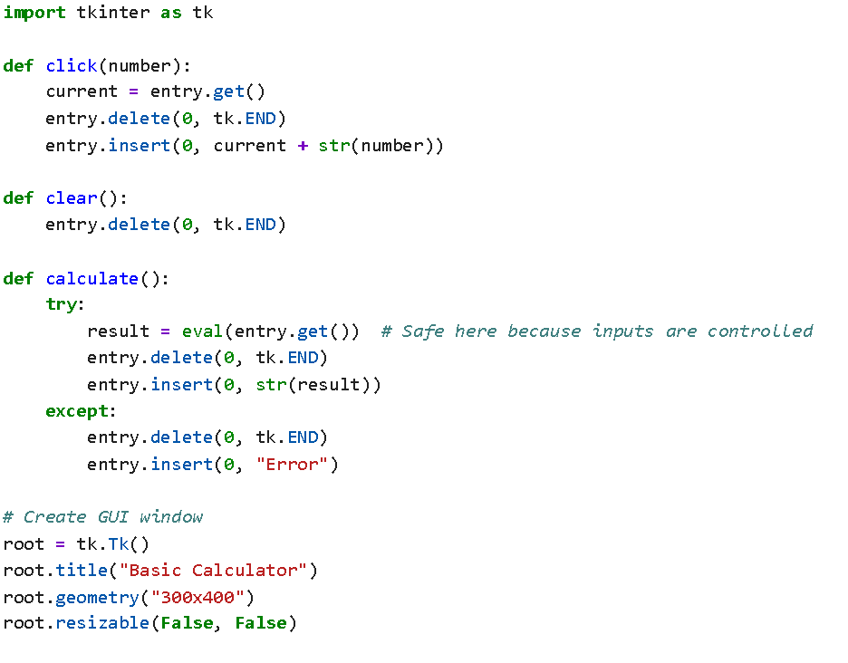

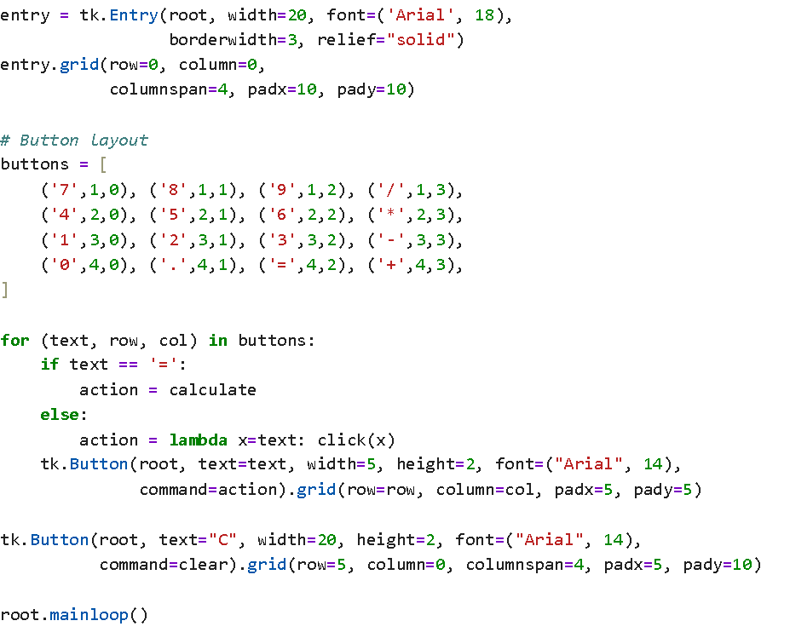

OUTPUT:-

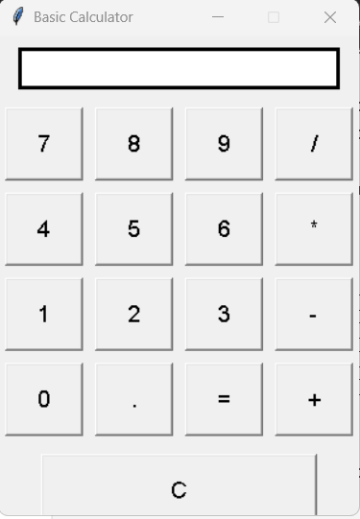

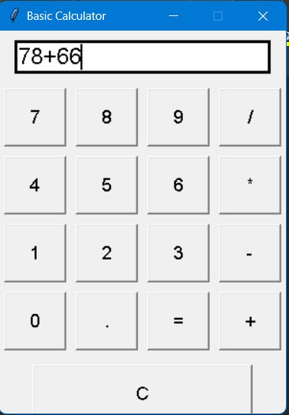
AFTER CALCULATION:-
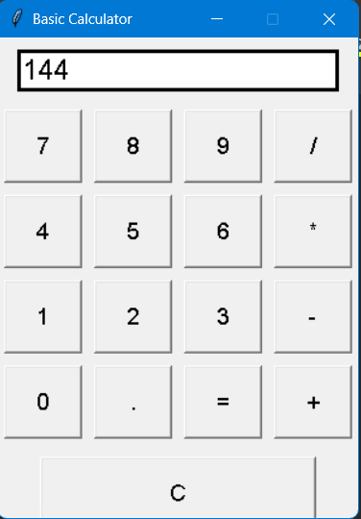

PROJECT REPORT
TITLE: Basic Calculator Using Tkinter

🔰 1. Introduction
This project presents a simple yet functional GUI-based calculator built using Python’s Tkinter module. It performs basic arithmetic operations: addition, subtraction, multiplication, and division. The project helps demonstrate the use of graphical user interfaces in Python through event-driven programming.

🛠️ 2. Tools & Technologies Used
- Language: Python
- GUI Toolkit: Tkinter (built-in with Python)
- IDE: Any Python IDE (e.g., VS Code, IDLE)
- Platform: Cross-platform

🧠 3. Key Concepts Used
- Tkinter GUI Elements: Tk, Entry, Button, and layout using .grid().
- Event Handling: Button clicks are linked to functions like click(), calculate(), and clear().
- Expression Evaluation: Uses eval() function to compute the entered expression.
- Lambda Functions: Used to dynamically assign digit and operator inputs to buttons.

🧾 4. Functionalities
- Allows the user to input numbers and operations by clicking buttons.
- Displays the current expression in an Entry widget.
- Performs evaluation when = is clicked.
- Clears the current input using the C button.
- Supports:
  - Numbers (0–9)
  - Operators: +, -, *, /
  - Decimal values

💡 5. Code Explanation (Brief)
- click(number): Appends digits or operators to the current input.
- clear(): Clears the entire input field.
- calculate(): Evaluates the mathematical expression using eval() and displays the result. If there's an error (e.g., invalid expression), it shows "Error".
- Buttons are dynamically created using a loop for clean layout and uniform size.
- The GUI is fixed in size and styled with a modern font (Arial, size 14–18).

📈 6. Output (Sample)
Users can input values like 7 * 5 + 3, press =, and see the result 38 displayed in the entry box.

✅ 7. Conclusion
This project successfully demonstrates how to build a basic calculator using Python's Tkinter. It provides an interactive interface for basic arithmetic, showing how GUI applications can be implemented effectively with minimal code. The project is ideal for beginners learning Python GUI programming and event handling.

