Mini Project 2 Report.

NAME :Roohan Riyaz Shaikh

CLASS : TY (AIML)

TOPIC : - Restaurant Billing System Using PYTHON Tkinter.

ENROLL NO: 23111590033

# 1. Introduction

## 1.1 Problem Statement

In restaurants, manual billing is time-consuming and error-prone. There is a need for a Restaurant Billing System that allows generating bills quickly, ensuring accurate calculations, applying taxes, and providing an organized bill format.

## 1.2 Objectives

1. Generate itemized bills automatically.  
2. Provide an easy-to-use GUI for staff.  
3. Apply tax calculations automatically.  
4. Allow reset and exit options for usability.  
5. Display the date and time of billing.  
6. Improve efficiency and reduce manual errors.

## 1.3 Scope of the Project

The scope of this project is to create a billing system using Python and Tkinter. It covers menu display, quantity input, automated total calculation, tax application, and formatted bill generation. The project focuses on GUI-based operation.

# 2. Technology Stack Used

## 2.1 Programming Languages

Python – Used for the entire application logic and GUI development.

## 2.2 Libraries / Frameworks

Tkinter – For GUI components (buttons, labels, text fields).  
Datetime – For fetching current date and time.  
Jupyter Notebook – For coding and execution.

## 2.3 Tools and Platforms

1. Jupyter Notebook – Development and testing.  
2. Python IDLE – Alternative testing environment.  
3. GitHub – Version control and repository management.

# 3. System Architecture

The system consists of a user interface where the cashier enters item quantities. The application logic layer processes the input, calculates totals, applies tax, and generates a formatted bill. The final bill is displayed in a text widget.

# 4. Implementation

The program initializes the Tkinter main window. A menu frame lists available items with entry boxes for quantity input. On clicking 'Generate Bill', the program calculates the cost of each item, applies tax, and shows the total in the bill frame. The reset button clears the entries, and the exit button closes the application.

## 4.2 Screenshots of Execution

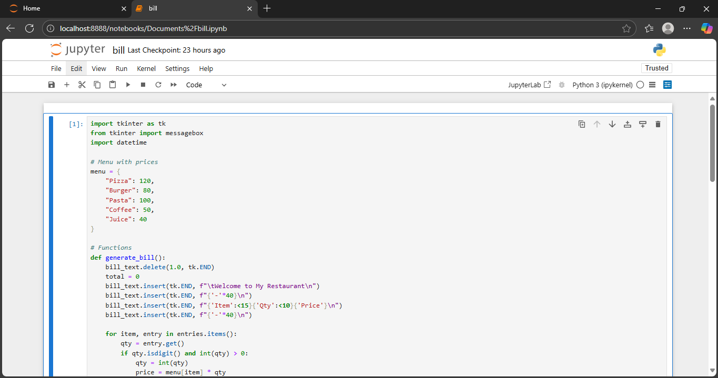

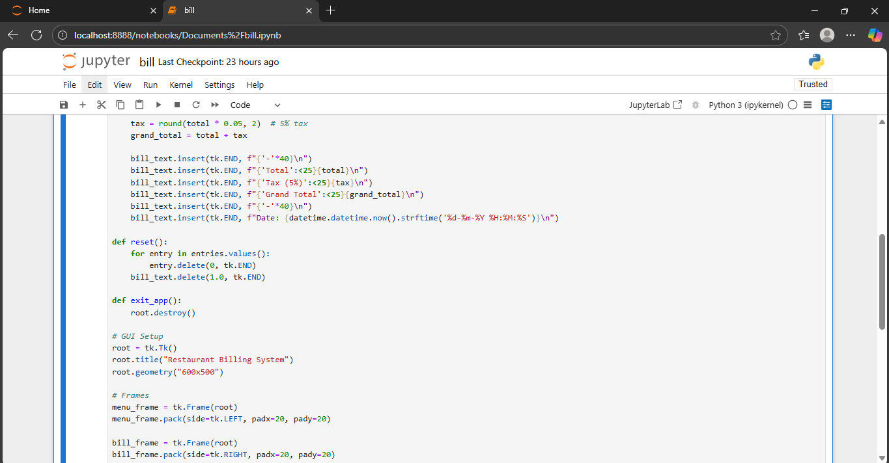

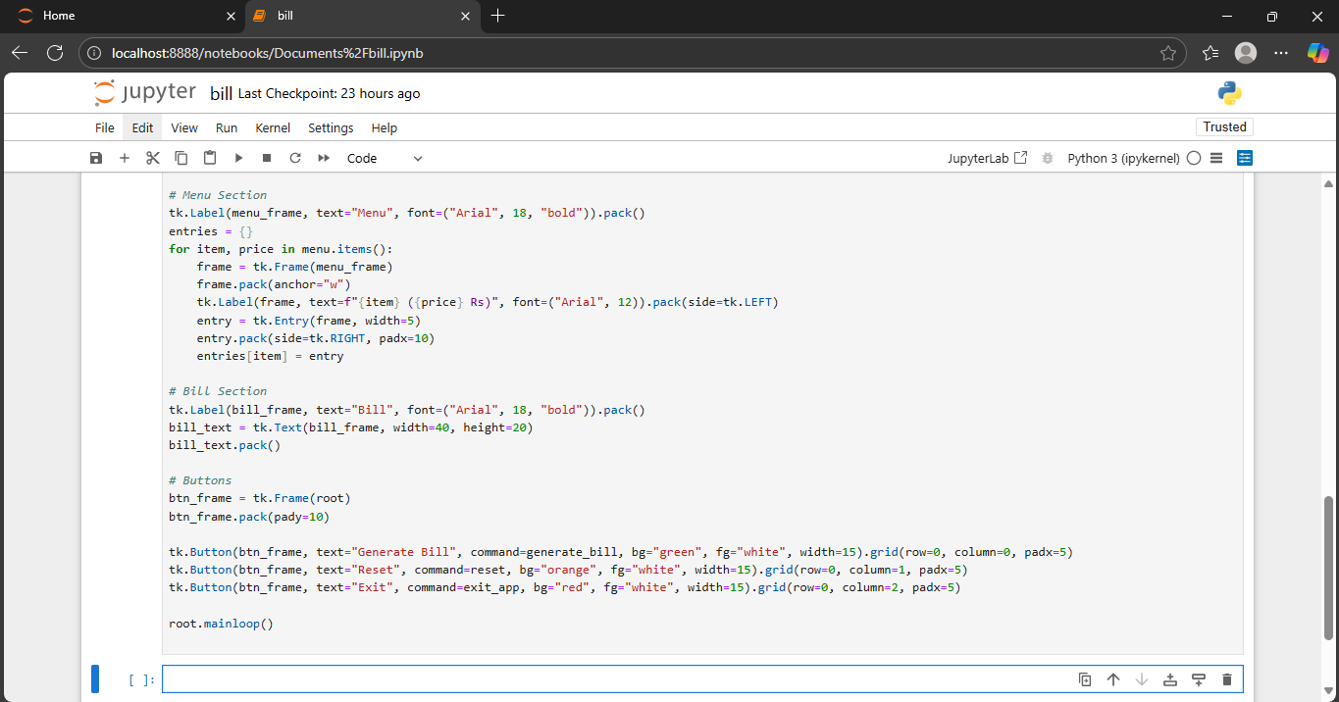

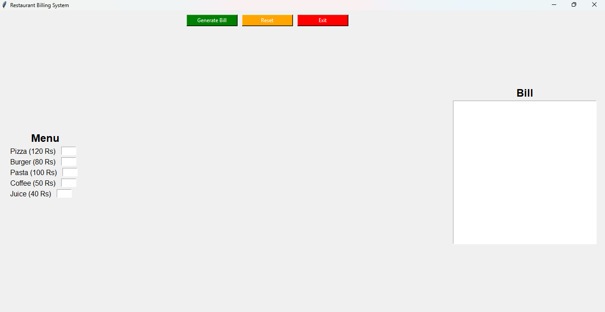

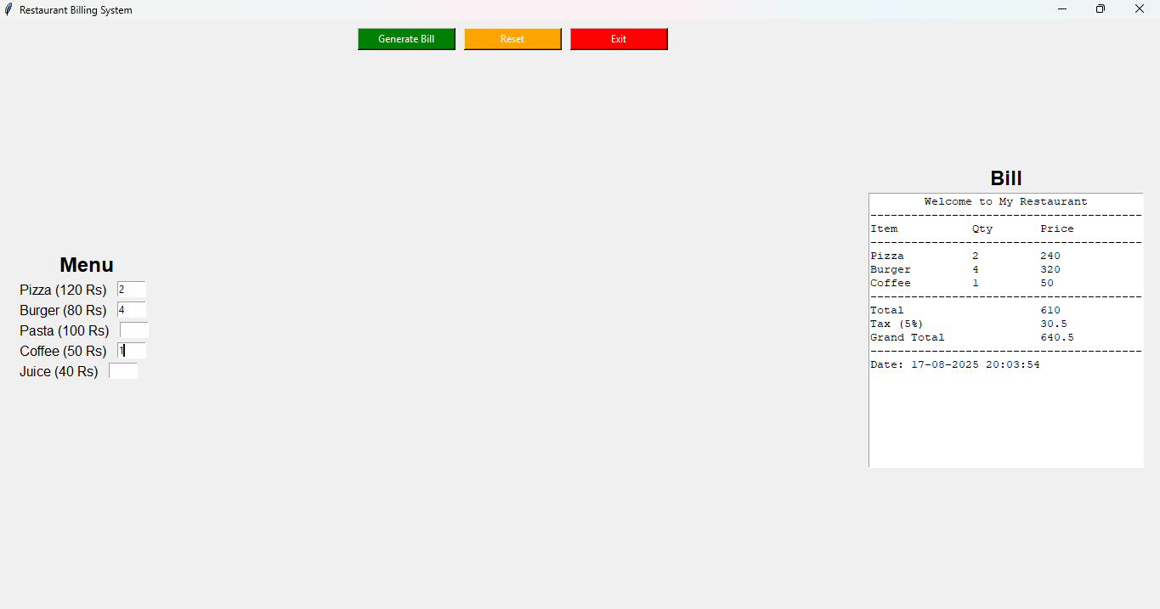

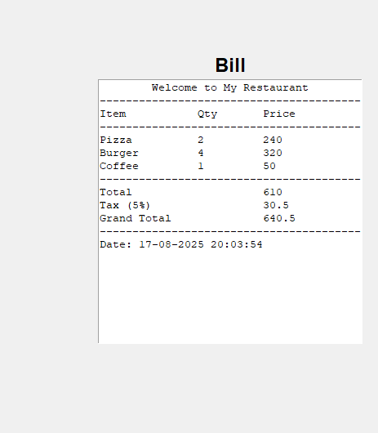

# 5. Results and Analysis

- The system correctly calculates totals and applies taxes.  
- Provides a clean and formatted bill.  
- Reduces manual effort and errors.  
- GUI is user-friendly for restaurant staff.

# 6. Challenges Faced and Solutions

1. Aligning bill text formatting – Solved using string formatting.  
2. Reset functionality – Implemented by clearing text and entries.  
3. Tax calculation accuracy – Ensured by rounding to 2 decimals.

# 7. Conclusion

The Restaurant Billing System successfully automates bill generation, making the process faster and more accurate. It demonstrates how Python and Tkinter can be used to build simple but effective desktop applications.

# 8. References

1. Python Official Documentation – https://docs.python.org/3/  
2. Tkinter Documentation – https://docs.python.org/3/library/tkinter.html  
3. GeeksforGeeks – Tutorials on Python Tkinter  
4. Stack Overflow – Programming Community Solutions