ASSIGNMENT – 1:
Create a Flask application with an /api route. When this route is accessed, it should return a JSON list. The data should be stored in a backend file, read from it, and sent as a response.
- Creating a list.txt file which stores list of AWS services which can be sent as a response.
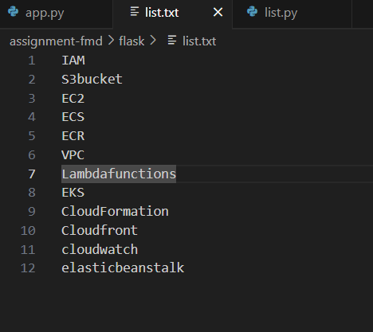

- Creating a list.py file with ‘get_data’ function, which reads the data from list.txt file and returns the data in list form.
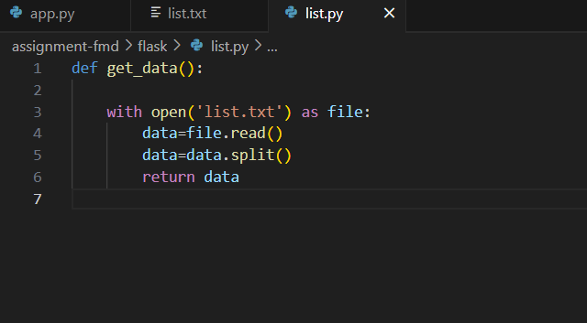

- Creating a flask application with api function which can be accessed through route ‘/api’ , It calls get_data function of list.py and returns the data in json format as a response when /api is accessed through browser.
Command: to run program
Python app.py
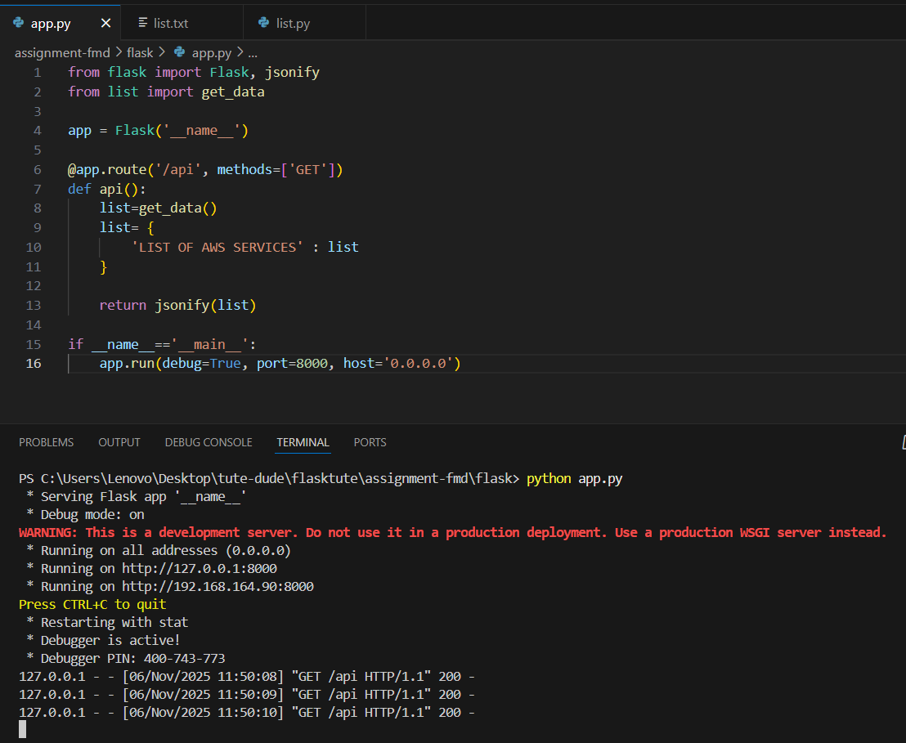

- Accessing http://localhost:8000/api, we get list of AWS services as a response to the api call.
Application is running on port 8000
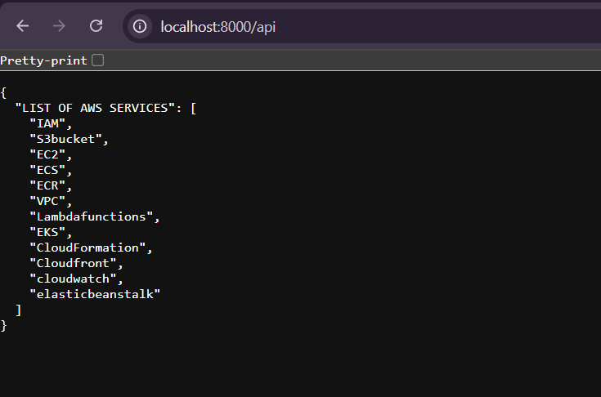

ASSIGNMENT – 2:
Create a form on the frontend that, when submitted, inserts data into MongoDB Atlas. Upon successful submission, the user should be redirected to another page displaying the message "Data submitted successfully". If there's an error during submission, display the error on the same page without redirection.

- Creating a Product Checkout Form (index.html) which asks the user to enter name, contact no., address, and payment details, when all the details entered and clicked on submit button we will be redirected to “success” (success.html) page with message “Data submitted successfully” and the same data will be fetched by backend and inserted into database called MONGODB.
If any of the fields are left empty the same page will show Error message saying “ALL FIELDS ARE MANDATORY”.

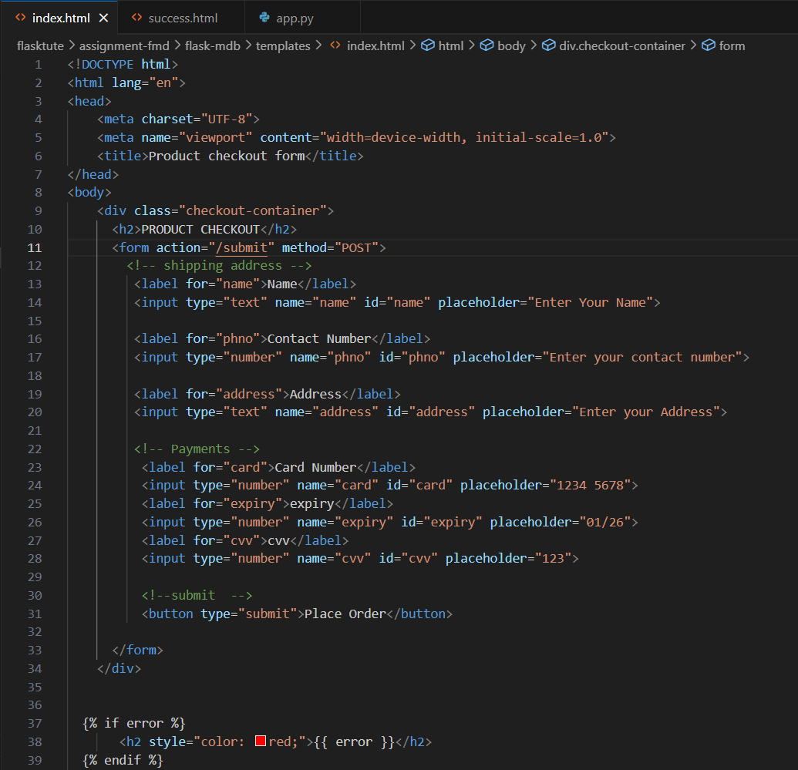

- Success.html
Upon successful submission of data, we will be redirected to success page and we can go back to submit page.
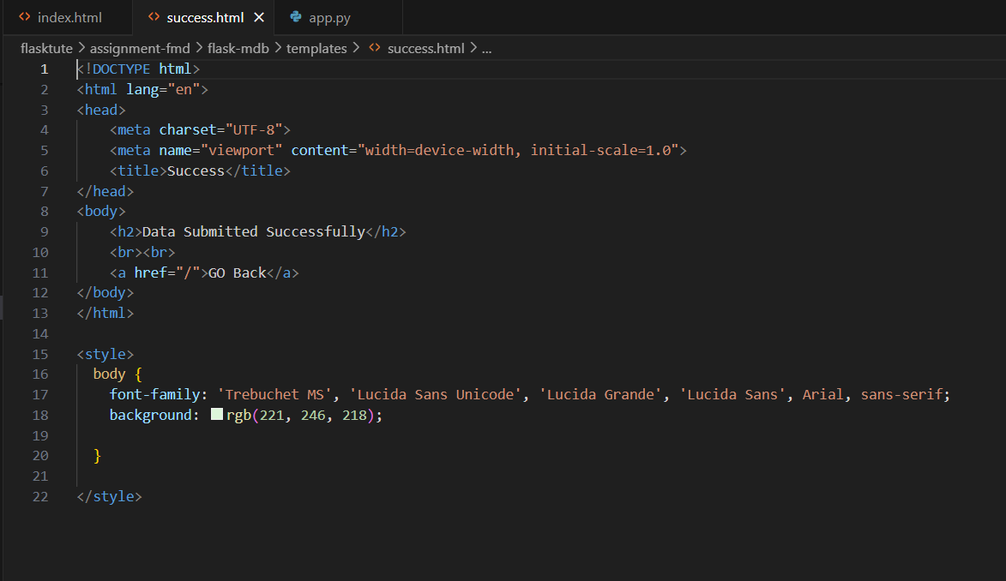

- Creating a flask application.
- It renders index.html and success.html pages
- Using MONGODB URI we will create the connection between flask application and mongodb so that backend can insert data into the database successfully.
client = MongoClient (MONGO_URI).
- Creating a database with name “assignment”
db = client[“assignment”]
- Creating a collection inside database.
collection=db[“flask-mongo”]
- Creating route ‘/’ which renders index.html page and can be fetched when we access http://localhost:5000 f from browser.

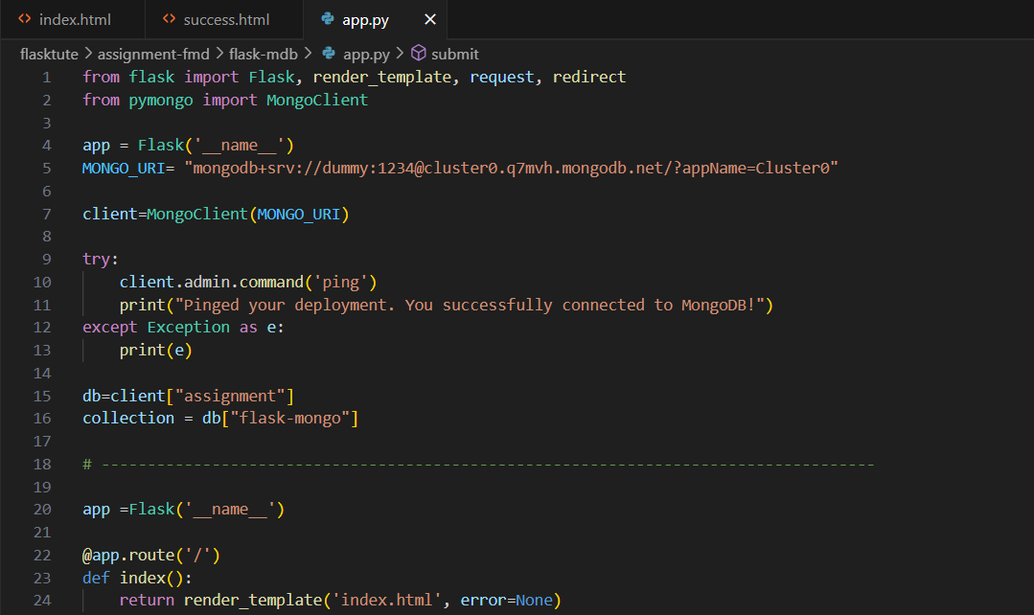

- Creating a function submit, which can be accessed with route ‘/submit’ with API methods ‘GET’ and ‘POST’. It gets the data from product checkout form and checks if all the data is received, if yes it will insert the data in mongodb database and redirects to success page which displays success message. If any of the data is not received it will send error message on same page saying.
- Application is running on PORT 5000
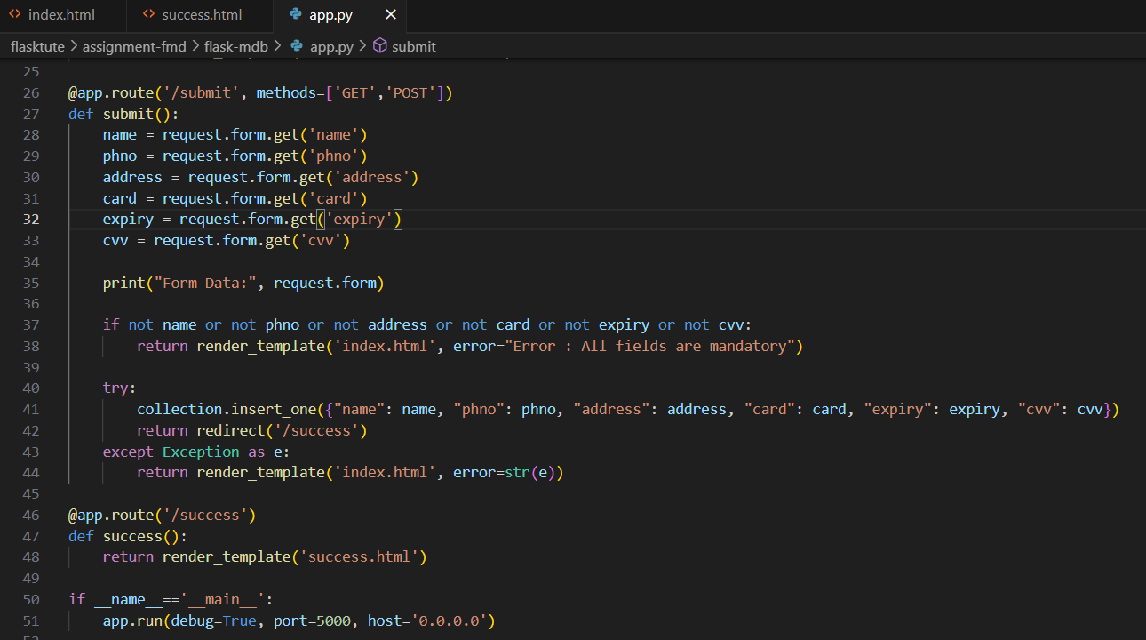

- Accessing form.
http://localhost:5000

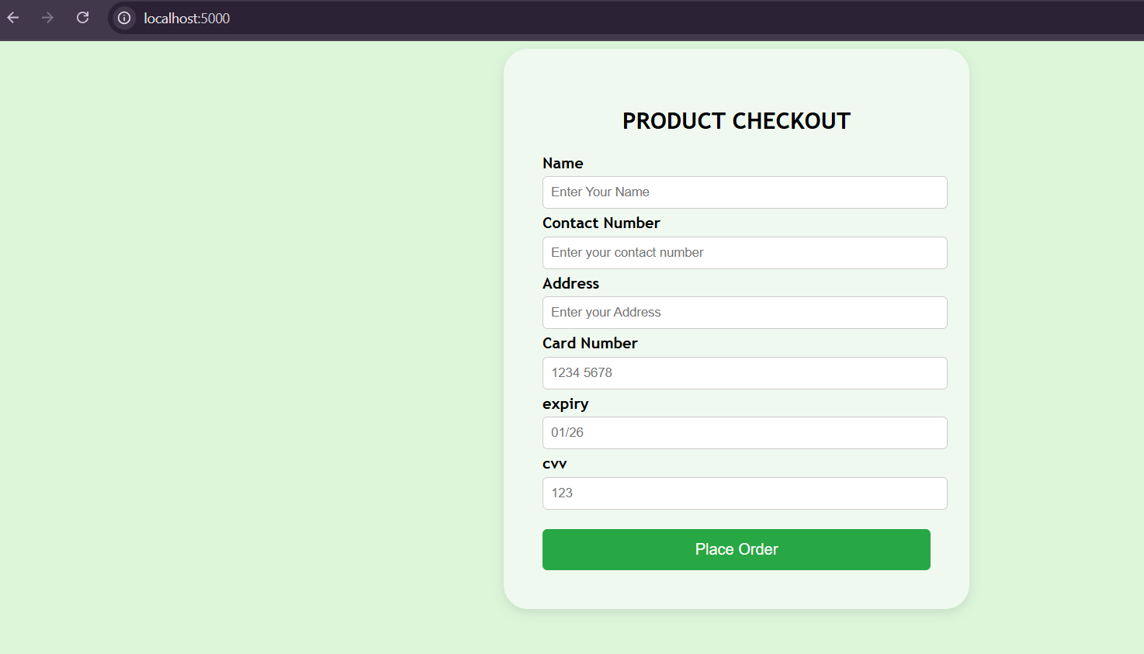

- Entering all the details and clicking on submit button.
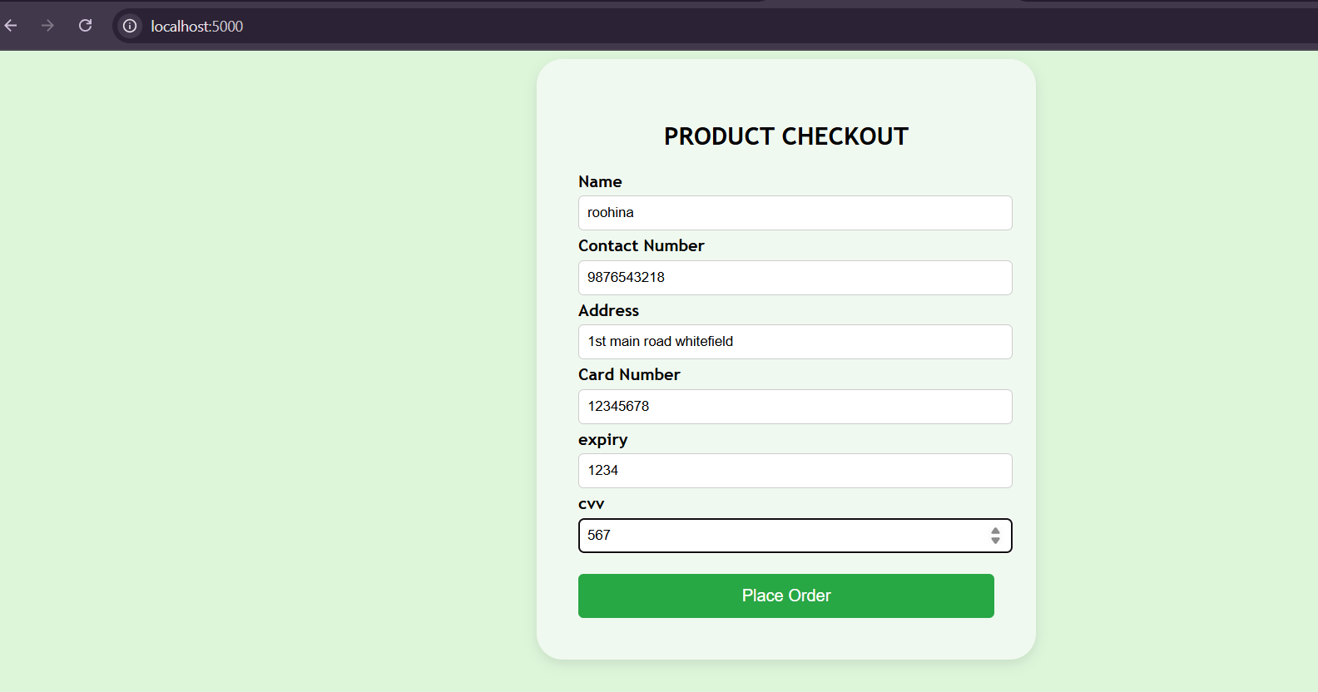
- Upon successful submission we will be redirected to “success” page with message.
http://localhost:5000/success
click on ‘GO Back’ to go to product checkout form.
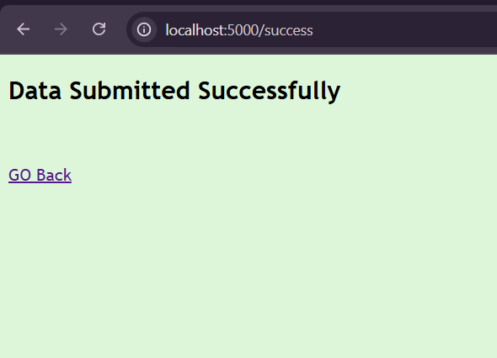

- Logging into MongoDB and checking whether the data is inserted or not.
It shows database “assignment” and collection “flask-mongo” is created and data inserted successfully.
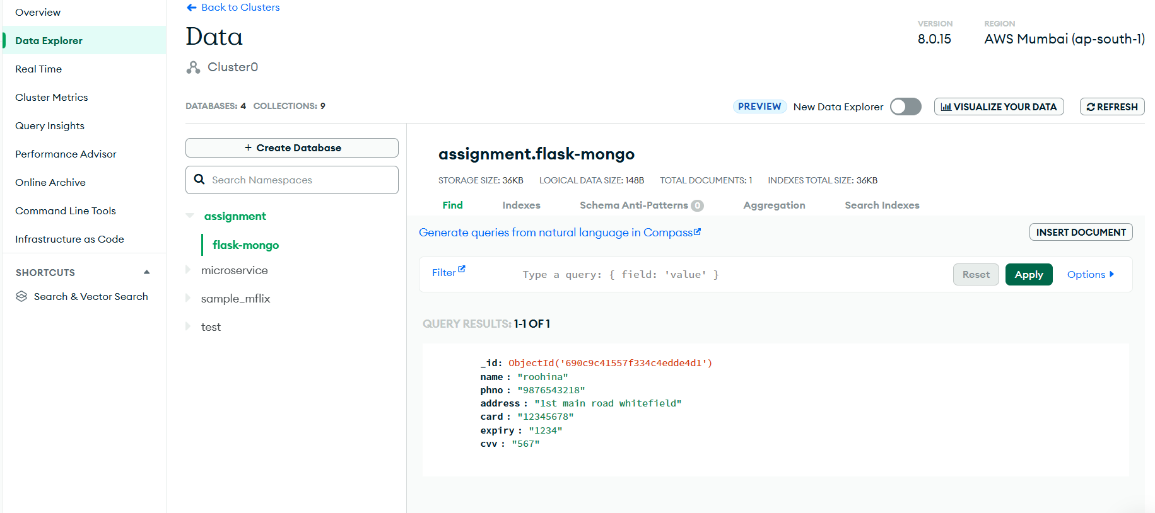

- Entering all the fields and leaving ‘cvv’ field empty and clicking on place order button to see if it shows error message.
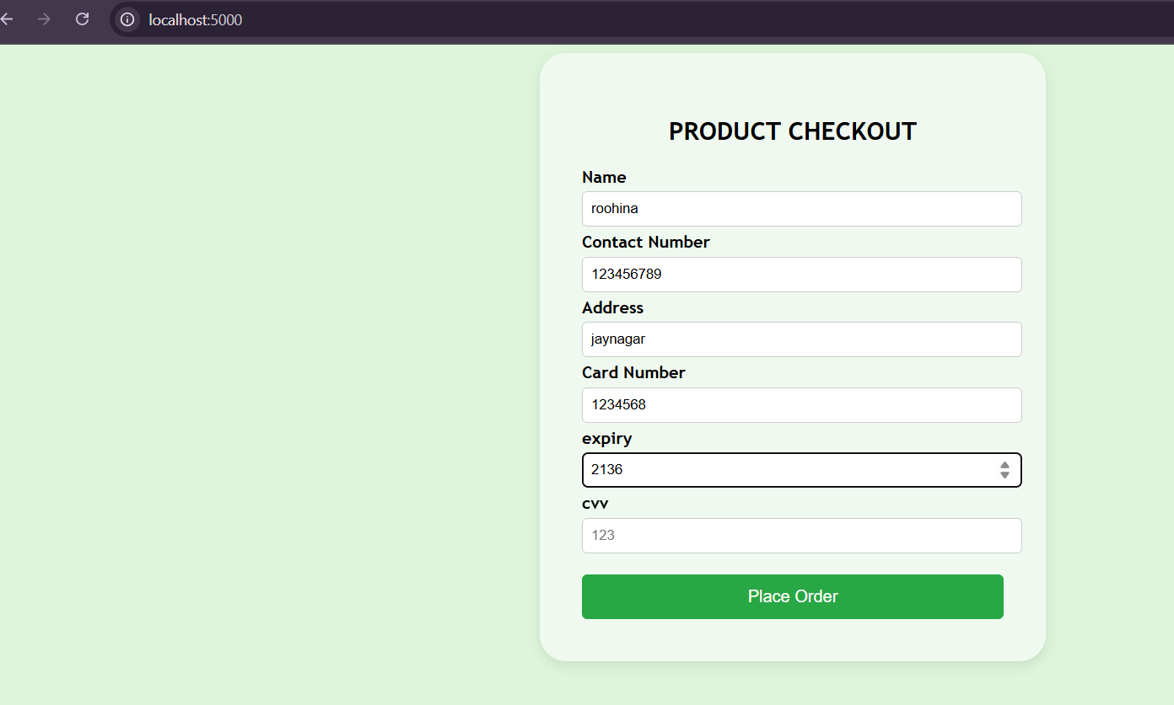

The Error Message is displayed.
