GitHub-link: https://github.com/roohinaks/git_github_assignment.git
Assignment-1:
Creating and merging branch-1:
- Created a github repository “git_github_assignment”.
- Cloning remote repository inside a directory on local machine using SSH link of remote repo.
Command: git clone git@github.com:roohinaks/git_github_assignment.git
- Open working directory (directory cloned )
Command: cd git_github_assignment
- stage and commit file a.txt to activate the main branch locally.
Command: git add a.txt
git commit -m “commit message”
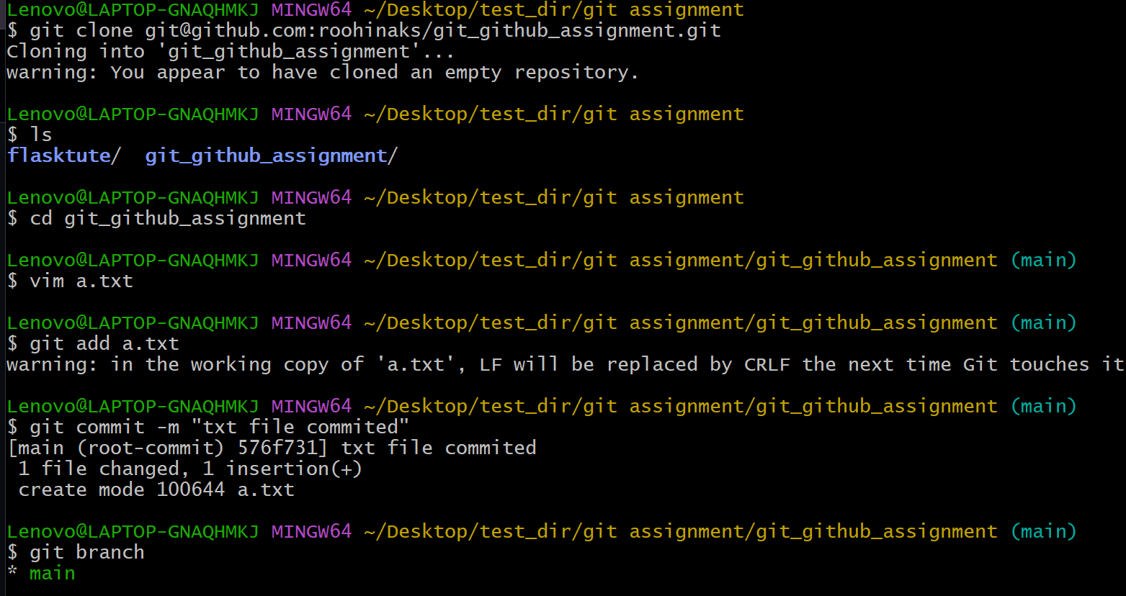
- create a new branch followed by username “roohina” and switch to branch “roohina”
command: git checkout -b roohina

- stage and commit flask application in this new branch.
Command: 1. git add flasktute/
2. git commit -m “commit message”
3. git status (to check status of files and folders staged or not)
4. git log (to check commits made)
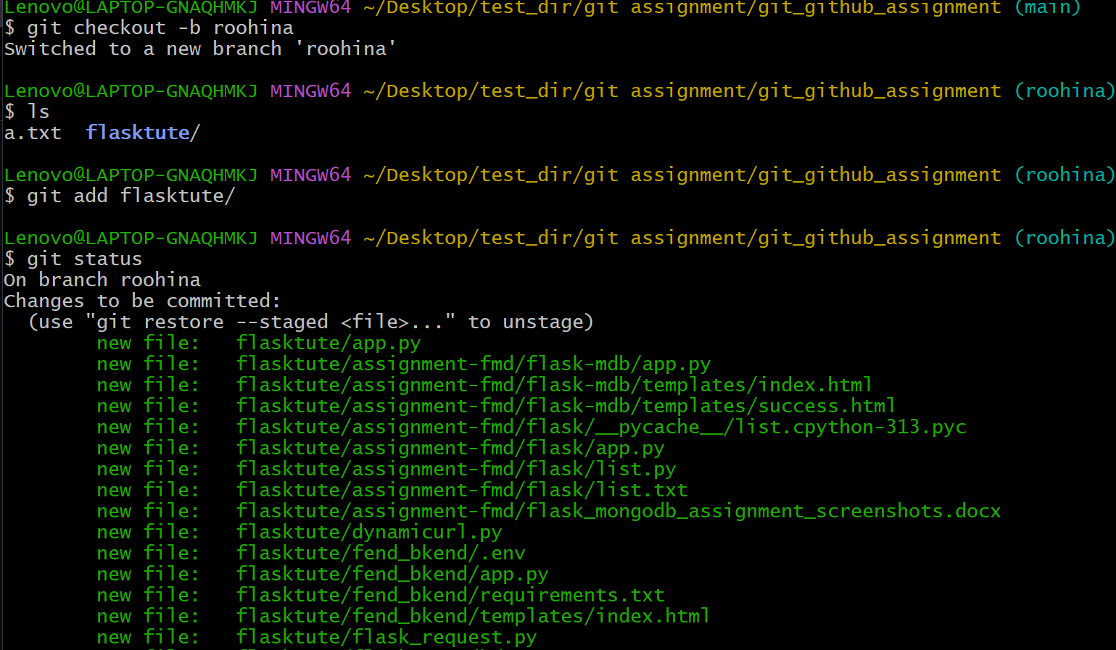

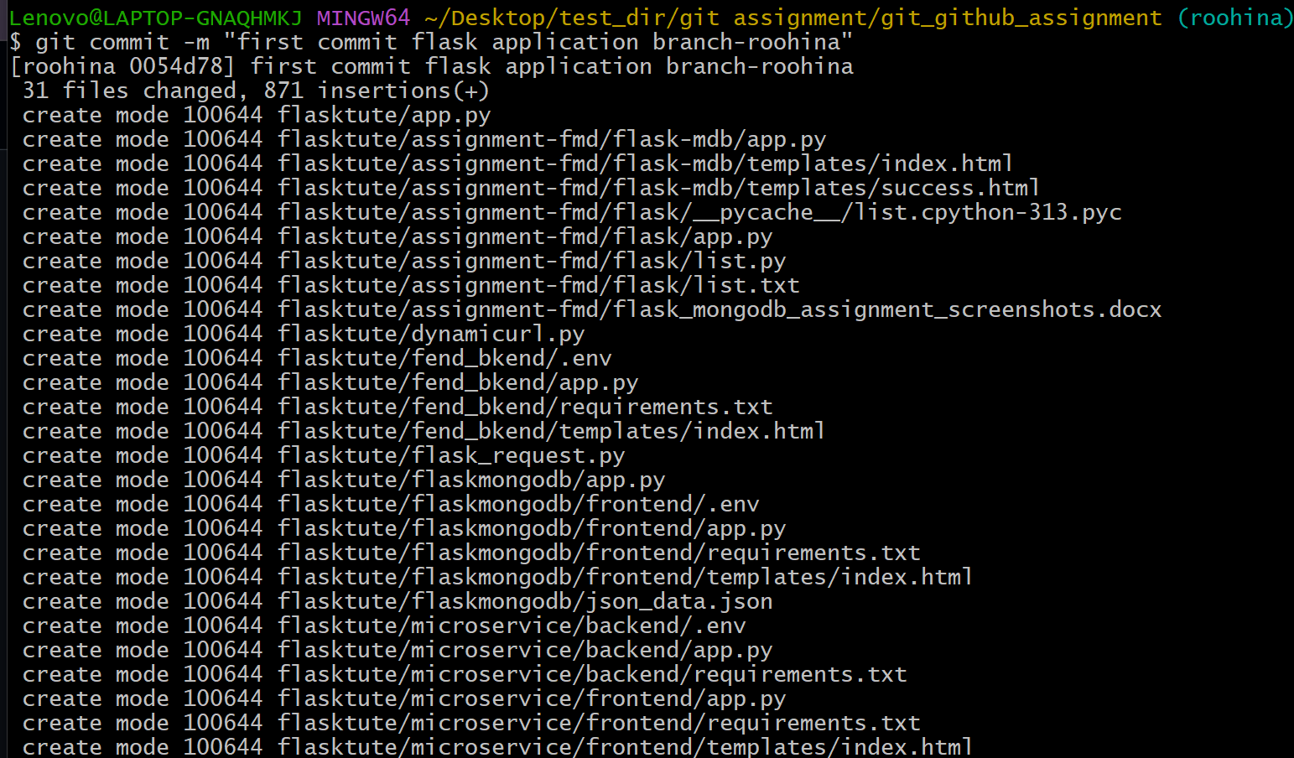
- switch to main branch
command: git checkout main
- merge branch “roohina” into “main”
command: git merge roohina
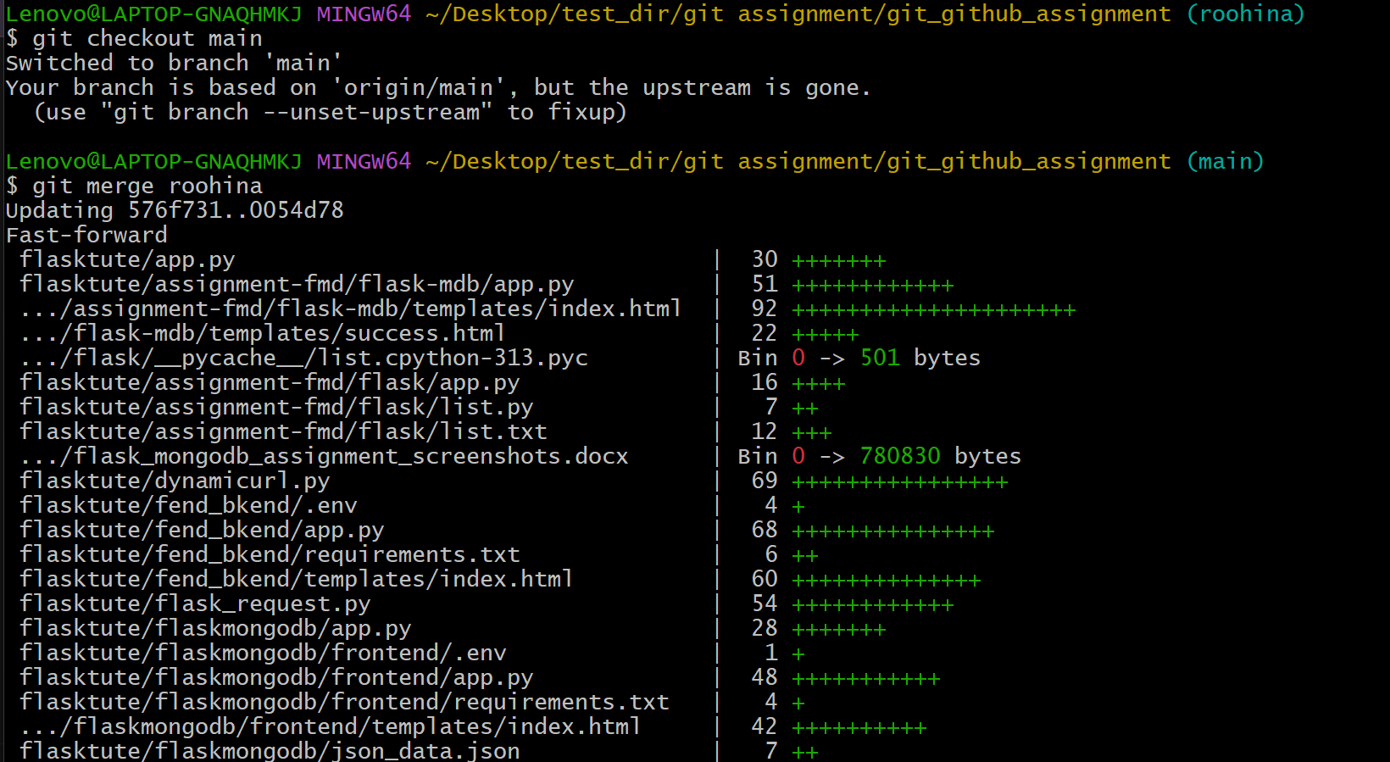
------------------------------------------------------------------------------------------------------------------- 2
Assignment-2:
Creating and merging branch-2: “username_new”
- Create and switch to new branch “roohina_new” form main branch
Command: git checkout -b roohina_new
- Edit “json_data.json” file in roohina_new branch
- Use the “git diff” command to check the changes made to the json file.
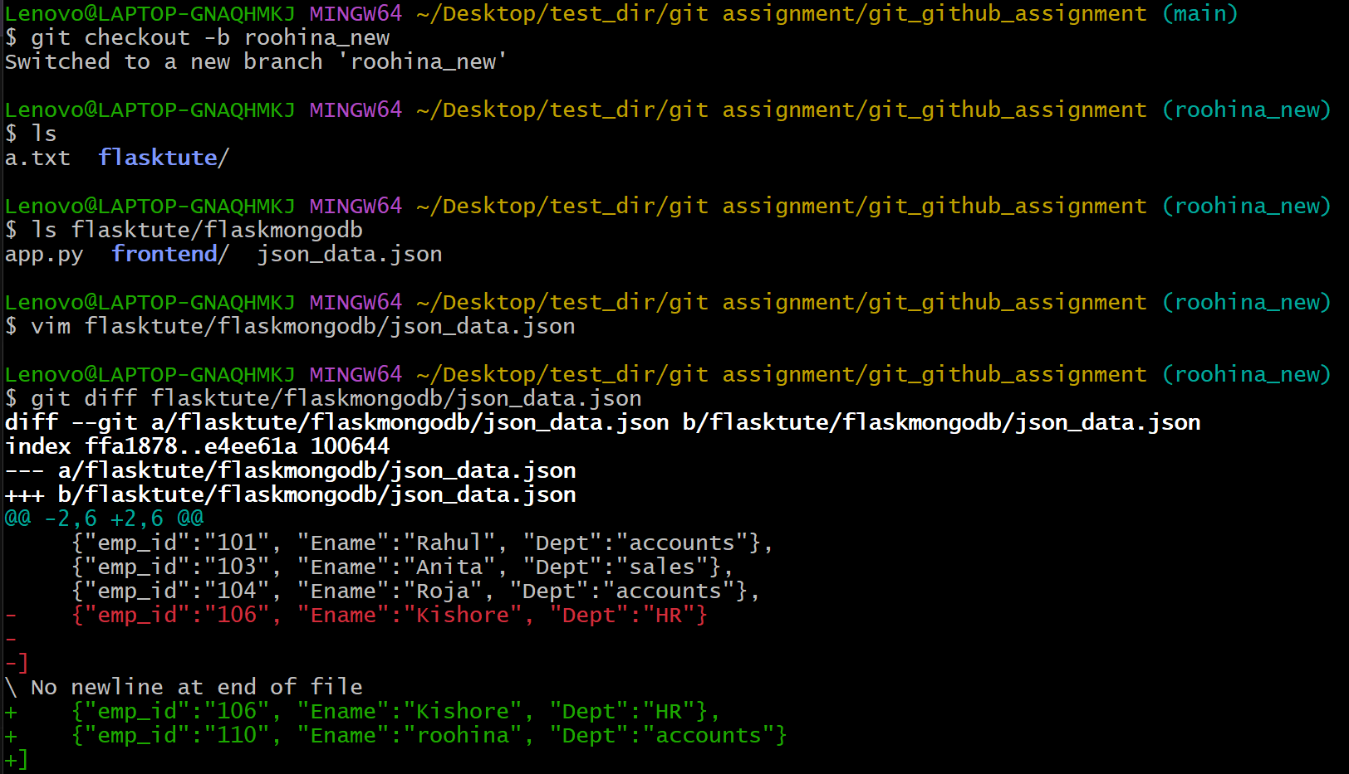
- Add changes made to the staging area and commit the changes made.
- Switch to main branch
- Merge the changes from “roohina_new” branch into main branch
Command: git merge roohina_new
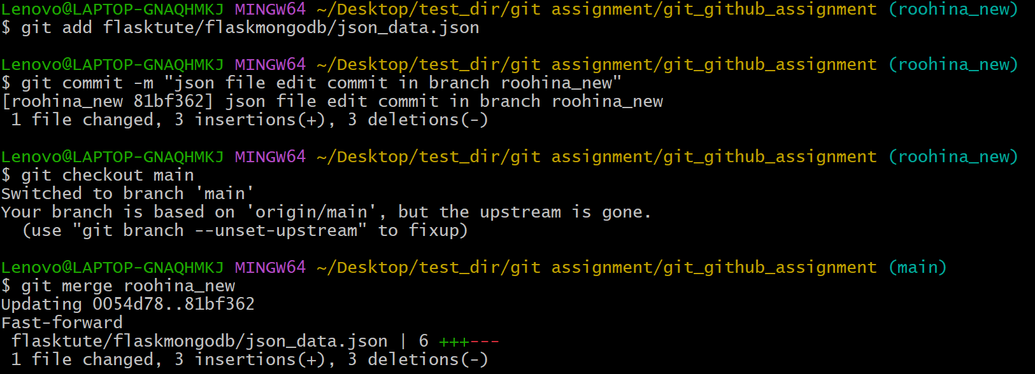
- Push all the commits to the remote repository.
Command: git push origin main
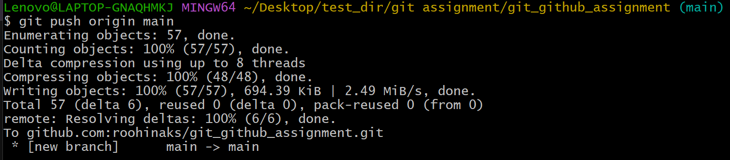

------------------------------------------------------------------------------------------------------------------- 3
Assignment-3:
Creating branches master_1 and master_2.
- Create a todo-app with a frontend containing “index.html” with two fields Item_Name and Item_Description.
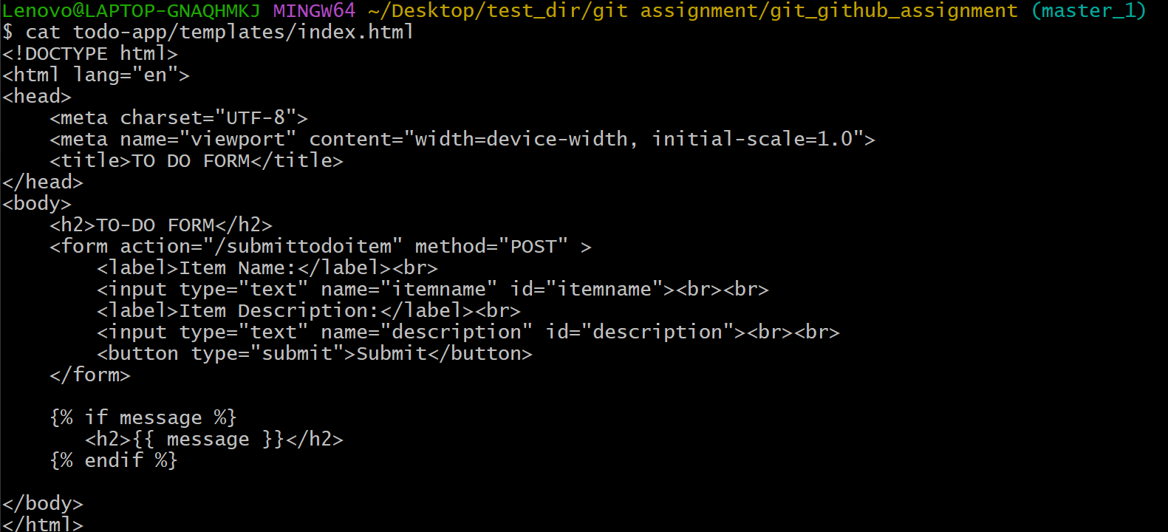
- Create a backend app.py with route “submittodoidem” with “POST” request which fetches data from todo-form and stores into MongoDB database.

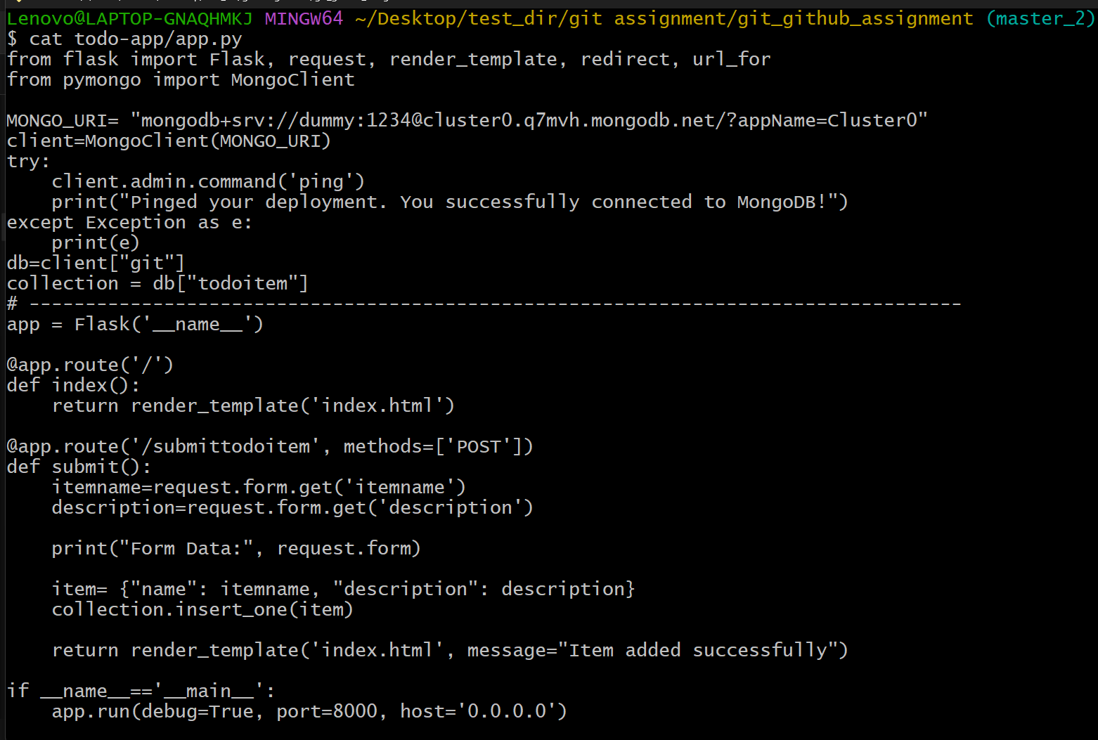
- Create master_1 branch from main and switch.
Command: git checkout -b master_1
- Add index.html form to the staging area.
- Commit the changes.
Command: git add todo-app/templates
git commit -m “commit message”

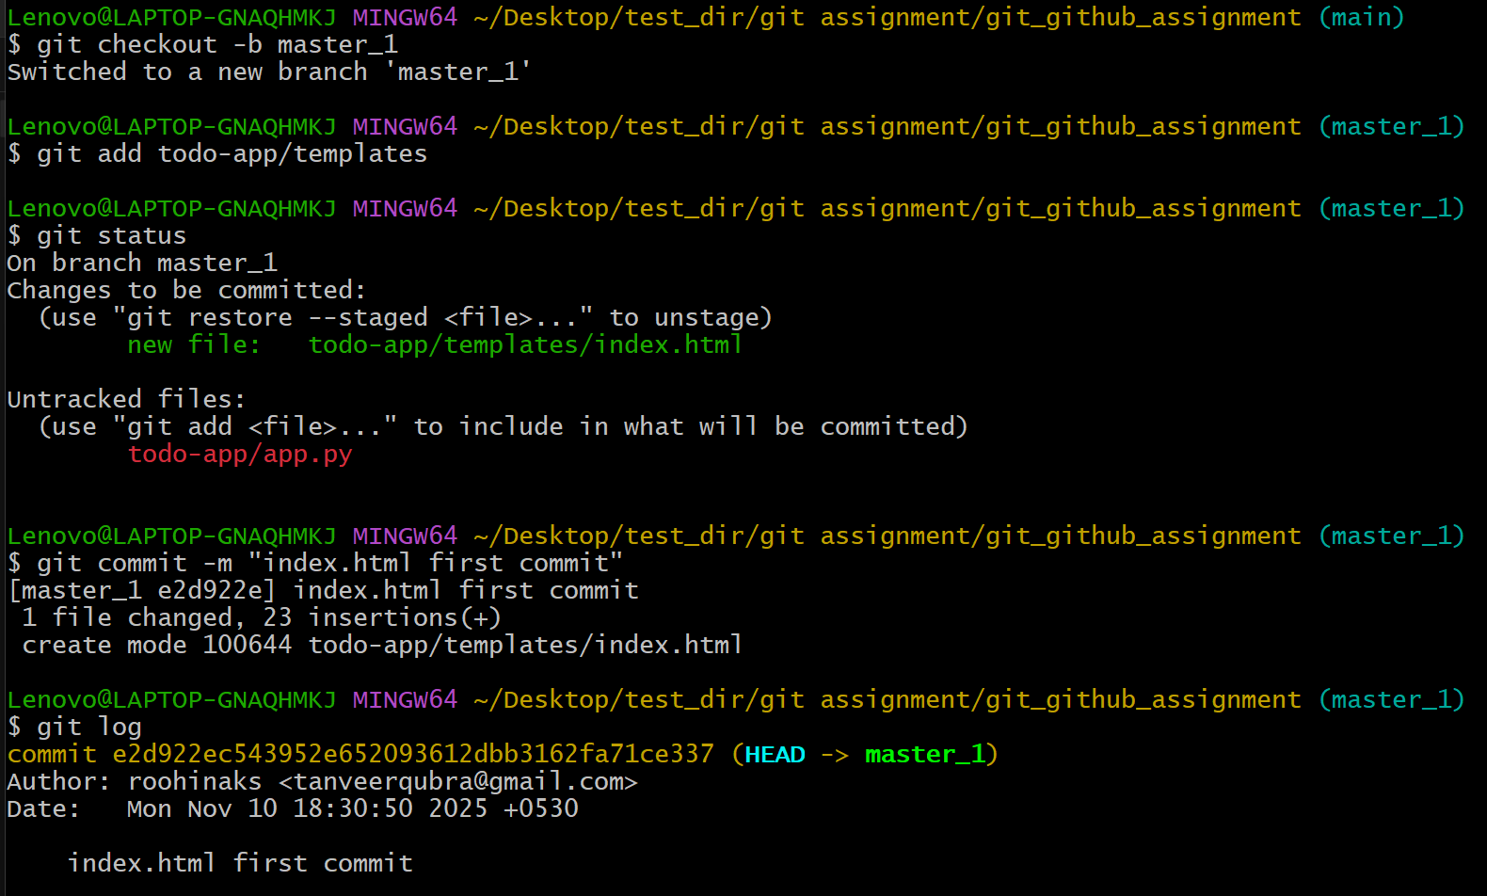
- Checkout to main branch and merge master_1 into main branch
Command: git checkout main
git merge master_1
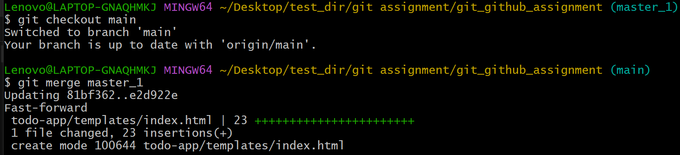

- Create and switch to master_2 branch, stage the backend app.py and commit the changes.
Command: git checkout -b master_2
git add todo-app/app.py
git commit -m “commit message”
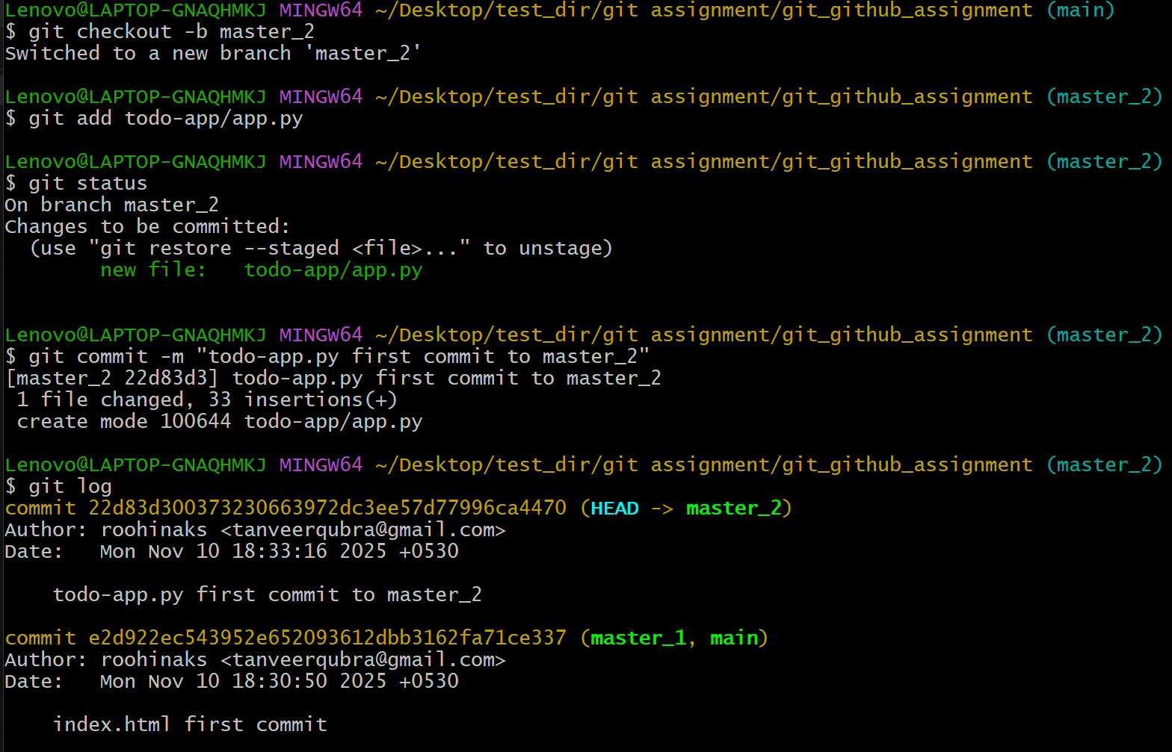
- Checkout to the main branch and merge master_2 into main.
Command: git checkout main
git merge -m “commit message”
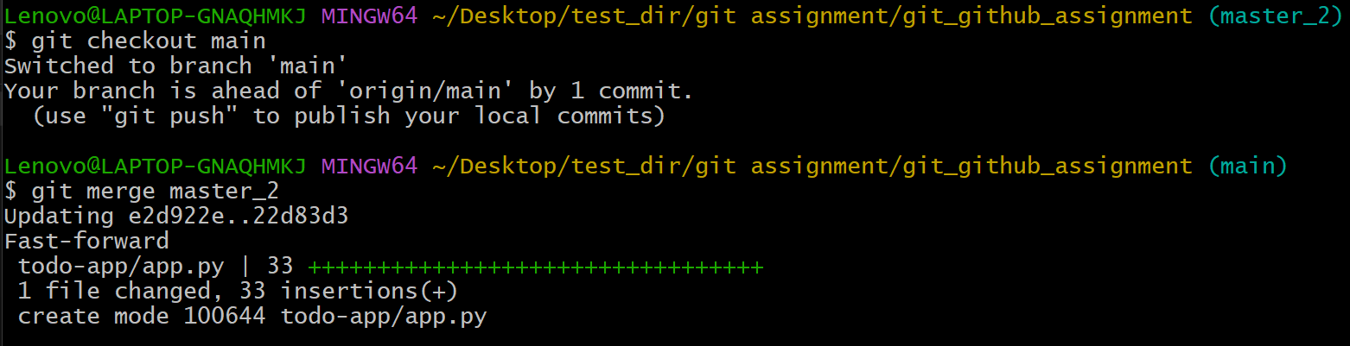

Running application:
- Python app.py
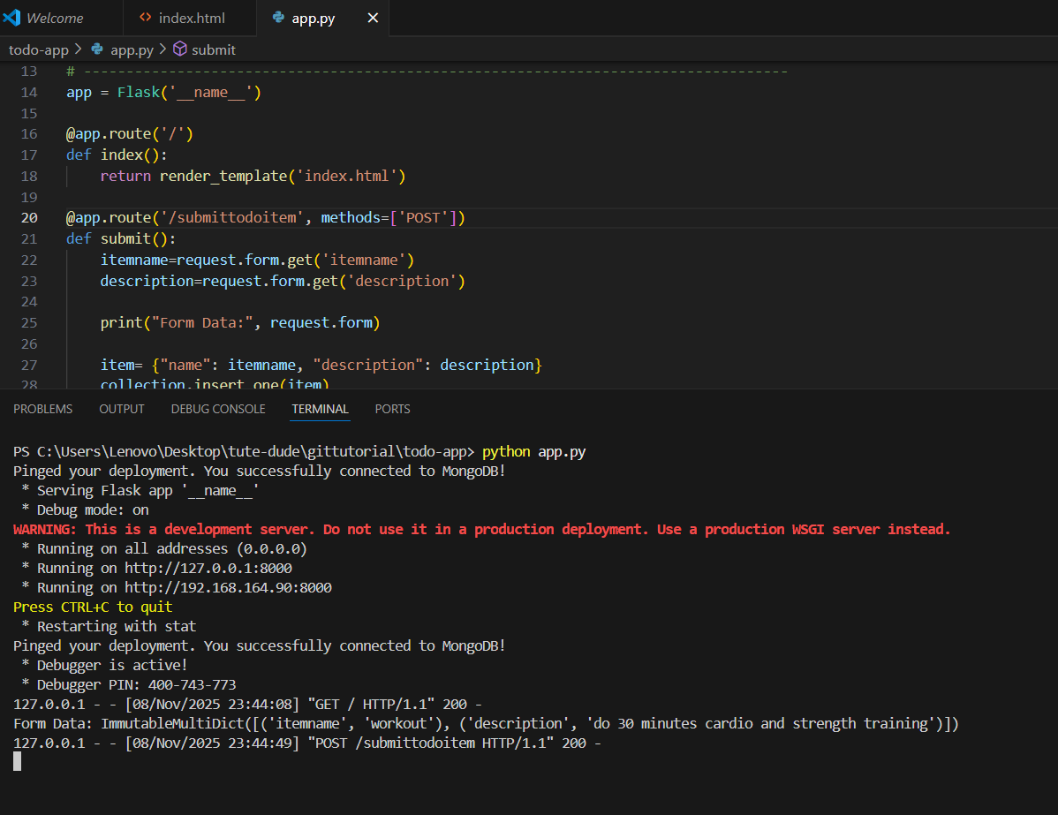

- Access to-do form on browser
http://localhost:8000
enter all the fields and click on the submit button.
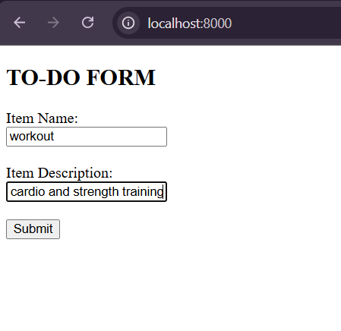
- After the form is submitted, we will be redirected to “submittodoitem” page with a success message.
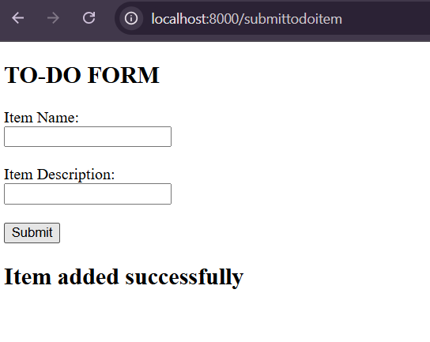

- Data submitted through from is successfully stored in MongoDB database under collection “todoitem”
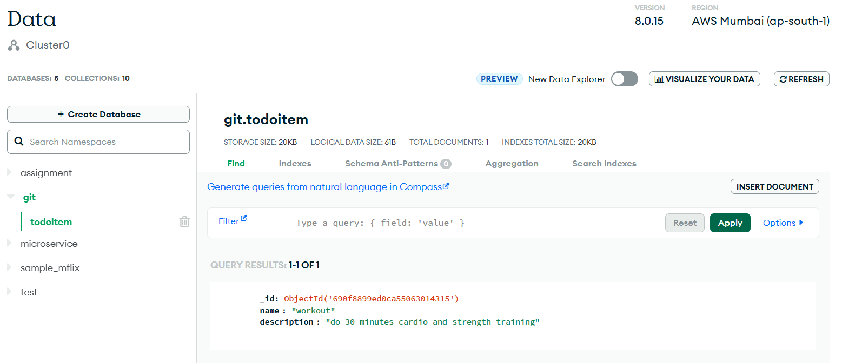

------------------------------------------------------------------------------------------------------------------4
Assignment-4:
Enhancing to-do form in master_1 branch.
- Switch to master_1 branch and add a new field “Item ID” to to-do form and stage and commit the changes to this branch.
Command:
- git diff (to check the changes made in the form before staging)
- git add (stage the changes)
- git commit -m “commit message” (commit the changes)

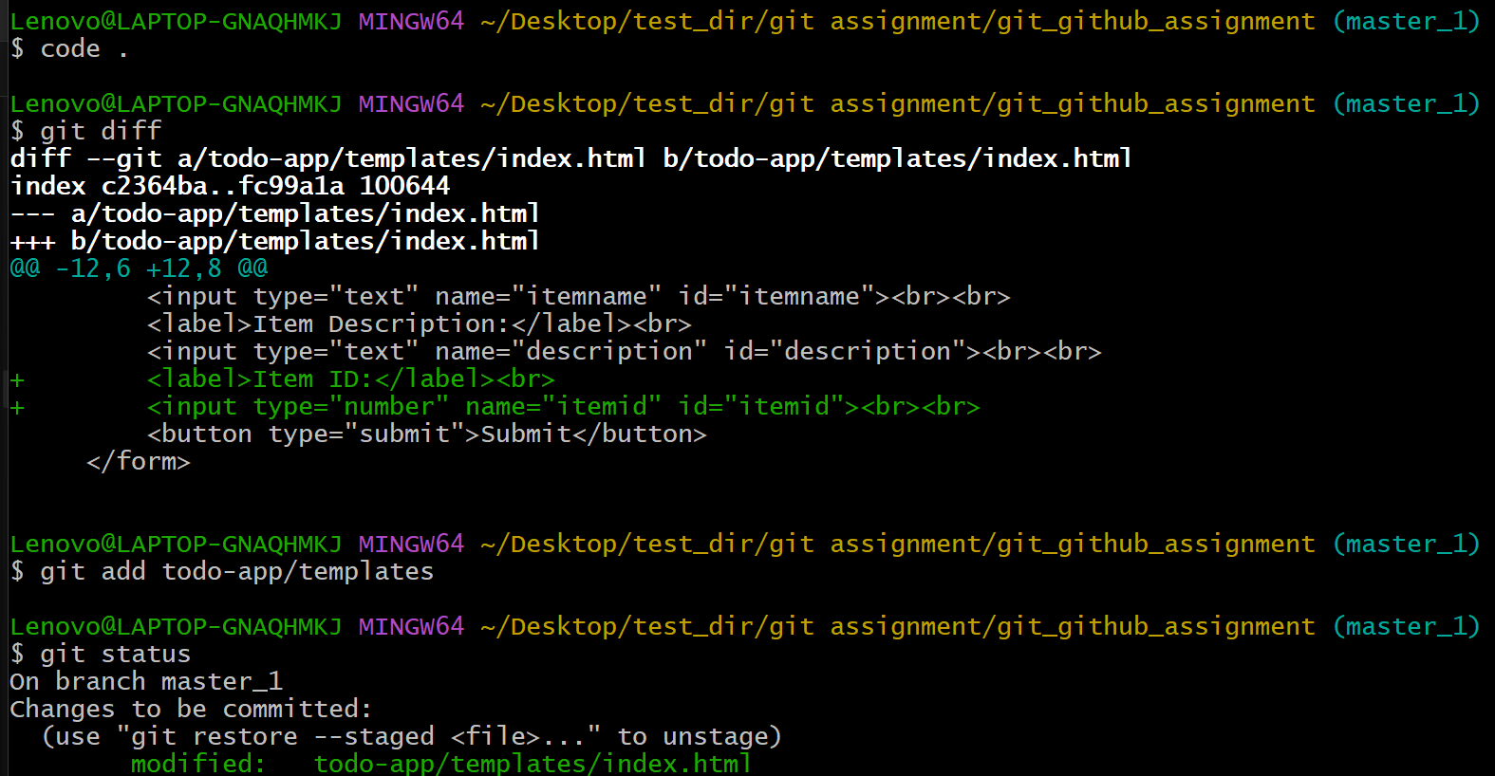
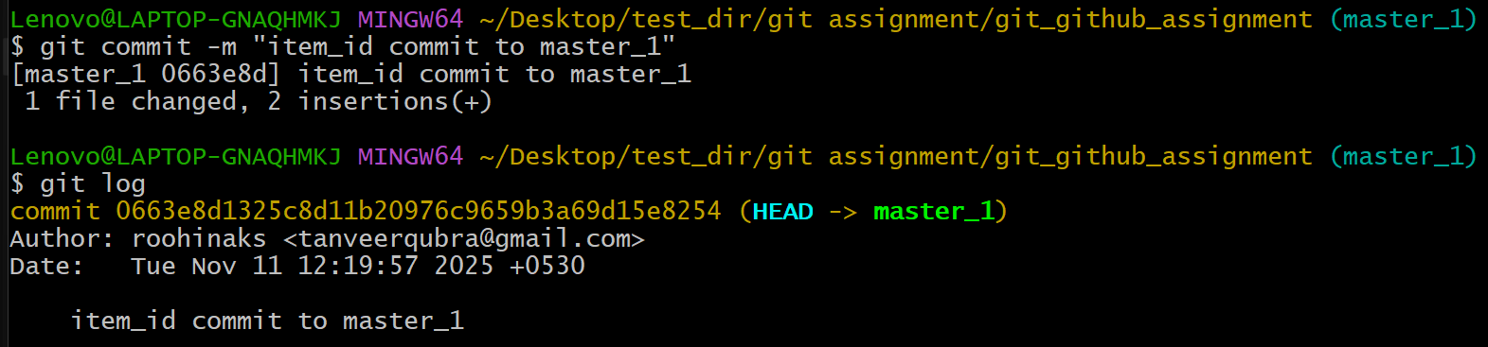
- add a new field “Item UUID” to the form and commit the changes to the master_1 branch.
Command:
- git add todo-app/app.py
- git commit -m “commit message”
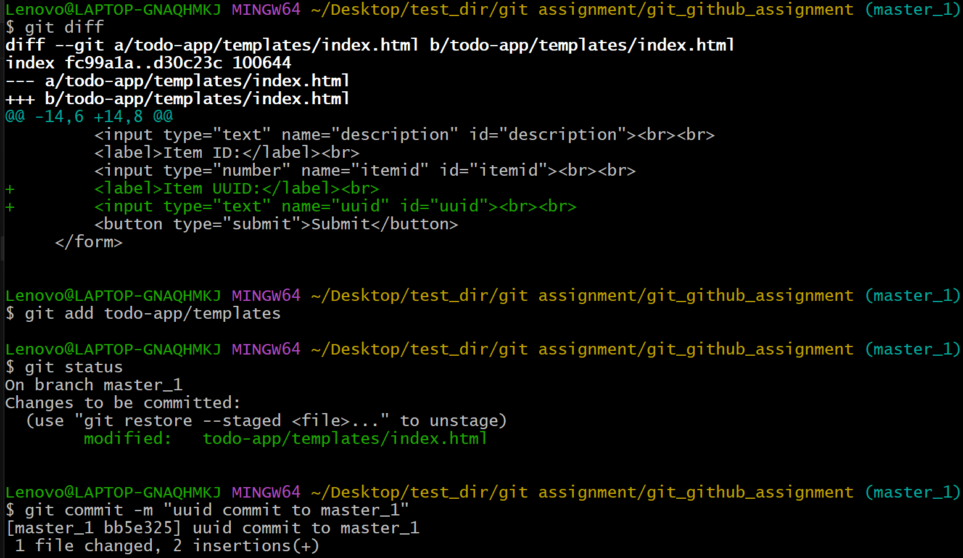

- add a new field “Item HASH” to the form and commit the changes to the master_1 branch.
Command:
- git add todo-app/app.py
- git commit -m “commit message”
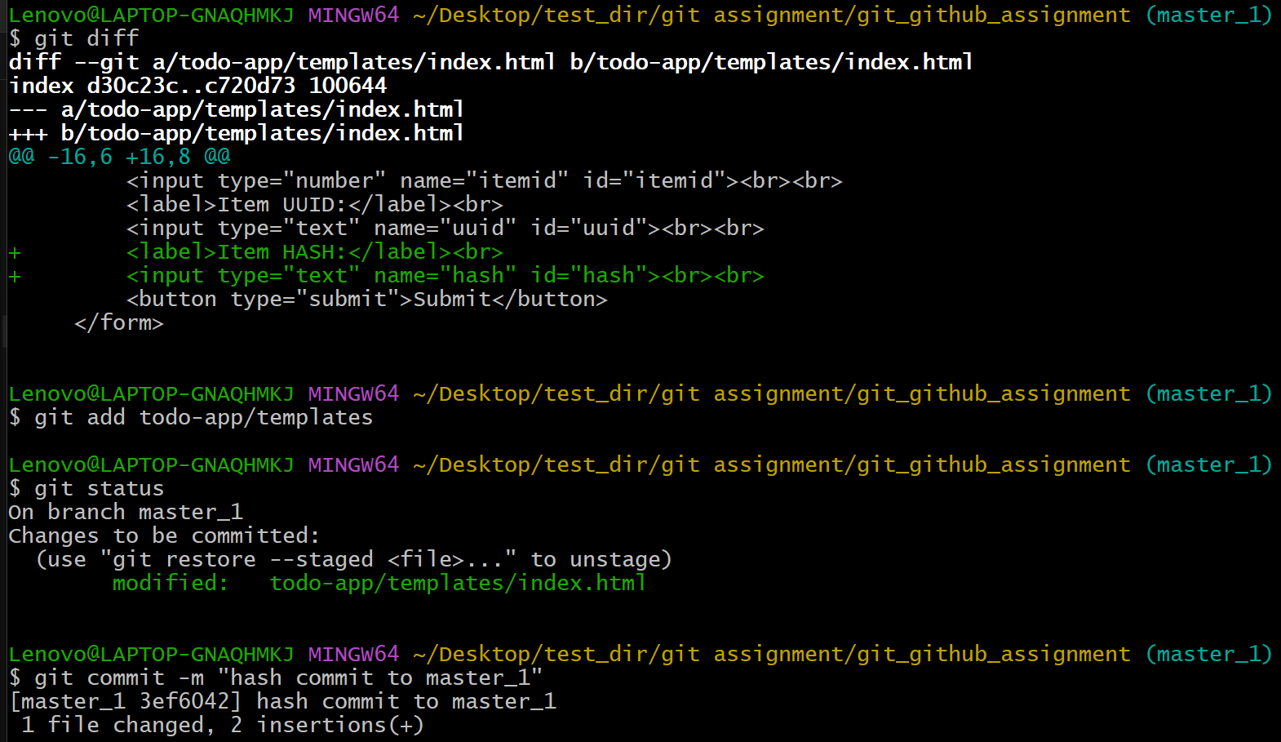
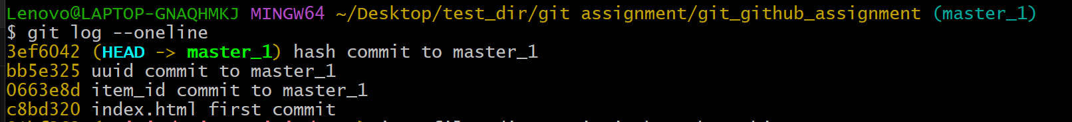

- switch to main branch and merge master_1 branch to main branch
note: added commit message to the merge.
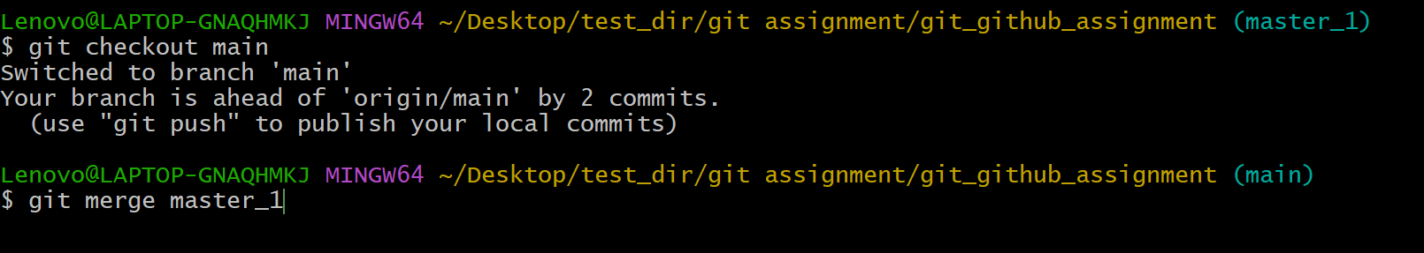
- roll back to the commit where only “Item ID” is committed in main branch
command: git reset - -soft <commit id of item id>
--soft: to keep the changes staged.
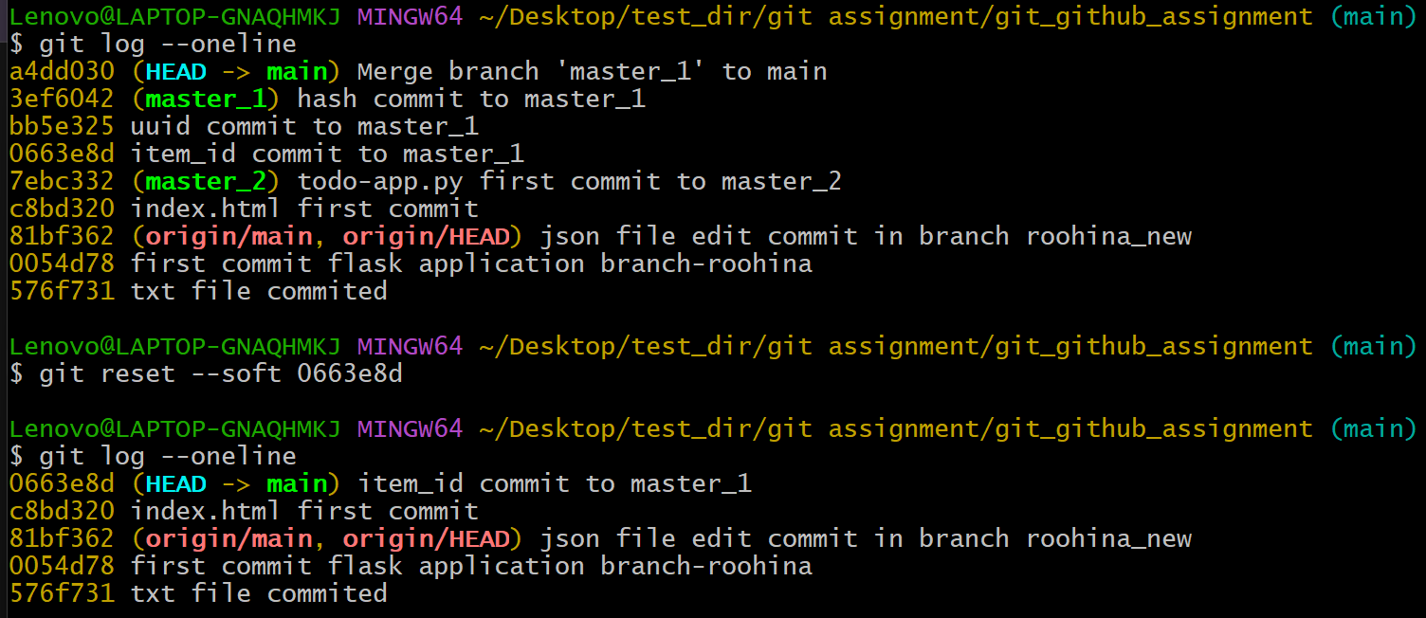
- re-commit the current state after roll back to item id to main branch
- resolving the merge conflict.
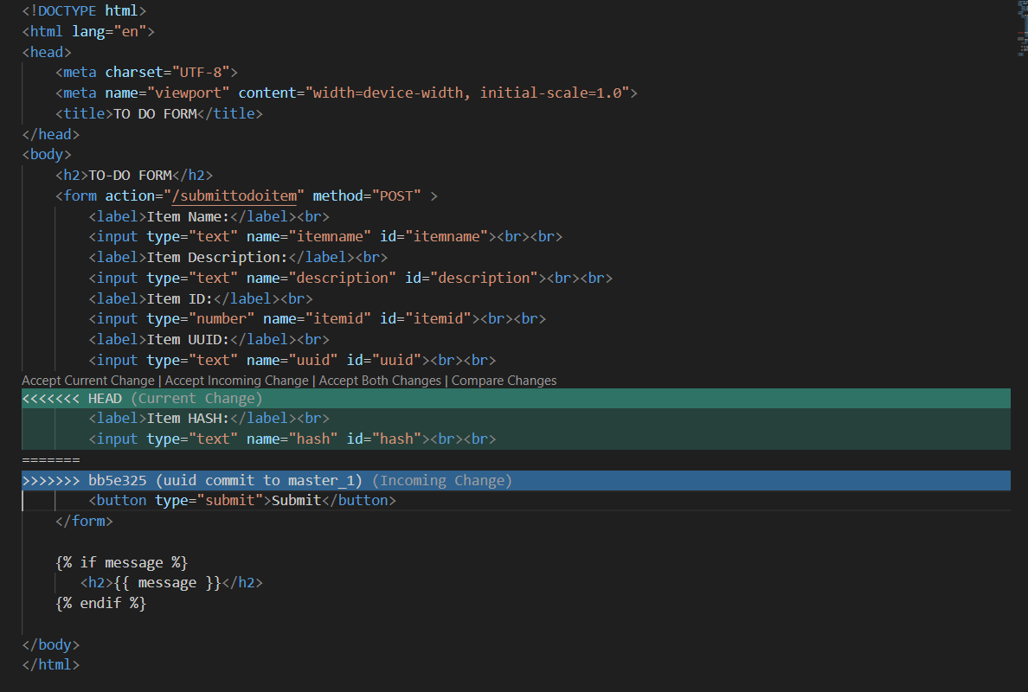
- switch to master_1 branch and rebase main branch commit with master_1 commits. To get master_1 commits on top of commits made in the main branch.
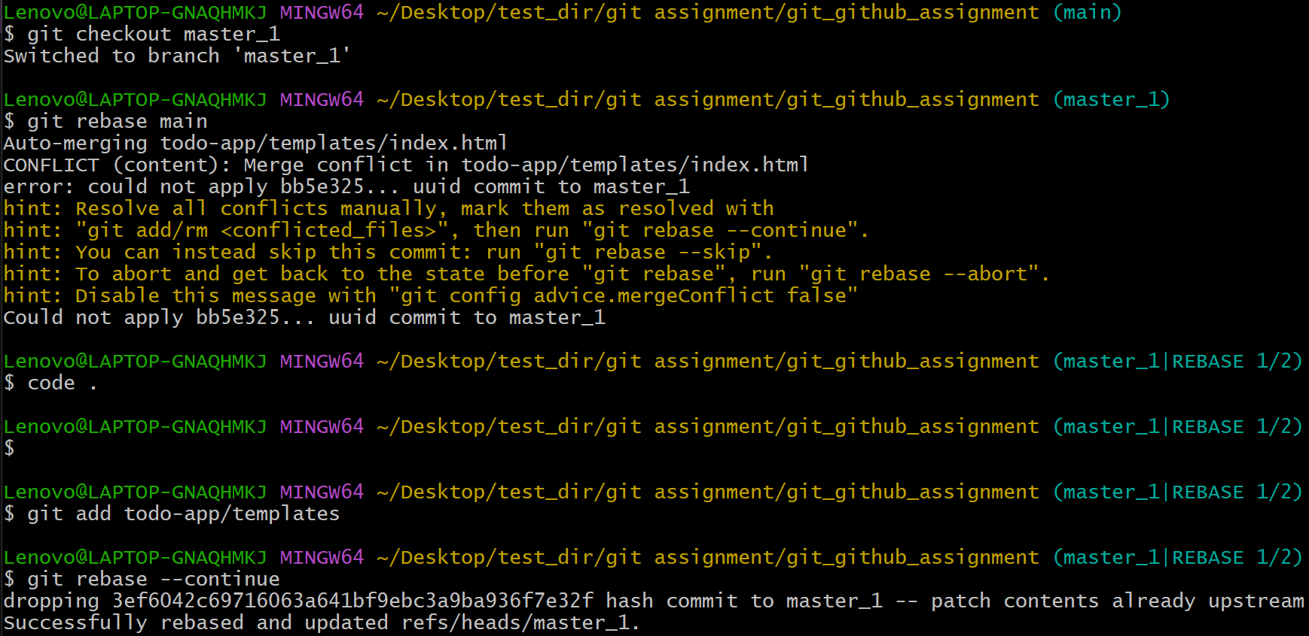
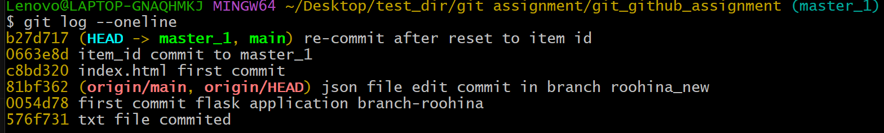
- switch to the main branch and push the changes to the remote repository.
