**Name:** Roohma Kadri

=============================================================

**ASSIGNMENT 01**

**Simple SQL Query with a single table with where clause**

=============================================================

**Northwind Database**

**Sample table: Products**

-ProductID

-ProductName

-SupplierID

-CategoryID

-QuantityPerUnit

-UnitPrice

-UnitsInStock

-UnitsOnOrder

-ReorderLevel

-Discontinued

=============================================================

**USE DATABASE AND CREATE TABLE**

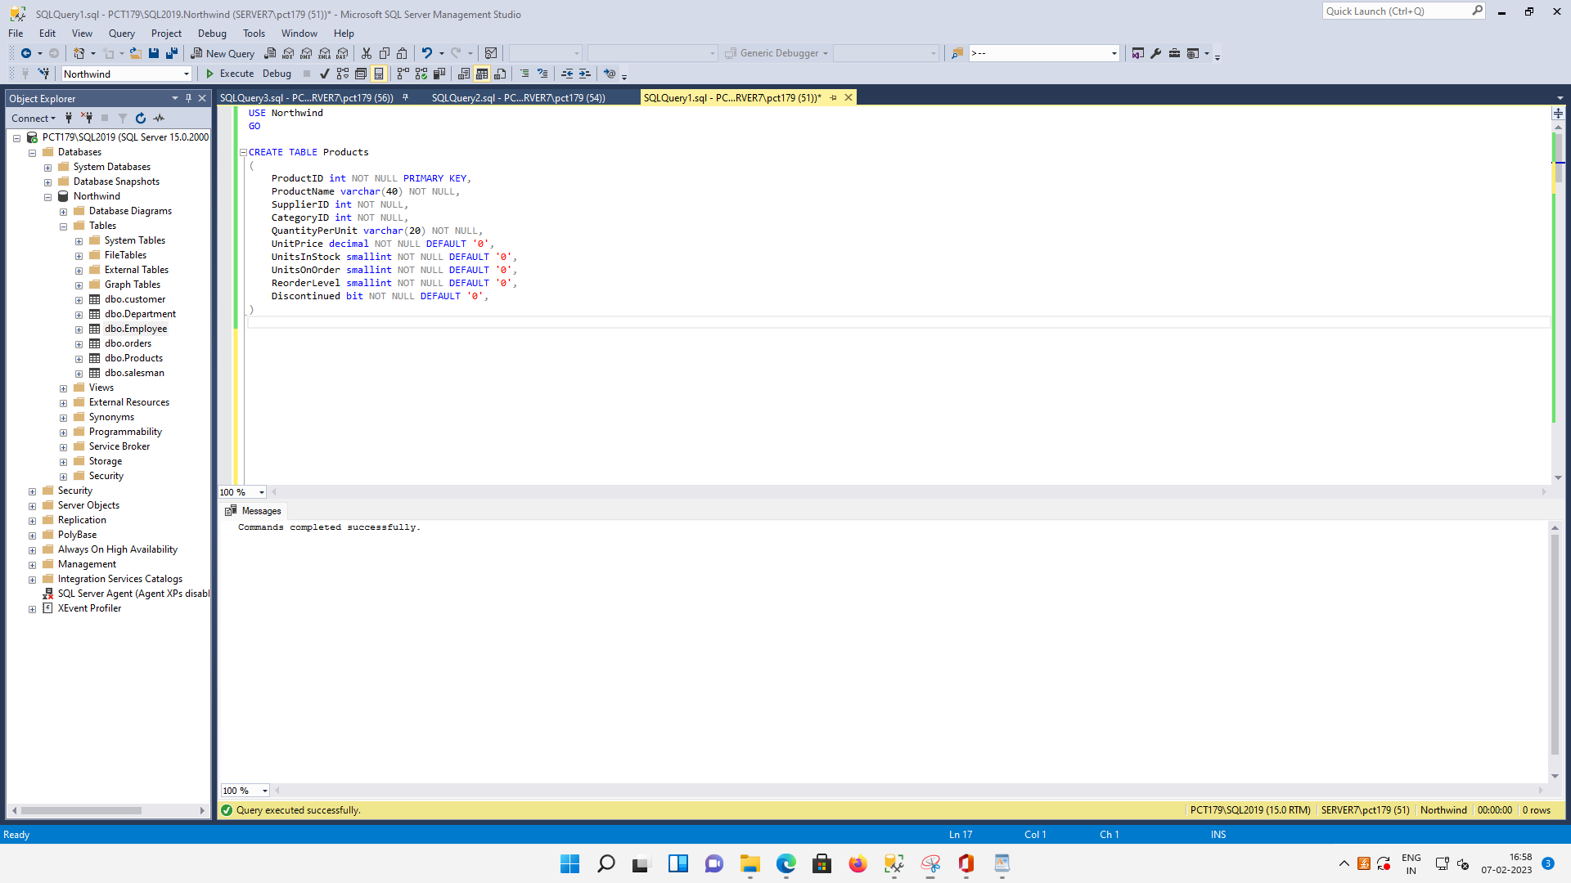

=============================================================

**INSERT DUMMY DATA**

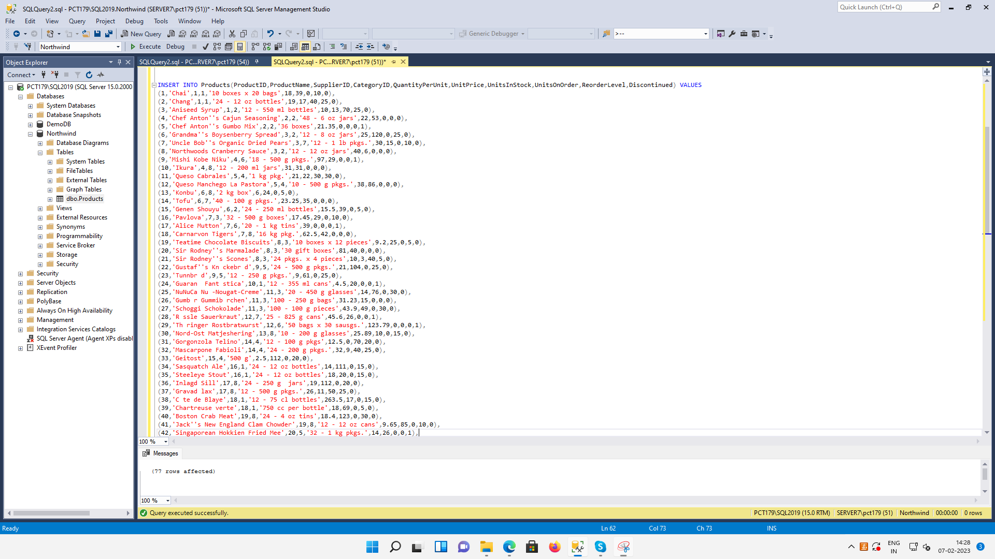

=============================================================

**ALL DATA STORED IN THE TABLE**

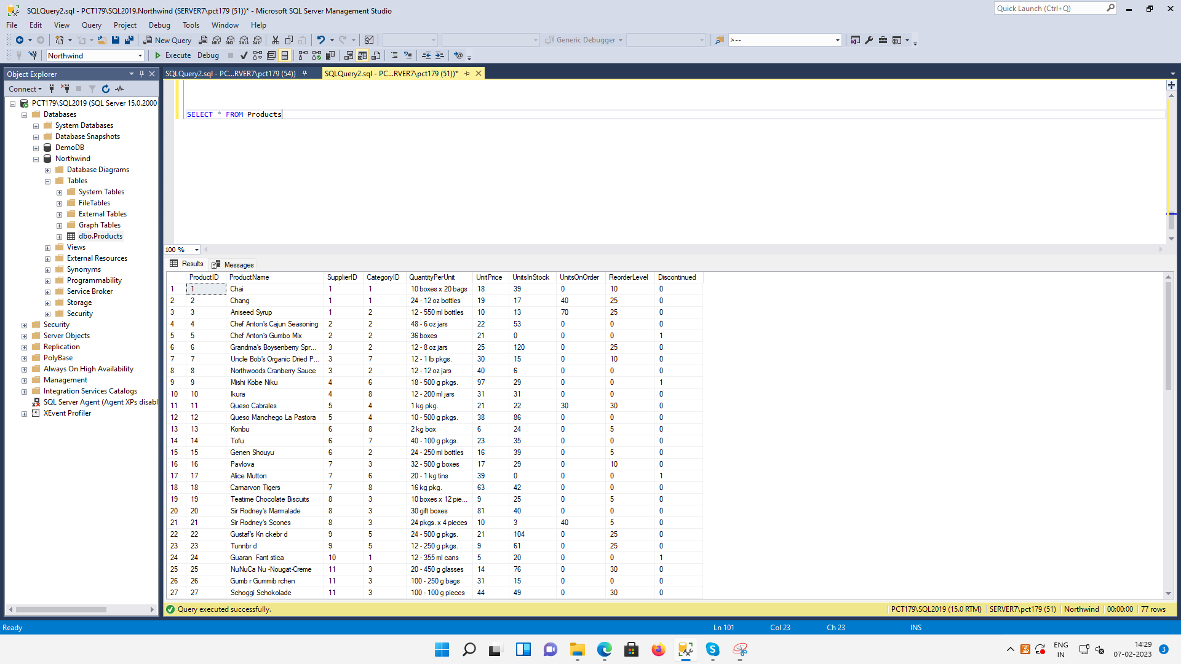

=============================================================

**QUERY 01:** Write a query to get a Product list (id, name, unit price) where current products cost less than $20.

SELECT ProductID, ProductName, UnitPrice

FROM dbo.Products

WHERE Discontinued = 0 AND UnitPrice < 20.00

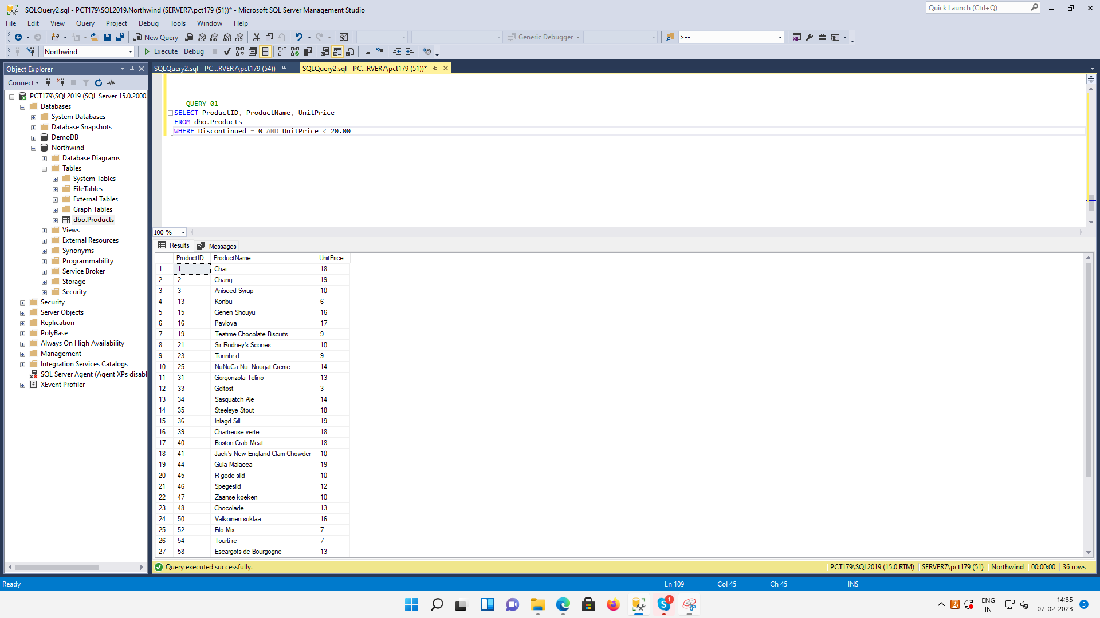

=============================================================

**QUERY 02:** Write a query to get Product list (id, name, unit price) where products cost between $15 and $25

SELECT ProductID, ProductName, UnitPrice

FROM dbo.Products

WHERE UnitPrice BETWEEN 15 AND 25

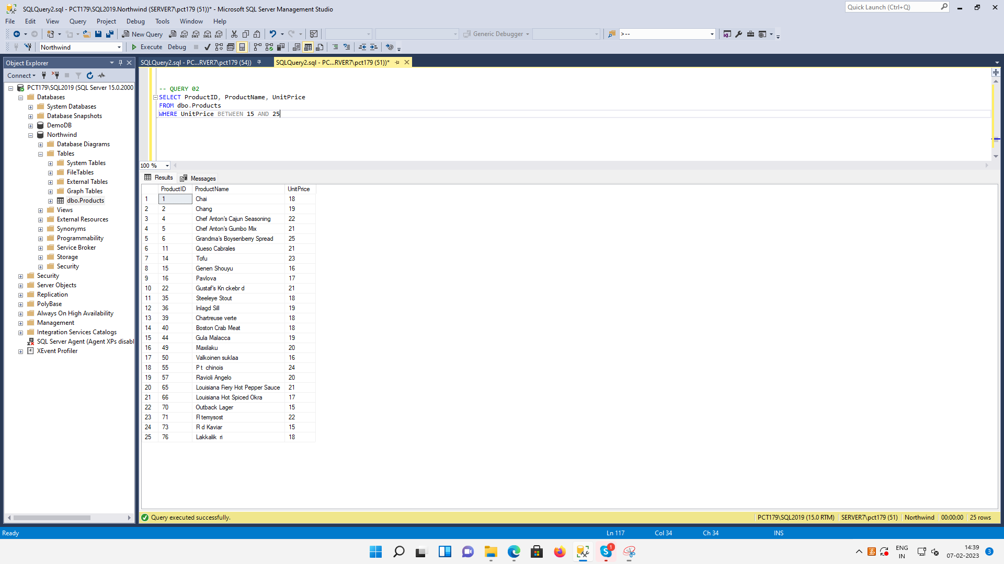

=============================================================

**QUERY 03:** Write a query to get Product list (name, unit price) of above average price.

SELECT ProductName, UnitPrice

FROM dbo.Products

WHERE UnitPrice > (SELECT AVG(UnitPrice) FROM dbo.Products)

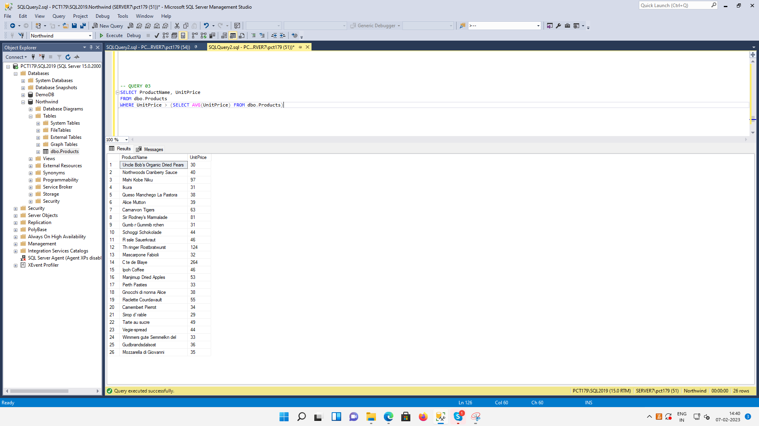

=============================================================

**QUERY 04:** Write a query to get Product list (name, unit price) of ten most expensive products

SELECT TOP 10 ProductName, UnitPrice

FROM dbo.Products

ORDER BY UnitPrice DESC

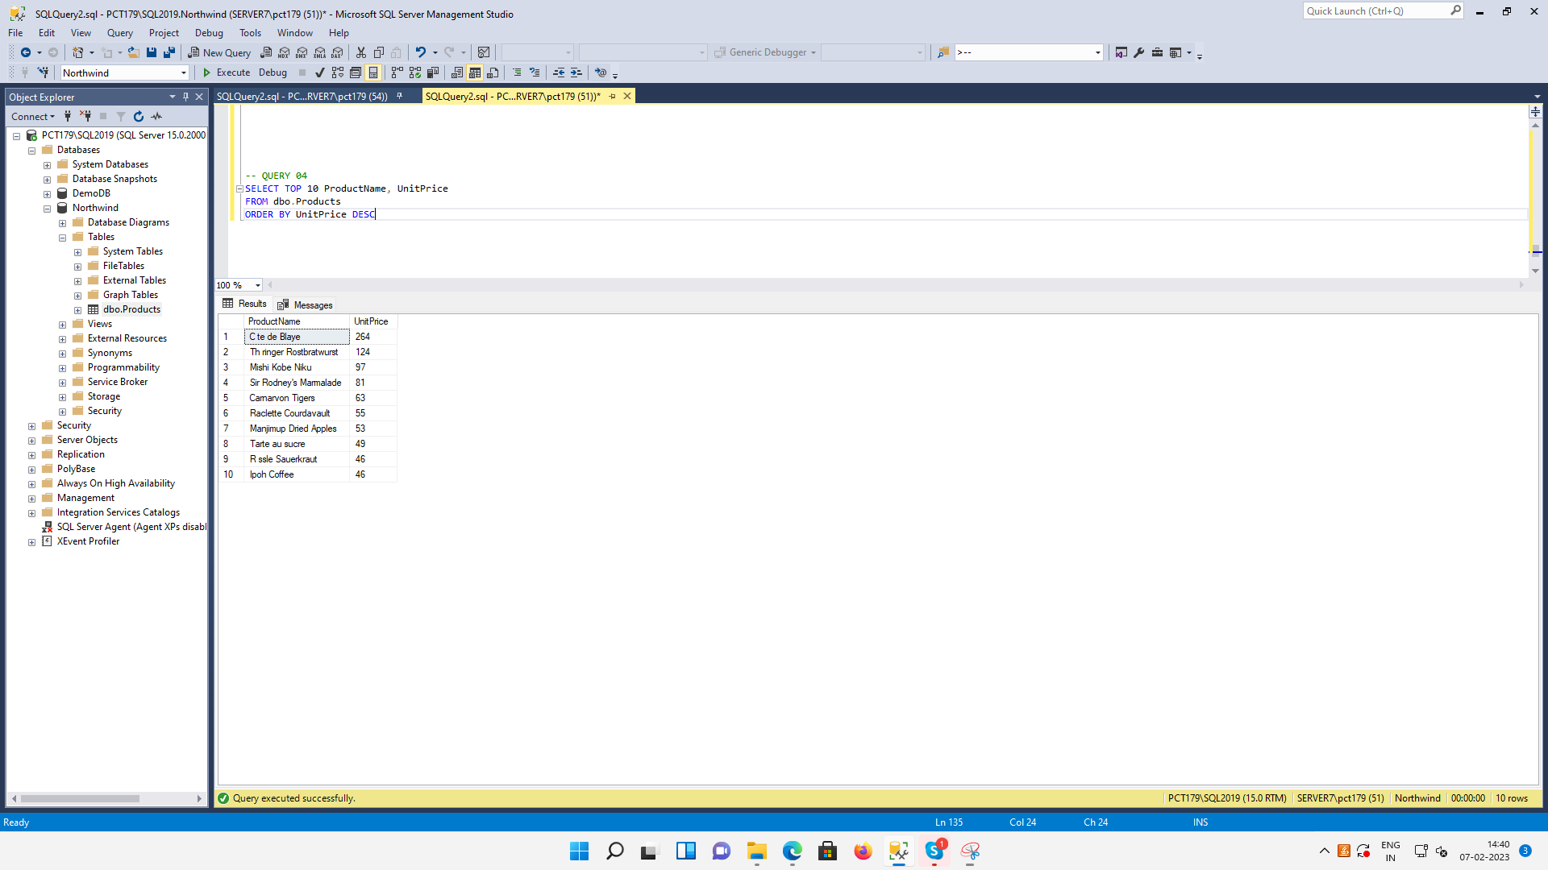

=============================================================

**QUERY 05:** Write a query to count current and discontinued products

SELECT COUNT(Discontinued) AS Current_And_Discontinued_Products

FROM dbo.Products

GROUP BY Discontinued

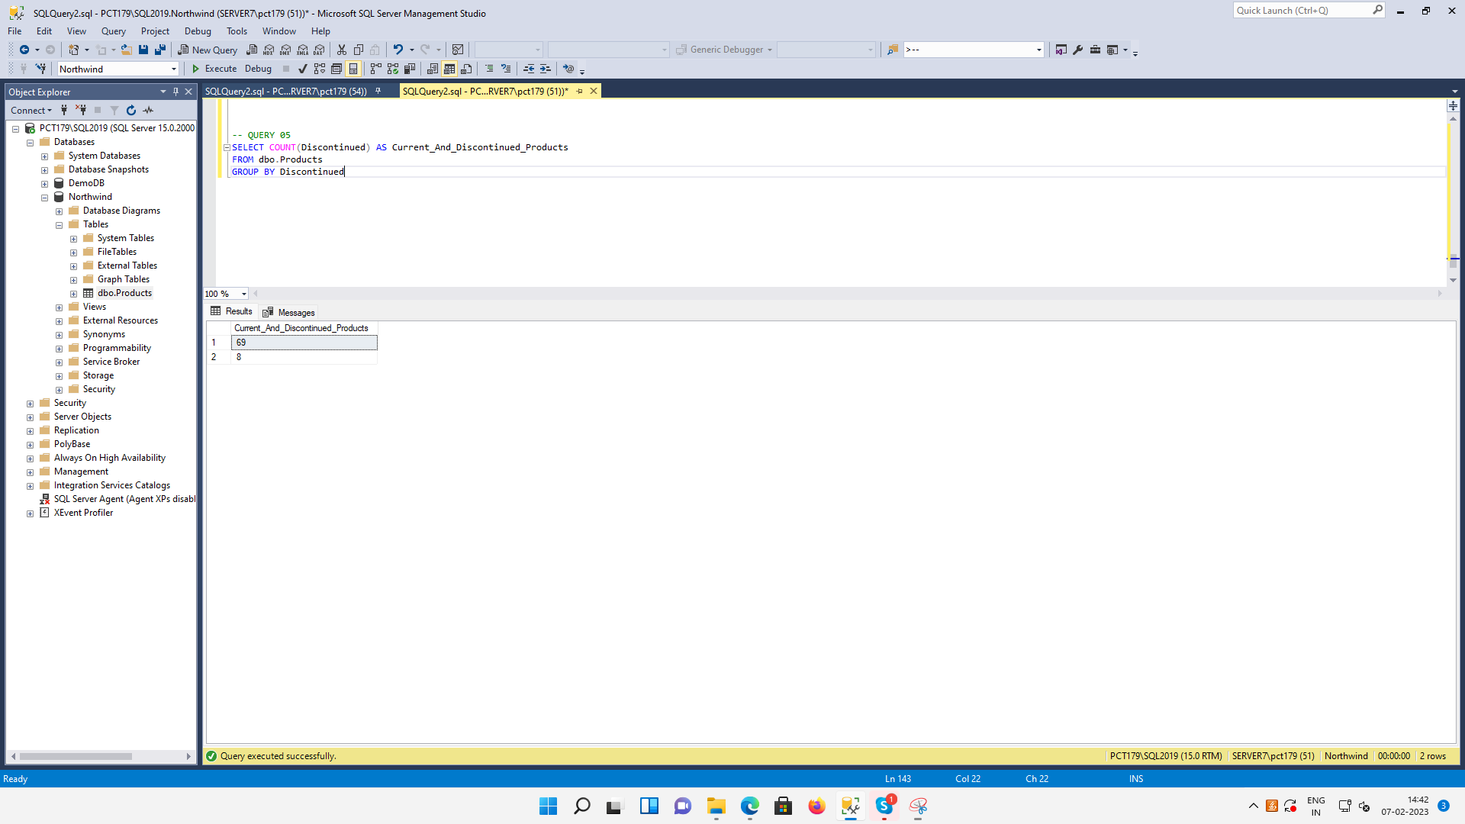

=============================================================

**QUERY 06:** Write a query to get Product list (name, units on order, units in stock) of stock is less than the quantity on order

SELECT ProductName, UnitsOnOrder, UnitsInStock

FROM dbo.Products

WHERE UnitsInStock < UnitsOnOrder

