**Name:** Roohma Kadri

=============================================================

**ASSIGNMENT 03**

**Retrieve data using Group By clause**

=============================================================

**Sample table1:Department**

-dept_id

-dept_name

**Sample table2: Employee**

-emp_id

-dept_id

-mngr_id

-emp_name

-salary

=============================================================

**DEPARTMENT TABLE**

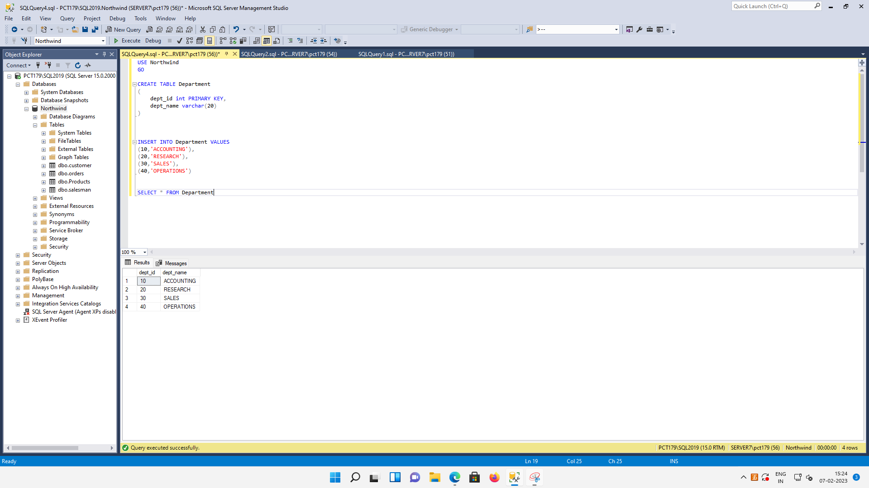

**EMPLOYEE TABLE**

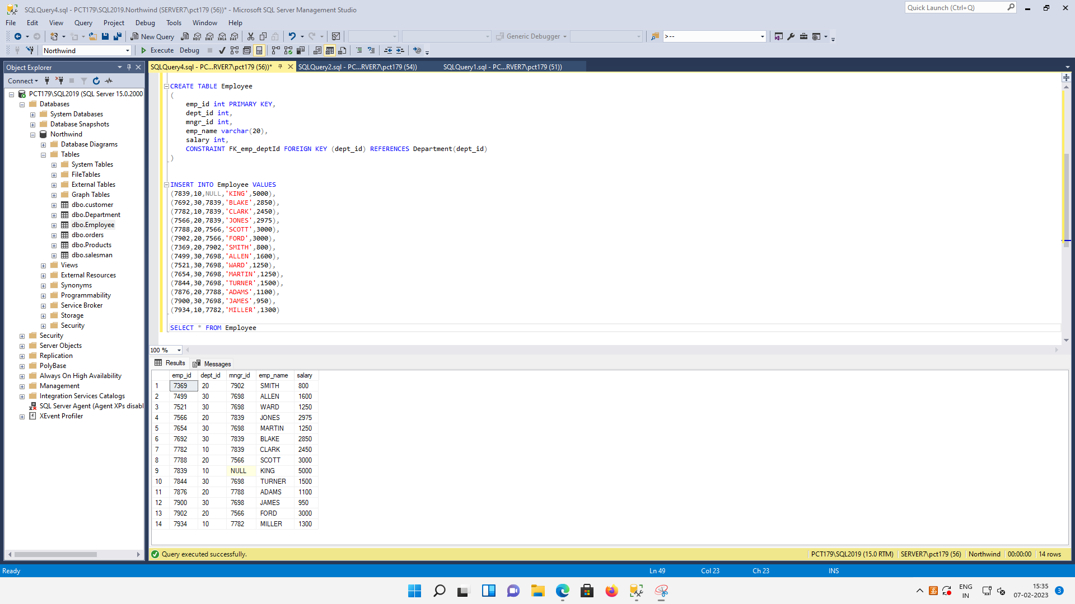

=============================================================

**QUERY 01:** Write a SQL query to find Employees who have the biggest salary in their Department

SELECT e.emp_name, d.dept_name, e.salary

FROM Employee e

LEFT JOIN Department d

ON e.dept_id = d.dept_id

WHERE (e.salary IN (SELECT MAX(salary) FROM Employee GROUP BY dept_id))

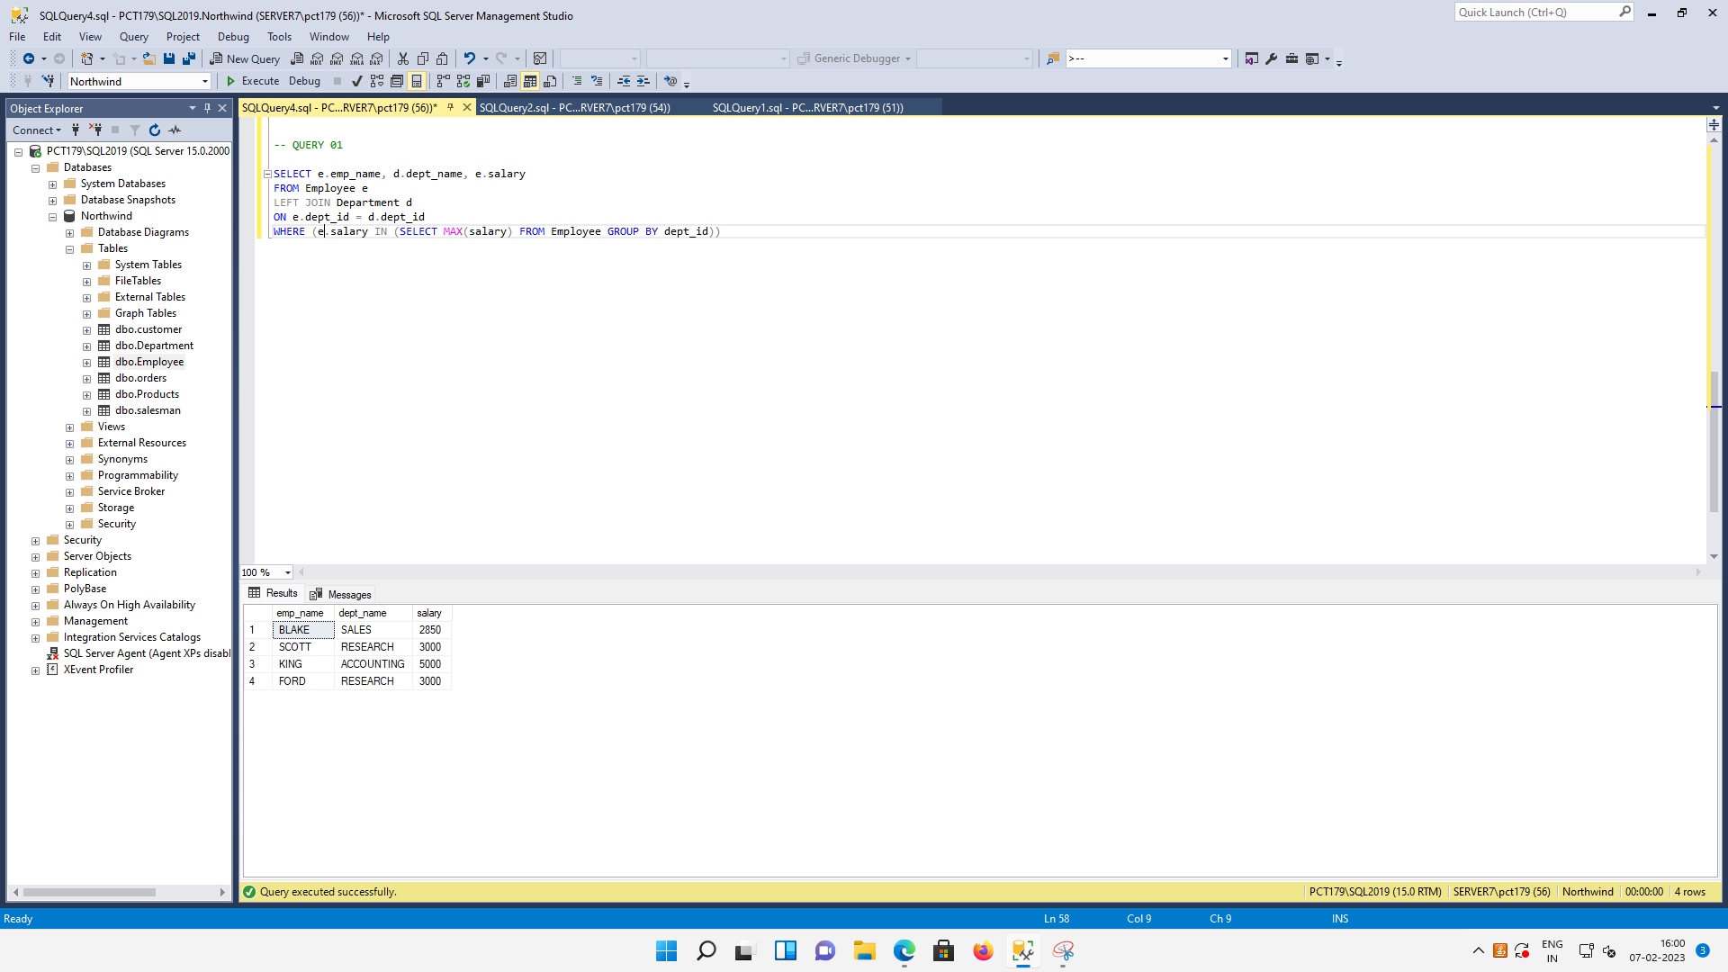

=============================================================

**QUERY 02:** Write a SQL query to find Departments that have less than 3 people in it

SELECT d.dept_id, d.dept_name, COUNT(e.dept_id) AS [Employee Count]

FROM Department d

LEFT JOIN Employee e

ON d.dept_id = e.dept_id

GROUP BY d.dept_id, d.dept_name

HAVING COUNT(d.dept_name) < 3

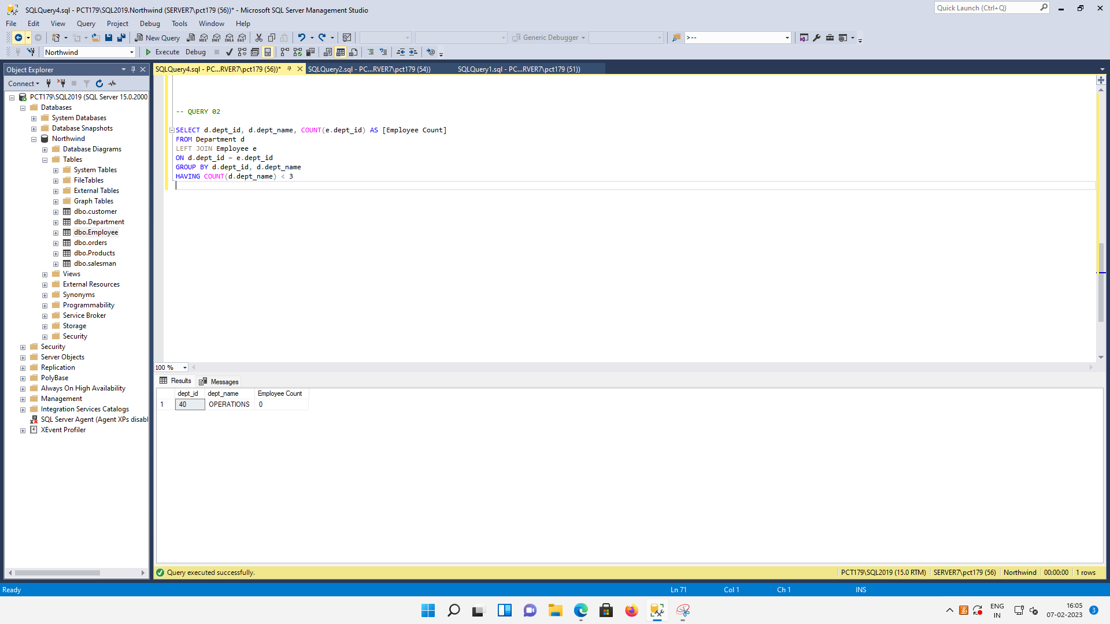

=============================================================

**QUERY 03:** Write a SQL query to find All Department along with the number of people there

SELECT d.dept_id, d.dept_name, COUNT(e.dept_id) AS [Employee Count]

FROM Department d

LEFT JOIN Employee e

ON d.dept_id = e.dept_id

GROUP BY d.dept_id, d.dept_name

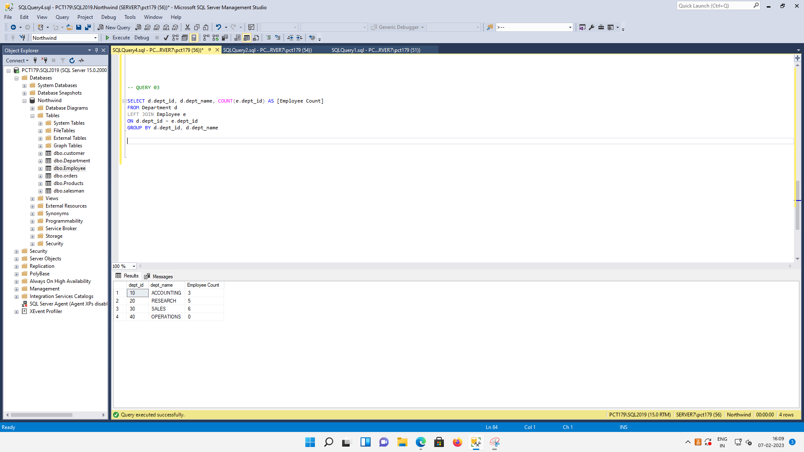

=============================================================

**QUERY 04:** Write a SQL query to find All Department along with the total salary there

SELECT d.dept_id, d.dept_name, SUM(e.salary) AS [Total Salary]

FROM Department d

LEFT JOIN Employee e

ON d.dept_id = e.dept_id

GROUP BY d.dept_id, d.dept_name

