**Name:** Roohma Kadri

=============================================================

**ASSIGNMENT 04**

**Create Stored procedure in Northwind database to insert or update a**

**record in a table**

=============================================================

**QUERY 01:** Create a stored procedure in the Northwind database that will calculate the average value of Freight for a specified customer. Then, a business rule will be added that will be triggered before every Update and Insert command in the Orders controller, and will use the stored procedure to verify that the Freight does not exceed the average freight. If it does, a message will be displayed and the command will be cancelled.

-- PROCEDURE 01

CREATE PROCEDURE "AverageFreight_By_Customer"

@CustomerID nchar(5),

@EmployeeID int,

@OrderDate datetime,

@RequiredDate datetime,

@ShippedDate datetime,

@ShipVia int,

@Freight money,

@ShipName nvarchar(40),

@ShipAddress nvarchar(60),

@ShipCity nvarchar(15),

@ShipRegion nvarchar(15),

@ShipPostalCode nvarchar(10),

@ShipCountry nvarchar(15),

@type nvarchar(6)

AS

BEGIN

if(@type='insert')

if(@Freight<(select AVG(O.Freight) from Orders O where O.CustomerID=@CustomerID))

INSERT into Orders (CustomerID,EmployeeID,OrderDate,RequiredDate,ShippedDate,ShipVia,Freight,ShipName,ShipAddress,ShipCity,ShipRegion,ShipPostalCode,ShipCountry) values (@CustomerID,@EmployeeID,@OrderDate,@RequiredDate,@ShippedDate,@ShipVia,@Freight,@ShipName,@ShipAddress,@ShipCity ,@ShipRegion,@ShipPostalCode,@ShipCountry)

else if(@type='update')

if (@Freight<(select AVG(O.Freight) from Orders O where O.CustomerID=@CustomerID))

update Orders set Freight=@Freight where CustomerID=@CustomerID and OrderDate=@OrderDate

else

print('invalid')

END

EXEC AverageFreight_By_Customer 'VINET',6,'1996-07-04 00:00:00.000', '1996-08-01 00:00:00.000','1996-07-16 00:00:00.000',3,32.3800,'Vins et alcools Chevalier','59 rue de lAbbaye','Reims',NULL,51100,'France','insert'

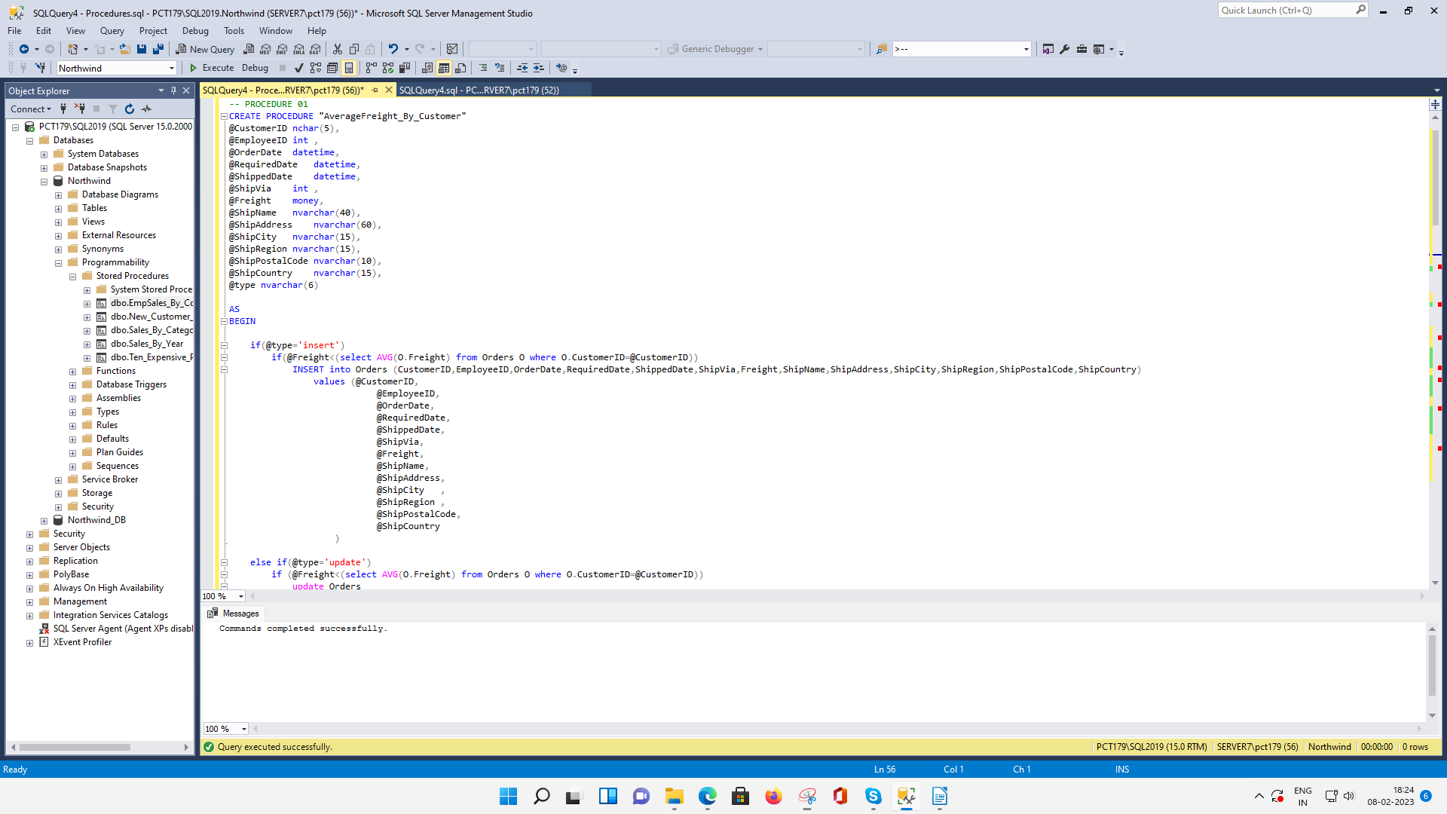

=============================================================

**QUERY 02:** write a SQL query to Create Stored procedure in the Northwind database to retrieve Employee Sales by Country

-- PROCEDURE 02

CREATE PROCEDURE "EmpSales_By_Country"

@countryName nvarchar(15)

AS

SELECT e.FirstName, e.LastName, o.ShipCountry, COUNT(o.EmployeeID) AS [Total Sales By Employee]

FROM Employees e

JOIN Orders o

ON e.EmployeeID = o.EmployeeID

WHERE o.ShipCountry = @countryName

GROUP BY e.FirstName, e.LastName, o.ShipCountry

GO

EXEC EmpSales_By_Country 'Austria'

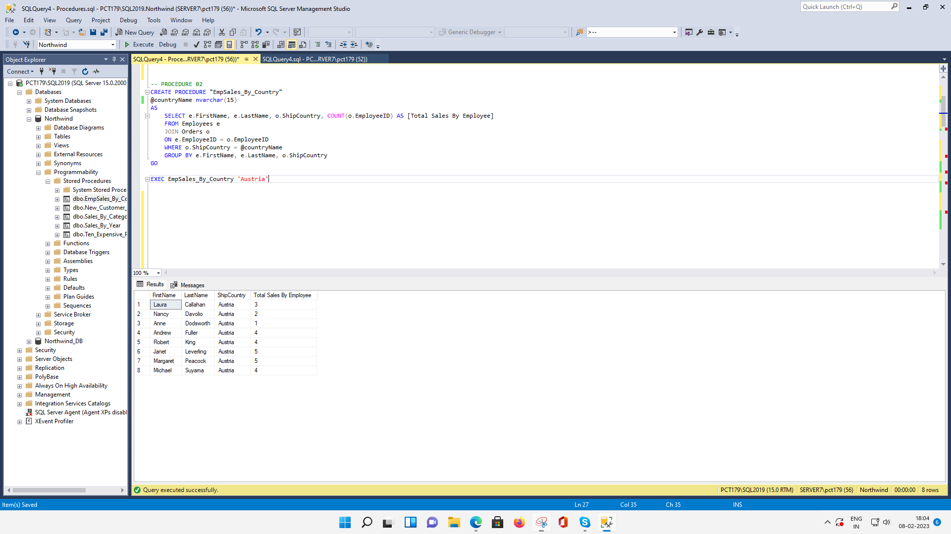

=============================================================

**QUERY 03:** write a SQL query to Create Stored procedure in the Northwind database to retrieve Sales by Year

-- PROCEDURE 03

CREATE PROCEDURE "Sales_By_Year"

@year int

AS

SELECT YEAR(o.OrderDate) AS [Year], COUNT(o.OrderId) AS [Total Sales]

FROM Orders o

GROUP BY YEAR(o.OrderDate)

HAVING YEAR(o.OrderDate) = @year

GO

EXEC Sales_By_Year '1996'

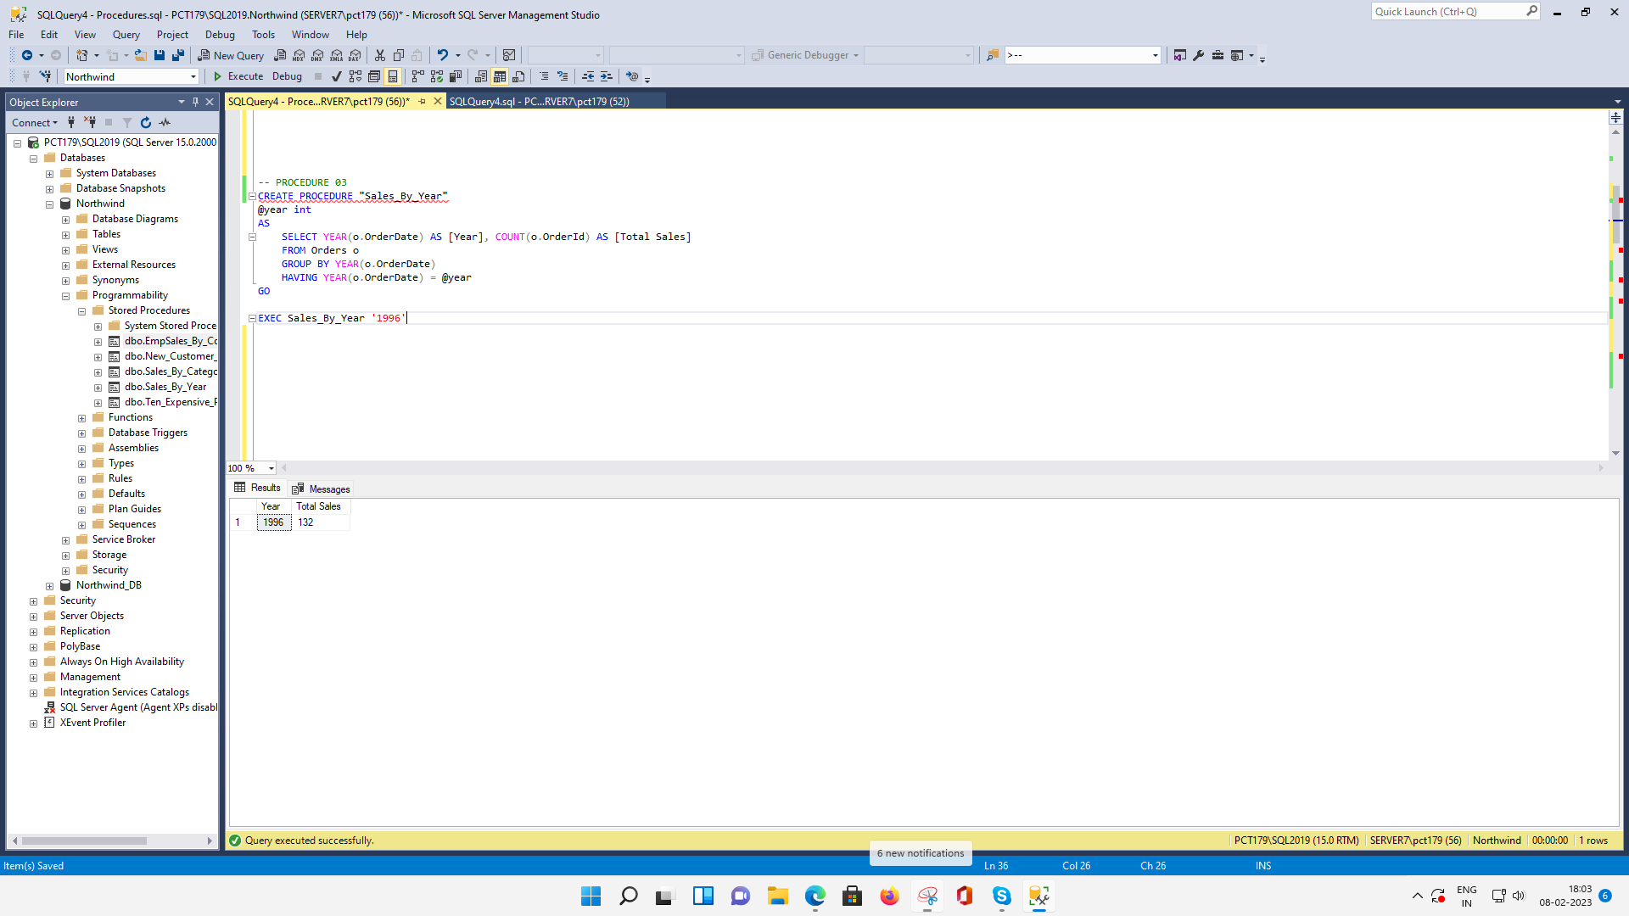

=============================================================

**QUERY 04:** write a SQL query to Create Stored procedure in the Northwind database to retrieve Sales By Category

-- PROCEDURE 04

ALTER PROCEDURE "Sales_By_Category"

@categoryName nvarchar(15)

AS

SELECT c.CategoryName, COUNT(c.CategoryName) AS [Total Sales]

FROM Categories c

JOIN Products p

ON c.CategoryID = p.CategoryID

JOIN [Order Details] od

ON p.ProductID = od.ProductID

GROUP BY c.CategoryName

HAVING c.CategoryName = @categoryName

GO

EXEC Sales_By_Category 'Dairy Products'

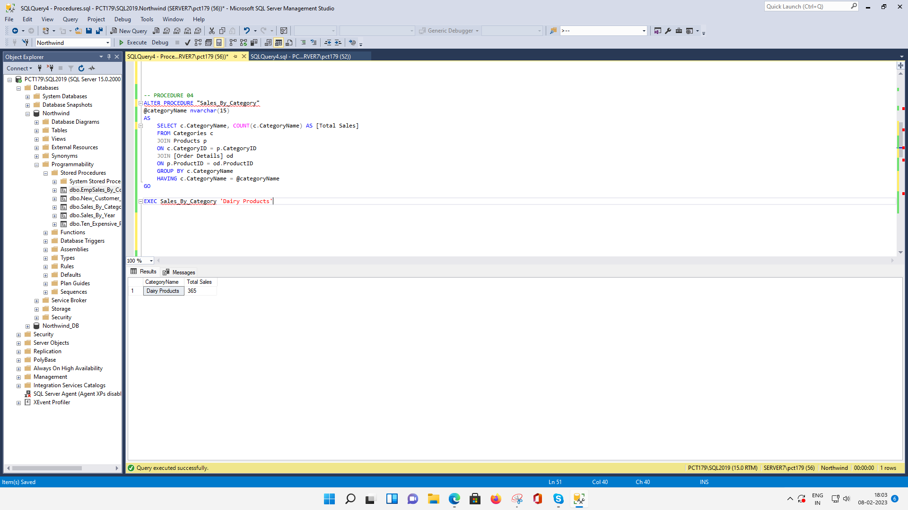

=============================================================

**QUERY 05:** write a SQL query to Create Stored procedure in the Northwind database to retrieve Ten Most Expensive Products

-- PROCEDURE 05

CREATE PROCEDURE "Ten_Expensive_Products"

AS

SELECT TOP 10 p.ProductID, p.ProductName, p.UnitPrice

FROM Products p

ORDER BY p.UnitPrice DESC

GO

EXEC Ten_Expensive_Products

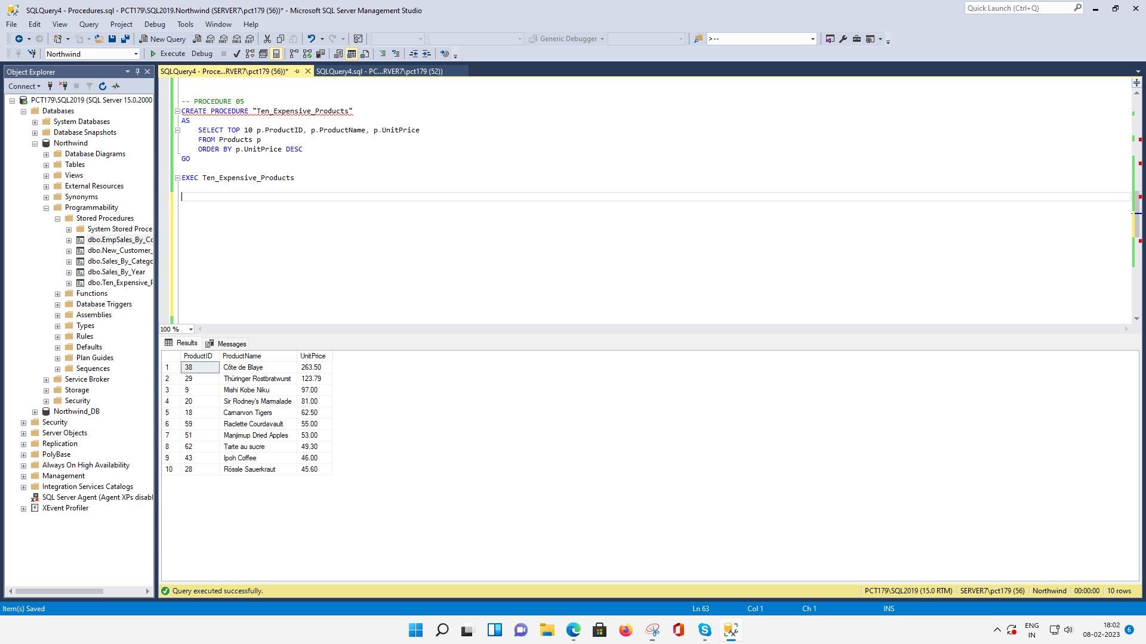

=============================================================

**QUERY 06:** write a SQL query to Create Stored procedure in the Northwind database to insert Customer Order Details

-- PROCEDURE 06

CREATE PROCEDURE "New_Customer_OrderDetails"

@orderID int,

@productID int,

@unitPrice money,

@qty smallint,

@discount real

AS

INSERT INTO [Order Details] VALUES

(@orderID, @productID, @unitPrice, @qty, @discount)

GO

EXEC New_Customer_OrderDetails '10265','10','99.99','99','0.12'

SELECT * FROM [Order Details] WHERE OrderID = '10265' AND ProductID = '10'

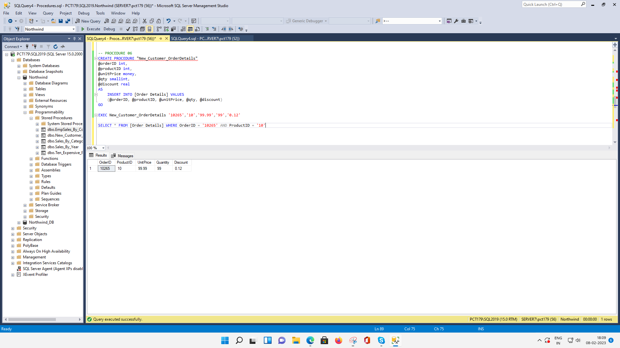

=============================================================

**QUERY 07:** write a SQL query to Create Stored procedure in the Northwind database to update Customer Order Details

-- PROCEDURE 07

CREATE PROCEDURE "Update_Customer_OrderDetails"

@orderID int,

@productID int,

@unitPrice money,

@qty smallint,

@discount real

AS

UPDATE [Order Details] SET

UnitPrice = @unitPrice,Quantity = @qty, Discount = @discount

WHERE OrderID = @orderID AND ProductID = @productID

GO

EXEC Update_Customer_OrderDetails '10265','10','89.99','9','0.22'

SELECT * FROM [Order Details] WHERE OrderID = '10265' AND ProductID = '10'



