Services / Help Section Data
- Icon: 🎨 (Design / UI)
Title: Web & UI Design
Paragraph: Crafting visually stunning websites and intuitive interfaces that engage users and boost conversions.
- Icon: ⚙️ (Development)
Title: Web Development
Paragraph: Building fast, scalable, and secure websites and web apps tailored to your business needs.
- Icon: 📱 (Mobile)
Title: Mobile App Development
Paragraph: Developing high-performance mobile apps for iOS and Android with seamless user experiences.
- Icon: 🚀 (Marketing)
Title: Digital Marketing
Paragraph: Creating data-driven marketing campaigns to increase brand awareness and drive measurable growth.
- Icon: 🛒 (E-commerce)
Title: E-Commerce Solutions
Paragraph: Designing and developing online stores optimized for conversions and smooth shopping experiences.
- Icon: 🔍 (SEO)
Title: SEO & Analytics
Paragraph: Improving search rankings and website performance through SEO strategies and analytics insights.
- Icon: 🖥️ (Branding)
Title: Brand Strategy
Paragraph: Defining brand identity, voice, and positioning that resonates with your target audience.
- Icon: ☁️ (Cloud/Tech)
Title: Cloud & IT Solutions
Paragraph: Providing cloud-based solutions and IT support to keep your business secure and scalable.

Portfolio Section Data (6 Example Projects)
- Title: Modern E-Commerce Website
Paragraph: Designed a sleek, user-friendly online store that increased client sales by 35%.
Image URL: https://images.unsplash.com/photo-1581091215361-376ed0d7b5c1
- Title: Mobile App Redesign
Paragraph: Redesigned a mobile app with improved UX/UI, boosting user retention and engagement.
Image URL: https://images.unsplash.com/photo-1590608897129-79be4b3bcae4
- Title: Branding & Identity
Paragraph: Developed complete brand identity, including logo, color scheme, and brand guidelines.
Image URL: https://images.unsplash.com/photo-1522202176988-66273c2fd55f
- Title: SaaS Dashboard Platform
Paragraph: Built an interactive dashboard for SaaS product, enabling data visualization and insights.
Image URL: https://images.unsplash.com/photo-1551033406-611cf9f4f1bf
- Title: Marketing Campaign Website
Paragraph: Created a landing page and campaign assets to boost product awareness and leads.
Image URL: https://images.unsplash.com/photo-1519389950473-47ba0277781c
- Title: Webflow Portfolio Site
Paragraph: Developed a creative portfolio website for a designer using Webflow for rapid deployment.
Image URL: https://images.unsplash.com/photo-1504384308090-c894fdcc538d

Team Section Data
📌 Section Title:
Meet the People Behind Our Digital Magic/Meet Our Digital Experts
📝 Paragraph:
Every project we deliver is powered by passion, creativity, and collaboration. Our team brings unique talents together to turn ideas into experiences that inspire and drive real impact for our clients.
👥 Team Members (5 Example Cards):
- Name: Sophia Williams
Role: CEO & Founder
Paragraph: Leads our agency with 10+ years of experience in digital strategy and design.
Avatar Image: https://randomuser.me/api/portraits/women/68.jpg
- Name: James Anderson
Role: Lead Developer
Paragraph: Builds scalable web and mobile applications, ensuring top performance and user experience.
Avatar Image: https://randomuser.me/api/portraits/men/75.jpg
- Name: Olivia Brown
Role: Creative Director
Paragraph: Oversees creative direction, branding, and UI/UX design for all client projects.
Avatar Image: https://randomuser.me/api/portraits/women/44.jpg
- Name: Ethan Johnson
Role: Marketing Strategist
Paragraph: Crafts data-driven marketing campaigns to grow client reach and engagement.
Avatar Image: https://randomuser.me/api/portraits/men/34.jpg
- Name: Mia Thompson
Role: Project Manager
Paragraph: Ensures smooth project execution, on-time delivery, and excellent client communication.
Avatar Image: https://randomuser.me/api/portraits/women/52.jpg

Contact:
Here’s a professional, polished Contact section for your digital agency website:

📌 Section Title:
Let’s Build Something Together
📝 Paragraph:
We’re here to bring your ideas to life. Reach out to discuss your project, ask questions, or explore how we can help grow your brand with innovative digital solutions.

It’s:
- Professional & inviting – encourages users to connect
- Clear & action-oriented – explains why they should reach out
- Aligned with agency tone – matches your hero and team sections
If you want, I can now create the full React + Tailwind Contact component with form fields, CTA button, and responsive design.

Testimonials:

Perfect! Here’s a realistic, professional testimonial section for your digital agency website. I’ll provide image, review, name, and status for each testimonial:

Testimonials (5 Examples)
- Image: https://randomuser.me/api/portraits/women/65.jpg
Review Paragraph:
“Working with this agency transformed our online presence. Their design and strategy boosted our engagement and conversions significantly.”
Name: Emily Carter
Status: CEO, BrightWave Solutions
- Image: https://randomuser.me/api/portraits/men/44.jpg
Review Paragraph:
“A professional and creative team! They delivered our project on time and exceeded all expectations.”
Name: Daniel Moore
Status: Founder, NovaTech
- Image: https://randomuser.me/api/portraits/women/52.jpg
Review Paragraph:
“Their digital marketing expertise helped us reach new audiences and grow our business faster than we imagined.”
Name: Sophia Lee
Status: Marketing Director, Elevate Inc.
- Image: https://randomuser.me/api/portraits/men/58.jpg
Review Paragraph:
“From concept to execution, the team was collaborative, innovative, and extremely responsive. Highly recommended!”
Name: Michael Thompson
Status: Product Manager, TechNova
- Image: https://randomuser.me/api/portraits/women/49.jpg
Review Paragraph:
“Professional, creative, and results-driven. They truly understand how to build digital experiences that work.”
Name: Olivia Bennett
Status: CEO, Horizon Digital

💡 Recommendations:
- Display in carousel/slider for better UX on mobile
- Include avatars for authenticity
- Keep quotes short and impactful
- Optional: add star ratings or subtle animation for extra polish

If you want, I can create a fully coded React + Tailwind testimonial slider component using these 5 testimonials, with avatar, review, name, status, and smooth carousel effect.
Do you want me to do that next?

Footer:
© 2026 YourAgency. We craft digital experiences that inspire, engage, and drive measurable growth for brands worldwide.”

Below logo:
We are a full-service digital agency dedicated to creating innovative solutions that help brands grow and connect with their audience.

Fix the responsive bug:
Add the hover of the entire button effect: Fixed

Change the trusted: fixed:
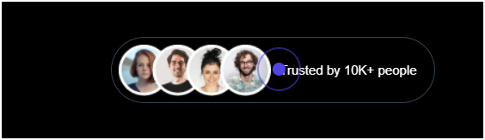
Change the trusted logo: Fixed

Change the hover color match with entire site; and update the data. fixed
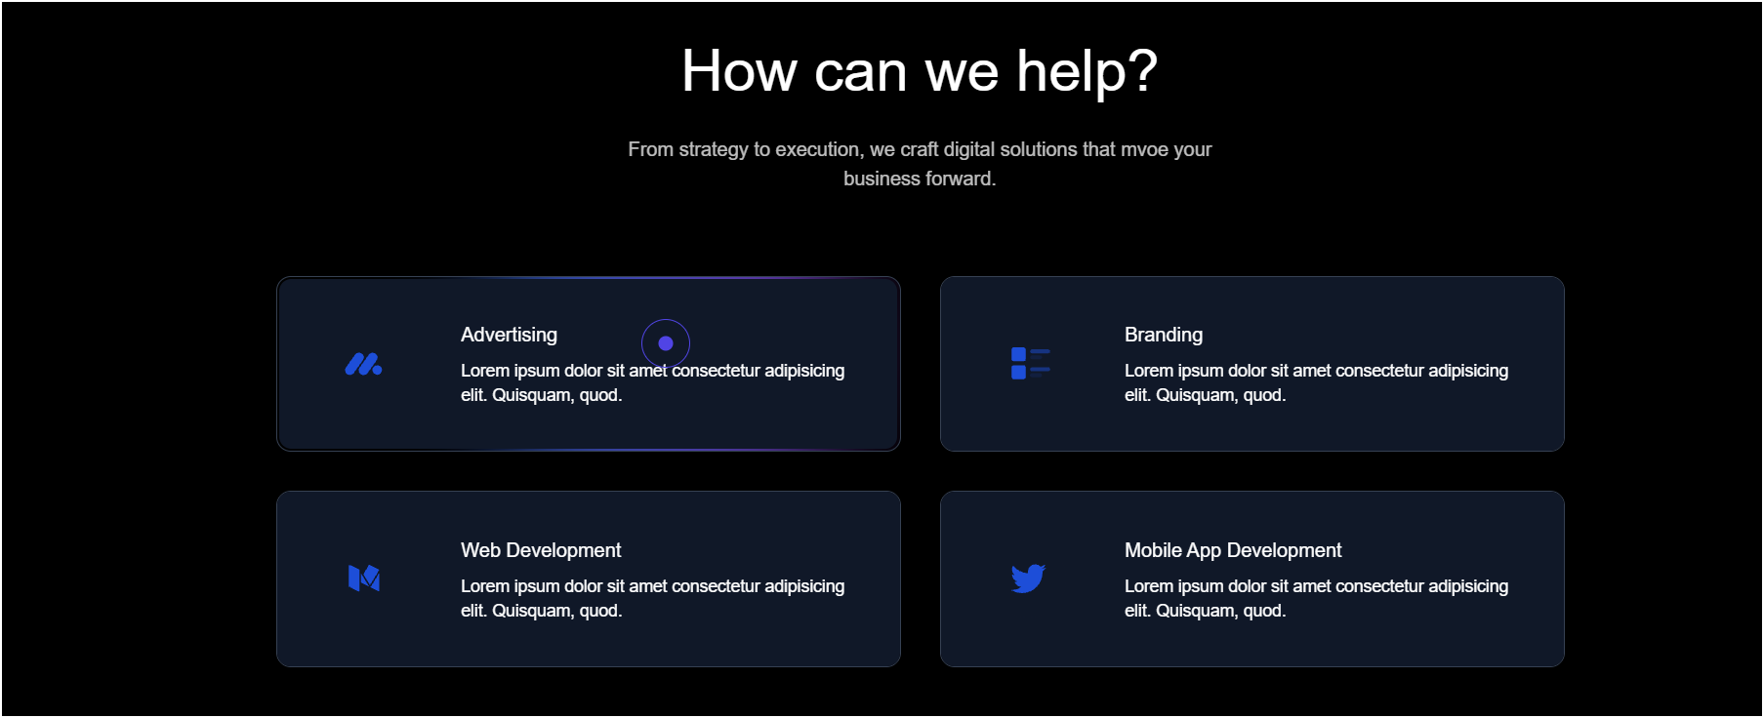
Change the text color with entire site color: Fixed
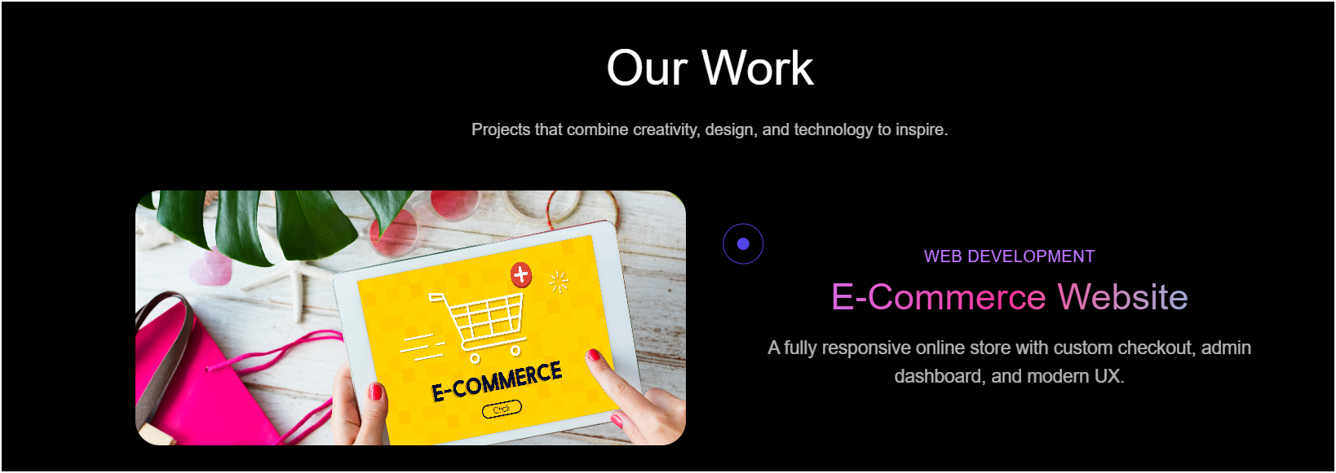
Update the Team data and images:
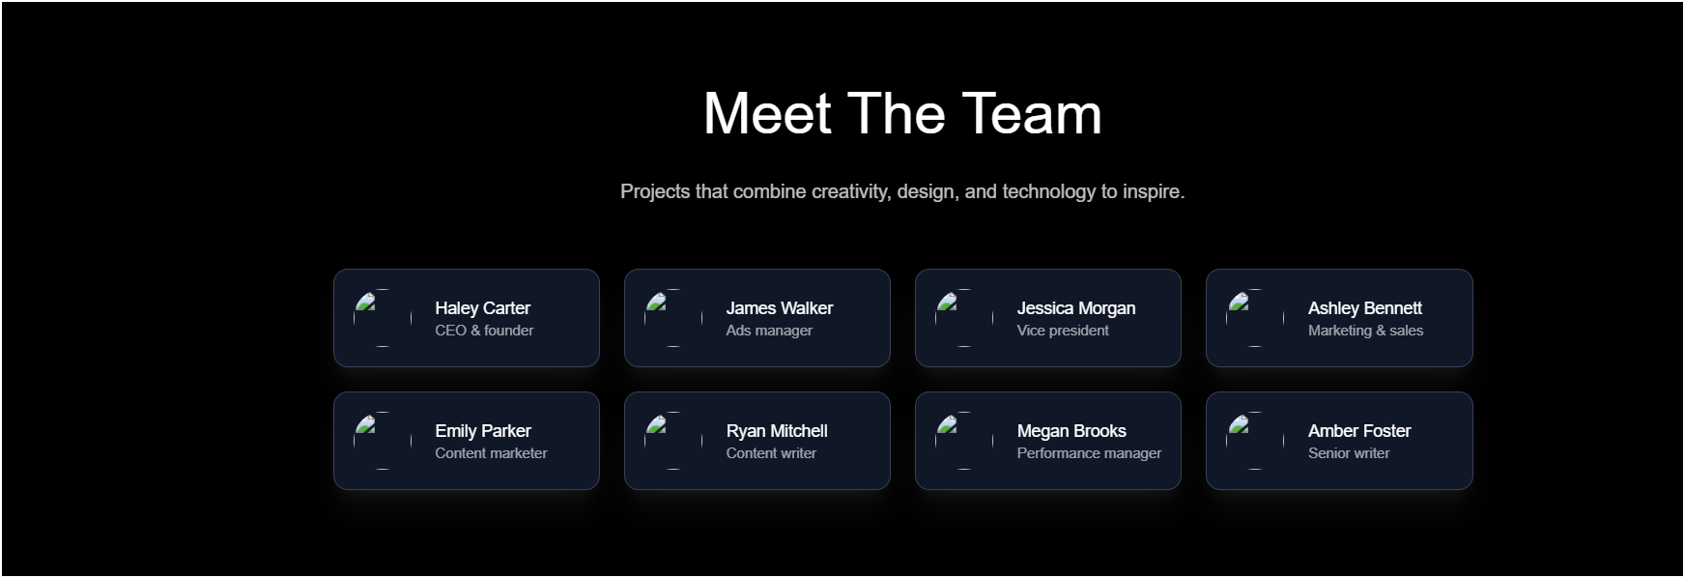
Change the testimonial use portfolio testimonial layout:
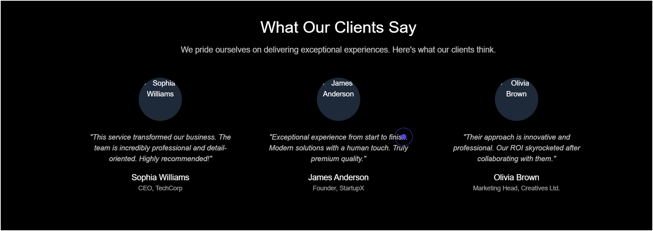
Change the bg color for dark mode:
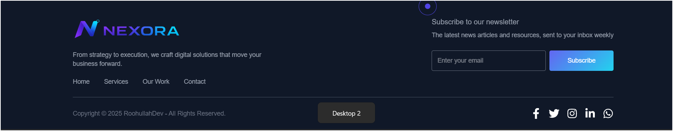
Fix the hover: fixed:

