EE 325: Probability and Random Processes

**Question1 : Recall the capture-release-recapture problem: Catch m sh, mark them and release them back into the lake. Allow the sh to mix well and then you catch m sh. Of these p are those that were marked before. Assume that the actual sh population in the lakes is n and has not changed between the catches. Let Pmp(n) be the probability of the event (for a xed p recatches out of m) coming from n sh in the lake. Generate a plot for Pmp(n) as a function of n for the following values of m and p : m = 100 and p = 10205075 For each of these p use the plots to estimate (educated guess) the actual value of n i.e., what is the best guess for n if m = 100 and you catch p of the marked sh after mixing them up. Call these four estimates n1 n4 You de ne your notion of best guess. Do not search, THINK!**

**Approach :** The above is nothing but a binomial random variable. We get Pm,p(n) as follows:

Pm,p

Taking m = 100 and plotting this probability as a function of n for various p values we get:

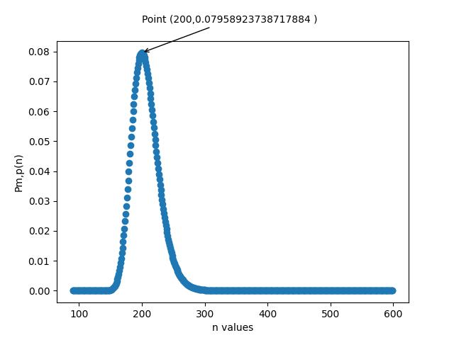

p = 50

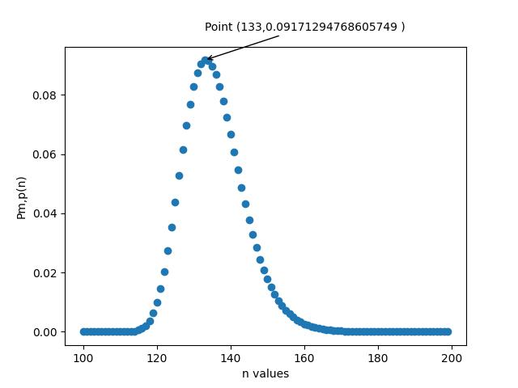

p = 75

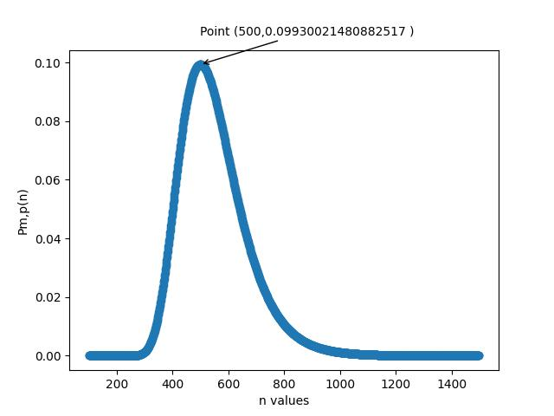

P = 20

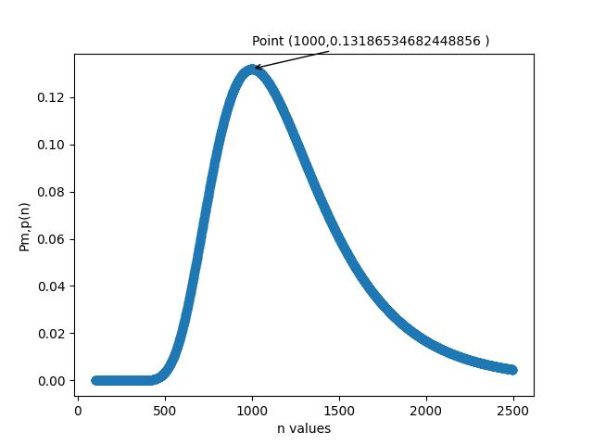

P = 10

* According to us, the best guess for the value of n would be the value for which obtaining the corresponding p is most probable.
* We are using the notion that if an event has highest probability, it is most likely to happen.
* So, our guesses are :
  + N1 : 1000
  + N2 : 500
  + N3 : 200
  + N4 : 133

**Question4 : A jury of N members is to be constituted to decide on a complaint. In the population from which the jury has to be selected, each member makes the correct (fair) decision with probability (05 + c) 005 c 025 The majority rule is applied, i.e., all members vote yes/no and the majority vote is the decision of the panel. If the probability of the correct decision has to be at least 0.75, what combinations of c and N are feasible. Discretize c in steps of 0.01. You can assume N to be odd numbered integers. Repeat if the requirement is to be correct 90% of the time. Provide a short discussion of your ndings. Submit the plots for the combinations of c and N for the two correctness requirements.**

**Note that there is typically a cost involved with the choices of c and NA juror with a higher c is both rare and expensive. Similarly higher N makes the logistics of managing them complex. Suggest suitable cost functions that depend on c and N and comment on the right combination of c and N for each of the two preceding correctness requirements.**

**Approach –** Let X be the random variable which denotes the number of people who gave a fair decision.

P(Decision is correct ) = P(X > [)

Given N is an odd integer, say N = 2M +1, where M is a non negative integer. Then

P(Decision is correct ) = P( X > M )

Which can be given as

P( X > M) =

Where

P(X = i ) =

Where p = probability that a given member makes a fair decision, here

p = 0.5 + c , 0.05 <= c <= 0.25

We get

P(Fair Decision ) =

We need to plot