Duration of each song

* Open time.csv
* 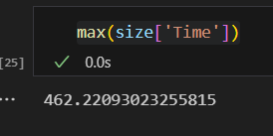
* 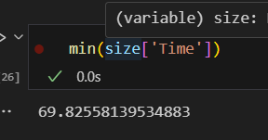
* Indian national anthem has standard length of 52 seconds
* Only one file less than 100 seconds
* We expect lesser time durations to be of Indian national anthem
* Maybe files with around 100 seconds duration are padded with some no sound for a lot of time

Heatmaps of files

